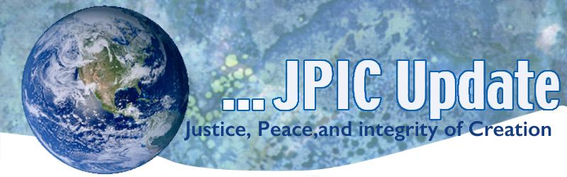
April 17, 2017
Calendar
Save the date
April 17-30 continue the 100 day prayer-see attachment
April 21, 2017 anniversary of John Muir’s birthday
April 22,2017 Earth Day
April 23, 2017 Mercy Sunday – se the attached prayer for Mercy to the Earth

Taking Action
Prevent Nuclear War
Earlier this year, Congressman Ted W. Lieu (D-CA) and Senator Edward Markey (D-MA) introduced new legislation to address the unchecked power of the President to launch nuclear weapons. The Restricting First Use of Nuclear Weapons Act would prohibit the President from launching nuclear weapons without a declaration of war from Congress, except in response to a nuclear attack. Women’s Action for New Directions urges us to tell our Members of Congress to support the Lieu-Markey bill HR 669 to end this unchecked nuclear launch authority. Click to TAKE ACTION

Death Penalty
Last night, something big happened. A judge in Arkansas temporarily blocked the remaining six executions from taking place after Amnesty members and activists like you stood up.
Amnesty members and other activists from around the country and the world were heard. Hundreds gathered at the Arkansas State Capitol to deliver signatures – more than 157,000 – demanding a stop to the assembly line of death.
Just hours after we delivered the petitions, an Arkansas judge stopped the executions from moving forward. The executions are halted for now, but we need to keep up the pressure on Governor Hutchinson to stop them for good. Please click below to sign the petition to stop the executions.
Join us as we continue to fight against the death penalty. Take action now

Earth Day
In honor Earth Day sit out in nature and slowly read Daniel 3: 60-81 (attached). Give praise to the Creator for the gift of creation. What can you do today to protect God’s creation?

Information/Reflection
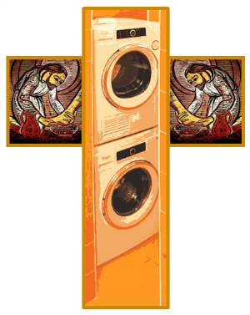
The Cross of
the Holy Wash

Pope Francis Laundry
The Vatican kicked off Holy Week by announcing the opening of the Pope Francis Laundry that will serve "... the poorest people [in Rome], particularly the homeless, who will be able to wash, dry and iron their clothes and blankets. The Vatican said, "Here, then, is a concrete sign... a place and service to give a concrete form of charity and mercy to restore dignity to so many people who are our brothers and sisters." Just as Jesus washed feet, Pope Francis is washing clothes.

Resources
A History of the Syrian Conflict
This 6 minute is worth watching as it puts the war perspective. .
https://www.youtube.com/watch?v=JFpanWNgfQY
8th Work of Mercy
Pope Francis has given Catholics a fantastic gift: an 8th work of Mercy, showing care to our common home. And he has given us clear directives in Laudato Si that “every person living on this planet” is called to care for creation as responsible citizens, and as followers of Christ.
To help you, we've put together a toolkit full of resources on signing up for the March, bulletin and pulpit announcements to invite your congregation, and printable signs and banners

