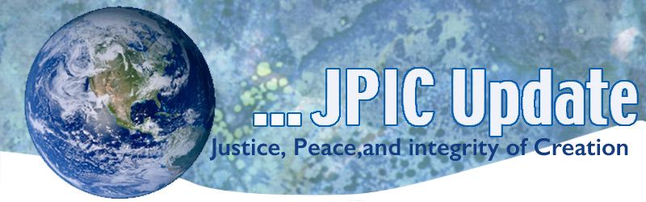
April 3, 2017
Calendar
April 3, 2107 continue praying the Hundred Day Prayer – See Attached
April 7, 2017 World Health Day – see attached prayer
April 7, 2017 Justice for Immigrants Phone-In Fridays Lenten Campaign – see information below

Taking Action

CSSJ Federation Action for the week of April 3rd
Take action for a fair judicial system/constitution and stand against corporations having the same rights as people. Become more involved locally - invite 2 or 3 friends to join you in visiting a courtroom to observe the judicial system in action in your city.
Tell your legislators to overturn Citizens United https://secure2.convio.net/comcau/site/Advocacy?cmd=display&page=UserAction&id=149&s_subsrc=take_action&_ga=1.241916162.1039170844.1490907187

Take Action on the BRIDGE Act
There are more than 750,000 young people who have received and benefitted from Deferred Action for Childhood Arrivals (DACA). These youth entered the U.S. as children and know America as their only home.

The BRIDGE (Bar Removal of Individuals who Dream and Grow our Economy) Act, S.128/H.R. 496, was recently introduced in Congress as a bipartisan effort to sustain the temporary relief from deportation and employment eligibility offered to youth through the (DACA) program. DACA recipients are contributors to our economy, veterans of our military, academic standouts in our universities, and leaders in our parishes and communities.
Take Action to urge your legislators to support the BRIDGE Act - Click here

Justice for Immigrants Phone-In Fridays Lenten Campaign
(From LCWR Immigration Coalition)
We are continuing to ask that in addition to fasting and prayer during this Lenten season, that you please join us in voicing support for vulnerable immigrants and refugees. You can do so by calling the offices of your members of Congress during Justice for Immigrants Phone-In Fridays, a weekly advocacy event which we are undertaking this liturgical season.
Every Friday until April 14, please call your federal lawmakers and urge them to co-sponsor legislation that supports immigrants and refugees seeking protection and safety in the United States. If your representative has already supported the legislation protecting immigrants and refugees listed below, call in to thank them!
Contacting your representative:
Call this toll-free number 1-855-589-5698.

Information/Reflection

“Today, as Christians,” Pope Francis encouraged, “all of us are called to put behind us all prejudice towards the faith that others profess with a different emphasis or language, to offer one another forgiveness for the sin committed by those who have gone before us, and together to implore from God the gift of reconciliation and unity.”

Living Rivers
The Ganges River, considered sacred by more than 1 billion Indians, has become the first non-human entity in India to be granted the same legal rights as people. The decision, which was welcomed by environmentalists, means that polluting or damaging the rivers will be legally equivalent to harming a person.

In a world-first a New Zealand river has been granted the same legal rights as a human being.
The local Māori tribe of Whanganui in the North Island has fought for the recognition of their river – the third-largest in New Zealand – as an ancestor for 140 years. “We have fought to find an approximation in law so that all others can understand that from our perspective treating the river as a living entity is the correct way to approach it, as in indivisible whole, instead of the traditional model for the last 100 years of treating it from a perspective of ownership and management.”

New York City now generates more than 100 MW of solar
New York City residents and businesses recently surpassed the 100 megawatt (MW) solar generation milestone, according to utility Con Edison
Resources
“Centering Stories: April 20 and April 21, 2017
A Symposium on Asian American and Pacific Islander
- Undocumented Student Experiences.”
- The film screening on Thursday 5-7 p.m.
- The symposium on Friday 9 am.-3:30 p.m.
Will explore the experiences of AAPI undocumented community members and students.
All are welcome. RSVPS required by April 12: https://centeringstories.eventbrite.com

State refugee action tracker. Highlights for the week include:
- Illinois: HR 194, condemning hate crimes against refugees and other groups, was referred to the House State Government Committee.
- Montana: SB 97, the anti-sharia law bill, was transmitted to the Governor for signature or veto.
- Nebraska: LR 27, affirming the state's commitment to refugees, was heard in committee; no vote has been taken yet.
- North Dakota: HB 1427, amended to direct consideration of a refugee resettlement study, failed to pass in committee.
- Texas: HB 582 and SB 260 both were heard in committee; not vote has been taken yet.

