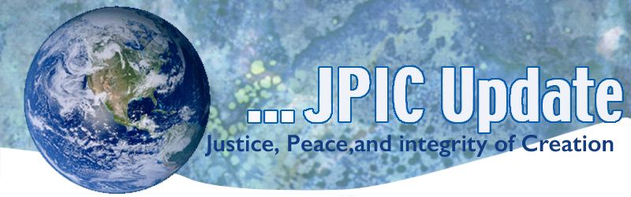
February 20, 2017
Calendar
Save the date

February –April 30, 2017 continue the 100 days of prayer for National Unity and Healing –
February African American History Month – see attached prayer
March 7, 2017 Voting

Taking Action

What does it mean to ‘Take Action?’
We are all called to live the mission of Jesus in making life better for others and the earth community. That calling takes different forms. For some it is simply greeting others with respect and with a listening ear. As one Sister in a wheel chair said to me today, “My soul greets your soul.” I was energized by her love and respect. For others the call means sending letters, signing petitions or picking up the phone and talking to your legislators. Some are called to march or publically protest against unjust systems that keep others improvised or discriminated against because of race, religion or gender.

Given the many unjust issues that face us today it can be overwhelming. We can’t do it all so focus on and put your energies on the issue for which you are most passionate. When the JPIC UPDATE is sent each Monday remember that you do not have to do it all but do something however small or big.

Ground your action in prayer. It is not what you do but how you do it that makes the difference.

Information/Reflection

Dream - Move - Stand up – Speak – Love – Respect - Don’t be afraid.

Dr. Martin Luther King, Jr. taught us this and so much more.

Hyphen Nation
At its best, the United States today resembles the global ideal of a multicultural, inclusive and equitable society. At its worst, it represents a hypocritical empire steeped in white supremacy.

[WATCH: Hyphen Nation: Exploring What it Means to be American]

Good News
The U.S. solar market saw its most successful year yet in 2016, installing a remarkable 14.6 gigawatts (GW) of new solar capacity – an increase of 95 per cent from 2015 figures – according to new statistics released on Wednesday 15 February.

The latest “US Solar Market Insight” report from GTM Research and the Solar Energy Industries Association (SEIA) details that the U.S. is now home to more than 1.3 million solar photovoltaic (PV) installations with a capacity of over 40 GW, enough to power 8.3 million households.

Resources
Bread for the World believes ongoing prayer is essential for creating and sustaining the political will needed to achieve the end of extreme hunger by 2030. Each year they produce a six-panel “table tent,” Lenten Prayers for Hungry People. You can download or order print copies of Lenten Prayers for Hungry People to share with family, friends, and members of your church or parish by going to www.bread.org/lent

From Maryknoll

In this time of turmoil on so many fronts, we offer our 2017 Lenten Reflection Guide. Come pray, study, and act with us.

Other Lenten Web sites
http://onlineministries.creighton.edu/CollaborativeMinistry/Lent/Daily-prayers-01.html
https://www.coc.org/search/node/Lent

