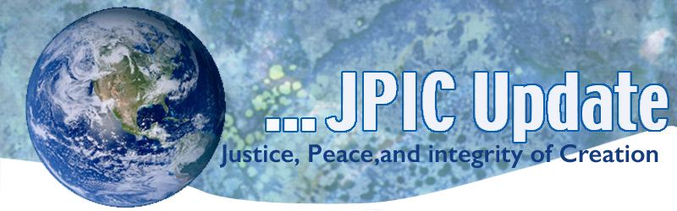
February 6, 2017
Calendar
Save the date

February –April 30, 2017 continue the 100 days of prayer for National Unity and Healing –see attached for February prayers
February African American History Month
February 8, 2017 International Day of Prayer against Human Trafficking – see attached prayer
February 19, 2017 Symposium on Chocolate - see attached

TAKING ACTION
Methane Pollution
This week, Congress is slated to begin votes to overturn important safeguards put in place by the Obama Administration to reduce methane pollution from the oil and gas industry. The Bureau of Land Management (BLM) finalized protections last year that would require companies extracting oil and gas from public lands to reduce their methane emissions. Take action: Call your members of Congress to side with the American people, not polluters! To be contacted with your congressional representative call 202 224-3121 See information for California Senators in resource section.
SNAP
As Congress comes back to work, we need to make sure they don't put millions of Americans at risk by stripping their access to food. The single largest program aimed at curbing hunger in America is the Supplemental Nutrition Assistance Program (SNAP). Join us in telling Congress that there's one guaranteed outcome if SNAP is cut: More hungry Americans. Click here to Stand up for SNAP.

Tell Trump Administration: "Protect Creation!"
"As you take office, we urge you to demonstrate bold leadership in addressing the climate crisis by honoring the Paris Agreement, contributing to the Green Climate Fund, and implementing the Clean Power Plan."

SIGN NOW

INFORMATION/REFLECTION
Separation of Church and State
The Council on American-Islamic Relations (CAIR), the nation’s largest Muslim civil rights and advocacy organization, today decried President Donald Trump’s pledge to “totally destroy” the Johnson Amendment, which prohibits churches from engaging in political activities such as endorsing or campaigning for political candidates.
SEE: Trump Vows to ‘Destroy’ Law Banning Political Activity by Churches
“Destroying the separation of church and state, the foundational concept upon which our nation, our Constitution and our democracy were built, would be the beginning of the end for the religious freedom we all cherish,” said CAIR Government Affairs Director Robert McCaw.

Launch of new standards for financing sustainable development
 Worldwide, Finance, Sustainable Investment Forum
On Monday 30 January 2017, 19 leading global banks and investors – worth a total of $6.6 trillion in assets, launched the Principles for Positive Impact Finance, setting standards for financing sustainable development.
The four Positive Impact Principles – which are the first of their kind – provide a global framework for financiers and investors to analyze, monitor and disclose the social, environmental and economic impacts of the financial products and services they supply.
The Principles were developed by the Positive Impact Working Group, a group of United Nations Environment Finance Initiative (UNEP FI) banking and investment members.

Sustainability sector provides 4.5 million jobs in U.S.
 North America, Carbon Reduction, Finance, Sustainable Energy
Today, the sustainability sector in the U.S. employs roughly 4.5 million people, a sharp increase on the 3.4 million jobs recorded in 2011.
The report “Now Hiring: The Growth of America's Clean Energy & Sustainability Jobs” from the Environmental Defence Fund (EDF) Climate Corps initiative shows that as the economy becomes more sustainable and energy efficient, a new market for clean energy and sustainability jobs is created.

State Refugee Legislation
Please find attached the latest tracker of state refugee legislative activity. There are now an estimated 20 anti-refugee measures in 12 states, and 5 pro-refugee measures in 5 states. Please note that these do not include bills submitted for drafting, or bills pending introduction.

Since the President's Executive Order on refugees was issued, 4 resolutions opposing tenets of the EO have been introduced; SR 16 in California passed.

RESOURCES
Senate:
Senator Dianne Feinstein
331 Hart Senate Office Bldg.
Washington, D.C. 20510
senator@feinstein.senate.gov
Phone: (202) 224-3841
Fax: (202) 228-3954
TTY/TDD: (202) 224-2501

Local Office
11111 Santa Monica Blvd.
Los Angeles CA 90025
310 914-7300

The Honorable Kamala D. Harris
B40B Dirksen Senate Building
Washington, DC 20510
senator@harris.senate.gov
Phone: 202 224-3553

Your

carbon footprint and live more justly.

