March 20, 2017
Calendar
Save the date

March 20, 2017 Feast of St. Joseph – see attached Prayer
(normally on March 19th but because it fell on third Sunday of Lent it has been transferred to today
March 21, 2017 Week of solidarity with people struggling with Racism begins today
March 22, 2017 World Water Day – see attached

Taking Action

Budget Cuts in Domestic Programs
President Trump has announced plans for deep cuts in domestic programs to pay for Pentagon increases. Learn about the expected impact on housing, services for children, seniors and people with disabilities, nutrition, public health, and more.
This is the first step in a long budget process. You'll hear from experts about what's next - and the strategy to fight back. Tuesday, March 21, 12:00 noon Pacific Time.
Register Now
American Health Care Act-say no
Please join our friends at NETWORK and call your Representative today, March 20 and tell them to vote NO on the American Health Care Act. Dial 1-888-738-3058.
When you call, here is what you might say:
“Hi, my name is [NAME] and I am a constituent from [CITY/TOWN]. As a member of [NAME OF PARISH/CONGREGATION], I'm calling to urge you to oppose the American Health Care Act. The CBO estimates that 24 million people will lose healthcare if this terrible bill is passed and my faith teaches that this is wrong. I am especially concerned about the changes to Medicaid proposed in this legislation. I hope the Representative agrees and will keep the health and wellbeing of us all in mind. Please oppose the American Health Care Act."

Thank you for standing in solidarity with the 24 million people who could lose their healthcare coverage if this bill passes!

Information/Reflection

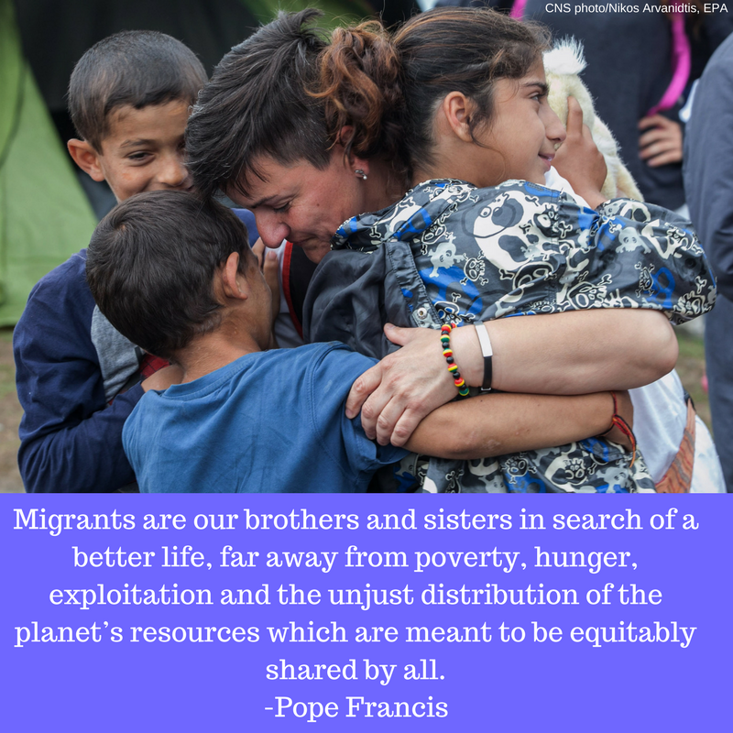

Thanks to those of you who signed the Catholic Climate Covenant petition!
The petition to President Trump which was signed by many of you and 15,000 Catholics was made public yesterday with ads in Crux and The Hill newspapers. We asked that his administration honor the Paris Agreement, keep U.S. commitments to the Green Climate Fund, and implement the Clean Power Plan.

Cutting Food Waste Is Saving Companies Money and Helping the Climate
One-third of all food produced in the world is lost or wasted from farm to fork. Food waste generates about 8 percent of global greenhouse gas emissions a year in part because much of it ends up rotting in landfills, generating methane. Now, a first-of-its-kind analysis finds that there is a robust business case for companies, countries, and cities to reduce food loss and waste. Read more:
https://insideclimatenews.org/news/07032017/food-waste-solutions-greenhouse-gas-emissions-methane-climate-change-wri?utm_source=Inside+Climate+News&utm_campaign=a535ba2456-InsideClimate_News12_10_2014&utm_medium=email&utm_term=0_29c928ffb5-a535ba2456-326459009

Guterres: Women's rights threatened
United Nations Secretary-General Antonio Guterres addressed the Commission on the Status of Women this week, warning that women's rights around the world are facing new attacks. "Our world needs more women leaders" and "more men standing up for gender equality," he said.

Resources
Justice for Immigrants
This week’s “Faces of Migration” features an inspiring story of Javier, one of the many talented individuals who we work in partnership with from the Archdiocese of Washington DC.
Please share this wonderful story at this link http://bit.ly/2kG21RI with your networks.

