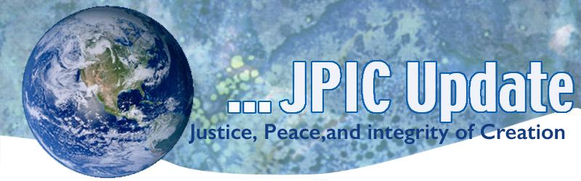
March 27, 2017
What I do shows people what kind of person I am.
Cesar Chavez

Calendar
Save the date

March 27, 2017 Continue praying the hundred day prayer – see attached

March 31, 2017 César Chávez Day is observed in the United States on this day each year. It celebrates the birthday of César Estrada Chávez and it serves as a tribute to his commitment to social justice and respect for human dignity.
Taking Action
We the People
Every voice does matter! It was you the people who made your voice heard through phone calls, visits to your legislators, emails, attendance at town halls and on the street. Because you claimed your power the House failed to pass the American Health Care Act (AHCA) and millions of Americans will continue to receive health care.
Continue to claim your power as an American citizen. Reread the Preamble to the Constitution today. Reflect on this statement and what it calls us to as citizens.
Advocate and participate for Climate Justice
The CSSJ Federation focuses on an issue each week. This week it is on Climate Justice. Pope Francis reminds us that “…Governments are obliged to honor the climate commitments they made… It is up to citizens to insist that this happen, and indeed to advocate for even more ambitious goals.” Contact President Trump and let him know of your opposition to the elimination from the EPA all legislation regarding Climate Change. Leave a voice message on the White House phone number at 202-456-1111 to leave a comment or the switchboard: 202-456-1414.

Information/Reflection
To make a great dream come true, the first requirement is a great capacity to dream; the second is persistence. Cesar Chavez

Undocumented Immigrants in the U.S. Contribute Billions in Local and State Taxes
Undocumented residents in the United States pay an estimated $11.74 billion annually in state and local taxes, an amount that would increase significantly if these immigrants were given a pathway to citizenship, according to a new report. On average, the nation's estimated 11 million undocumented residents pay about 8 percent of their incomes in state and local taxes every year.
http://www.latimes.com/nation/sns-tns-bc-immigrants-economy-20170302-story.html

Straws
Environmentalists in Southern California have focused on a new plastic target.
Huntington Beach-based StrawFree.org is hoping to make its city the first in Orange County to ban straws, which they say is one of the top 10 pieces of garbage polluting the ocean and not recycled by most municipalities.

Nuclear Weapons
During March 27-31st the U.N. conference is scheduled to negotiate a legally binding instrument to prohibit nuclear weapons, leading towards their total elimination.
Resources
Ballotpedia
Ballotpedia is an organization that presents legislation and current political events in a nonpartisan way and maintains neutrality on issues. I personally find it helpful and receive it daily on the internet.
https://ballotpedia.org/

Celebrate Earth Day with your parish, school, and religious community!
We are so pleased to share with you our new, free educational program for parishes, schools, and religious communities to celebrate Earth Day (April 22nd) and embrace our call as Catholics to care for creation, climate change, and our neighbors.
From Catholic Climate Covenant

Get the Earth Day Program

