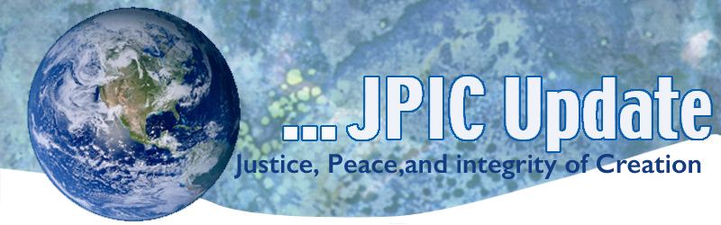
May 22, 2017
Calendar
Save the date

May 22, 2017 International Day for Biological Diversity
May 25, 2017 UN Africa Day
My 29, 2017 International Day of UN Peacekeepers

Taking Action

International Day for Biological Diversity
"Biological diversity" means the variability among living organisms from all sources including, inter alia, terrestrial, marine and other aquatic ecosystems and the ecological complexes of which they are part; this includes diversity within species, between species and of ecosystems.

Take time this week to go out and sit in nature or take a walk. Make a list of all the various organisms that you encounter. Some may be of the same species but note their unique expressions. Give thanks to the Creator for the gift of life found in each. Know that you are one with all that God creates. Make a commitment to do five additional acts this week to heal the earth.

Paris Agreement on Climate change
A decision on whether the United States will remain in the Paris Agreement on Climate Change will happen any day. You have the chance to ensure we do. Please take a moment to send this letter to President Trump, your US Representative, and your US Senators.
By clicking the button below, you will be able to send this message to President Trump and your federal elected officials in one quick and easy step.

TAKE ACTION

Prohibit California Public Utilities Commission CPUC shut offs
We join with TURN now to support Sen. Ben Hueso (D-San Diego) whose bill, SB 598, will reduce shut offs for our elders and those with life-threatening conditions requiring the use of supportive machines. Shut offs have skyrocketed among struggling households, no matter the life circumstances of the people involved.
SB 598 will prohibit shutoffs for residents with life-threatening medical conditions, providing increased protections to the most medically vulnerable families. This bill also require the CPUC to adopt rules to reduce shutoffs by 50% by 2021; moving California closer to universal utility service for all by requiring the California Public Utilities Commission (CPUC) to develop policies, rules, or regulations to reduce gas and electric service disconnects for nonpayment by residential customers and adopt shutoffs as a metric in order to measure utility service reliability, public safety and affordability.
To access your state senators in the Capitol or in your local district, please go to: http://www.churchimpact.org/take-action.html

Information/Reflection
How does what I do today affect the Earth Community?

Watch Trailer for Al Gore’s New Climate Change Movie Coming This Summer
Former vice president and environmentalist Al Gore is featured in a new movie, which will be released July 28. “An Inconvenient Sequel: Truth to Power” picks up where his award-winning 2003 film, “An Inconvenient Truth” left viewers. Celebrating all the environmental action that led to the Paris Climate Agreement, then confronting the current U.S. president’s denial of climate change, this movie is sure to stir a reaction in those who care for the earth. Go to: https://www.youtube.com/watch?v=huX1bmfdkyA&feature=youtu.be

Nuclear Experts Team Up to Advise World Leaders on Avoiding Nuclear War
Nuclear experts are creating a global coalition to advise President Donald Trump and other world leaders on preventing nuclear war. The Nuclear Crisis Group was launched in Vienna on last week. The coalition assembled in response to Trump and Russian President Vladimir Putin's rhetoric, which the experts say is increasing the risk of a nuclear conflict. Read more:
https://www.commondreams.org/news/2017/05/04/nuclear-experts-team-advise-world-leaders-avoiding-nuclear-war

First US offshore wind farm powers island
 North America, Sustainable Energy
The United States’ first offshore wind farm is now online and powering an island community off the coast of Rhode Island with renewable energy.
Block Island’s five turbine wind farm – the only one of its kind – has a total capacity of 30 megawatts (MW), more than enough power to supply the town’s 1,000 inhabitants with cheap and reliable power.

Resources
For a Summary of the American Health Care Act Click on the following:
- Summary of the American Health Care Act - Kaiser Family Foundation
- American Health Care Act of 2017 - Ballotpedia

