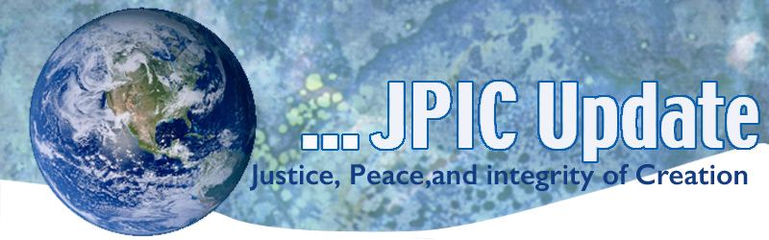
October 23, 2017

CALENDAR
2017
Month of October Respect Life Month
October 24 Disbarment Week begins
December 2 Anniversary of the El Salvadorian Martyrs

2018
January 23 Walk for Life

TAKING ACTION

DACA
You are invited to join the Sisters of St. Joseph of Carondelet in the LA Province to be a voice for the Dreamers. Approximately 200 Sisters from six states signed post cards addressed to President Trump, their Senators and Representative to Congress on behalf of promoting legislation to provide a legal path to citizen ship. Attached is way you can participate in also being a voice for these young people.

Iran Nuclear Deal
On Friday, Donald Trump shoved us closer to confrontation with Iran, and it’s up to all of us to contact Congress encouraging them to choose diplomacy instead.
The International Atomic Energy Association, to the U.S. Intelligence Community, to Secretary of State Rex Tillerson agree that sticking with the Iran Nuclear Deal is in everyone’s best interest.
Write to your senators and tell them to resist Trump’s war agenda: say no to sanctions, and no to legislation that would kill the Iran Nuclear Deal.
The Iran Deal isn’t perfect, but it’s infinitely better than Trump and Netanyahu’s shared agenda of escalating conflict.

Federal Budget
As Congress debates the FY2018 budget, LCWR and NETWORK are inviting Catholic sisters across the country to help ensure that the federal budget is a reflection of the values of the nation and the principles of Catholic Social Teaching. The federal budget is a moral document that reflects the priorities of the nation. A budget worthy of this nation must prioritize human needs programs, ensure funding to care for vulnerable members of society, restore economic opportunity, and invest in the common good.

We invite you to join this effort and to write letters to Speaker Paul Ryan letting him know that a budget that cuts protections for the most vulnerable does not reflect the values and principles of Catholic Social Teaching. See Attachment

INFORMATION/REFLECTION

Ask yourself:
How does this action, decision affect the Earth Community?

RESOURCES

See Attachments

