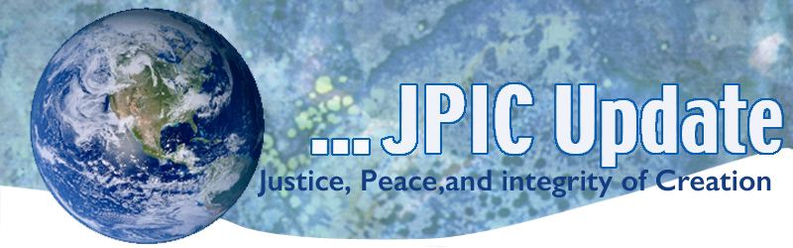
October 30, 2017
CALENDAR
2017
November 1 Anniversary of Brothers and Sisters to Us 1976 (USCCB Pastoral Letter)
Anniversary of Economic Justice for all 1986 (USCCB Pastoral Letter)
November 3 Feast of St. Martin de Porres
November 10-12 Border Encuentro

December 2 Anniversary of the El Salvadorian Martyrs

2018
January 23 Walk for Life

TAKING ACTION
New Refugee Ban
The administration has announced a new three-month ban on refugees from Egypt, Iran, Iraq, Libya, Mali, North Korea, Somalia, Sudan, South Sudan, Syria, Yemen, and stateless Palestinians. The new executive order also indefinitely suspends the family reunification process for certain refugees who have been separated from their spouse and children as they have fled for safety. These announcements grind refugee resettlement to a halt, layering on policy changes that will result in long delays, family separation, and vulnerable refugees with no option for safety.
Take action today! Tell Congress & the White House that you OPPOSE Trump’s latest refugee ban. We have launched a new tool that makes it easier for you to call Congress, post on social media, and make your voice heard. Please click here to take action.
Limit the President's Power to Start a Nuclear War
President Donald Trump -- like every president for decades-has sole authority to launch a US nuclear attack. And literally no one has the authority to stop such a launch. The Union of Concerned Scientists asks us to urge our lawmakers to cosponsor the "Restricting First Use of Nuclear Weapons Act," which would prohibit the president from launching a nuclear first strike without a declaration of war from Congress. Go to: https://secure.ucsusa.org/onlineactions/UPRO5mOyPUuwCytCr4r1NA2?_ga=2.178207845.1332350237.1508293232-290188895.1508293232
Request From Justice for Immigrants
This week’s Faces of Migration story is of Mitsu, a recipient of Temporary Protected Status (TPS). Mitsu was attending college in the U.S. when the massive 2010 earthquake devastated her home country of Haiti. She was granted TPS and after her studies now works as a physician assistant. With TPS designation for Haiti set to expire soon, Mitsu is unsure if she will have to return to a country that has yet to recover from the earthquake and has been ravaged by hurricanes in recent years. Read her story at http://bit.ly/2ou7RKZ

Finally, please ask your advocacy networks to take action on the new Share the Journey alert at http://bit.ly/2lrO91D
The alert asks the TPS be extended for El Salvador, Honduras, and Haiti.

Open enrollment period for states using Healthcare.gov is November 1 – December 15.
Because the enrollment period is half as long as in previous years, we need to mobilize to make sure people are covered. Faith communities play a particularly important role in enrollment because we view healthcare as a right and can speak from a moral perspective to make sure people’s needs are met. See the 8-page Faith Open Enrollment Toolkit for you to share with pastors, social justice coordinators, and more for ideas to encourage enrollment in their communities. There is a longer toolkit from Get America Covered – which includes more specifics that might be helpful, like a sample email blast. Get America Covered’s 30-page toolkit can be found here.

INFORMATION/REFLECTION
The economy exists for the person, not the person for the economy.
All economic life should be shaped by moral principles. Economic choices and institutions must be judged by how they protect or undermine the life and dignity of the human person,
support the family and serve the common good.
A fundamental moral measure of any economy is how the poor and vulnerable are faring
(USCCB Pastoral on Economic Justice)

Economic Justice for All
In celebrating the anniversary of the 1986 USCCB Pastoral on Economic Justice for all you may want to read a brief summary of the pastoral by clinking below. It certainly behooves us to advocate Congress to present a budget that is for the common good of all.
A CATHOLIC FRAMEWORK FOR ECONOMIC LIFE

Good News for the Earth
- The Seattle Seahawks has created a special initiative to celebrate the ongoing sustainability efforts at their home stadium CenturyLink Field, by serving fans 6,000 pounds of locally sourced cut potatoes. CenturyLink Field has long committed to promoting sustainability in sports and is considered one of the most environmentally friendly and sustainable sports and entertainment facilities worldwide.
- IKEA has launched a national mattress recycling program in the US, as part of its People and Planet Positive Sustainability strategy, aiming to reduce landfill waste and give more value to natural resources used as raw materials.

California AB 1008
On October 14, California Governor Jerry Brown signed into law AB 1008, the California Fair Chance Act. California becomes the 10th state to require both public- and private-sector employers to delay background checks and inquiries about job applicants’ conviction records until they have made a conditional job offer to the applicant. The law takes effect in 2018. It is one of the strongest laws of its kind in the country. Congratulations to all who helped make California the 10th state to adopt these vital background check reforms for the private sector. Read the NELP press release here.

RESOURCES

Brothers and Sisters to Us
This United States Catholic Conference of Bishop’s pastoral was issued in 1976 and continues to be a call to each in addressing racism. Hit on the link below for more information. This pastoral deserves to be revisited.
Brothers and Sisters to Us

An All Souls Day Remembrance
Each year on November 1 and 2, Catholics around the world pray for our loved ones and the community of saints who have died and returned home to God, Creator of Life.
As we remember and honor those who are near to us, let’s also take a moment to honor those who have been lost in the struggle for creation. This brief resource provides:
names and stories of eco-martyrs who have given their lives to protect creation,
a list of creatures that have gone extinct, and a prayer to cherish them.

