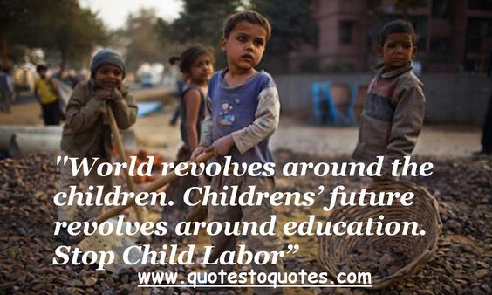
Visually Similar Results

Prayer adapted from

Prayer for Children involved in child labor - Ngo Prayer Network - By Sr Marie Françoise Mestry
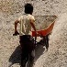
Whoever welcomes one of these children in my name welcomes me; and whoever welcomes me isn’t actually welcoming me but rather the One who sent me.” Mk9,37
Reader 1: Today, throughout the world, lots of children work, some of them, full-time. They do not go to school and have little or no time to play. Many do not receive proper nutrition or care. They are denied the chance to be children. They are sometimes exposed to the worst forms of child labour such as work in hazardous environments, slavery, or other forms of forced labor, illicit activities including drug trafficking and prostitution, as well as involvement in armed conflict. The World Day against Child Labor, marked each year on 12 June, is the major annual advocacy event focusing on child labor. In 2012 the theme was “Human Rights and Social Justice: Let's end child labor”. Events have been held in more than 50 countries involving governments, employers, workers, the United Nations, non-governmental and civil society organizations.
Take a moment of silence to think of all the children you may know living in similar situations. Name countries or situations.
Reader 2: Two of the biggest areas of influence in a child’s life today are their own family experience and their educational opportunities. There are significant challenges to be faced in both of these areas: globally there appear to be more family breakdowns than at any other time in history, and although the number of children attending primary school is increasing across the developing world, the rate of that growth is slow.
One of the largest factors influencing family life and education is poverty. Many families are separated because one parent needs to find paid work, often far away from home. Also when parents are struggling to provide for their families they can often turn to alcohol or drugs to escape the pressure, with the potential effect of divorce and family separation. Poverty also affects children’s likelihood of receiving an education, because many children are unable to afford the basic requirements for school attendance.
Reader 1: Together we pray that:
Single parent households, often headed by women who are vulnerable to abuse and exploitation, are cared for and helped to find ways out of poverty.
Child-headed households, where children have to work hard to keep the family going, will be given emotional and practical support.
All children, regardless of their financial situations, can experience a holistic education where their spiritual, physical, emotional and academic needs are met.

Reader 2: “It is indeed a terrible indictment of our civilization that in spite of economic growth, technological advances and food surpluses in so many countries, over 800 million people in the world - mainly women and children - still go hungry every day.”
Together we pray that those elected to government, and leaders would be moved with compassion for the needs of the next generation. Governments would be called to honor their commitments to the Millennium Development Goals, and that progress would be made towards reaching them in the time set.
God’s righteousness and justice would be the foundation for government and business structures, no matter what the religious beliefs of those in positions of power.
REFLECTIONS
“Let the most tender love, the most exquisite cordiality be the rule and principle of all your thoughts and actions”
How could love make a difference in our communities, our family, and our country?
Submitted by Francoise Mestry, Communications Coordinator.

