Prayer in Honor of St. Isadore
Dear St. Isadore, you know how normal it is to cultivate the land for you were employed as a farm worker. You saw the wonders of the Creator strewn on this earth.
Encourage all farmers in their labors and help them to bring food to all who are hungry.
ALL: How manifold are your works, 0 Lord! In wisdom you have wrought them all; the earth is full of your creatures.
ALL: O Lord, our Lord, how glorious is your name over all the earth! *
You have given rule over the works of your hands, putting all things under the farmers feet:
All sheep and oxen, yes, and the beasts of the field. The birds of the air, the fishes of the sea, and whatever swims the paths of the seas.
O Lord, our Lord, how glorious is your name over all the earth!
ALL: How manifold are your works, O Lord! In wisdom you have wrought them all; the earth is full of your creatures. You raise grass for the cattle and vegetation for use, producing bread from the earth, and wine to gladden hearts.
ALL: O God, * who taught Adam the simple art of tilling the soil, and who through Jesus Christ, the true vine, revealed Yourself the husbandman of our souls, deign, we pray, through the merits of St. Isidore, to instill into our hearts a love of prayer, so that working the soil in the sweat of our brow, we may enjoy eternal happiness in heaven. Through the same Christ our Lord.
R. Amen.
REFLECTION: The farmer's is a sacred calling because of being a collaborator with God in the work of creation. In partnership with God one becomes a provider of the food, fiber, and shelter they need. The farmer's calling is among the noblest in all in the world. The Lord considered it so, and the farmer must think of it in the same terms. Living with God and working in the vast realms of bountiful and beautiful nature. The famer is not one of the millions who in thick formations swarm through factory gates. The farmer is free striding through the fields guiding a plow, sowing the seed, or harvesting the crop. The farmer's calling is one that must command great respect. Much knowledge and skill are required to manage well the farmstead with its land and fences, barns and granaries, tools, and machinery. Farming is among the greatest of human arts. The farmer must be an artisan and a craftsman, a capitalist, financier, manager, worker; a producer and a seller. The farmer must know soil and seed, poultry and cattle; must know when to till the soil, cultivate his fields, and harvest his crops. In the presence of the Lord the farmer should recall all this, not in a spirit of vainglory or pride, but in grateful appreciation of the calling that God gives as a tiller of the soil. Praise and thanksgiving should rise in ones heart reflecting on the high regard the Lord has showered upon this work.
LEADER: Let us pray. Pour down your blessing, we beseech you, O Lord, upon your people, and upon all the fruits of the earth, so that when collected they may be mercifully distributed to the honor and glory of your holy name.
St. Isadore pray for us and all farmers.
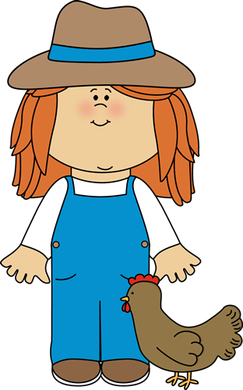

(Prayer adapted fromCatholicculture.org)

