Congregación de las
Hermanas de San José de Carondelet

Jr. Talara 344 – Jesús María, Lima 11, Perú Tel. Casa 01-431-0881
Apartado 11082 – Jesús María, Lima, Perú Tel. Oficina 01-424-5092
Emaoficinaprovincial@csjvpperu.com
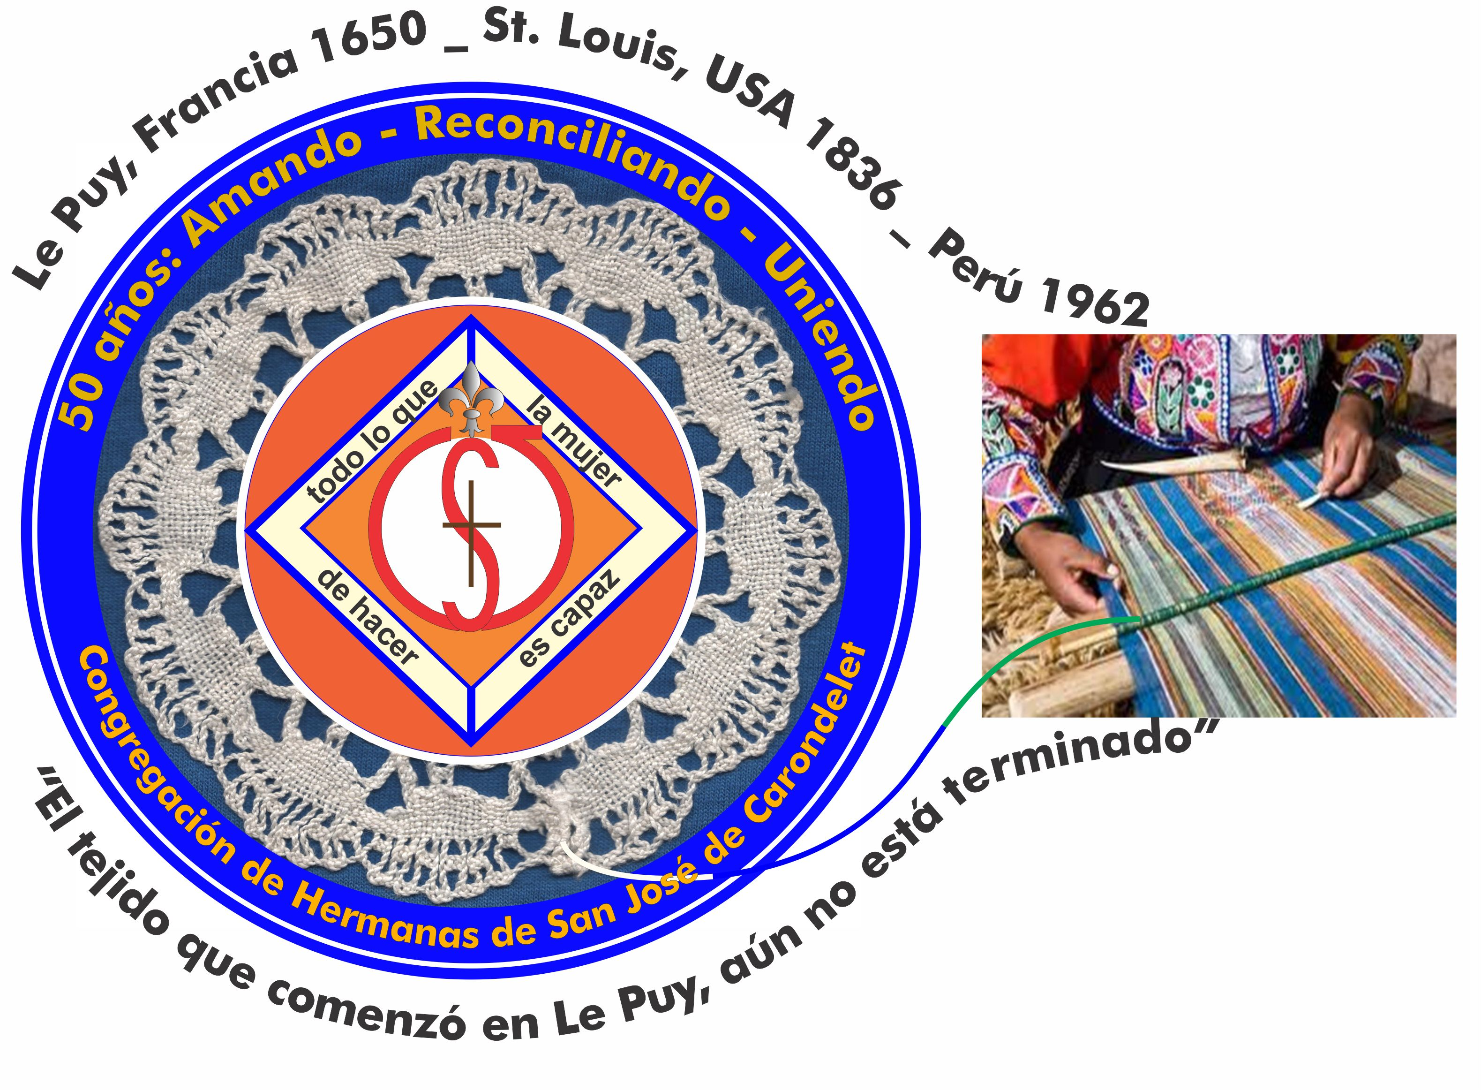

NOTICIERO - JUNIO 2016
Dear Sisters,
The optional Reading for the Feast of the Visitation of Mary to Elizabeth, calls us to be sisters in community…”Love one another with sincerity. Have a horror for evil and a passion for good. Love one another cordially with a fraternal love, considering others as more worthy. Serve the Lord with tireless care and with a spirit of fervor. Rejoice in hope, be patient in tribulation and be persevering in prayer…Practice hospitality with generosity. Bless those who persecute you, bless them and never curse them. Rejoice with those who rejoice, and cry with those who cry. Live in harmony with others; don’t try to stand out; put yourself at the level of the most humble.” (Rom 12, 9-16)
We hope that we may put this Word of God into practice!
With love,
Teresa, Genoveva and Sally

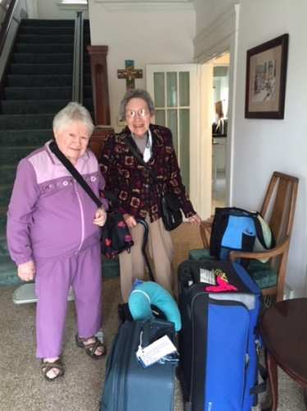 BETTY AND DOLO HAVE ARRIVED, WELCOME!

Sigue…

NEWS FROM TACNA
May is full of great significance and tenderness: we celebrate the Marian month and Mothers’ Day. This refers to the fact that we initiated the celebration of our Mother, the Virgin Mary in our institution Fe y Alegria. Every day at 12:00 m. we prayed the Angelus and you could hear a beautiful melody and prayer at 6:00 pm. by the children and personnel of the school. honoring our Mother the Blessed Virgin Mary!
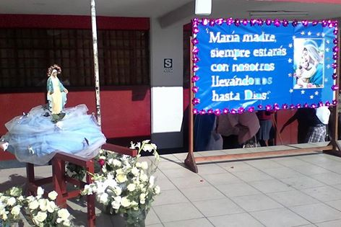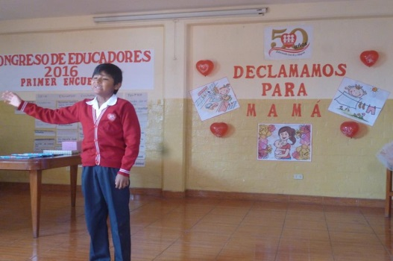
We also celebrated Mothers’ Day! We paid homage to the mothers of our institution. We, as CSJ Sisters led the prayer. Then we had some beautiful recitation of poems and surprise gifts for many of our mothers and we ended the day by honoring the teachers who are mothers with a delicious dinner.
Another important event was the inauguration of our Professor Hernán Chiri, as the new principal of our educational institution. We wish him our very best wishes!
At the same time, our Sister Gloria Zapata became the “The Promoter of the school”; she has a new office for this new mission. Welcome, Sister, to the Department of Pastoral!
In the area of psychology we continue to attend to our children, adolescents and parents, especially the most vulnerable; it is a ministry that challenges us to the hilt! These weeks are dedicated to formation and information workshops and we began with the workshop “A Life Project” with 5th year high school students.
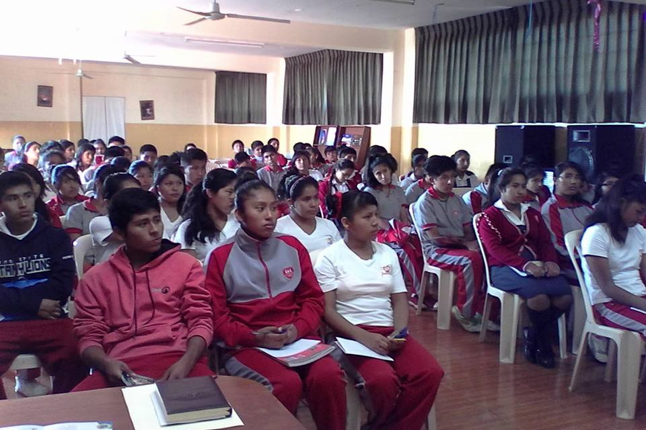 Sigue…

With the parents of the students of 1° to 5° high school we are developing workshops on the prevention of drug use; it is a challenge to move the parents to respond to this proposal.
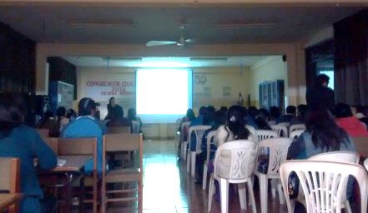
And our Sister Rosa Luz, continues her work in the area of psychology at the school, “Corazon de María” (the Heart of Mary); she has been preparing and giving workshops for them!
From the city of Tacna, we send many Greetings filled with our love to our Sisters and we ask God to help us to continue to be caring women who witness to the joy of Jesus!
Gloria, Rosa L, Yoli

NEWS FROM CANTO CHICO
The Holy Rosary
During the month of May, from the first to the twenty-seventh, we had the Rosary in honor of the Holy Cross of May where the devotees of the barrio and others came together to pray.

On May 28th we had the liturgy celebrated by Father Jorge Alvarez and many devotees of the Holy Cross participated.
After the Mass, the people celebrated with the accompaniment of a band of musicians, fireworks and they shared a meal.
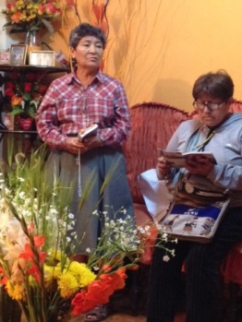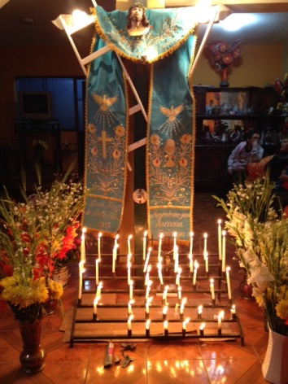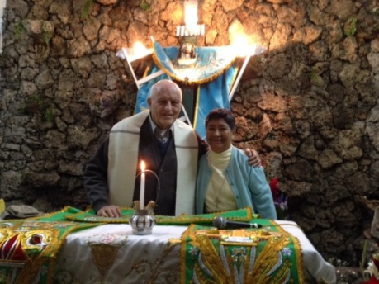

Salón San José
In the Salon San José we have had a good turn out with the participation of so many children—who are studying to learn more, drawing, helping to clean the salon and in this process, we are discovering their many gifts and talents.
The children made Mothers’ Day cards with the help of Señorita Graciela. Sister María Vasquez received a gift of chocolates from two of the children!
During the month of May we received 52 children in the Salon San José for help with their homework.

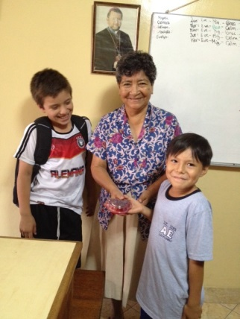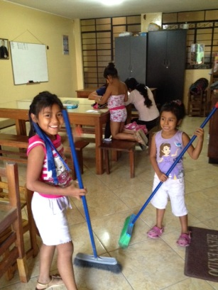
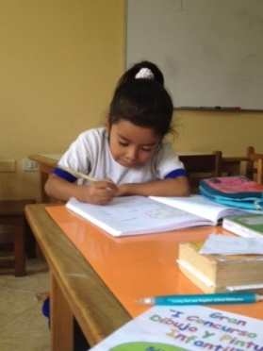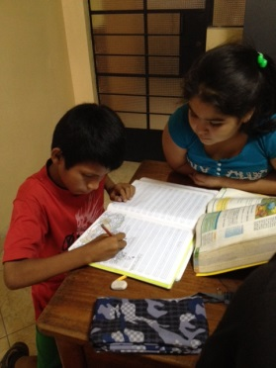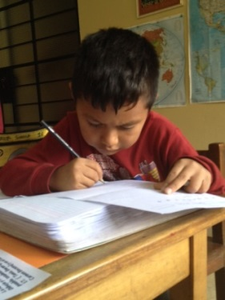
Hospitality
We gave hospitality to Sister Maria Elena’s niece for a week because she had to move out of the Sisters of Mercy Center House during the time of their congregational meetings. We enjoyed having her with us!

Service Project in Peru
Three students from the University of St. Catherine from St. Paul arrived in San Juan de Lurigancho (Canto Grande) to help with the Project Eleanor. This project gives wheel chairs to children with physical handicaps. It also gives information to the parents of these children to help them and to be a support in the health and care of their children so as to encourage the children to participate more fully in the family, school and society.
The volunteers were in Yancana Huassy, a center for children with special needs that was founded by the Holy Cross Congregation. Anne Davis went to Yancana Huassy to welcome the group and to get more information about the Project Eleanor that was founded by a student of St. Catherine`s University.

NEWS FROM CASA CENTRAL
Sister Mary Luz Salazar teaches religion in two schools. One of the schools, “María Auxiliadora”, had their patron´s fiesta, so she and some of her students had all the responsibility for the religious part-- Mass and Procession. That meant arranging flowers, helping students to do the readings, etc. It turned out to be a beautiful celebration.
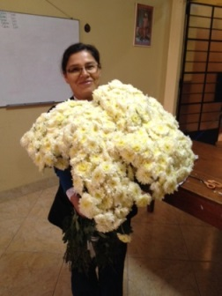 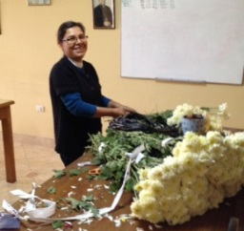 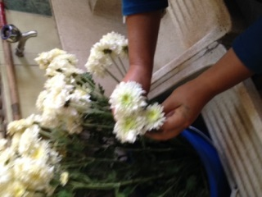 Sigue…

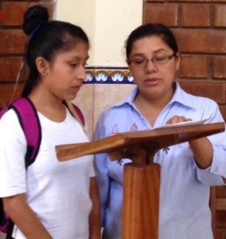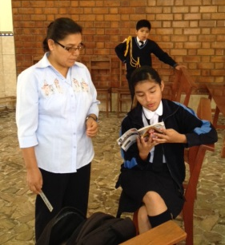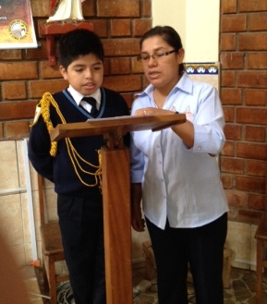
NEWS FROM BRISAS DE VILLA
Last May 14, our Pequeño Proyecto de Brisas Community has lived a very good experience celebrating with the parish community the anniversary of their Chapel, Nuestra Señora de la Evangelización. (Our Lady of Evangelization) With a lot of enthusiasm, all of the Chapel groups organized the novena, as well as the Fiesta Mass and Procession. During the Mass and Novena, the Pastor Father José and Father John (in charge of the Chapel), encouraged the people to live the Christian life with more commitment. The pastoral agents have had several workshops on Christian formation to encourage community life. The Sisters accompany some groups, depending on their free time and the priests and pastoral agents are grateful for our time, presence and accompaniment.
We also participated in the pilgrimage with other parishes and chapels of the Deanery to celebrate the Year of Mercy and to be able to gain the Plenary Indulgences in the Church, San Pedro de Chorrillos. It was very well attended and we were able to share this devotion with all the people who participated.
As usual, Sister Teresa Ponce participated in the annual outing with her companions from CONFER. They visited the town of Chancay and Sister Teresa said, “It was very relaxing to be able to enjoy the campo and the beach, and some of the interesting places in town, the food, and the people and above all, to be able to share this experience with our work companions. At the end of the day we felt renewed…”
At present, an enjoyable experience in community is to take time in our personal prayer to reflect on the theme of Discernment of Spirits according to St. Ignatius Loyola and to share the fruits of our reflection in our community prayer.
REST IN PEACE
After a time of suffering as a result of a stroke, Father Miguel Parets Cerna, a priest who was committed in friendship to the prisoners; he passed away on May 30th. Sisters María Schuh, María Elena Caceres and Anne Davis were able to participate in his Mass and internment in the Retreat Center San Martín in Jicamarca after having had a wake in various places: Caja de Agua (where he lived), the Prison, “San Pedro de Lurigancho” and the Prison “Castro Castro”(where he ministered). What a good example of total commitment Miguel gave us!
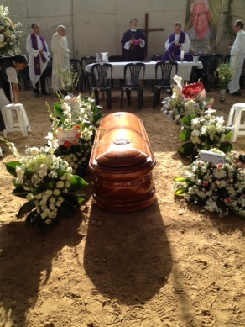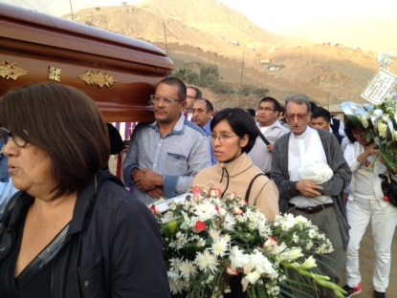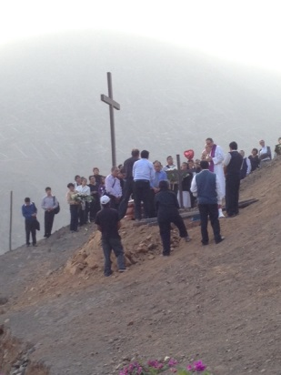
PRAYERS
+Let us pray that all goes well for Sisters Robertina Espinoza and Ruth Matos when they have their interviews in the US Embassy: the 14th and the 20th respectively.
+Let us pray for Sister María Elena Caceres as she enters into the “last step” in the process to terminate her thesis.
+Let us thank God because Robertina’s sister has had a significant improvement in her health.
+We pray for our families and friends, for their health and other needs.

TWO EVENTS IN CONFER
ANNIVERSARY IN CONFER
The week of the 7th to 10th of June, from 5:00 to 8:00 pm, we celebrate our anniversary. Sister Marcela Saenz, aci; President of the CONFER in CHILE will speak about: “En el Año de la Misericordia, salgamos aprisa al encuentro de la vida” (In the Year of Mercy, let us hurry to encounter life)
Your collaboration of S/ 10.00 (soles) is requested. We count on your valued presence which will enhance the quality of our celebration..
Sigue…
THEOLOGICAL WEEK
On the July 5, 6, 7, the Theological Week will take place in Colegio de Jesús.
The theme is: Seguir a Jesús de generación en generación: El diálogo intergeneracional en la vida consagrada. (The following of Jesus from generation to generation: Intergenerational dialog in the consecrated life) The speakers are Father Kevin Flaherty SJ and Brother Hugo Caceres CFC.
Registration is S/. 30 (soles). If you want to register, please contact Sally.

CSJ CANDIDATES
The Los Angeles Province joyfully welcomes two candidates. They are:

Chizuru Yamada She has already been a candidate for a year, living with our sisters in Tsu, Japan. She will arrive in Los Angeles on June 8th. Right now, she has a tourist visa for three months. She will live at Carondelet Center together with Sisters Irma Araneta, Anna Mary Anesi and Joan Henehan as members of the St. Joseph Community. The study of English will take up most of her time, but she will have the opportunity to participate in the Federation Event in Orlando, Florida, as well as the Province Assembly. She will return to Japan in September when her visa runs out. It is our hope that her R-1 visa will be approved permitting her to return to Los Angeles in order to finish her time as a candidate and be able to enter the novitiate.

Chizuru received the sacrament of Baptism in 1996 at the age of 35. It was during her baptismal preparation that she first met the CSJs specifically, Sisters Teresa Mitani and Lucia Yamada (same last name but not related). It was during her 30 day retreat that she felt the call to be a member of the Congregation. Before that, she participated in various ministries in her parish which included sign language. She is also a member of the Franciscan Third Order. In addition to sign language, Chizuru has a facility with languages, having learned Italian and Korean. We hope that she will soon conquer the peculiarities of American English.

Sally Koch, quien llegó de Portland, Oregon el mes pasado para vivir con la Comunidad de Medaille en la Casa de Discernimiento ha sido aceptado por el Equipo de Liderazgo para seguir discerniendo su vocación con nosotras como candidata de la Congregación. Ella también va a participar en el Evento de la Federación donde ella y Chizuru compartirán con una reunión especial de nuevos miembros de varias congregaciones C/SSJ.

Sally creció con su tres hermanos/as en una finca familiar en Nebraska. Suya fue una familia muy católica, tenía una educación católica y participó en las liturgias de su parroquia, ayudando con sus habilidades musicales como miembro del coro y tocando la guitarra y el órgano. Después de terminar secundario, fue a la Universidad de South Dakota, terminando en 2008 con un bachiller en psicología con mención en música. Después de seis años recibió su maestría en ministerio pastoral de la Universidad de Santa Clara con un énfasis en espiritualidad. Mientras estaba estudiando, trabajaba en la pastoral juvenil en el internado de la misma universidad con las alumnas de primer y segundo años

Sally ha participado en organizaciones de servicio, trabajando como Coordinador de Actividades en el Corps de Servicio de los Vicentinos, Coordinador del Hogar para una comunidad de L’Arche, Coordinador del Programa para el Corps de Voluntarios de los Jesuitas en el noroeste y, más recién, como Especialista en Inclusión para la Organización de Parálisis cerebral de Oregon y Washington. Sigue…
Sally ha conocido varias comunidades religiosas, pero ha decidido seguir su peregrinaje vocacional con nosotras. En sus propias palabras: “He escogido a las CSJ por mi admiración por San José, las enseñanzas de San Ignacio que las CSJ han incorporado y, más importante, el “jale” que siento hacia su carisma.”

Happy Birthday
10 Peg Murphy
20 Mary McKay
27 Julie Marciacq
29 Agripina Morales

