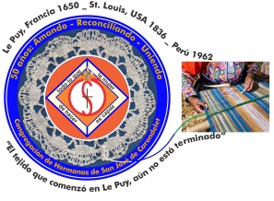
Congregación de las
Hermanas de San José de Carondelet

Jr. Talara 344 – Jesús María, Lima 11, Perú Tel. Casa 01-431-0881 Tel. Oficina 01-424-5092
Apartado 11082 – Jesús María, Lima, Perú Email: hna.csjperu@gmail.com
___________________________________________________________________________________________

NOTICIERO JULIO – 2017

Dear Sisters:

We begin our month with Greetings for our Sisters in the United States for the Anniversary of the Independence of their country. We can also send Greetings to all of us at the beginning of this patriotic month. We can feel proud of the great diversity and richness of our people.
We are called to reflection as we read about the service of the firemen as they worked arduously to save lives in the terrible fire we had recently here in Lima. At the same time, we are very sad because we lost two young workers who were not able to escape as a result of their condition of exploitation. We fervently wish that these unjust situations are never repeated ever again.
We are also impacted by the presence of our brothers and Sisters from Cerro de Pasco (Junín), who marched from their area in the mountains down to Lima to protest in front of the Ministry of Health, demanding immediate attention for their children who are suffering the consequences of the indiscriminate practices of the mine. We hope that their pleas will be heard.
Looking at another aspect of our society, the Church continues to respond with solidarity to the needs of the victims of the floods that have occurred recently. Groups of religious both men and women’s are working very hard in this task together with many volunteers and NGOs.
These and other things that have ocurred make us question our own life and how we live it and so we are called to continue to listen to God’s call through the dear neighbor. We ask for God’s blessing on our Peruvian people and we hope that all the efforts to achieve the common good will contribute to making us more conscious of our ecology and of our citizenship. Happy Fiestas Patrias!

With love,
Gloria, Zaida and Maritza

IMPORTANT NOTICES
*July 29 and 30 we will have a meeting of the Vice Province to share the experience of the Sisters who participated in the encounter of Seeding for the future and some other items that we need to dialog.
*Sister Gloria Zapata’s new cel number is 945883870 (Movistar) and she has another
E-mail: glozapatar@gmail.com Please add this to your directory.

CONDOLENCES
* We want to express our condolences to Sister María Inés, for the death of her sister, Sra. Elida Gutierrez Blondet. Some of us accompanied her at the wake and at the Mass. We continue to accompany her and the family with our prayers and with our love. The eighth day Mass will be celebrated on July 7.

TRIP TO THE USA
* We wish Sister Teresa Ponce a good trip and good experience when she leaves for the Los Angeles Province on July 19. May every experience lived continue to nurture our desire to be ONE as Sisters of St. Joseph.
* Sister Anne Davis is visiting her family and sisters from the Los Angeles Province from July 6 to August 6.

VISITS TO THE COMMUNITIES
We are very grateful for the hospitality and the sharing with the Sisters in the communities of Gran Amor de Dios (Lima) and Pequeño Proyecto (Lima) in our first visit. We will visit the Comunidad de Trinidad (Tacna) from July 14 to 16 and we will visit Casa San José (Lima) the first days of August.

MISSION OF CONFER
As you may know, Sisters Ruth Matos and María Vasquez, coordinating with CONFER-Lima, are organizing the donations in the area of Catacaos-Piura in the north of Peru. They have been there over a week and already realize that there is a whole lot to do. They are coordinating with other congregations, authorities and other entities of the area to effectively make available the help where there is an urgent need. We accompany them with our prayers and our suggestions during this time when they are accompanying our needy dear neighbor in the North.
The San José Community sent them off with a prayer and a blessing on June 23.
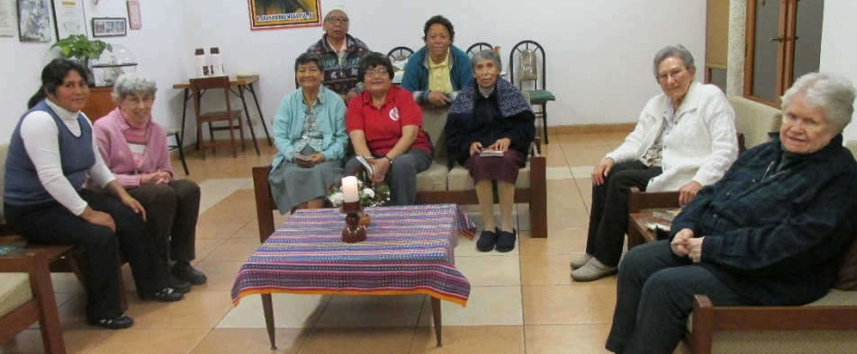

SOLIDARITY WITH THE DEAR NEIGHBOR

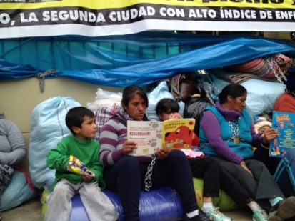
“One can e hear a cry of sadness and impotence because of the contamination of the water, the air and the soil; a cry of incomprehension because of the lack of inclusive processes and help from local and national authorities whose fundamental duty it is to promote the common good. Hopefully, this cry of so many persons, families and communities who suffer directly or indirectly because of the negative consequences of the mining companies can be heard.” (Pope Francis, 2015).

The Province of Yauli – La Oroya has a population of approximately 67,724 persons. The majority of this population, (91.7%) lives in the urban areas. Indiscriminate mining activities are an enclave which surrounds the impoverished population. There are 62.4% of the families whose basic needs are not satisfied. There are 23.7% of the people living in overcrowded dwellings and 44.8% who do not have sewerage. In this area, we have the North American mining company Doe Rum Peru, which is a subsidiary of The Doe Rum Company (http://www.eumed.net). Over the years, this company has generated a great deal of contamination which has been detrimental to the population, especially the children that, to this day, suffer serious difficulties with their health. That’s why, in order to make their voices heard, they traveled to Lima, to demand their right to clean water, to a secure place to live and to receive medical attention. The children and their parents were forced to sleep in cold and humid Salaverry Avenue in Lima.
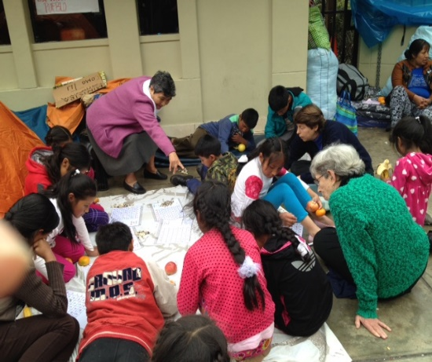
Our Sisters went to be with the children of La Oroya: Sister Anne Davis took a game of Bingo for mathematics from the “Salón San José”; on another day, she took reading books and on another day, the goodies that Sister Mary Luz Salazar’s students collected to share with the children. Not to be outdone in generosity, our Sisters. María Vazquez, María Schuh and Agripina Morales accompanied and played games with them.
P.S. Thanks to our Sister Sally Harper, we were able to be in contact with the reality of our dear neighbor.

Infertile mine pits left by the mining company.
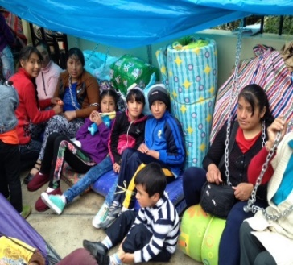
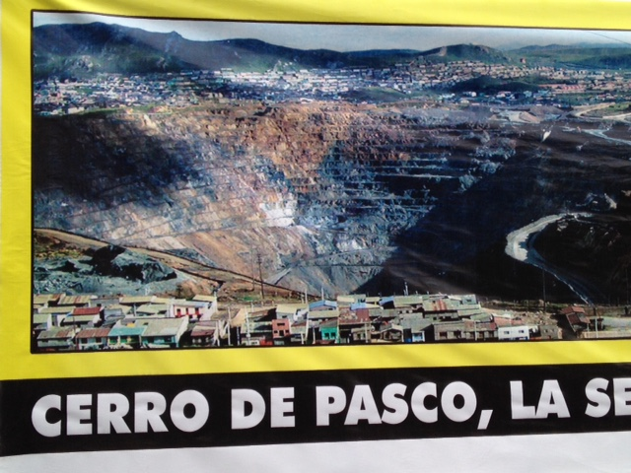

Children who suffer the consequences as a result of contamination

Written by Sister Yolanda Arribasplata.

NEWS FROM CASA VP SAN JOSÉ (CASA CENTRAL)

*On June 6, we welcomed back our Sister Ruth Matos who shared with a lot of emotion and feeling, her wonderful experience with our Sisters of the Albany Province and who she missed tremendously. We hope that these experiences will continue to nourish us as CSJs.
* Sister Mauricia Carcasi went to Puno on June 11 to accompany her sister; she tells us it is very cold there. We hope that this will be a blessed time for her as well as for her dear family. Our love and prayers go with her.
* On June 10, Sister Genoveva Herrera returned to Lima after her home visit with her family. Now, she is in her ministry of visiting the sick at Rebagliati Hospital.

*On June 13, Sister Maria Schuh returned to Lima after having assisted at the Mass in memory of her dear brother, Robert. She was very grateful for all the signs of love expressed by her family and friends during this special ceremony.
*We participated, together with the People of God, in the Mass and Procession of Corpus Cristi in our parish, San José.
* Sister Gloria Zapata is participating in different talks offered by CONFER. Joyfully, she shares what she is learning. This is a time of new things to learn, she says.
* With joy, we celebrated the life of our Sister Pina, (Agripina Morales).
NEWS FROM THE COMMUNITY EL GRAN AMOR DE DIOS (CANTO CHICO)
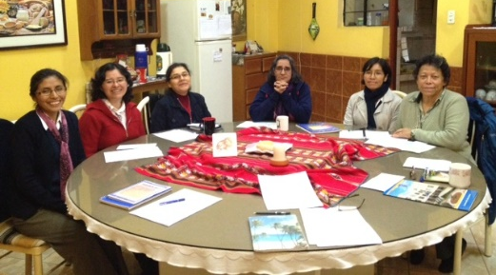
During this month, we had a pleasant visit with our V.P. Leadership Team, Sisters Gloria Zapata and Maritza Jarro. Thank you for bringing us joy, for sharing our lives, for your warmth; thank you for encouraging us to renew our efforts to follow in the footsteps of our Teacher, Jesus. Our prayers go with you!
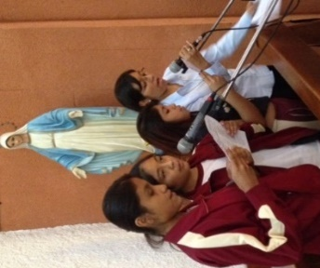

San Antonio School celebrated their 50th Anniversary. Here, Sister María Elena has her ministry, as a teacher of Religious Education. She coordinated the celebration of the Mass and Procession of San Antonio, their patron. She also directed the choir for the Mass.
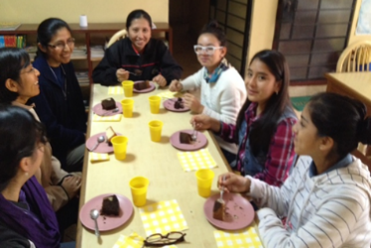
We received a very pleasant visit from our Sister Maritza Jarro, with one of her colleagues and their lovely students. They were presenting a project to the San Antonio School regarding the care of the green areas; they especially taught them how to care for their school gardens. We are very happy that they had this initiative.

Jesus is always in constant relationship with his disciples, with his neighbors, with the people of the town. He teaches us to sit down and share; he teaches us to multiply the bread and the fishes. That is to say, he teaches us to multiply love: he tells us “love one another as I have loved you”. Our Sisters in the Congregational Leadership Team and our VP invite us to strengthen our confidence in one another as Sisters. Invited by love, we join together to enjoy moments of unity and fraternity. THANK YOU SISTERS FOR SITTING AROUND THE TABLE, to enjoy one another!
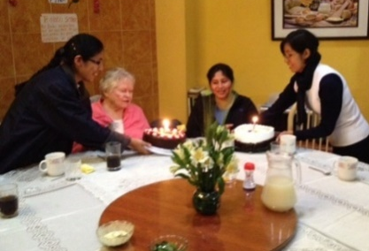
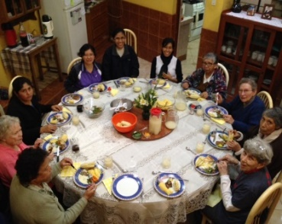

PINA (Agripina), Happy Birthday! What joy it has been to have celebrated together. We thank God for the gift of your life.

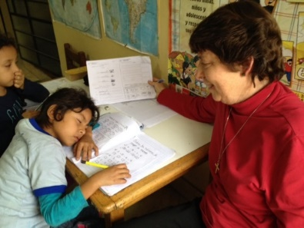
Let the children rest!
How comfortably you sleep … because you feel that you are loved … keep your eyes where life flows… look for that gesture, that smile where God lives… may confidence and tenderness join together… may we contemplate life… and sing to love… Let us pray for humanity… that when we look upon each other, we contemplate God… YAV (free expression)

From the community “Del Gran Amor de Dios”, we send our special Greetings to each CSJ Sister.

NEWS FROM LA COMUNIDAD TRINITARIA (TACNA)
Sisters, receive our Greetings from the Heroic City of Tacna and from your Sisters of la Comunidad TRINITARIA: Zaida and María Inés.

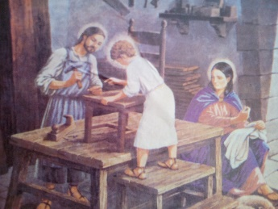
Here we go, with our news:
* With the arrival of “Zaidita”, the community is complete. She was lovingly received at the airport by me and Hannah, a volunteer who shares meals with us and who is giving service in the Fe y Alegría School. Sra. Antonieta, our cook, prepared for her a delicious cazuela (soup), very healthy for her health. She quickly resumed her work, both in community and in “”Fe y Alegría”.

* We signed a contract with the Central Office of “Fe y Alegría” represented by Father Javier Quiroz sj, and with the director of the Region, Edith Anahua and Sister Zaida Perez, the Promoter and representative of the Sisters of St. Joseph of Carondelet. This event took place in the Regional Education Office where there was an ambient of cordiality and joy. After that, refreshments were served.

* We had a visit from the director of the Regional Education Office and from a representative of the Ministry of Education, asking us to take charge or be the promoters of the “Instituto Superior de Educación”, because the Sisters who had been in charge of it were leaving Tacna. They told us that the Ministry didn’t see any other Congregational Institute better prepared than the Sisters of St. Joseph.

* Once again, we had a visit from the Regional Director asking us to be promoters of the Early Stimulation Institute which involves children from 0 to 3 years of age that has recently been opened. This institute is attending special children in a community center in Viñani.

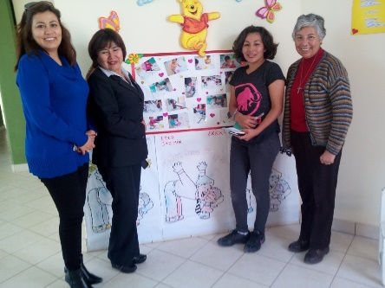
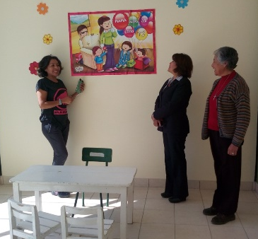
* On June 27 we have initiated encounters of spiritual life formation with the teachers We hope that there will be a lot of enthusiasm for these encounters..
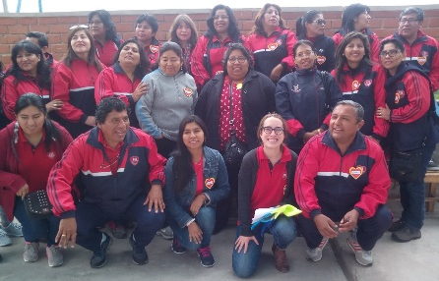

* On June 30, we had the second workshop of spirituality with all the personnel of the school. These workshops were initiated in March and they really help strengthen us and to be fortified by Jesus.

*The Psychology Team is developing and putting into practice the “Parent’s School” with a lot of success. They also have a program for students with low achievement. Hannah, the volunteer, joyfully and with a lot of enthusiasm, is in charge of the therapy sessions in Language skills for children in first and second grades.
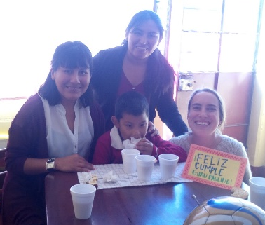

* The Partnership of Schools of Tacna celebrated “Teachers’ Day” on July 4, for teachers who serve in Tacna. There were a good number of participants for this important celebration. We recognize and appreciate their work with their students.

NEWS FROM SALLY
Greetings from the USA. Yesterday was the 4th of July and here in Carondelet we had a picnic in the garden—very pleasant—the company and the food. But I felt that there was very little sense of a “national celebration” because many people are discouraged by what’s happening in the country. Trump’s attitudes and activities worry a lot of people and this includes some members of his party. There is a lot of division and many people are attacking each other because of their differences of opinions. Pray for the USA; please.

This Saturday, June 8, I am going to Indianapolis to talk at all the Saturday and Sunday Masses. After that, I go to North Carolina to visit my nephew and his family and after that to Texas to visit with my cousin and a friend. I will return to St. Louis on July 24.

Here, there is no news about Peru, but there is about Brazil and Colombia. I hope that everything is going well for you and all the Sisters.
Love to each of you.

PRAYERS
6 Geno (P)
May God bless you all the days of your life¡
14 Gladys Leigh (SL)
29 Inés Telles (LA)
31 María Elena (P)

