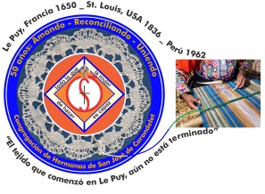
Congregación de las
Hermanas de San José de Carondelet

Jr. Talara 344 – Jesús María, Lima 11, Perú Tel. Casa 01-431-0881 Tel. Oficina 01-424-5092
Apartado 11082 – Jesús María, Lima, Perú Email: hna.csjperu@gmail.com
___________________________________________________________________________________________

NOTICIERO JUNIO – 2017
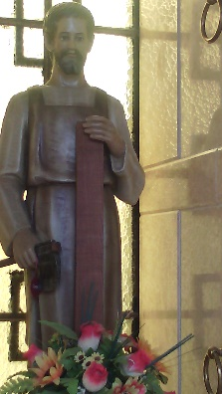
Dear Sisters:

In this year of Grace, we are united with the Universal Church through our faith in God the Father, the Son and the Holy Spirit; we enrich our love of God and of the dear neighbor without distinction by sharing our lives: the joys, sufferings and efforts we make to ensure a life of dignity for all. When we share the faith through participating in the simple devotions of the people and when together we discover evangelical values that we live by as a people, then, we can know that we are mutually evangelizing each other.
Let us give thanks for these marvelous opportunities!
With love,
Gloria, Zaida and Maritza

IMPORTANT NOTE
* Please note that Sister Zaida Perez has another email: zaidaperezcsj@gmail.com

WELCOMES AND TRIPS
* On June 6, Sister Ruth Matos will return to the Vice Province after a year of sharing community life and spending time learning English in the Albany Province. Welcome home, dear Ruth, and continue to nurture and share your wonderful experiences here in the VP.

* On June 7 Sister Genoveva Herrera will return to Lima after spending some time with her family as part of her sabbatical. Welcome home!

* From June 10 to July 11 Sister Mauricia Carcasi will accompany her Sister in Puno. We wish her the best of times with her as she also enjoys her return to her “holy land”. We accompany her with our prayers and with our love.

PARTICIPATION IN THE NATIONAL EXAMS FOR TEACHERS
* Sisters María Elena Cáceres, Mary Luz Salazar and Maritza Jarro participated in the National Exams for Teachers on May 28. It was an important evaluation to be able to obtain future contracts and tenure.

VISITS TO THE CEMENTARY
* On June 26 the Leadership Team visited the mausoleum to honor the memory of our Sisters who have gone to the Father before us. We are united to them while we continue our mission with our people. We ask for their intercession for new vocations to the Congregation.

NEWS FROM THE VP SAN JOSÉ COMMUNITY (CASA CENTRAL)

*We began the month welcoming Sister Robertina. We continue to accompany her in her new community and pray for her father´s speedy recovery.

* Genoveva went to Puno on May 7 to accompany her family. She will return on June 7. Welcome home, Geno!

*Peg left the night of the 16 of May to go to Albany for her medical checkup and Sally went to St. Louis to begin her sabbatical. May they enjoy their time!
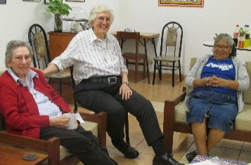
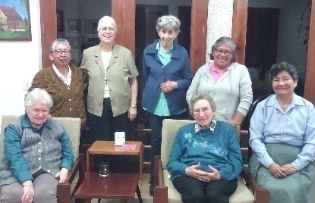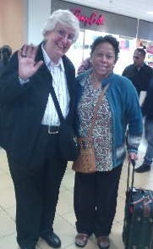
Sitting: Betty, Dolo, María V. Dolo, Sally and Mauricia Sally and Gloria
Standing: Rosa, Peg, María S., Mauricia

* María Schuh went to Syracuse (New York) for her brother Robert´s funeral on the night of May 22 and will return on the night of June 13. We continue to accompany her with our prayers.

* Mauricia, Dolo and Agripina went to Casma (Ancash) the week end of May 20 and 21 to visit with our friend, Romy Llontop, whose family suffered from the floods in March. They shared with us their wonderful experiences with joy and gratitude for Romy´s and her family´s love of the sisters. Once again, they were the recipients of the dear neighbor´s generosity even in such difficult situations. .

Rosana and Dolo Dolo and friends
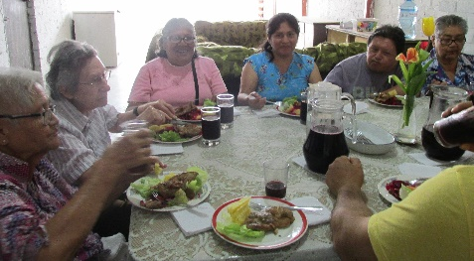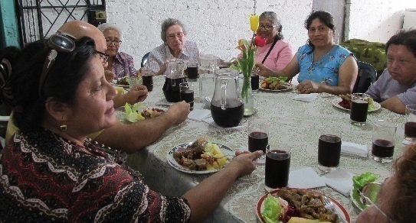
Sharing with Romy´s family

* Zaida is getting better and better every day; thank God, she is responding well to all her treatments. We appreciate her patience and fortitude during her time of recuperation. We have enjoyed her presence among us during this time.
* María Vasquez continues to share her ministry with the children of Canto Chico. With her teaching experience, she goes Monday through Friday to help the children.

NEWS FROM THE GRAN AMOR DE DIOS COMMUNITY (CANTO CHICO)

LOVE DOESN’T HAVE A NAME, LOVE IS A LIFE EXPERIENCE… From life in Canto Chico

To maintain the heritage of our faith, many times, signs are needed; that’s why, during the month of May, we joined together around the Cross and we experienced the gift of humility and simplicity; this is giving and being able to find the best. This is God´s grace!

Around the Cross and praying the rosary, we have lived the dimension of what it is to be neighbor; to feel with the other, to be there and to know that together we share one faith. Diverse, yes, personal, yes; but with our heart and eyes on Christ. In this experience we have lived what God says: “I will take you to the desert and speak to your heart” and the people respond: “I want to hear your voice.” (Canticle of Canticles)

Testimonies of some of the neighbors about their experience of prayer during the month of May:
“This is the first time I have lived this experience, of being at prayer and to have the cross in my house. I don’t have the words to explain what I felt. I have found peace in my heart. I was worried and afraid that the neighbors wouldn’t come to my house because I live in the last house on top of the hill and it is difficult to climb (…). I didn’t know how to express my gratitude; my husband was happy! God is beautiful. I feel that the Community of Canto Chico should be united by our faith. I am overjoyed and so happy to receive the Cross!” Celmi.

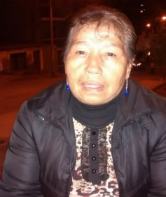
“I am happy that the Cross comes to accompany us; I have a lot of faith in it. It reminds us of our Lord Jesus Christ. With the Cross, we believe that we are with Jesus.” Sra. María (Photo on the left)
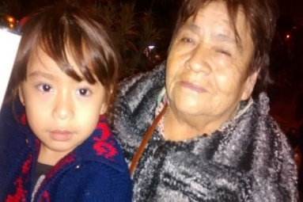
“I am very moved, Our Cross reminds us of our God; I have a lot of faith. We ask that he take care of our family, to take care of our neighbors. We all have lived an experience of the cross, we all have something to carry; but God helps us. Praying our rosary helps us to fortify our faith.” Sra. Carmen and her granddaughter.
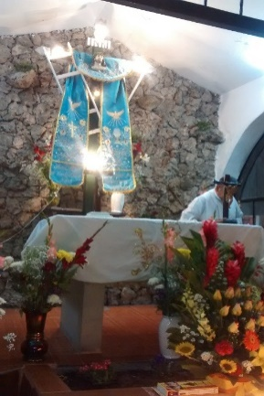
Oh Cross of Canto Chico, Sacred Wood, this month you have called us to live an experience of faith and to share who we are and what we have.
May we be able to follow, by way of the Cross, the way that Jesus invites us to “Come and you will see”, and always ask: “Master, where do you live?” (Jn 1, 38 -39)
Sharing
Praying in family
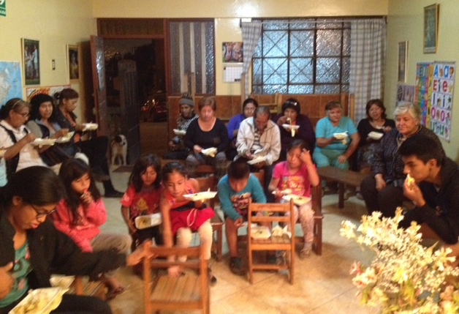
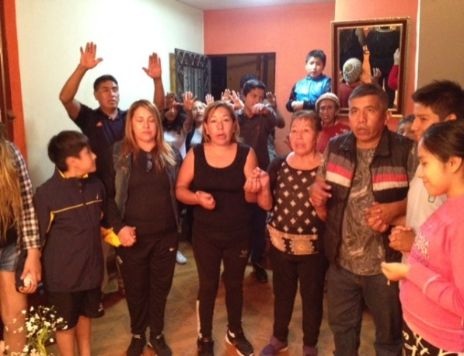

Happenings of gratitud
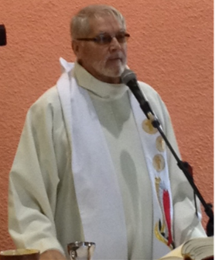
On May 7, the pastor, Father Camilo announced: “today is my birthday, I celebrate my 71 years. A third of these years, I have lived my priesthood in Canto Chico and almost 50 of them my sacerdotal life. Well, today, I am accompanied by the image of the Good Shepherd, a beautiful Gospel (…). The Good Shepherd opens the door and the sheep follow him because they know him. That’s why Father Camilo says: “For me, liberty is fundamental:” because then, I can deeply respect each one of you, the way you live your faith and can see this faith from the point of view of liberty because the only thing that God does is love us (…). Jesus is the open door, through it, we come and go and we can find verdant pastures.” Thank you, Father Camilo, for your commitment and the gift of your life.
Welcome!
On May 12, our Sister Robertina Espinoza became part of the Gran Amor de Dios community. She is happy to be in the barrio. And besides this, she is enjoying her students once again. Welcome Rober, we are very happy to share our lives with you!

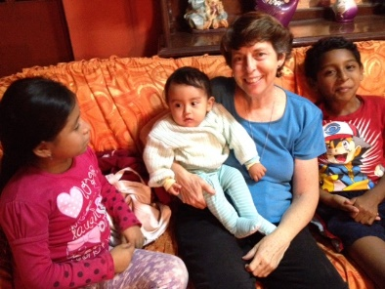
On May 20, our Sister Anne went to the States so that she could continue her practice of deepening and living her experience of being a leader. We rejoice with you and hopefully, you can share with us the things you have learned so that we can be better Sisters, better members of the community and we can mirror the leadership of Jesus.

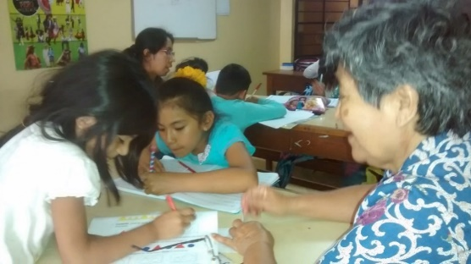
Sala San José
You will always find a Sister of St. Joseph where she is needed. An example of this is Sister María Vasquez. She helps the children in the Sala “San José”. María always shows her sense of humor and the magic she uses to get the children to concentrate on their homework. Thank you, María!

NEWS FROM THE TACNA COMMUNITY

* María Inés arrived in Tacna on May 11 after having spent two week in Lima to participate in the Post-Chapter and for health reasons.
* The Mothers’ Day celebration was well prepared. There was an atmosphere of fiesta with happiness and gratitude for all the work that mothers of Fe y Alegría do.

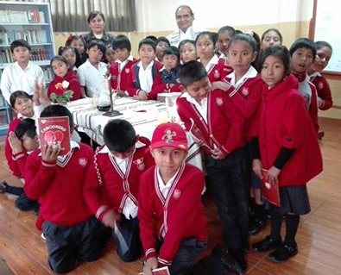
* María Inés participates in the preparation of the Para liturgies on the primary school level and the Eucharistic celebrations on the secondary school level. By doing this, the students of each classroom along with their teachers are having an important spiritual experience. Father Quique Castro is a valuable asset in the spiritual formation of our students and teachers.

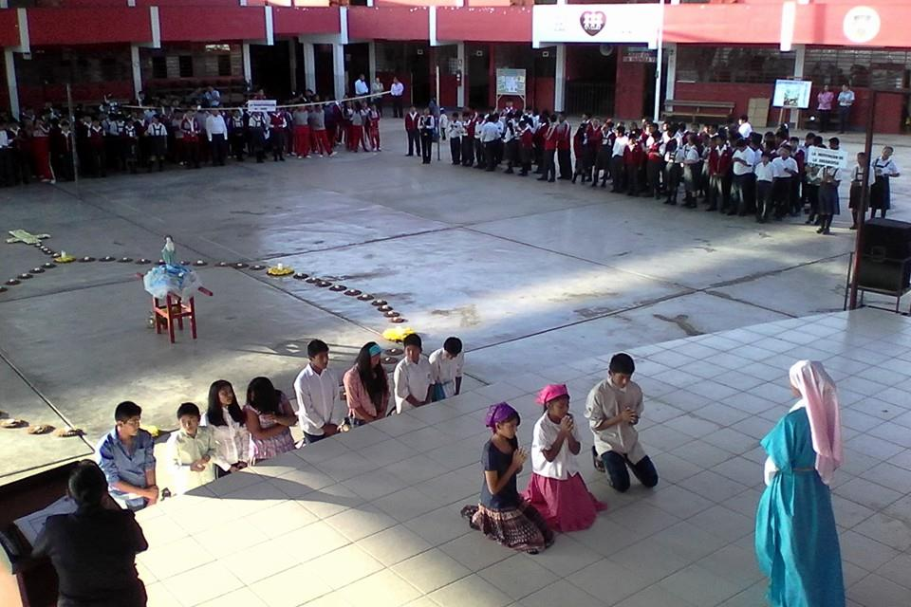
*I admire the commitment of the Pastoral Team for having prepared and organized the activities of the month of May dedicated to the Blessed Virgin Mary. Each day the students prayed the Angelus and sang, joyfully, the hymn María Tu”. This was Sister María Ines´ experience.

* We have missed Sister Zaida, but as you know, she is in Lima for health reasons, but thank God she is getting better and will soon return.

WE PRAY FOR:

10 Peg Murphy
May God bless them all the days of their lives!
20 Mary McKay (ELC)
27 Julie Marciacq
29 Agripina Morales

We will wait for your news until the 29th of each month, thank you for sharing your lived experiences in community. We encourage you to write some stories of experiences with the dear neighbor and send them to Sister Eleanor Ortega at the email: missionoffice@csjcaondelet.org

