Congregación de las
Hermanas de San José de Carondelet

Jr. Talara 344 – JesúsMaría, Lima 11, Perú Tel. Casa 01-431-0881
Apartado 11082 – JesúsMaría, Lima,PerúTel. Oficina 01-424-5092
Emaoficinaprovincial@csjvpperu.com
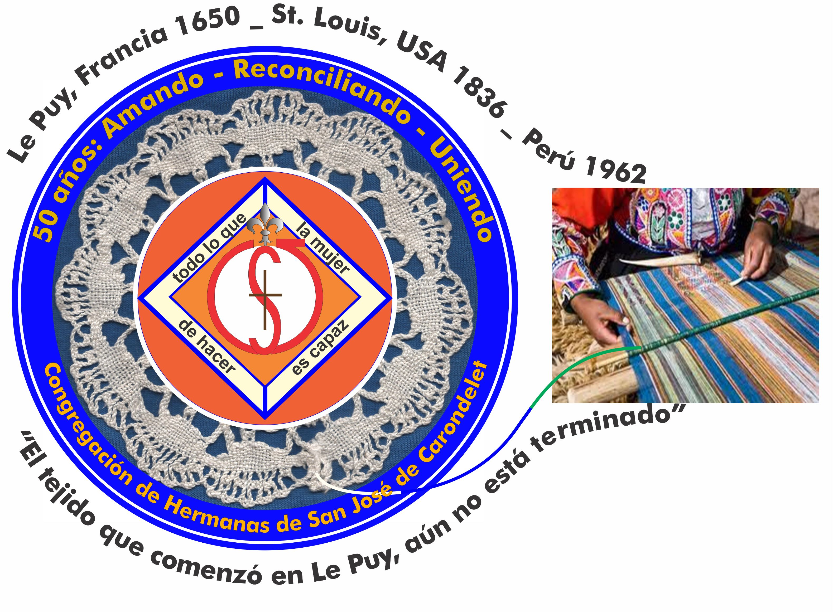

NOTICIERO - NOVIEMBRE 2016

HAPPY ALL SAINTS DAY

Dear Sisters,
Today we celebrate all the Saints who don’t have a special day in the liturgical calendar—many of whom are friends and relatives of ours. They offer us examples of dedication to living a life of love and for them we give thanks. In Peru, besides the known saints: St. Rose of Lima, St. Martin de Porres, St. Toribio de Mogrovejo, St. Juan Masías and St. Francisco Solano; there are 16 beatified, 4 venerable and 11 servants of God. So you see, the road to sanctity is possible when we open ourselves to and embrace the grace that God so generously gives us. Let us continue to pray for each other so that we can respond to this grace in order to live a little bit closer to the ideal that Jesus puts before us.
With love,
Genoveva, Teresa and Sally

RETREAT FOR THE SISTERS WITH TEMPORARY VOWS
October 7 to 9, Sisters María Elena, Rosa Luz, Agripina and Yolanda met with Anni Davis in the Monte Carmelo Retreat House for a week-end of prayer. We give thanks to all of you for your prayers and support of our sisters with temporary vows, especially during this time of discernment.
.

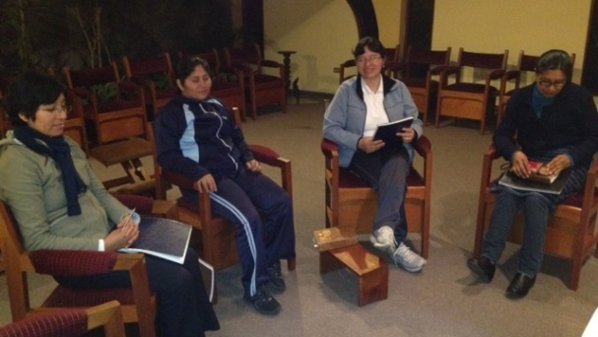

ACOF MEETING
The ACOF directors met in Los Angeles from 5 to 9 of October. There were representatives from the four provinces and Hawái, Chile and Peru. Sister Mary McKay is the ACOF liaison from the CLT and Sisters Margaret O’Rourke and Louise Bernstein came as the translators.

On Wednesday night, we had the opening prayer and sharing of the heart, followed by a welcome, sharing of food and drink. We began each morning and afternoon session with a prayer lead by one of the units.

During the three days each representative shared what is happening in their unit; we shared common themes, concerns and objectives. Some of these were:
- The Convocation in St. Louis programmed for the 22 to 25: its theme, schedule, content and finances.
- Emerging ways to live the CSJ charism including agregee.
- The international dimensions for ACOF—relationship between Chile and Peru.
- The implications for ACOF in regard to the process of reclaiming our being one and the extraordinary Chapter in April 2017.
- To update the comparative statistics and information about ACOF and the results of the sharing in the entire congregation regarding the identity and commitment of ACOF members.
- The conclusions from the CARA/NACAR report about profiles of both men and women associates and religious in the USA and Canada.
- The vision that is evolving regarding “The Center of CSJ Heritage “for ACOF.

The representatives returned to their homes enriched by the sharing and with enthusiasm for our shared future in the Congregation of the Great Love of God.

Canto Chico News
Visit from our Leadership Team: October 13 and 14 Sally and Geno came to share our experiences and community life. They lead us in prayer and we shared about the reality of our vice province, and our desires for the future. To thank Sally, Teresa and Geno for their accompaniment all these years of service to the vice province, we invited them to go to the Gran Teatro Nacional to listen to a symphony concert.

The Sacrament of Baptism: We were invited by the little girl, Zaida Huamán, to participate in her baptism in the chapel of San Pablo. We enjoyed the event with her and her parents and family.

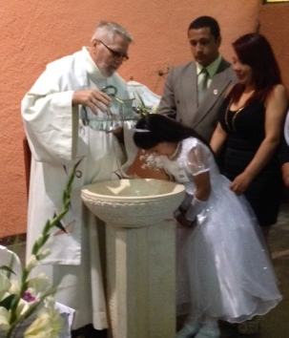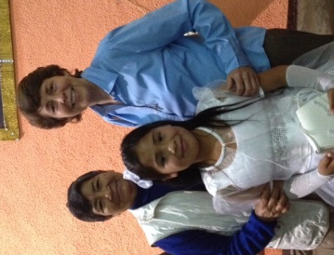
Salón San José
In this month of October, Together with our young collaborators in the salón we had a meeting to evaluate, if the help that the children receive is effective. Fifty-one children have assisted during this month and they have also played and learned the tables for adding, subtracting and multiplying by playing bingo. The children are also encouraged and happy when they receive their prize for attendance and participation.

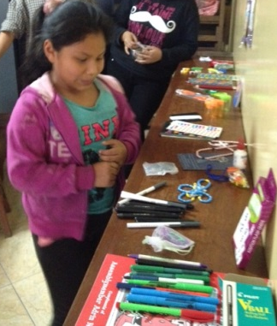

Our Garden: We feel more secure now that the stairs going to the third floor to hang our clothes to dry have been fixed. María cleaned our garden and it looks better; some of our plants even have beautiful flowers.

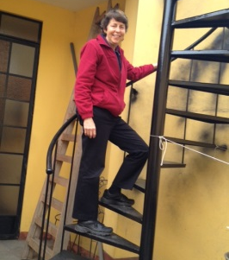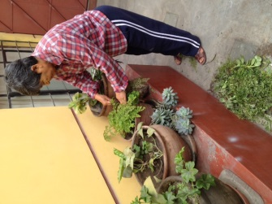

COLLABORATORS IN THE MISSION
On DOMUND Sunday, we wrote to the sisters in gratitude for their work with the Mission Office of the Congregation in collaboration with the Propagation of the faith. They are: Kitty Hanley, Maureen Murphy, Deb Timmis, Anne Kelly, Mary McGlone, Jeanne Marie Gocha, Doreen Glynn, Rose McLarney, Nancy Corcoran, Marjorie Craig, Laura Bufano, Diane Zigo, Imelda D’Agostino, Roseanne Belpedio, Margaret O'Rourke, Rosalie Callen, Danielle Bonetti, Ida Robertine Berresheim, Susan Hames, Joan Mitchell, Carolyn Puccio, Theresa Sherlock, Cathy Steffens, Robertina Espinoza, Eleanor Ortega and Mary Ann Leninger (Coordinator of Missions).

Many of them wrote back to say it was a privilege and joy to be able to do it. Two of them shared experiences that they had:

From Margie Craig:
Thank you for the message. I have always felt a dichotomy between pride and humility when I give these talks—the last 20 years. Of course, the pride is when I share about all that our sisters do to help the poor of Peru. The humility part is in receiving the generosity of strangers who believe in you because we believe in you. I will never forget a grandmother who talked to me after Mass last summer and she gave me $2.00. It made me think of the Gospel story of the poor widow putting in all she had into the collection box. I am never the same after I give one of these talks for the Missions.

From Margaret O’Rourke:
Last year in Sacramento, a mother approached me with her little child of about four or five years. She told me her daughter was sad because she didn’t have any money to offer, but that she wanted to share a box of colored pencils that she had received. Then, they went home and returned after the next Mass. The little girl gave me the new box of 12 colored pencils and I assured her that some child in our Colegio Fe y Alegría (of which I had spoken) would be happy to receive them and that it was a very generous gift. Later, I gave the pencils to the woman who takes care of the children in the Learning Center here in our poor neighborhood and put the money (equivalent to the price of the pencils) in the collection for Peru here in Carondelet Center.

HAPPY BIRTHDAY
3 Betty Conrad
6 Kathy Crowley
7 Teresa Kim
26 Gloria Muchaypiña

