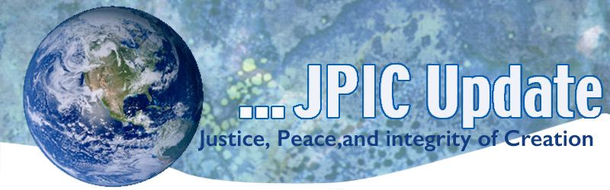
January 30, 2017
Calendar
Save the date

January 30 –April 30, 2017 continue the 100 days of prayer for National Unity and Healing –see attached for February prayers
February African American History Month
February 19, 2017 Symposium on Chocolate - see attached

TAKING ACTION
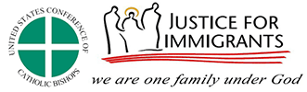

In Solidarity with Refugees
Background:
President Donald Trump has issued an Executive Order that has devastating impacts on refugee resettlement in the United States. The Executive Order:
Halts the entire refugee admissions program for 120 days to determine additional security vetting procedures;
Cuts the number of refugees admitted in FY 2017 from 110,000 to 50,000;
Suspends resettlement of refugees from Syria;
Suspends the issuance of visas to individuals from countries of concern, including Syria, Iraq, Iran and other countries.
Please clink on http://bit.ly/2kG21RI Once you are in the web page hit the words Take Action and it will give you a letter to sign or you can download the attached letter and send it to your congressional representatives.

1st 100 Days Action for the week
Please join the Sisters in the CSSJ Federation for this week’s action:
Learn about the Sanctuary Movement, Sanctuary cities, and Sanctuary Colleges and support the efforts of these groups.
- http://sanctuarynotdeportation.org (Sanctuary Movement)
- http://college.usatoday.com/2016/12/19/heres-where-the-sanctuary-campus-movement-stands (Sanctuary Campuses)
- Participate in a webinar on sanctuary space Monday, Jan. 30th, hosted by Policy Link - http://www.policylink.org

A request from Mercy Earth Advocates:
President Trump on Tuesday signed orders that could revive plans for the Keystone XL and Dakota Access pipelines.
You may immediately join Interfaith Power & Light in contacting President Trump to alert him to these concerns. Meanwhile, we will continue to monitor these developments and inform you of opportunities for further advocacy as it is helpful.
Please Support the BRIDGE Act and Protect DACA Youth
The BRIDGE (Bar Removal of Individuals who Dream and Grow our Economy) Act, S.128/H.R. 496, was recently introduced in Congress as a bipartisan effort to sustain the temporary relief from deportation and employment eligibility offered to youth through the Department of Homeland Security's Deferred Action for Childhood Arrivals (DACA) program. Under the BRIDGE Act, young people who came to the United States as children would maintain their eligibility to work and live in the U.S. without the fear of deportation and family separation so long as they meet certain requirements, such as showing a commitment to education or honorable service in our military and having no history of serious crime.
As Catholics, we have long supported DACA youth and their families as we believe in protecting the dignity of every human being, especially that of our children.
See the attached letter that can be sent to your congressional representatives.

INFORMATION/REFLECTION
The peace of which Paul spoke is a calmness of soul amid terrors of trouble, inner tranquility amid the howl and rage of outer storm, the serene quiet at the center of a hurricane amid the howling and jostling winds. (Martin Luther King, Jr in his book Strength to Love page 94)

"The irreversible momentum of clean energy"
published on Jan 9th, 2017. SOE Mary Southard, CSJ, Try this link: http://digitalcommons.unl.edu/cgi/viewcontent.cgi?article=1365&context=usdoepub

RESOURCES
The 65 Million-together we can make a difference
For all of us wondering how we can be powerful, thoughtful voices in our current reality, I think the link below is a very powerful resource. It provides scripts for calls to congress on a variety of topics, as well as a weekly call to action on a particularly pertinent issue. It also has some great background information on the power of calling.
http://thesixtyfive.org/home

From Mayor Garcetti
Hundreds of thousands of Angelenos took to the streets in an incredible display of unity, peace, and strength at the Los Angeles Women's March. We joined together to show that L.A. will speak and act out for our values, because democracy is something that happens every day — not just on Election Day. In that spirit, we've created this easy-to-use action center with eight great ways to get and stay involved.

Symposium on Chocolate
Come to learn the truth about chocolate and the social implications about what we buy.
Explanations on fair trade products will be available
A chocolate fondue will be avail-able to enjoy the rich delight of chocolate! See attached flyer.

Great concept to be supportive of immigrants.
http://m.startribune.com/restaurants-the-next-front-for-the-immigration-debate/411723746/?section=nation&utm_source=CLINIC+Mail&utm_campaign=156d1e1057-CLINIC_Daily_1-26-17&utm_medium=email&utm_term=0_a33179621a-156d1e1057-283995401

