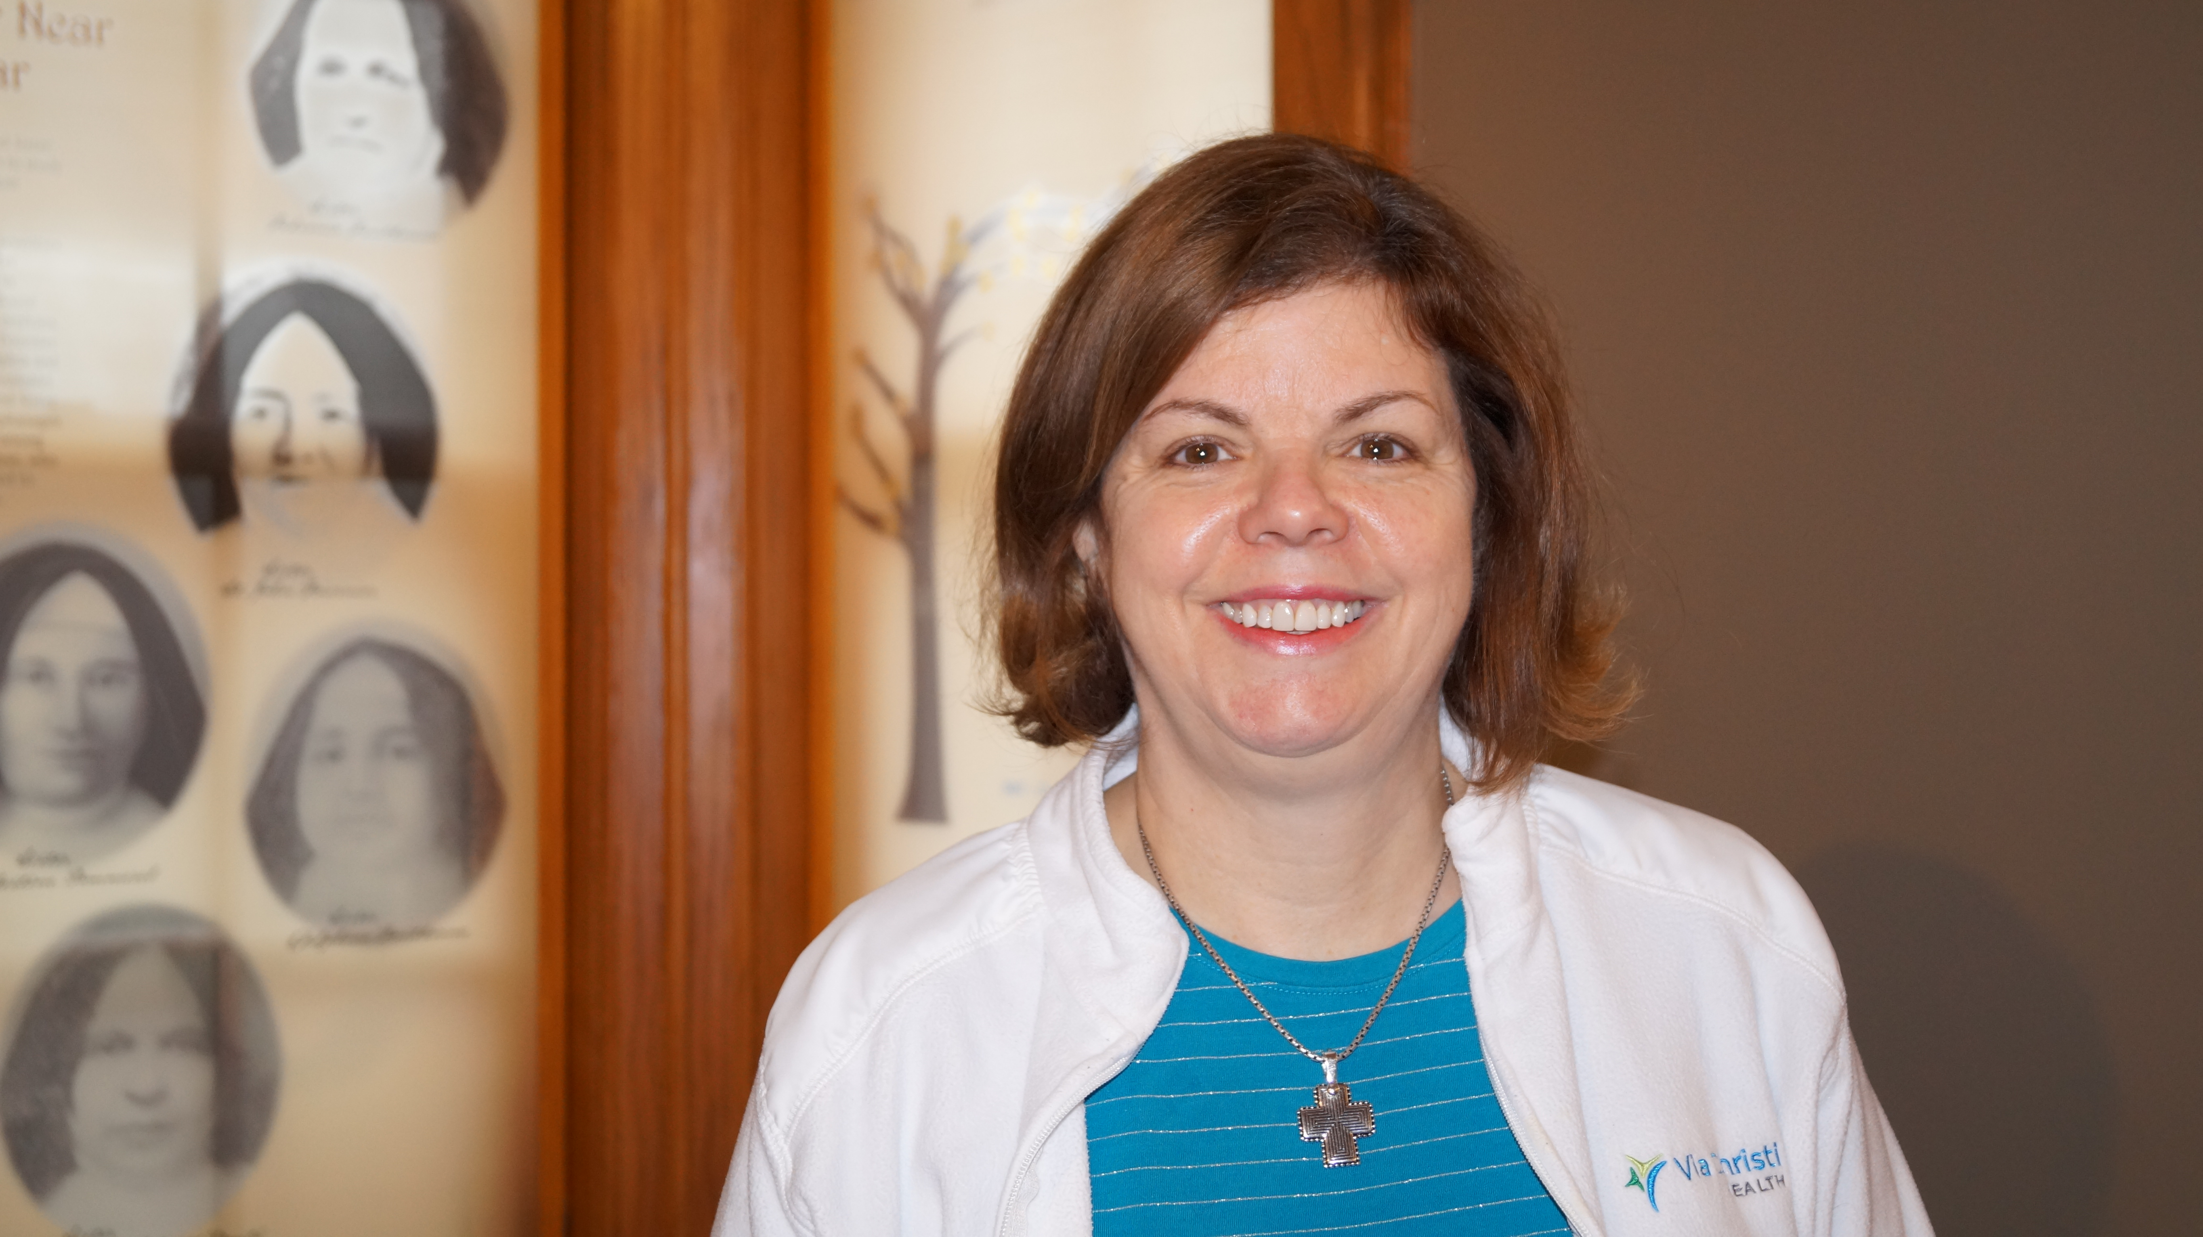

Meet Mary Collar, Our Newest Candidate
Mary Collar is our newest candidate, but this is not her first experience with the Sisters of St. Joseph.
Growing up the youngest of seven children in Pittsburg, Kansas, Mary was taught by Sisters of St. Joseph of Wichita (now a part of the Congregation of St. Joseph). She developed strong relationship with two Sisters in particular.
In 1993, Mary entered formation with the Sisters of St. Joseph of Wichita. She journeyed with them for six years, but ultimately felt it was not the right fit for her at that time. “I still had a hunger to form myself,” she said. So she continued to work in youth ministry and dental hygiene, then moved to St. Louis to attend Aquinas Institute of Theology. She completed her Master of Arts in Pastoral Studies in 2005. There, she met a few Sisters of St. Joseph of Carondelet, and ended up living in community with some of our Sisters.
Mary always knew she wanted to return to religious life, but hadn’t been sure it would be with the Sisters of St. Joseph. Ultimately, she found that our charism articulated something deep within her. “This unifying love is about bringing people together. In doing that I’m uniting myself with them but them I’m also bringing them together with their God and with others.”
Today, Mary still lives in community with sisters in St. Louis, and she works as a hygienist in a private dental practice. This may seem like a non-traditional ministry for a Sister, but Mary sees a direct correlation with our charism. “Even in the dental office, I provide an environment because people are terrified of going to the dentist. It’s a very intimate setting,” she says. “So I make sure that my environment has a certain gentleness, a peace about it. I’m very thorough. I’m very caring. Like all religious, I want to bring God’s love into the world.”
Mary is currently discerning if God might be calling her back to youth ministry, to a chaplaincy, a post in healthcare mission integration or a teaching position. She would also love to learn Spanish and volunteer at Annunciation House on the Mexican border in El Paso.
Wherever she ends up, Mary will also be living out what she calls her “truest vocation,” being an aunt, great-aunt and great-great-aunt. “That makes me sound old, but I became an aunt when I was nine!” she insists.

