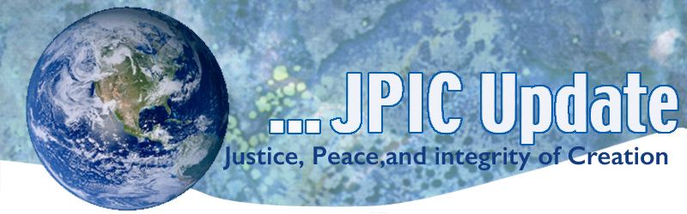
December 18, 2017
CALENDAR
December 18 International Migrants Day
December 20 International Human solidarity Day
December 25 Christmas
2018
January 1 World Day of Peace
January 8-17 National Migration Week
January 13 Walk for Freedom

TAKING ACTION

Today is International Migrants Day Please see attached prayer.

Global Compact on Migration
The US is no exception. Earlier this month, the Trump Administration announced it would no longer participate in the Global Compact on Migration - a critical process to respond to the needs of migrants and refugees, and for safe, orderly, and regular migration around the world. By turning its back on life-saving cooperation with other nations, the US is abandoning its leadership as a safe haven for those who want to build a better life for themselves and their families. Please click on the following to take action:
Take a moment today to contact President Trump and his Administration, urging them to re-engage in the Global Compact on Migration. Your voice is important and it is time to take a stand on behalf of migrants everywhere. (note: when you click on this site my name will be in the spaces. You can click above where it says not Diane and then you can fill in your name.)
No Unconstitutional Strike against North Korea
A bill in the House of Representatives seeks to stop an unconstitutional attack against North Korea. The bill, H.R. 4140, would prohibit the president from launching a first strike against North Korea without congressional approval. The bill also calls on the president to engage in diplomacy to reach a peaceful outcome. The Nuclear Age Peace Foundation asks us to encourage our Representatives to become co-sponsors of the bill. Go to: http://org2.salsalabs.com/o/6357/p/dia/action4/common/public/?action_KEY=25596

INFORMATION/REFLECTION
"O Antiphon" to your daily or meal-time prayer today:
"O Leader of the House of Israel, giver of the Law to Moses on Sinai:
come to rescue us with your mighty power."
(Catholic Household Blessings and Prayers, Revised Edition, 76)

Leading economists and major corporations call for the end of fossil fuel investments
More than 80 leading economists from 20 countries have signed a Declaration on Climate Finance urging for an immediate end to investment in new fossil fuel projects and a dramatic increase in renewable energy investment.

France awards ‘Make Our Planet Great Again’ grants to US climate scientists
French President Emmanuel Macron has awarded long-term research grants to 18 research scientists so can they continue their research on climate change in France.
One of the winners, Camille Parmesan from the University of Texas, said: “Macron’s appeal gave me such a psychological boost, to have that kind of support, to have the head of state saying I value what you do”.
She revealed that at the moment there are significant funding challenges in the US for climate research stating that climate researchers have a constant feeling that “you have to hide what you do”.

RESOURCES

Global Catholic Climate Movement
As 2017 draws to a close, I’d like to share this colorful blog post with a good summary of our joint Laudato Si action this year. Thanks for being part of this movement.
Catholics Living Laudato Si’: GCCM’s Top 10 Highlights for 2017

Free yourself from your filter bubbles
09:18 minutes · TEDWomen 2017
Joan Blades and John Gable want you to make friends with people who vote differently than you do. A pair of political opposites, the two longtime pals know the value of engaging in honest conversations with people you don't immediately agree with. Join them as they explain how to bridge the gaps in understanding between people on opposite sides of the political spectrum -- and create opportunities for mutual listening and consideration (and, maybe, lasting friendships).
Watch now »

ISLAM-OPED: Love for Jesus Can Bring Christians and Muslims Together

Take Action/learn more:
What causes homelessness?
Watch: Giving to people who give
Lesson Plans / Teaching resources / Classroom Module

