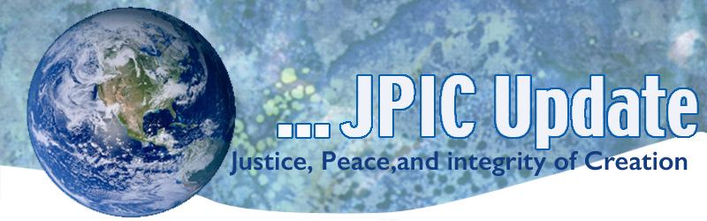
December 4, 2017
CALENDAR
December 6-17 National Events to End Gun Violence December
December 10 Human Rights Day
December 18 International Migrants Day
December 20 International Human solidarity Day
2018
January 1 World Day of Peace
January 8-17 National Migration Week
January 13 Walk for Freedom
TAKING ACTION

Congressional Budget
Beginning this morning we need to put pressure back on the House of Representatives and keep up pressure on the Senate. Please join LCWR and our friends at NETWORK and call members of Congress—toady and every day until we win this fight for all the people.

Please call and urge your sisters, family, and friends to do the same
· Senate: 1-888-885-1748 (Call twice to reach both Senators)
· House of Representatives: 1-888-422-4555
Suggested call text:
My name is _______. I live in TOWN, STATE and I’m a constituent of the Senator/Representative.
As a constituent and a person of faith, I believe that everyone should pay their fair share of taxes. I ask Senator/Representative [NAME] to OPPOSE the tax bill that delivers huge tax cuts to the richest 1% and wealthy corporations, paid for by increasing taxes on 87 million Americans and by slashing Medicare, Medicaid, and education. It’s wrong to give special tax breaks to the wealthy and powerful at the expense of working families. It’s a violation of my faith and a betrayal of American values. It’s not too late for the Senator/Representative to do the right thing and defeat the tax bill that is being considered by the conference committee.

Can I count on the Senator/Representative to do the right thing and defeat the Republican tax plan?

Thank you for your consideration.

December 6th begins Events to End Gun Violence
Here are some things you can do:
SIGN A PETITION
Sign your name and demand that lawmakers FINISH THE JOB and make expanded background checks federal law ( you will have to click on not Diane Smith and put in your own name on this petition.)

Urge your local, state, and federal elected officials to support expanded Brady background checks for every gun sale

INFORMATION/REFLECTION

We have to enter into the humility, simplicity, patience, and delicate nature
of what’s unfolding in our hearts
to discover how God is being born in our lives. (James Findley)

Human Rights Day
In honor of Human Rights Day you may want to read the attached the UN Declaration on Universal Human Rights. It was adopted on December 10, 1948 and still calls us to respect all peoples. See Attached

Solar capacity in developing nations more than doubled in 2016
According to the latest review from Bloomberg New Energy Finance (BNEF), new solar capacity is growing at an unprecedented rate due to decreased costs and innovative applications that facilitate energy access for millions.

RESOURCES

See attached Beyond 100 Days of Prayer for December
Global Catholic Climate Movement
As we read in the Gospel of John, Jesus was a gift from God, who “so loved the world.” (John 3:16) During the season of Advent, we have the opportunity to deepen our own sense of love for the world. Protecting creation and vulnerable people is an important way to love.
We have produced a brand-new Advent resource kit to help you to reflect on the call to care for our common home and to live out your call through concrete actions.

Two articles you may want to read:
'Please, God, don't let me get stopped': Around Atlanta, no sanctuary for immigrants by Vivian Yee for The New York Times
The nationalist's delusion by Adam Serwer for The Atlantic

