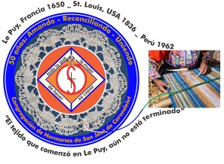
Congregación de las
Hermanas de San José de Carondelet

Jr. Talara 344 – Jesús María, Lima 11, Perú Tel. Casa 01-424-5092 Oficina 01-757-0980
Apartado 11082 – Jesús María, Lima, Perú Email: hna.csjperu@gmail.com
___________________________________________________________________________________________

NOTICIERO DE MARZO – 2018

Dear Sisters:

In the Spirit of having celebrated the Resurrection, we wish that the joy of the Resurrection be an experience that will continue in all the different moments of our lives.

We thank God for His generosity to us during this time. We rejoice because the health of our Sisters Maria Ines and Maria Schuh is improving: our prayers have been heard. We continue to be with them during this special time of recuperation. We are also grateful for the testimonies we are sharing in our community life and with the dear neighbor. Our country need all of this as we pray, in this new political moment.

We encourage you to remember the words of Pope Francis during his visit “not to allow anybody to steal away your hope”. Some of you are starting new work experiences and service to the dear neighbor and others are continuing to advance God’s project. We are in different spaces in order to continue sharing our joy and faith in God, because he will give us the grace to respond to different situation of life. With this conviction, let’s continue to listen to how God calls us as a Congregation.

Enjoy this Pascal time and may we continue to announce the Good News.

With Love,

Gloria, Zaida and Maritza

IMPORTANT NOTICE
*Sister Agripina Morales has a new cel number: 998-698-154.

* Please put the 30th of July to August 1st on your calendar for our CSJ Days. Sister Mary McGlone will be our guide during those days of encounters. As of now, we welcome her.

CLG MEETING
* Gloria and Zaida participated in the CLG meeting Los Angeles from February 28 until March 6th.
* We had Sisters Cathy Bertrand and Joanne Hanrahan, Notre Dame Sisters, as our facilitators. They shared their vision about a chapter that will help us to continue conversations with a wider panoramic view, attending to “the more important things”. These conversations will require a change of focus from “I” to “us” and be for the good of the congregation.

* We received the report about the Congregational Formation Plan (from the Federation). Sisters Jean Marie Gocha and Carol Brong (co-directors of the Congregational Novitiate), informed us about the house and about the entrance into the Novitiate of Chizuro Yamada on March 27th and about the second candidate who will probably enter in August.
* We had a zoom session with the directors of JPIC. The three areas to work for this year are: Care of creation, to get rid of racism and to promote peace and nonviolence.
* The CLG has asked the Sisters and the ACOF to continue to pray that the Spirit of God will open our hearts, minds and wills.
* Zaida and Gloria visited the novitiate after the CLG; they loved it.

VISIT TO THE FAMILIA DE SAN JOSÉ (CHILE)
* From March 9 to 14, the VP Leadership Team went to Chile for their first visit to the Familia San José. For us, it was a very significant experience. We got to know the members of the Familia, both in Talca and Curepto. We were in Talca from March 9 to 11th, and in Curepto, March 11 to 13.
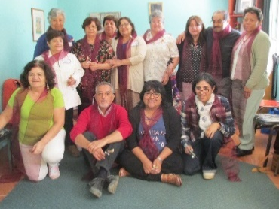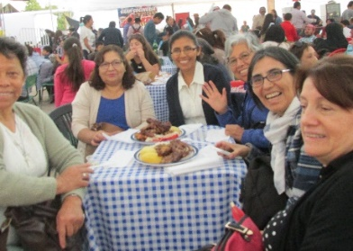
Familia de San José – Talca Sharing a delicious meal…

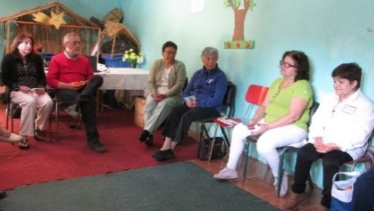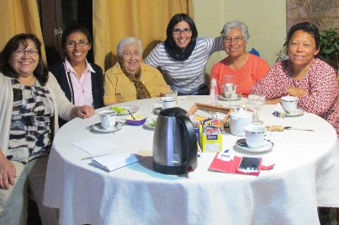
Prayer and Sharing of the Heart Ibarra Family in our farewell from Talca

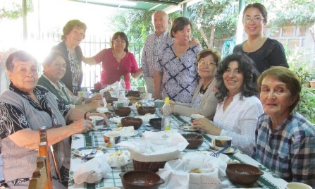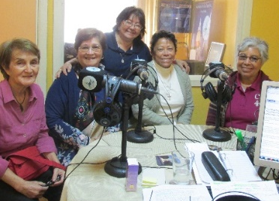
Familia de San José – Curepto Sharing on the radio…

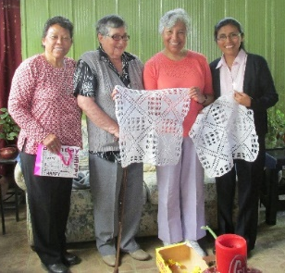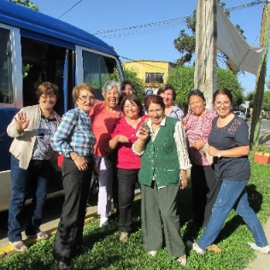
A gift made by hand… The farewell from Curepto
* We appreciated the warm welcome, their Christian commitment, their testimony of the charism, their love for the Sisters of St. Joseph, their sharing of the heart, and we appreciated listening to their concerns and hopes as members of the Church. We also listened to their pain because of the losses in their families. In both places, they shared the reality of their groups and then we offered the prayer: “A different way of Being” which was a missioning prayer, and then we shared our own concerns of the moment. We invited them to the three CSJ Days in July-August.

* Here we reiterated our gratitude to the Familia de San José, their love and hospitality. They were super!

VISITS TO THE LOCAL COMMUNITIES
* We have scheduled our first visit to the local communities as follows:
- Gran Amor de Dios Community (Canto Chico) = From April 30th to May 2nd
- Pequeño Proyecto Community (Brisas) = May 3rd and 4th
- Trinitarian Community (Tacna) = June 30th
- San José Community (Jesus Maria) = July 1st to 3rd

LA CASA VP SAN JOSÉ COMMUNITY (CASA CENTRAL)
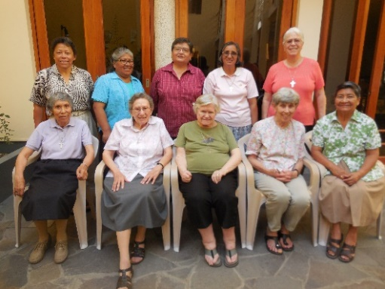
Standing: Gloria, Mauricia, Ruth, Robertina, Peg
Sitting: Geno, Dolo, Betty, María S. y María V.

Inter-Congregational Community:
* The San Jose Community is now inter-congregational; we have two Sisters from other communities as members of this community. Sister Norma Ramos Díaz is from Honduras. She belongs to the Congregation of the Sisters of St. Joseph of Lyon of the Province of México. She is here participating in the Formation Program offered in CONFER. Sister Patricia de la O is from Huancayo. She is a Dominican Sister who is participating in the DEVIDA Program for adolescents and older men who are in drug rehabilitation. This is a public health program which is an annex of the Council of Ministers.

*To celebrate St. Joseph’s Day, the three communities: Las Brisas, Canto Chico and Jesus Maria met on Sunday, March 18 to celebrate together our patron’s day. We shared a delicious dinner and participated in the renovation of Agripina’s and Yolanda’s vows.

Another Inter-congregational Experience:
* March 17th, our Sisters Gloria and Maria Vasquez went to Chincha to accompany the Sisters there at the funeral Mass for Sister Nicole of Canada.
* We have initiated another inter-Congregational experience with Maria Vasquez accepting to go to Chincha for a month to share life and ministry with the Sisters of St. Joseph of Canada. She left March 28 to begin her experience.

During Holy Week:
Sisters Norma Ramos and Robertina Espinoza were in Chincha-Ica for Holy Week. They actively participated in all the celebration of the Christian communities of the parish. The Sisters affirmed the fact that “it is the laity that is in charge of the organization of the celebrations of the parish”. The Sisters of St. Joseph of Canada, Gloria Muchaypiña and Maria Choquez are their support and mentors to these communities. They have also shared their community life and richness of their own spirituality and appreciation of the life of the people.

Home Visits:
Sister Genoveva Herrera is visiting her family in the city of Puno. She will return April 11th. Also on home visits are Sisters Dolores Muñoz (LA) and Elizabeth Conrad (SL); they are visiting family and Friends Los Angeles. They will return on May 5th.

Health:
Sister Maria Ines Gutierrez is recuperating from her surgery. She has the help of a nurse 24 hours a day; and besides that, her nephew, Dr. Martin, does the follow up for the surgeon. She appreciates all your prayers.

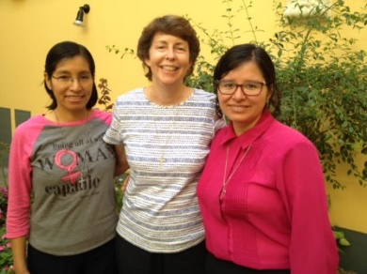
NEWS FROM EL GRAN AMOR DE DIOS COMMUNITY (CANTO CHICO)
María Elena, Anne and Yoly

The Gran Amor de Dios Community began their 2018 community life by beautifying the house and putting in some plants in the garden with the help of the children and youths of the barrio.
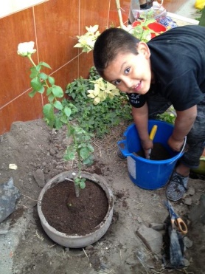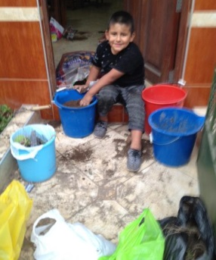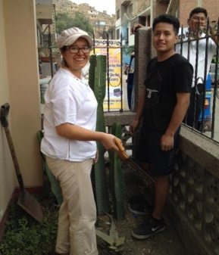

* March 12th, our Sister Maria Elena started her work at the Fe y Alegría School N° 32 with a good number of students and teachers. Here she is with her pastoral education team.
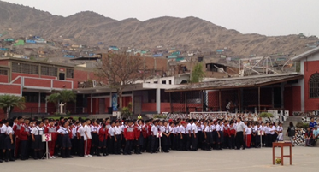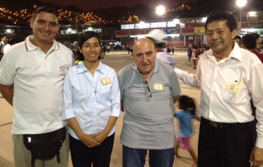

*March 13th, there was a farewell breakfast for Father Camilo, who after 30 years of service in Peru, returns to Canada take care of his health and to continue his service as the provincial of his congregation.
We had the farewell in the Gran Amor de Dios community with a prayer and a delicious breakfast. Present were our Sisters Maria Schuh, Maria Dolores, Maria Vasquez y Mary Luz.
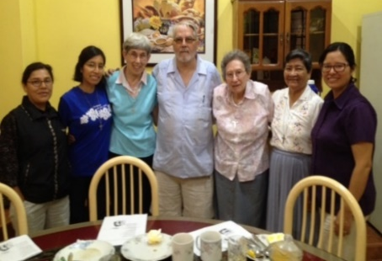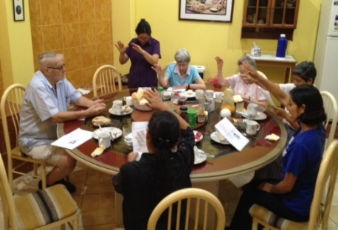

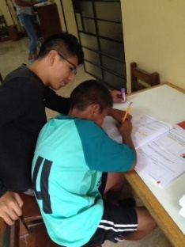
* March 13th, we opened Salon San José where we offer help to the children who need assistance with their school homework. Up until now, we have 70 children who come for help. However, besides the homework, Salon San Jose offers the children time to relax from their studies and have a good time in different activities so that they will be motivated in their studies. These last few days the salon didn’t have enough room for the number of children so we had to use the community dining room which is adjacent to the salon.
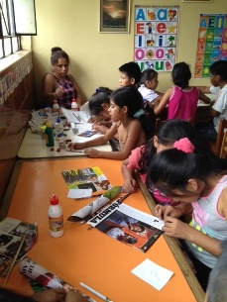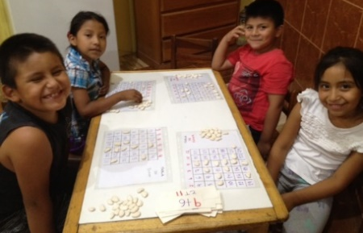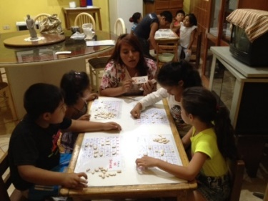

* March 15th, the salon community celebrated Anne’s birthday with a lot of activities. The children and the youths surprised Anne with a beautiful celebration.
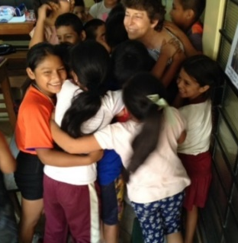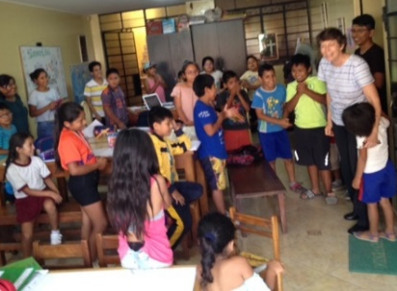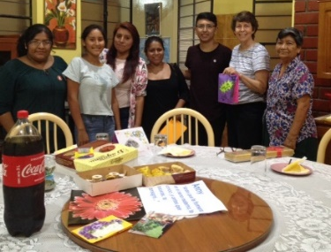

* Our Sister Anne, besides her work with the children in Salon San Jose, also has a separate ministry in the prison and she accompanies Yoli with her preparation for her Final Vows, and accompanies a refugee family from Ethiopia, Hanna and her daughter, Betty. The other day, the family and Anne welcomed Betty’s father. Anne said that the meeting was very emotional because they have not been together for three years. Betty’s father expressed his gratitude for Anne’s accompaniment and gave her a gift from Ethiopia. That’s why in the third photo, Anne is dressed in the typical Ethiopian garb.
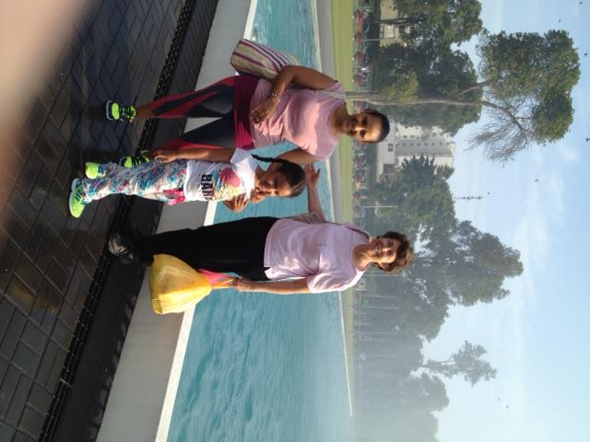

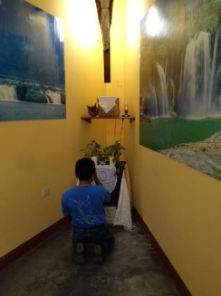
* We had a visit from children from a home where Rosa Luz Condo works and we were touched by the prayerful attitude of one of the children kneeling in front of the altar in our chapel.

* On Good Friday, the community participated in the Stations of the Cross from our parish chapel and we had the second station. It was good to be able to accompany the people in this procession of the Cross.
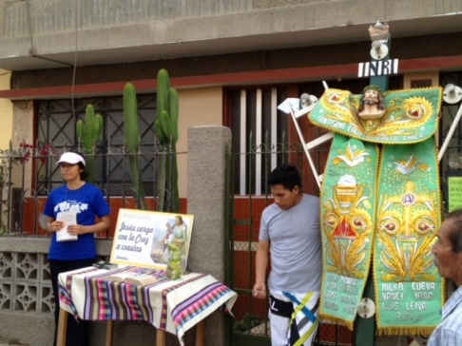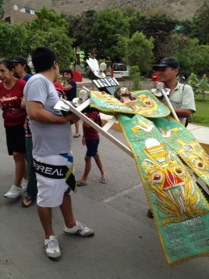

* From March 24 to April 1st Yoli was on retreat in the Marist Retreat House; we pray for her in her meeting with the Lord.

NEWS FROM THE PEQUEÑO PROYECTO COMMUNITY (BRISAS)

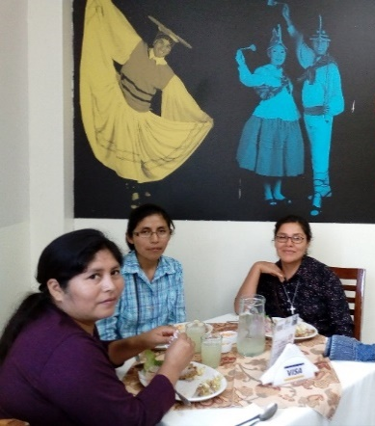
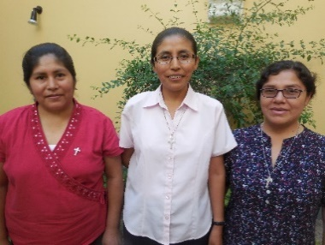
Agripina, Maritza and Mary Luz

*We began our community life with a delicious dinner in the Brisas de Titicaca Restaurant, paying tribute to the name where we live. This has also been a time, in spite of our many comings and goings when we have tried to be together and get to know each other as a new community. We have also enjoyed cleaning and adding details to our house and we still had time to greet our dear neighbors.

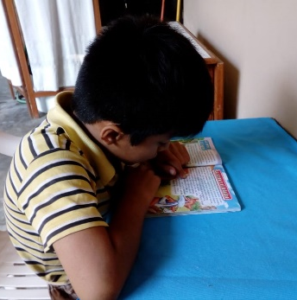
* Mary Luz has started her ministry in the Fe y Alegría N° 43 School of Chorrillos. She works with primary school children who need language therapy. She also does Reflexology at home. One of the women, happy with her therapy said: “Ay, Sister, it is so good to be here, you can feel the tranquility and peace here”. Another one said: “Ay, Sister, I feel like I have been relieved of a big load that was oppressing me”. We realize that when we open the doors of our house, we can offer them a special place to be.
*We are trying to find other ways where we can use our gifts with the dear neighbor. Mary Luz has started some classes in arts and crafts; she already has two students, Sra. Carmen and her daughter.
* Agripina had her home visit then she started her 30 days retreat in Chaclacayo, Lima. She is in our prayers.
* Maritza is getting around the barrio and in the process, discovering new ways of going to the Center House. We celebrated her birthday on Saturday the 17th of March with a delicious homemade banquet. From the 24th to the 1st of April, she will be on retreat, enjoying her privileged time with God in the same place with Yoli at the Jesuit’s Retreat House.
* Mary Luz accompanied the faithful of the Barrio Chapel in the Pascal Triduum; even though it was a lot of work, she enjoyed this new experience with the people of God.
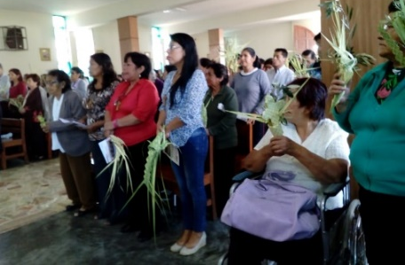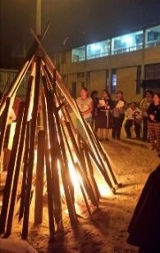
NEWS FROM THE TRINITARIAN COMMUNITY (TACNA)
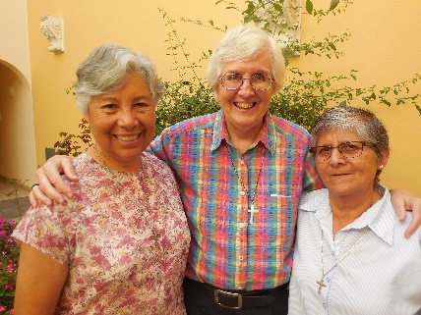
Zaida, Sally and María Inés

*The community started by accompanying Maria Inés with her health issues. We had a time of comings and goings. As you know, Maria Ines is still in Lima recuperating from her operation and regaining her strength. Zaida returned to Tacna on March 15th after her trip to the CLG and then to Chile with the Leadership Team. Sally was alone for a while and then she went to Lima on the 19th and then on to the USA for the Innovation Committee.

* In spite of this time of much movement, we have been able to enjoy our encounters with the Fe y Alegría school and the neighborhood. We can appreciate the love and commitment of the teachers; it is a testimony of service and love without distinction. Classes started in the school on March 13; there is a lot of positive energy and a desire to do a good joy this year. We thank God for everything that we experience. Vemos que el cariño y la entrega de los docentes es un buen testimonio de servir y amar sin distinción. Las clases del colegio iniciaron el 13 de marzo, hay energía positiva y deseo de hacer un buen trabajo para este año. Agradecemos a Dios por todo lo que nos permite experimentar.

* Zaida spent a special time during Holy Week with her family in Arequipa, a very special time that she appreciates a lot.

PRAYERS
* For the health of our families, relatives and friends.
* For the health of Sister Miriam Ukeritis CLT), who will have surgery on her back on the 16th of April.
*For the health of our Sister Maria Inés, who will begin chemotherapy this month.
* Sister Gloria asks prayers for her cousin, Liliana and her grandson, Alessio; both need heart surgery. Also, please pray for her little friend, Maria whom she met in the Hospital “2 de mayo”.

Month of APRIL…
¡Felicidades! Dios siga guiando sus pasos
6 Sally Harper (P)
7 María Schuh (P)
8 Gloria Zapata (P)
17 Robertina Espinoza (P)
21 María Inés Gutiérrez (P)
28 Francisco Trujillo (FSJ-Chile)

