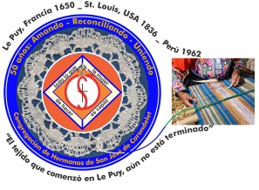
Congregación de las
Hermanas de San José de Carondelet

Jr. Talara 344 – Jesús María, Lima 11, Perú Tel. Casa 01-424-5092 Oficina 01-757-0980
Apartado 11082 – Jesús María, Lima, Perú Email: hna.csjperu@gmail.com
___________________________________________________________________________________________

NOTICIERO DE MAYO – 2018

Dear Sisters:

With the hope that the Spirit that inspired the first women who initiated the Little Design will continue to inspire us in these new challenging times and call us: to care for our common home, to value and protect life in the face of so much violence which lately has increased so alarmingly, to be in solidarity with countries suffering from natural disasters such as in Hawaii and Guatemala. Also, that we not lose “the capacity to feel offended by the loss of ethical behavior and the lack of moral values”, in the way that Pope Francis invites us to be proactive in our proclamation of the Good News to a world in need.

We accompany Hawaii, Guatemala and Nicaragua with faith and hope during these difficult times that they are called to live. We pray that all the help and collaboration efforts continue to unite all people with a generous heart. We know that in spite of everything, God does not abandon his people.

It is our desire that our lives and ministries as Sisters of St. Joseph will continue to be a sign and testimony of joy wherever we find ourselves.

United in prayer and love,

Gloria, Zaida and Maritza

IMPORTANT NEWS
* To write to Mary Luz Salazar, this is her new email address: csjperumary@gmail.com
* The painting of the second and third floors of the Center House is in process. By the end of July, we hope to have the work finished.
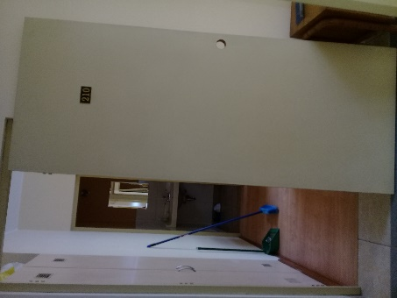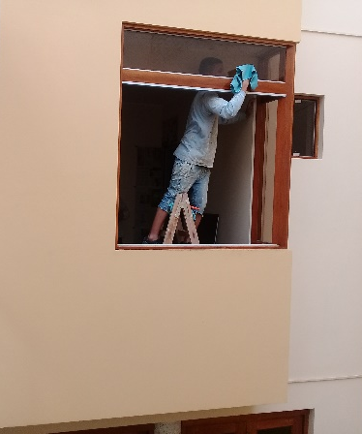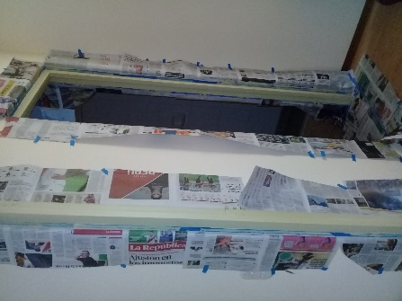

WELCOME, SISTERS
* Our Sister Patricia Chang arrived on May 24 and will be with us until June 30. All the communities of the Vice Province are enjoying her visit with us.
* Our Sister Rosa Orellana will arrive on June 13.
* Our Sister Gladys (Laly) Leigh is visiting us until June 13
* Miss Pamela Navarro will arrive on June 15 to begin her live-in community experience with us. We hope that this time will be special both for her as well as for us. We extend a warm welcome to you, Pamela.

NEWS FROM CASA VICE PROVINCIAL SAN JOSÉ (JESUS MARÍA)

* Betty and Dolores returned from their vacation on May 5. They shared that their stay in Los Angeles was very enjoyable both with their families as well as with their friends. They are very happy for the time shared and because their relationships continue to be fortified.

* Betty, Dolores, Genoveva, Mauricia and Ruth participated in the CONFER monthly retreat day. The theme was, “Francis in Peru, a commitment to live” and the presenter was a Benedictine priest, Roberto Padilla. It was a special time for reflection and to deepen the Pope’s messages and to embrace a commitment in the social context of our country. Both men and women religious of all ages were the participants and it was a good representation of the “generations”.

* Laly is on vacation and she has visited us several days and we shared a lot of joy. Thank you, Laly.

*On May 20, Maria Schuh participated in a Celebration for the Sisters of St. Joseph of Albany in the City of Amsterdam, which has been a mission of this province since 1881. This is considered a historic city. There is a museum featuring the Jesuit Mission to the Mohawk tribe, later on, immigrants from Eastern Europe arrived and then later, Hispanic and Latinos.
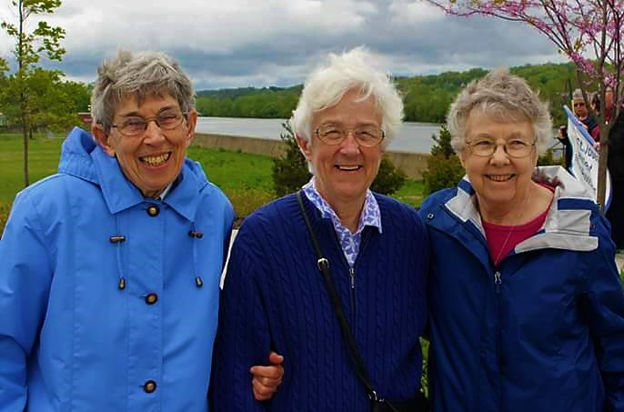
Photo with Mary Rose Noonan: Marie S.; Marion H. and Patricia H.

* Norma returned from France after her workshop on multiculturalism in Le Puy. She is very happy and grateful for the opportunity that her congregation is giving her to prepare herself to accompany new members. She continues to study in the CONFER Program for Formation Directors.
*We celebrated the life of Patricia de la O’, enjoying tamales, wine, cake and a lot of fun. She shared that when she was ready to leave her office she received a message that a young man was waiting for her. The young man was a former member of the Center for Rehabilitation who is now preparing himself in bakery and pastries; he wanted to give her a gift of a cake and cookies that he himself had made because he knew that it was her birthday. They were delicious!
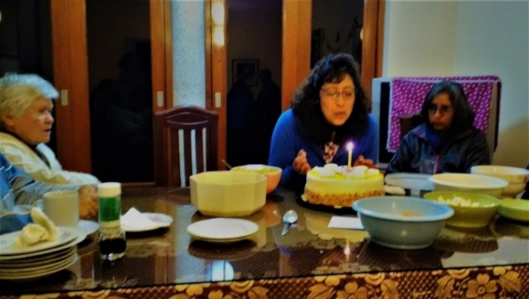

* Patty Chang is with us so that she can get to know us and to practice her Spanish. She studied two semesters of Spanish in Hawaii. It is important to remember to speak slowly so that she can understand us, especially during meals.

NEWS FROM THE GRAN AMOR DE DIOS COMMUNITY (CANTO CHICO)

* May 1st we began the annual prayer of the Rosary in our Canto Chico barrio to commemorate the month of the Cross and of Mary. Because it is customary, the community of Gran Amor de Dios accompanies the people in their prayers helping them with songs and reflections. This is the beautiful experience of a whole month being with our neighbors of the barrio; praying, singing, reflecting and sharing something to eat.
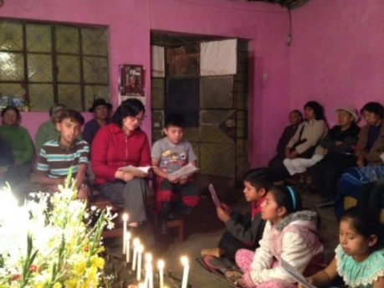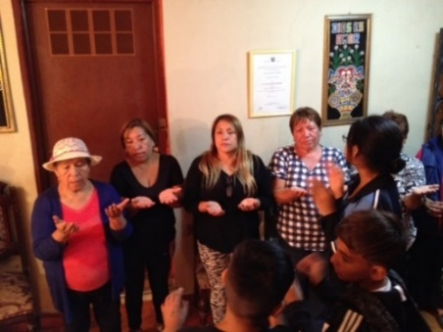
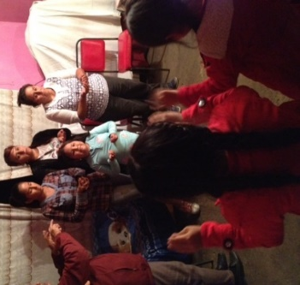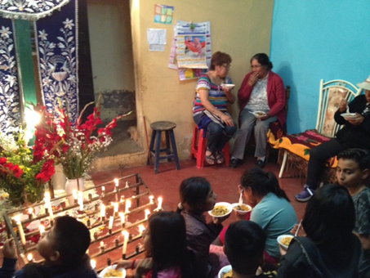

* On May 13, Mothers’ day, it was our turn to have the prayer in our house and we celebrated the mothers in a special way. It was very special to have our neighbors in our house and to receive their blessing. Yoli prepared “carapulcra” to eat with them after the prayers.
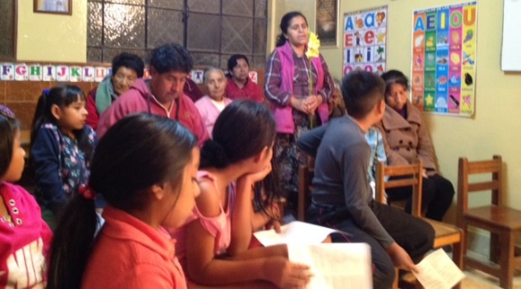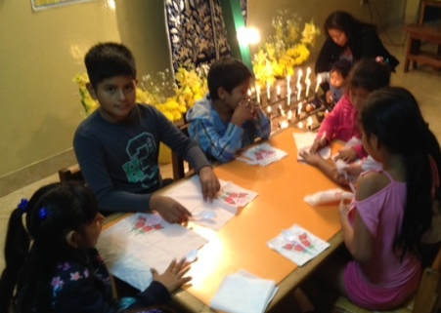

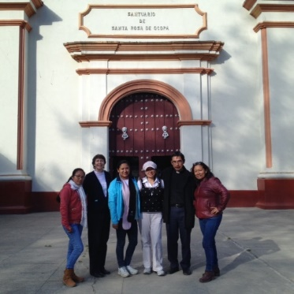
* May 25 to 27 our Sisters Anne and Yoli went to Huancayo for the promotion of vocations. They visited Pamela and met her family. They wanted them to get to know us, too. They also visited Yolanda, a young woman who also lives in Huancayo and who participated in a live in experience in January of 2018.
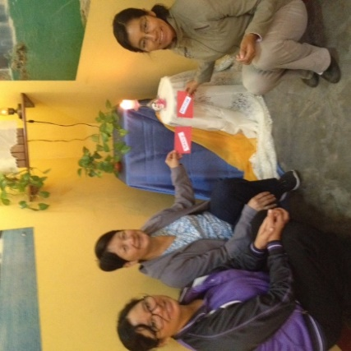
* On May 28 we welcome our Sister Patty Chang, who came to share our life and mission. Here in the photo, we are in the chapel after our community prayer. We are very grateful for her presence because she has been a great help during this time: with the children in salon San Jose; with the families in the Rosary prayers; and welcoming our visitors from Our Lady of Peace Academy. We are very grateful for that presence with us.

Activities in salon San José
* Salón San José, actually, is known as the “Sisters of St. Joseph’s little school”; that’s how our neighbors and “mototaxi” drivers call it.
*In salón San José we continue to help the children with their learning skills so that they can improve their academic achievement and motivation for study. We also now have a personalized accompaniment for the children who have learning difficulties; the sessions are on Saturdays, morning and afternoon.
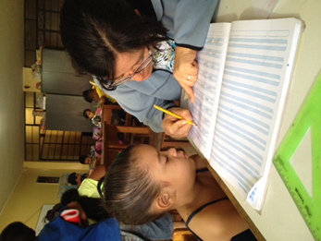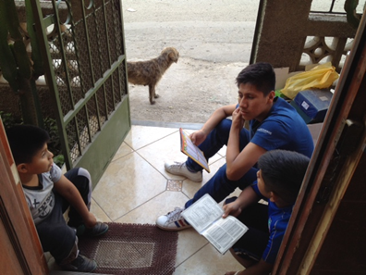
* The children and adolescents in Salon San Jose prepared and celebrated Mothers’ Day in a very creative way by making a gift for their mothers.
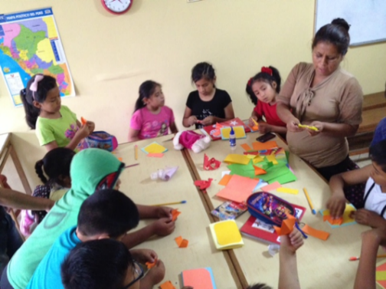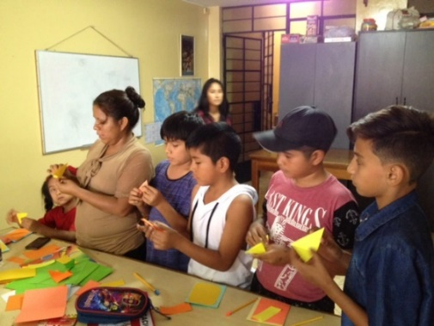
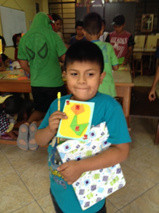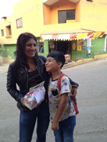
* The children and adolescents also prepared a welcome for the visitor from Our Lady of Peace Academy that was on May 30. In the following photos, the children and adolescents are busy preparing a warm welcome for the friends from the USA.
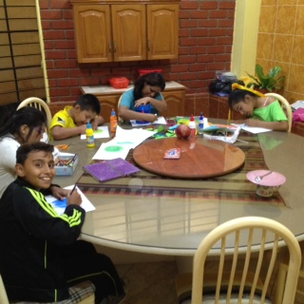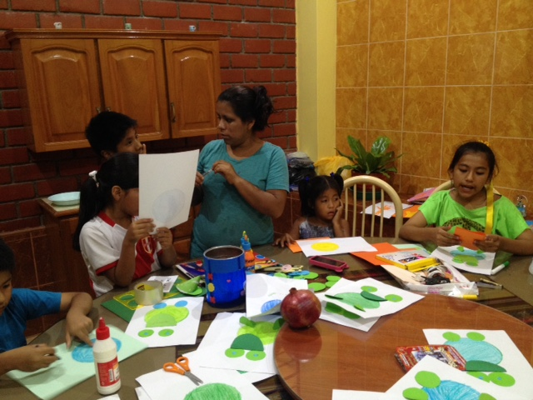
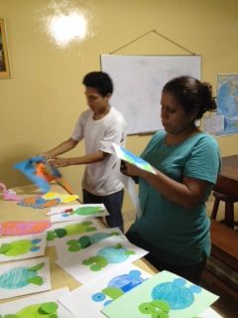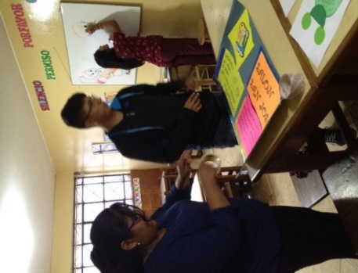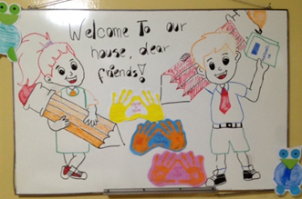

Lunch with our visitors from Our Lady of Peace Academy
* Lunch was in the Sisters’ dining room and also, in salón San José because there was no more room in the dining room. Consequently, in the salón, they ate at very small tables, but they enjoyed their rotisserie chicken, fries and salad. Our Sister Patty Chang in is the third photo sharing lunch with our visitors.
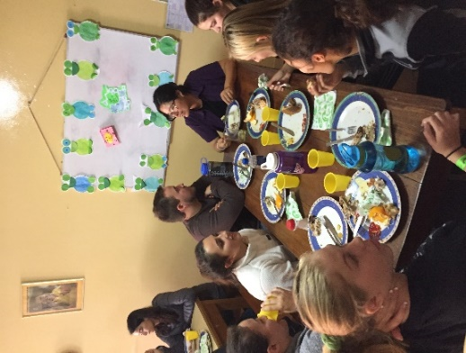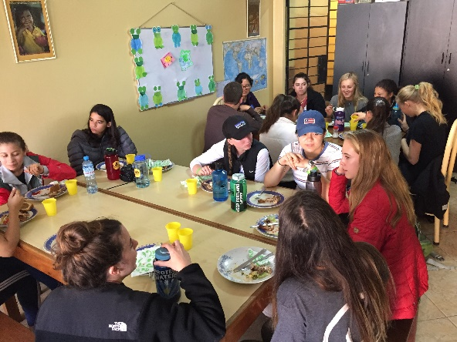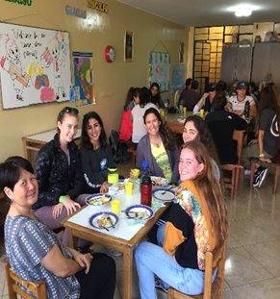
* After lunch, our friends from Our Lady of Peace Academy, they took part in the afternoon activities of the sala San José encouraging and helping the children.
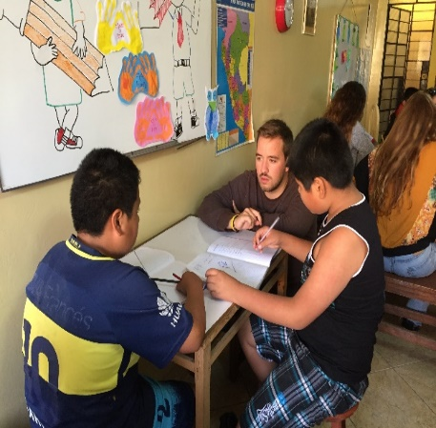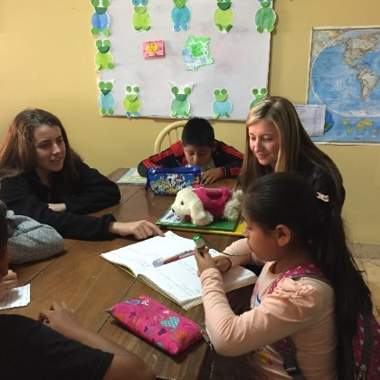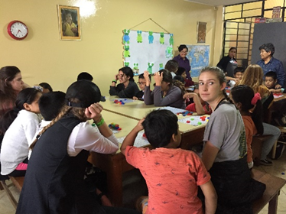
* As a result, the children had individual attention. The children as well as the visitors enjoyed other activities of the afternoon: they played mathematics bingo and a tour through the barrio; a snack time with “mazamorra”.
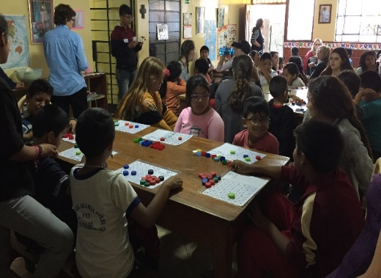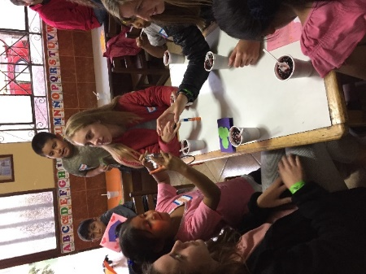
* Later, our visitors from the USA participated in the Rosary Prayer with the people and the sharing of a meal. At the end of the day, they sat down to write their reflections and experiences of the day.
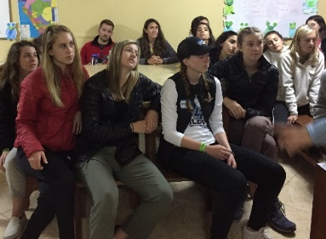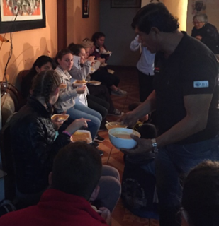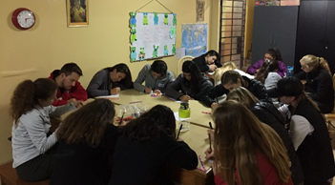

An activity in the Fe y Alegría nº32 (is a school where our Sister Maria Elena ministers).
*May 20 Maria Elena, together with the pastoral team of the school, organized a reflection workshop for students in the second year of high school. They had the event at the Centro Pastoral Patricio Payton belonging to the Holy Cross Congregation. It was a good experience to continue growing in the mission with children, adolescents and youths.
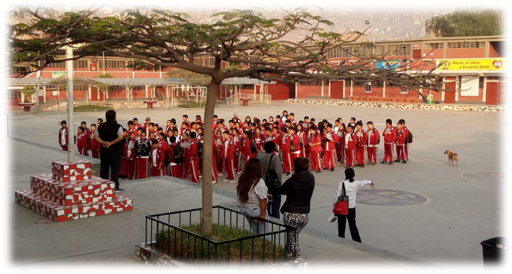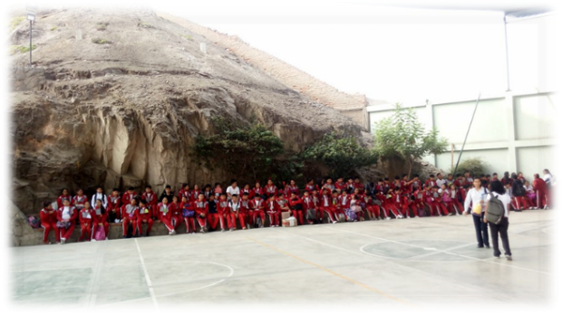
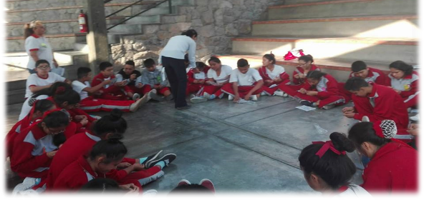

NEWS FROM THE PEQUEÑO PROYECTO COMMUNITY (BRISAS)

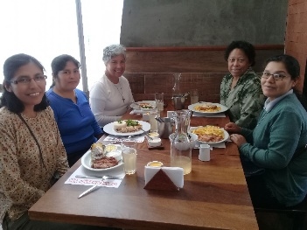
Visit from the Vice Provincial Leadership Team
Gloria and Zaida arrived in our community for their visit and it was an honor to share with them our lived experience as a community and of our mission here in this part of Lima where we live. These moments really help us, personally and as a community, to realize our CSJness.

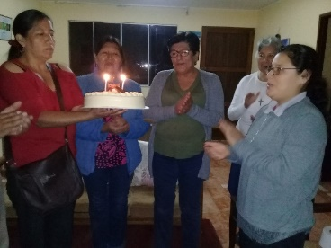
Mary Luz’s Birthday
Along with the visit from the Team, we celebrated the life of Mary Luz and we thanked her for sharing it with us and with the people because the liturgy group joined us in the chapel where we serve.
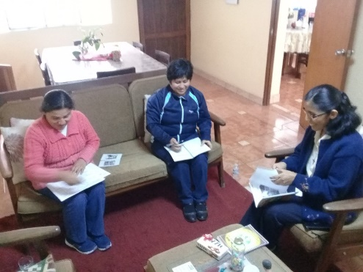
Our community
At last, our community has been able to meet together and to work on our vice province community plan. We also evaluated our work here to know if we are really doing what we set out to do. We shared our dreams and desire so we can continue sharing our CSJness.

We celebrate the Fiesta to honor the patron of the Chapel Our Lady of the Evangelization (Capilla Nuestra Sra. de la Evangelización) Las Brisas
May 14 the chapel was celebrating. All the groups in different ways contributed to making this fiesta the best one yet; some with donations, food, work, etc. The end result: everything was beautiful.

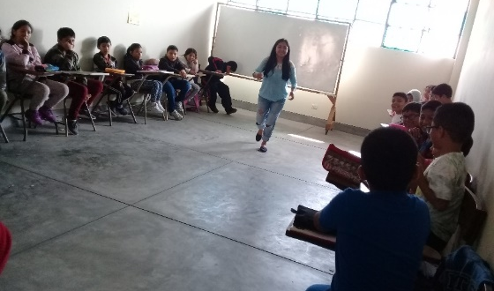
Companioning the God’s people
Our mission begins to take shape as we get to know the reality and needs of the dear neighbor. We have also made the pastor know about our desire to collaborate in the parish as Sisters of St. Joseph. Each one of us is giving her best participating in different activities. Our Sisters Maritza together with Sra. Carmen is visiting persons of the third age; Mary Luz is collaborating with the liturgy group; and Agripina collaborates with the children’s catechetic and the choir.

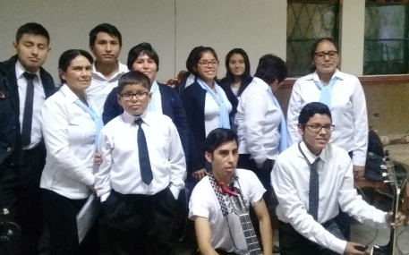
Preparation for the Final Vows
Our Sister Agripina is preparing herself for her final vows at this moment with a lot of emotion and joy. She is sharing with the people, especially by practicing the hymns with the choir for the celebration and by personally distributing the invitations.
We accompany her in this preparation with our prayers as well as for Yolanda who will make her finals on August 3rd.

NEWS FROM THE TRINITARIAN COMMUNITY (TACNA)

Besides activities in the Colegio Fe y Alegría, Zaida and Sally have participated in other events:

Integration Day in the group “Coraje”
Together with other Jesuit institutions in Tacna and Ilo, we had a lovely day of integration in Colegio Cristo Rey. There were presentations from each group and also enjoyable games and a delicious lunch.
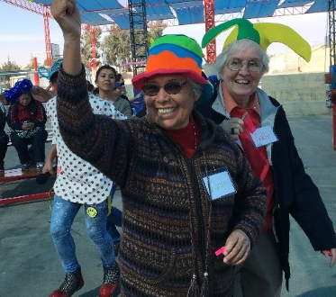
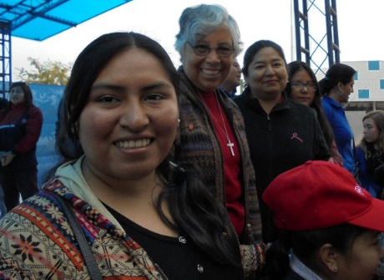

Red Kawsay
Sally is participating in Red Kawsay in Tacna. It is a group that Works to prevent and offer help to those trapped in human trafficking which is slavery. Doreen (Maryknoll), Blanca (Santa Cruz) and Sally visited an interprovincial bus company, Flores Hermanos, to ask them to post a notice in all their buses warning against human trafficking. One of the Flores brothers who received them was very open and the administrator, Sra. Rosa, permitted them to put a notice on one bus symbolic of what they would do on all their buses.

Conferences in Arequipa
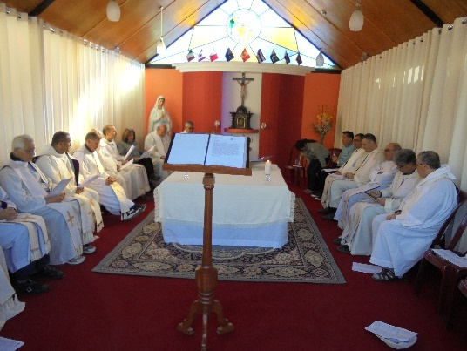
Sally was invited to give three conferences in the General Chapter of the congregation Missionary Society of St. Paul (Sociedad Misionera de San Pablo), a group founded in Malta and whose common language is English. They serve in Malta, Pakistan, Peru, the Philippines, Australia, Canada and Cuba. The theme of the Chapter was “La Vida Religiosa como Profecía Radical” (“Religious Life as Radical Prophecy”). Sally’s presentation was Mysticism-Prophecy; Jesus and Women; being prophets and opting for women.

Conference of Religious of Tacna
The religious of Tacna had an energizing meeting last Saturday, June 2 in the home of the Little Sisters of the Poor of Maiquetía. The team who was in charge of promoting the pontifical document, “Laudato Si”, gave us an excellent presentation followed by an interesting moment of personal and group reflection which brought us to the point of making some commitments and to continue practicing them and to diffuse information for the care of creation. We also want to note that we shared this document with the students in Fe y Alegría as well as other educative institutions, parishes and work centers during the first bimester. The fruit of the reflections was very good, even though we need to continue practicing it so that it becomes a habit to be careful with the use of water, cleaning our surroundings, etc. This month, the dioceses will conclude its program of the diffusion and sensibility in regard to the care of our common home.
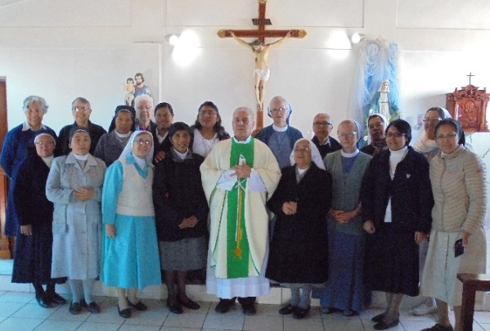

UNITED IN PRAYER
*For the health of our Sister Maria Ines who is continuing the treatment for her illness. Her spirit of courage and confidence is admirable. Thank you for your prayers.
* For the recuperation of Señorita Maria Cruz, a patient that Gloria met in the 2 de mayo Hospital. She had heart surgery.
*For the eternal repose of the father of Sra. Anita Morales, a member of la Familia San José de Chile-Talca. She is the wife of Manuel, who visited us last year for our CSJ Days.

Birthdays in June
1 Guacolda Saavedra (Familia SJ Chile)
10 Peg Murphy
27 Julie Marciacq
20 Mary McKay (ELC)
29 Agripina Morales

