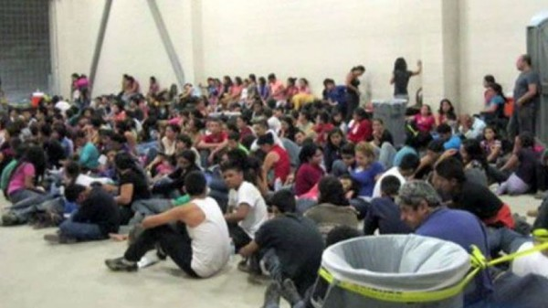
A Prayer for Immigrant Children

Good and Gracious God,
in your infinite compassion,
we seek your divine protection for refugee children who
are often alone and afraid.
Provide solace to those who have been witnesses to
violence and destruction,
who have lost parents, family, friends, home, and all they
cherish due to war or persecution.
Comfort them in their sorrow, and bring help in their time
of need.
Show mercy to unaccompanied migrant children,
too, Lord.
Reunite them with their families and loved ones.
Guide those children who are strangers in a foreign land
to a place of peace and safety.
Comfort them in their sorrow, and bring help in their time
of need.
Show us how we might reach out to these precious and
vulnerable children.
Open our hearts to migrant and refugee children in need,
so that we might see in them your own migrant Son.
Give us courage to stand up in their defense against those
who would do them harm.
For this we pray through our Lord Jesus Christ, who lives
and reigns with you
in the unity of the Holy Spirit, one God, forever and ever.
Amen

