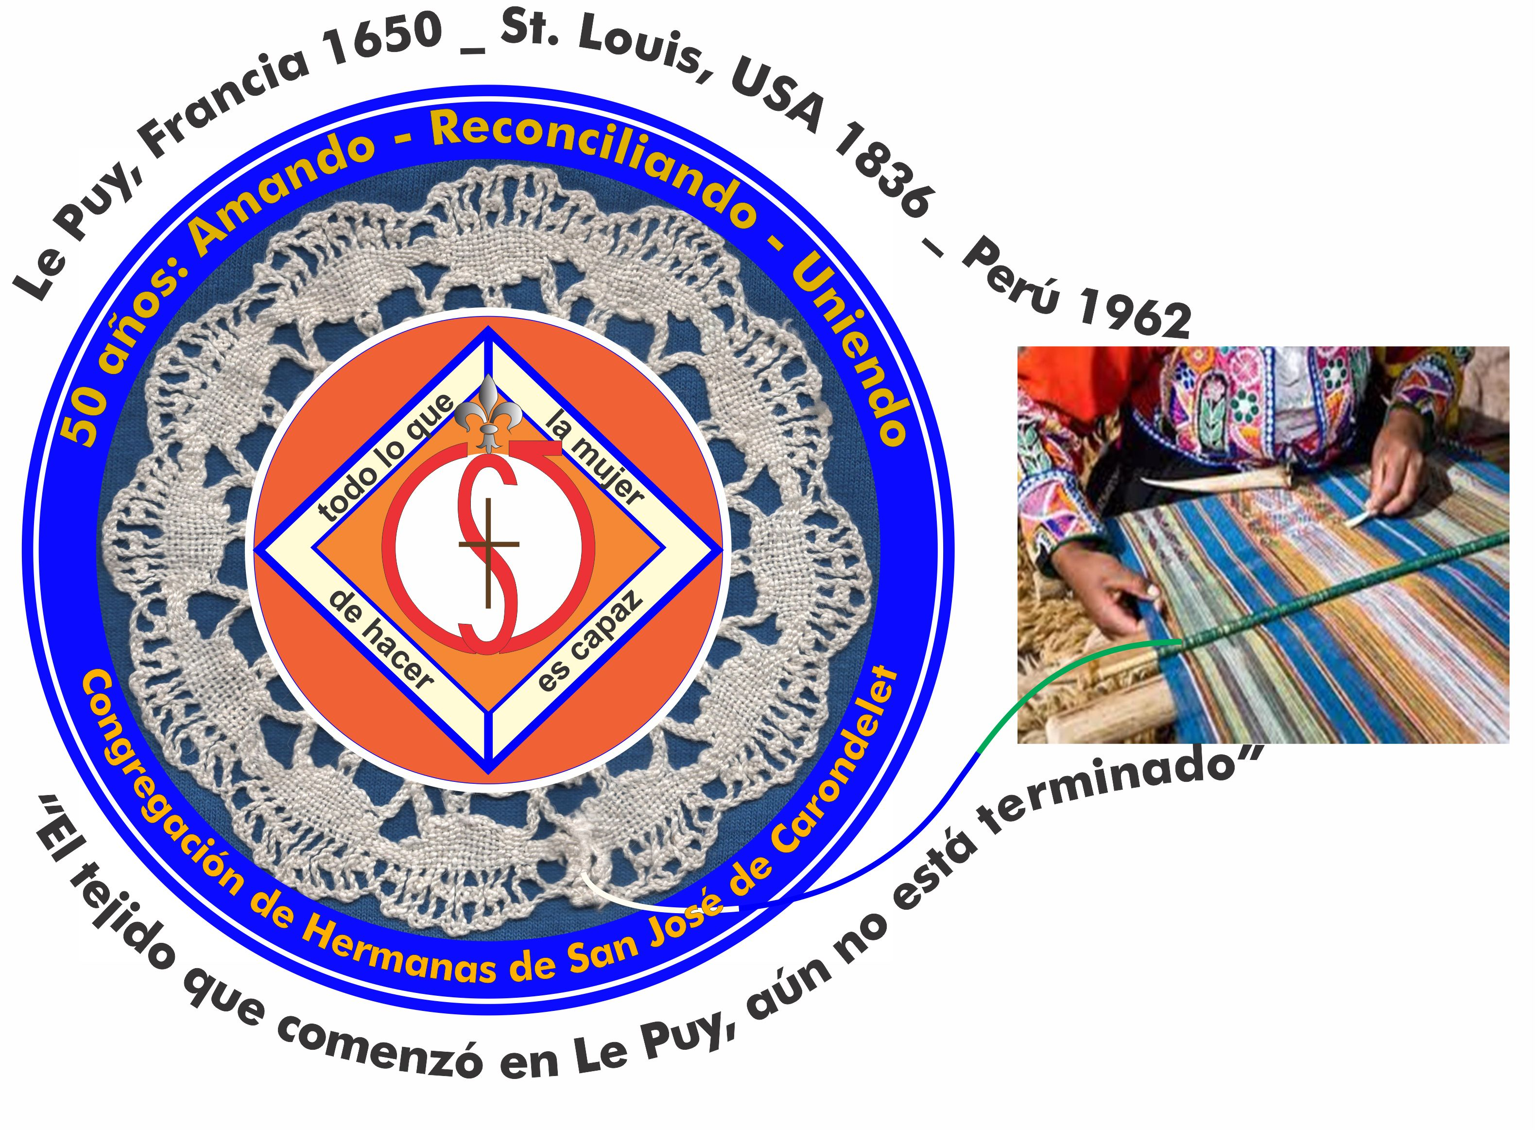
Congregación de las
Hermanas de San José de Carondelet

Jr. Talara 344 – Jesús María, Lima 11, Perú Tel. Casa 01-431-0881
Apartado 11082 – Jesús María, Lima, Perú Tel. Oficina 01-424-5092

NOTICIERO ABRIL – 2017
Dear Sisters,
In the book THE SHACK by Wm. Paul Young, God says to the protagonist: “You [human beings] were created to be in relationship, given that you were created in our image”. (p. 204) Our God is a Trinitarian community. Jesus, God made human, came to earth to teach us how to live as brothers and sisters and to give his life in love, in pardon, in reconciliation.
In this time of living the paschal mystery with intensity, we are called to reflect on our interpersonal relationships: ¿Do we live them like Jesus?
In addition, we unite our prayer with the whole congregation for the Extraordinary Chapter so that together we can discover the best way to live our congregational relationships in order to live more authentically the mission of Jesus in these times.

With love,
Genoveva, Teresa y Sally

CELEBRATING ST. JOSEPH
Given that the Center House was without water, the community of Canto Chico generously offered hospitality in order to celebrate our dear patron with one day of anticipation. We could do this with a delicious dinner and the renovation of the temporary vows of Yolanda Arribasplata y Agripina Morales. In addition, María Elena Caceres renewed her vows until the celebration of her permanent profession that will take place on Saturday, April 29th. It was a time to be together in joy.
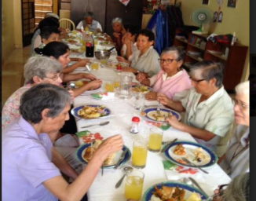
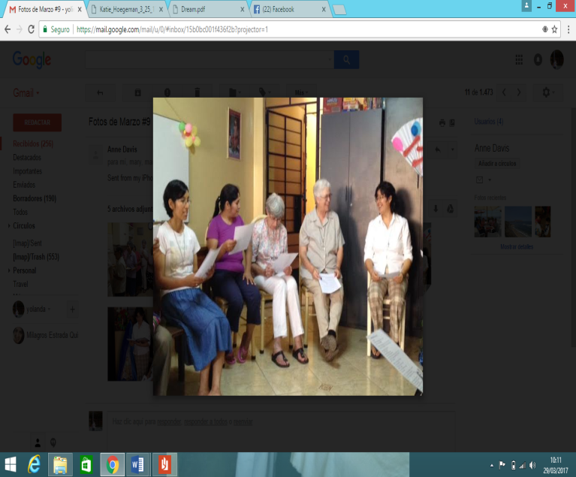

DATES: April 29th Perpetual profession of María Elena Cáceres
April 30th Post-Chapter
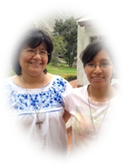
May 1st Affirmation of new leadership

NEWS FROM CANTO CHICO
The first of March began with the arrival of our sister Maria Elena after having lived the experience of the spiritual exercises for 30 days. She was very happy to have had this opportunity to strengthen her spirit in the God who loves her and to whom she responds in love. We are happy for you, dear sister.

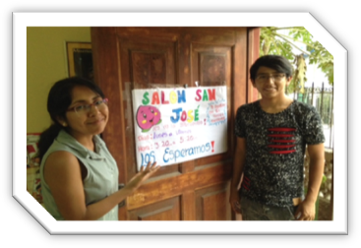
THE BEGINNING OF classes
The CSJ community and the young people who help worked to have the study room ready for the children who would begin to arrive looking for help with their homework.

¡AND THE AWAITED DAY ARRIVED! tHE PHOTOS SHOW THE CSJ MINISTRY IN CANTO CHICO.

EDUCATION Is the key that will take our society toward greater development and personal advancement. It will make us more human and thus more committed to our brothers and sisters.

Our children in Canto Chico gather every day (Monday through Friday) to learn, to socialize and to play. Our sisters with generosity and joy share their knowledge with these little ones. Our young people who support us in this program work with dedication and commitment to education, transmitting not only knowledge, but also values that humanize.
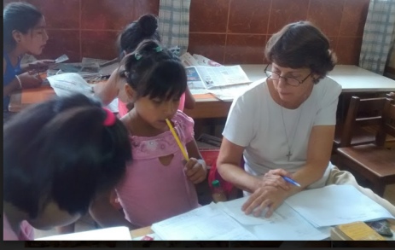
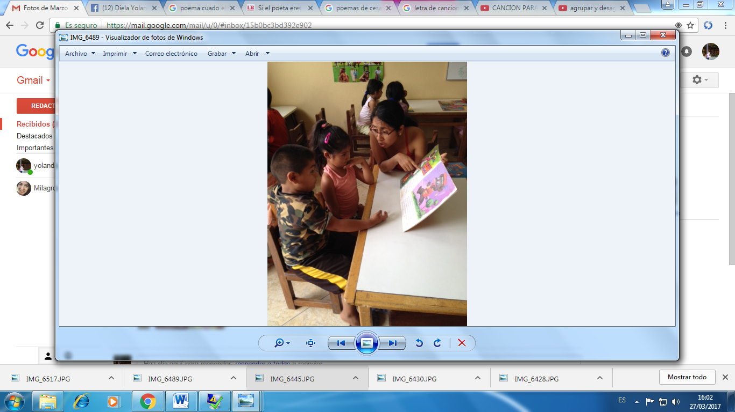
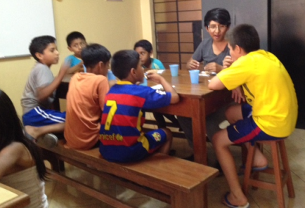
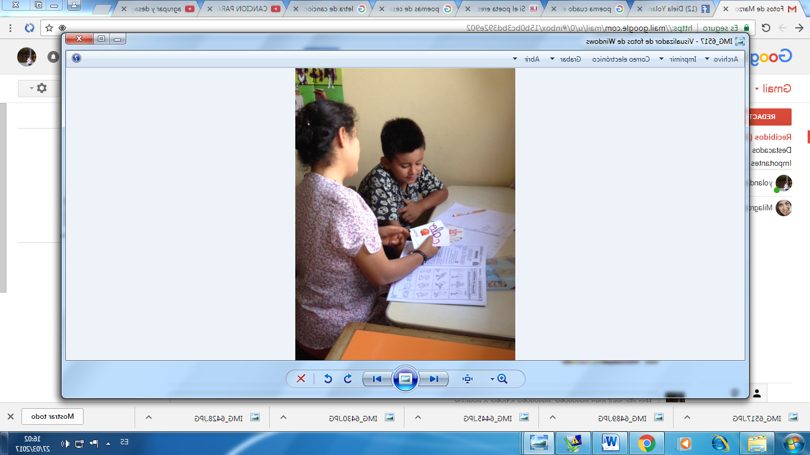
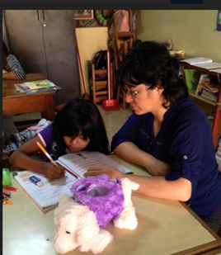

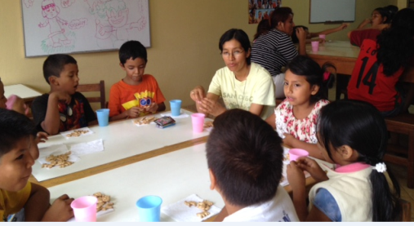

THERE ARE ALSO SURPRISES IN THE DETAILS OF SHARING LIFE
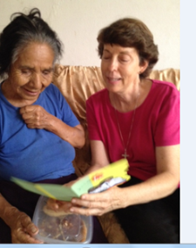
In the lyrics of Mercedes Sosa we sing: “Thanks for life that gives me so much. It gives me two lights with which I can distinguish perfectly…in the multitude the life that I love”. And God says: “From the womb of your mother I formed you”. With these words we gave thanks for the gift of life of Soledad, Maria and our sister Anne.
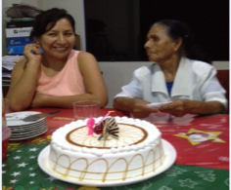
Soledad helps our dear Cory who is six years old with her speech therapy. Anne and Maria share a birthday card…they were born on the same day.
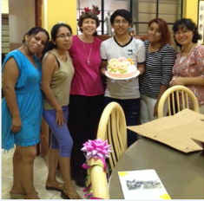
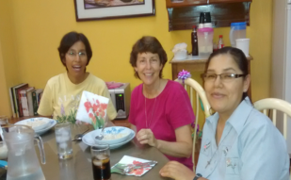

Anne is surprised by the Young people who support Salón San José. Thank you!
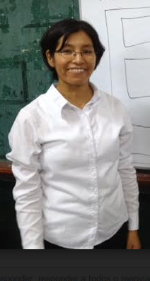
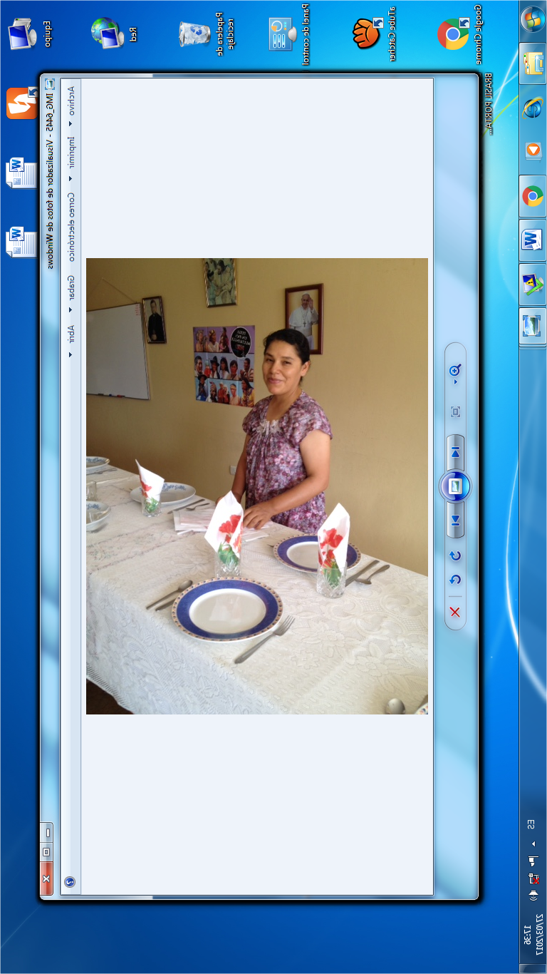
bEGINNING THEIR MINISTRY YEAR AS EDUCATORS
In Ecclesiastes we hear: “There is a time to plant…a time to harvest… a time to give. With these words our sisters Maria Elena y Mary Luz began giving what they have so generously received: education for children and adolescents in the following
schools: José Maria Arguedas, San Antonio and Orbegoso. Our prayer and good energy is with you, Sisters.
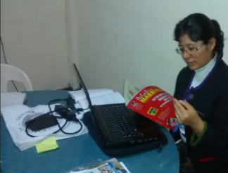

UNIVERSITY STUDIES: Yoli began some investigation in order to elaborate the project for her thesis (senior paper).

We say goodbye with part of the lyrics of this song:
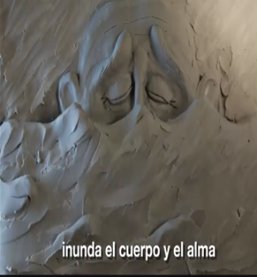
After so much rain, a new day dawns.
In it there is strength…because we are all one.
To the brother/sister give a hand.
We remember our dreams, we won’t forget the past.
Together we can struggles.
We have to begin to dream again.
UP, UP, PERU
Nothing can hold my people back; hope never dies.
Forward, Peru, from the mud we will arise.
D. Orozco

NEWS FROM THE CENTER HOUSE
We began the month with the presence of all the members of our community, giving welcome to Maritza Jarro and Gloria Zapata who joined our community. Welcome!

In this moment, Gloria is accompanying her sister, Flor in Zaña, one of the places affected by the flooding in the north. .

Our sisters Maria Dolores and Betty traveled to visit their families and enjoy the company of the CSJ’s in the States. We hope that they have a good time in all that the things that God offers to them and we await their return with much love. One special event for Betty is that her sister-in-law will be baptized the night of Holy Saturday. Congratulations, Norma! We accompany you with our prayers.

This month also saw the visit of our sisters Maria Ines and Zaida who came to celebrate St. Joseph’s Day..

At present one our sisters, Gloria Muchaypiña (CSJ from Chincha), is visiting us while she attends a course in Lima. It gives us great pleasure to have her with us.

NEWS FROM LAS BRISAS DE VILLA
The biggest new in Las Brisas is that our chapel, which has been a part of the parish of Jesus the workman, has been incorporated into the Parish of Our Lady of Lourdes, thereby the decision of ecclesiastic authority to restore the original boundaries between the two parishes. It came as a great surprise when the pastor announced it at a Parish Council meeting on the night of March 23rd and to all the faithful gathered in the chapel for Sunday Mas son March 26th. That same Sunday the Council had its first meeting with the new pastor, Father Julio. For now there will not be great changes. The first encounter between the faithful of our chapel and the faithful of the new parish will be on Holy Saturday.

Teresa continues to accompany the parents in Family Catechism and Sall will support with some themes in the preparation of the parent guides.

HAPPY BIRTHDAY
6 Sally Harper
7 María Schuh
8 Gloria Zapata
17 Robertina Espinoza
21 María Inés Gutiérrez

CONTINUE

THE FLOODS OF 2017
In the midst of the suffering of the victims of the flooding in our country, especially in Piura, Tumbes, Trujillo, Lambayeque, the Pope has exhorted us to continue to pray for our brothers and sisters who live in desolation. We are accompanying them with our prayers and trying to help them from our possibilities: donating food, assisting at the collection centers, and caring for the goods that we have.

In this time, we are also experiencing the solidarity of many people who are giving from what they have, preparing food, giving donations, and supporting the volunteers in saving lives, among other things. In addition, the government is coordinating all the efforts, together with businesses, institutions, the media and other countries that have united with us to attend the victims. Thank you for this testimony of unity and solidarity!

Many districts in Lima were without water for several days because of the flooding. We are grateful for this experience because it made us more conscious of the suffering of our people and now we are much more careful so that water reaches everyone.

We have experienced suffering in seeing so many people suffering. The question arises: Could some of this have been avoided or could it have been less devastating? It is our hope that from now on the funds for Peru are handled by honest and honorable people so that the common good can be served, because we all live with the consequences.
(Autores: María Vásquez y Yolanda Arribasplata)


