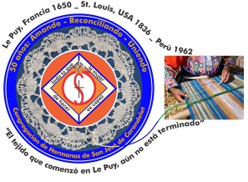
Congregación de las
Hermanas de San José de Carondelet

Jr. Talara 344 – Jesús María, Lima 11, Perú Tel. Casa 01-431-0881 Tel. Oficina 01-424-5092
Apartado 11082 – Jesús María, Lima, Perú Email: hna.csjperu@gmail.com
___________________________________________________________________________________________

NOTICIERO AGOSTO – 2017

Dear Sisters:
Congratulations Sisters for our 55 years since our foundation in Peru! August 3rd, a memorable date, our first Sisters arrived to sow the seed of our Charism; what richness, what generosity received and how much more to come! We pray that God will continue to bless our Congregation.

With love,
Gloria, Zaida and Maritza

IMPORTANTE NOTICE
* Sister María Elena Caceres´ new cel number is 937-685-824 (Movistar).

TRIPS TO THE USA.
* July 19, our Sister Teresa Ponce traveled to the Los Angeles Province, USA. Our wish for her is that this will be a good experience for her as she spends quality time with the Sisters and the dear neighbor. You can be sure of our love and prayers, Teresa.
* After experiencing a long time with paper work, Sister Rosa Orellana finally flew to Puerto Rico on July 27. Our prayer for her is that her reintegration into Puertoriquen life will be blessed with new opportunities to serve the dear neighbor.

VISITA A COMUNIDADES
* The first semester community visits to the VP have been completed. We are very grateful for the openness and the deep sharing by each Sister and the community. It is our wish that we continue these opportunities of sharing so as to be companion to each other in our lives as Sisters of St. Joseph.

EXTRAORDINARY MEETING
*July 29 and 30, we had an extraordinary meeting of the Vice Province. It was a time for dialog and consultation about several urgent aspects of our lives at this time. The Sisters, who went to Los Angeles, shared about the significance of their experience when they were at the meeting: Seeding our Future. Sisters Ruth Matos and María Vasquez gave us a report about their month´s lived experiences in some of the small towns that were flooded in Piura and therefore, left many people suffering the consequences. The Tacna Sisters shared information about some new invitations to serve there. We also dialoged about other items, such as: Vocational Promotion, The schedule for the 2018 Assembly, CSJ Days, Our Community Retreat, The use of the house in Brisas (Lima).

MISIÓN DE CONFER
* July 24, our Sisters Ruth Matos and María Vasquez returned after a month in which they served the people of Piura who were suffering as a consequence of the floods. We are grateful and we appreciate their sharing about the reality of these towns where they visited.

NEWS FROM THE SAN JOSÉ VP COMMUNITY (CASA CENTRAL)
* July 6, we gathered in prayer in gratitude for the life of our Sister Genoveva Herrera. Thank you, Geno, for sharing your many gifts with us!
* July 11, Sister Mauricia Carcasi returned after spending some time with her sister in Huancané, Puno.
* On July 16, Sister Rosa Orellana joyfully participated with the Benedictine priests and brothers who were celebrating their 50 years of presence in Peru.
* July 26, the Integral Health Team from the Clínica Stella Maris came to our house to offer us some of their services. It was a good way to promote specialized health care.
*We enjoyed our participation in the San José Parish Fiesta in honor of Our Lady of Mount Carmel. We spent some time with the parishioners of Jesus María.
* The night of July 27, we had a special prayer and missioning ritual for Sister Rosa Orellana to send her off on her return to Puerto Rico. Our prayers and constant love go with her on this new phase of her life.
*On July 31, we participated in the Eucharistic celebration in honor of St. Ignatius Loyola, during which, Tito Garcia was ordained to the priesthood accompanied by his many Jesuit companions and the people of God. It was a celebration of gratitude and joy.
* The community received the VP Leadership Team for their visit on July 31 until August 2, during which the personal and community sharing was very significant. We anticipated the celebration of the anniversary of our arrival in Peru with a delicious dinner in thanksgiving for the many gifts received as a VP during these 55 years. Thank you Sisters for your presence!

NEWS FROM “THE GRAN AMOR DE DIOS” COMMUNITY (CANTO CHICO)

* July 6, our Sister Anne Davis began her merited vacation time and also time for the planning of the Seeding Our Future. We are grateful for her service and her generosity to the VP in so many ways.
* Salón San José finished the first half of the year on July 19 by playing Bingo; a game the children love. They returned on August 7 to continue with their work.
* Our whole community went to Los Angeles to participate in the Seeding Our Future meeting. We are very grateful for these experiences that enrich our lives so much.
* On July 29, our Sister Yolanda Arrivasplata went to visit her family. Our love and prayers go with her. She will be returning on August 14.
*On July 31, we celebrated the life of our dear Sister María Elena Caceres. Thank you, María Elena for the gifts you bring and share with us!
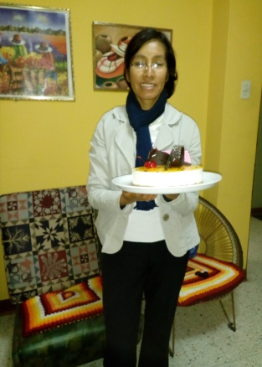
* Sisters María Elena, Robertina Espinoza and Mary Luz Salazar returned to their school classes on July 31 to continue with our mission.
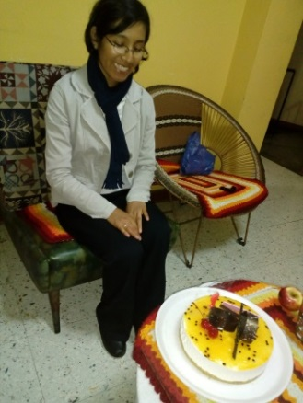

Testimony of the dear neigbor:
As we leave “El Gran Amor de Dios” community, we encounter the dear neighbor. This month, Angel, a young mototaxi driver from Canto Chico, pointed out: “Sisters, you have a beautiful work going on in your house, (Sala de niños San José). I recall that for years, the children have come to you. As I do my work every day, I see the little children running to your house to do their homework...It is beautiful to see how some of them run with their notebooks, holding them tight in their arms, others, get into a mototaxi! (…). Sometimes, we aren´t aware, but you Sisters help the barrio a lot; some of us are conscious of the work you do and know how necessary it is for the children (…) and the importance of your presence among us here. We adults should also have a place like that (…) I am going to visit you to talk about it”.

Celebrating with the Benedictine Fathers in Ñaña. Lima, July 16.
As a community, we went to the Benedictine Monastery in Ñaña to celebrate with them their 50 years of presence in Peru; Accompanying the poor of Ñaña and Chucuito. It was a very significant experience and very reflective. The Prior, father Bernard, said: “(…) We were able to remain faithful because of our friends who always encouraged us to persevere when we were ready to give up (…) The modesty of the Benedictines is a sign of the fidelity of God (…). We have to encourage ourselves because sometimes we don´t see anything, it seems that the seed doesn’t grow; it is then that we must live with faith. Sometimes, it seems that the seed that the sower planted doesn’t grow but some day it will grow”. P. Bernard.
Father Gustavo Gutiérrez reflected on the parable of the Good Samaritan and he said: “(…) we are not born neighbors, we make neighbors, and we make ourselves neighbors to those that we get close to. If I do not interest myself for those who are in my own house, they are not my neighbors”. G.G.

May these two reflections continue to encourage us, motivating us to live our consecrated life by making ourselves neighbors.

We send fraternal Greetings to each one of our Sisters.

NEWS FROM THE TRINITARIAN COMMUNITY (TACNA)
We Sisters are learning what this new service of promoters of the Education Institution. As we companion the Principals Team, together, we are discovering how to encourage the community of teachers to continue giving of themselves with love and dedication to their students. We appreciate the collaborative work of the teachers in this new challenge of competitive education. Successes are hopeful when we see the children informing, explaining and demonstrating what they have learned with freedom and joyfully. Congratulations to our teachers!

OUR CONDOLENCES
* We express our condolences to the Sisters of St. Joseph of Brentwood of Puerto Rico for the death of their Sister Judy Brchyns, vicar of the superior general.
We know that losing a Sister is painful but at the same time we know that is a grace to be able to count on her intercession.
* We express our condolences to our Sister Maritza Jarro, her mother and brothers and sisters for the death of their step-father. We continue our prayers and love to the family, especially Sra. Dominga, Maritza´s mother, who is still in Queñuani, Puno.

UNITED IN PRAYER:
* for the health of Sra. Liliam Vargas, mother of Sister Yolanda Arribasplata.
* For the health of Sra. Carmen, cousin of Sister Gloria Zapata.
* for the health of Sister María Vasquez’ sister-in-law.

7Celia Durea (LA)
May God bless all the days of your life!
23Catherine Schuyler (A)
28Miriam Ukeritis (GLC)
28Mary McGlone (SL)

