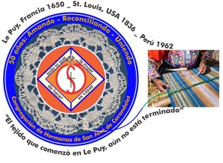
Congregación de las
Hermanas de San José de Carondelet

Jr. Talara 344 – Jesús María, Lima 11, Perú Tel. Casa 01-431-0881 Tel. Oficina 01-424-5092
Apartado 11082 – Jesús María, Lima, Perú Email: hna.csjperu@gmail.com
___________________________________________________________________________________________

November news – 2017
Dear Sisters:

During this month of November, we have seen what we call a “universal epidemic”: violence against persons, in all forms. Our society has been outraged because of the flagrant act of a father who raped his little two month old daughter; he is now in jail.
Violence against women doesn’t end with women, but it’s a problem that affects the whole of society and it invades all sectors of society. When more people understand it in this way, we will be able to advance into finding a solution.
“We women have to band together against this epidemic of mistreatment and abuse. Men, also, have to help. As a country, we have to stop doubting the testimony of the victim or must we wait to see video or broken bones? To file a complaint against an aggressor is harder when everybody looks at you with skepticism.”
(These are words by Lorena Alvarez taken from her article about the violence she herself suffered).
This situation challenges us and we ask ourselves: What else can we do in our ministries to contribute more so that people can acquire a greater consciousness and commitment for the life of the person, especially for the victims of violence?

With love,

Gloria, Zaida and Maritza

IMPORTANTES NEWS
* On Thursday, November 9th we will have Mass commemorating the 5º anniversary of the death of our Sister María Rubina (Coqui). The Mass will be in San José Parish at 7 a.m. After Mass you are invited to breakfast to accompany the Rubina Family.
* We remind you to send in your personal reflections (refer to Año de Gracia Nº 9) dated October 4th. The deadline is on the 30th of November.

COMINGS AND GOINGS
* Sister Peg Murphy will arrive the early morning of the 18th of November after spending some time in the U.S. Welcome, dear Sister Peg!
* From November 7th to December 12th, Sister Mauricia Carcasi will be with her Sister who is not well. We accompany her with our prayers.

A TRIP TO CAMANÁ
From the 11th to the 14th of October, Sisters María Vasquez, Gloria Zapata, María Ines Gutierrez, Anne Davis and Maritza Jarro went to Camaná (Arequipa) investigating the possibility of organizing a short mission in Ocoña (dioceses of Camaná) during the Summer in January, 2018. The Bishop, Jorge Eyzaguirre, gave them a warm welcome and accompanied them to visit some towns in the parish of Ocoña. More details will follow in the Circular Letter N. º 16.

NEWS FROM OUR SISTER ROSA ORELLANA
During this month, after what happened in Puerto Rico we are in constant communication with our Sister Rosa Orellana. Thank God she and her companion Sister Teresita are getting along well. They have started classes again, although they have a lot of difficulties due to the shortage of electricity. Internet has not been reestablished so they can’t communicate that way. She sends greeting to each one of us and thanks us for our prayers and our love. During this time, we continue to accompany her with our love and prayers.

NEWS FRIN CASA VP SAN JOSÉ (CENTER HOUSE)
* October 15th, we celebrated our Foundation Day as Sisters of St. Joseph, together with the Sisters from We shared a prayer and a presentation of a video about our history. The memories we shared were very enriching.
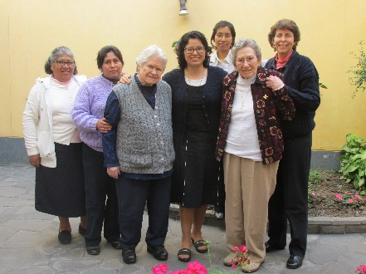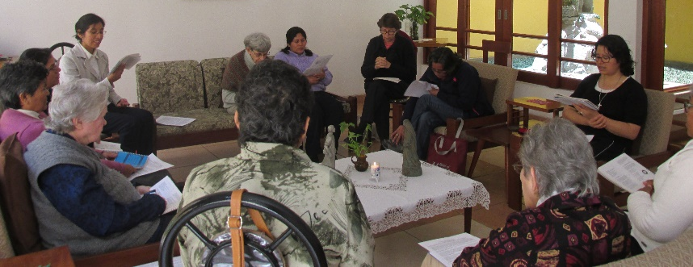

* Sister Ruth Matos has had her home visit with her family as well as time to help her parents who both have health issues. We continue to keep them in our prayers.

* This month we have accompanied Señor de los Milagros in different ways. We pray to Him so that our lives may continue to be expressions of that great love.

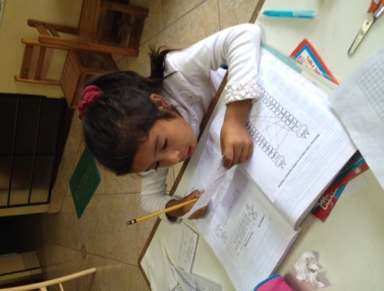
NEWS FROM THE GRAN AMOR DE DIOS COMMUNITY (CANTO CHICO)
Cori, 6 años
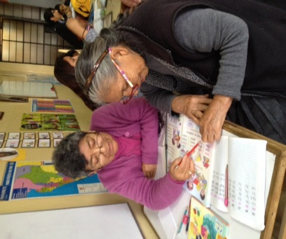
It is not riches, nor popularity, nor many studies nor is it to be perfect that gives meaning to life; it is rather to be authentic, strong and humble, and to be able to share what is best in each of us; that is what touches the lives of others. Having made this reflection, we will now share some happenings in our “Gran Amor de Dios Community”.
Hna. María Vásquez con Marcelina

“Just Man, let us follow your example, in a world that cries out for peace and justice…” From this perspective, salón San José, of Canto Chico, these two generations are evident with whom day by day we try to abolish the slavery of our precarious schooling in order to acquire independence and liberty based on knowledge. Sister Anne says: “Marcelina, has a young heart… she didn’t have the opportunity to learn as a child. However, her desire, today, is to learn to read by Christmas time, it’s her goal/her gift”. Cori is striving to learn to write, to read and to pronounce words correctly; she not only struggles with the impotence of not knowing how to read or write, but she also lives with the tragedy of a home lacking stability.
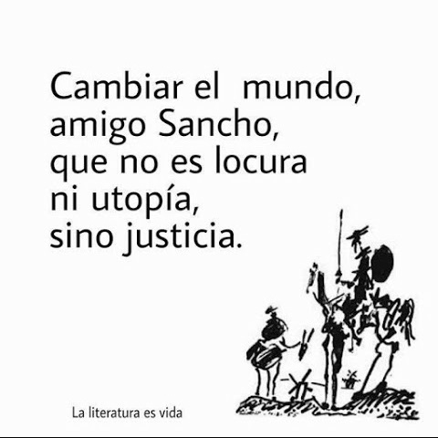
This classic phrase can tell us something about our ministry in Canto Chico
…

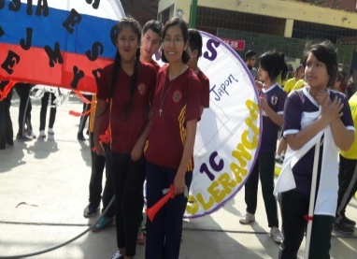
Our Sister Maria Elena joined her students from the School “José María Arguedas” in their student Olympics Day. She was lost among her students enjoying their relaxation which keeps them heathy. What a joy it is, Maria Elena, to see you enjoying yourself!

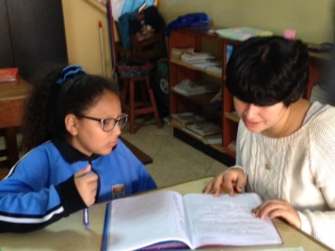
Brenda is a young woman, only 22 years old, a psychology student at the University of Antonio Ruiz de Montoya. She asks: What are the Sisters of Carondelet? (St. Joseph was missing). An explanation was given to her and this aroused in her a curiosity to know us. She was given an invitation to know us and she said: “I want to know you, what day can I come?” Later, after her visit, she offered her services to help in the Salón San José. She feels very excited about our Sisters and their ministry. Welcome, Brenda, to this Project that sometimes goes unnoticed.

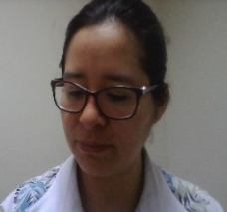
THE HASHTAG # PERÚ, A COUNTRY OF VIOLATORS,
Written by Sister Yolanda Arribasplata, csj

This is a product of my reflection while riding on the bus and content from my classes.
My routine is to leave home each day; some days joyfully, others hurrying, others with a smile, others worrying. Each day has its own particularity, but all of them have a touch of gratitude. In my travels to get to my destination, I find streets full of traffic, violence, insecurity but also tranquility, gentleness, etc. In this reality, by curiosity is aroused about what’s happening this morning.
Consciously, I have two reflections, analysis, observation, prayer, and concern. The first one has to do with the National census taken on October 22, 2017. It was a day full of civic fervor. In our community, we were all home, teasing about our “race” (It was one of the questions to be answered) I was on the second floor and heard a voice from the kitchen: “Yoli will probably say: the Inca Atahualpa was my uncle”. I just laughed. But sadly, in the afternoon on the news we heard: “Young woman taking the census was raped while doing her job.” Oh my God!
After the event, I began to read and hear commentaries: “Kill the miserable wretch, may he rot in jail, I hope they rape you in jail, life sentence for this wretched rapist…” My reaction was to not want to read more news, not to continue the subject. Two days after these sad and violent occurrences, I saw this: #PerúPaisDeVioladores. Peru is a country of rapists? This idea kept going around in my head; I felt my sensibility and my identity being attacked and beaten, and I felt shame that my country should be known like this. Probably, the phrase from the song “I am proud to be Peruvian and I am happy” was hidden from me at the moment. Facing this situation, I turned to prayer and what follows is “my timid reflection” as I traveled on the bus going to my classes.
Why is Peru considered a country of rapists? What is happening to the human race if we are conceived by love and for love? Why do we want to hurt one another? Why these attacks of violence, the majority of which are committed by men; why? I don’t understand. Some time ago, for my classes, I read Segato, Fuller and Motta; probably, some of their ideas are in this reflection.
Perhaps the case of sexual rapists originates in history; that is to say, in a system known as citizens contracts. In the beginning, this system was signed by white men. They signed this contract based on status which involved a series of laws. Today, we are still carrying around these ideas. The first one has to do with who are equals and are part of that contract that is: men. What holds them together in society is a horizontal bond, among them. Then, women enter the picture, for years, they had no rights. Today, little by little they have been able to win some rights, but even now we continue to have the pre-modern hierarchical relationship of the prior system. In this system of status, men and women have a vertical relationship, a hierarchical type; women now have more rights but, still continue to have a subordinate relationship. Men continue to have hierarchical ties among themselves, but this power has to have a source. So, where do they get their power? It is from the subordination of women by men. Men relate to each other as equals among themselves but they relate differently with women; that is, they form a vertical bond.
Relating this to sexuality, it is believed that the sexuality and the body of women give honorability to the men and their families. Example: if a woman is promiscuous and has several men, her brothers are going to put a stop to this type of conduct because it affects their honor as men. Another example: when a man is looked upon as feminine. The worst insult to a man is to be called gay. That’s why a man needs to pass through a process of triple negation: deny everything having to do with femininity; deny being a child under the care of its mother at home (even though he is an adult) because a man’s place is in dealing with the public sphere (independent). And third, it is to deny being a woman. This makes me think of the reaction of men in the case of the volunteer young woman who was raped while going about the business of taking the census. For hundreds of years, in order for a man to show his masculinity, he has to pass through known “tests”; to exhibit his sexual and physical power (he fights with other men).” He needs to have control over sexuality as such, which gives him status. Therefore, that man will demonstrate his machismo.
He needs to exercise this power over a woman; be in control, even with his family – mother, sisters, to maintain his power; here he has status of a man. So, at times he will turn to violations such as raping, to demonstrate to other men his machismo. A sexual violation is a power crime. The sexual violation sometimes is like a punishment upon a woman who transgresses the moral code of decency. We must remember that the young woman raped, who was working on the census went ALONE and UNACCOMPANIED, and that she entered the man’s house alone, and accepted a cold drink.(It was a hot day)
Analyzing this situation, people, both men and women would be heard saying, “she asked for it, it’s her fault, she shouldn’t have gone into the house, she shouldn’t have accepted that cold drink”. This kind of thinking, naive as it sounds, is commonly floating around among the people.
Finally, my second reflection is about my wounded sensibilities and my civic pride. How very sad! You have to remember that Peru is categorized as the third country in sexual violations and that Lima itself is considered the tenth in unsafe cities.
Facing this situation, calling attention to PerúPaisDeVIOLADORES, and that “my country has acquired a new name”; hard as it is to accept, it’s important to call attention to this because it can awaken the sleeping consciences of our society. It is true that this violent act committed against the young woman who was voluntarily taking the census had a greater impact and indignation on the country because it happened to her, a Census volunteer, on a day designated as a CIVIC duty for all Peruvians. On the other hand, if this violent sexual act had happened on any other day, to any other “young woman”, it could have been considered as an everyday occurrence, something you read about in the newspapers every day.
My reflection could have continued but I reached my destination and my classes were about to begin. It is my sincerest longing that instead of reading “Hashtag: PerúPaisDeVioladores” it would be a Hashtag: SociedadDeSeresHumanos. (Society of Human Beings).

NEWS FROM THE TRINITARIA COMMUNITY (TACNA)
* On October 15th, the family of Fe y Alegría School of Tacna celebrated its 28th Anniversary. This year, different from other years, they celebrated it with a Family Day. The parents from each grade presented a typical dance and the day ended with a delicious dinner. They enjoyed their Bingo, Tombola, Dance-a-ton, Games and Sports which gave them a sense of unity and integration.

PRAYERS:
* For the health of Sra. Agripina Acosta, mother of our Sister Agripina Morales.
* For the health of Sra. Neri Apolinario and Sr. Santiago Matos, parents of our Sister Ruth Matos.
* For the health of Sr. Richard, bother-in-law of our Sister Anne Davis.
* For the health of Sra. Mary Carmen Chong, cousin of our Sister Gloria Zapata.
* For the health of Sra. Carmela Herrera and Jorge Urbina, Sister and brother-in-law of our Sister Genoveva Herrera.
* For the health of Sra. Norma and Sr. Chuck Conrad, sister-inn-law and brother of our Sister Betty Conrad.
* For the health of Sister María Inés Gutierrez’ brother-in-law.

3 Betty Conrad (P)
6 Katty Crowley (SL)
7 Teresa Kim (SP)
26 Gloria Muchaypiña (Chincha)
May God bless them all the days of their lives!

) “Soy una mala mujer” El Comercio, 12 de octubre de 2017.

