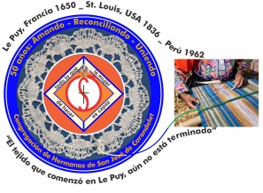
Congregación de las
Hermanas de San José de Carondelet

Jr. Talara 344 – Jesús María, Lima 11, Perú Tel. Casa 01-431-0881 Tel. Oficina 01-424-5092
Apartado 11082 – Jesús María, Lima, Perú Email: hna.csjperu@gmail.com
___________________________________________________________________________________________

NOTICIERO OCTUBRE – 2017

Dear Sisters:

We have begun the month of October; in Peru, we call it the purple month, because of our devotion to Christ crucified. This important manifestation of love and hope and belief that Christ will protect his people was begun in 1687 when Lima suffered a devastating earthquake followed by a tidal wave. The impact was so great that it leveled the Port of Callao and part of Lima, and destroyed the chapel built in honor of Christ on the Cross. The story traditionally told is that the only thing left of it was the adobe wall with the image of the crucified Christ. Since that time, every year, the image is taken through the principal streets of Lima in procession and it is followed by a multitude of people who pray fervently.
In the month of September, we have prayed for and realized some actions in solidarity with the many families who suffered as a result of the overflowing river which caused land slides and flooding with the destruction of many homes and farmlands. Our deep concern was for our own country’s suffering but also for the people in Central America, Mexico and the U.S. especially Puerto Rico where our Sister Rosa Orellana is working. We thank God because, in spite of the destruction, not everything is turning out bad. We see many people, institutions, and organization who are working in solidarity with many of the victim families who have suffered and some who have lost everything. These and many others have given us evidence that our people have many needs. We need to join forces so that we can raise our consciousness that can help us to work for the dignity of all. May our religious fervor help us to commit our lives to bring about a people who work in solidarity with the persons who are in need.
With love,

Gloria, Zaida and Maritza

IMPORTANT NOTICE
*The Congregational Leadership Team is sending to each of our personal e mails, documents in Spanish about the last CLG meeting, as well as information about the Animation and Innovation Committees. Let us take the necessary time to read them attentively and to talk about them and share in community.

CLG PARTICIPATION
Last September, we, the Vice Provincial Leadership Team had our first participation in the meeting of the Congregational Leadership Group. The experience was very enriching; we have participated in and learned about this moment in our history as a Congregation. Our sharing with other leadership teams has strengthened our desire for service and widened our congregational horizon. We have returned better equipped to animate, fortify and nurture the life of love and service in the Vice Province. We are grateful to the Albany Province for their generous welcome and the love expressed in the many details which made us very happy.
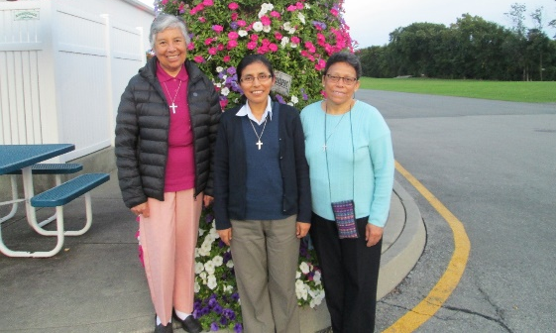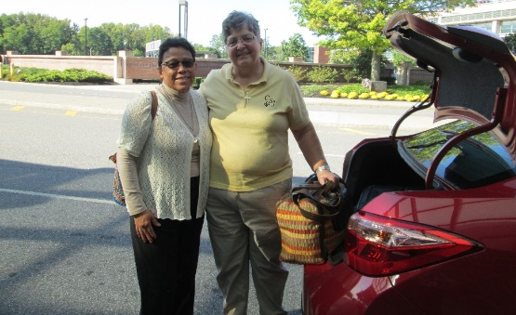

EXPERIENCE IN LE PUY EN VELAY
Our Sisters Genoveva Herrera and Zaida Perez had the opportunity to participate in the spiritual retreat offered by the St. Joseph International Institute in Le Puy en Velay, France. It has been a wonderful experience for both of our Sisters.

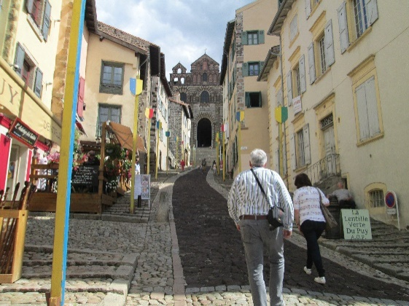
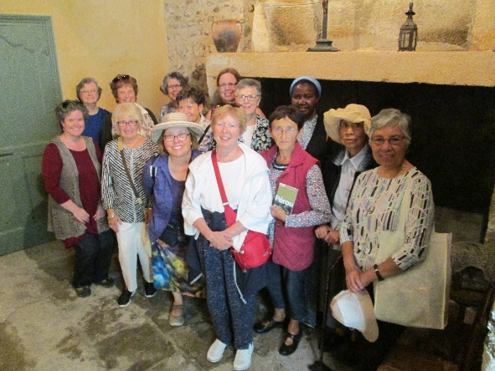

The group visiting the kitchen in Le Puy. The hill leading to the Basilica in Le Puy
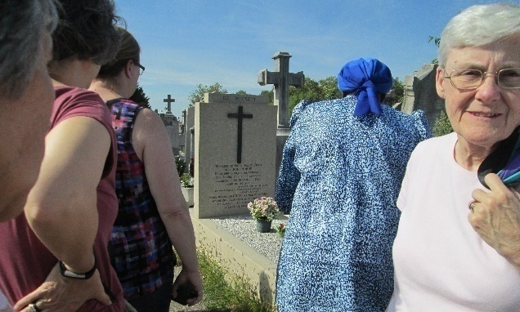
Visit to Mother St. John´s grave, Lyon. Celebrating in Paris before returning to Peru

Zaida shares with us words of gratitude and the impact of this experience:
“I want to express my deep gratitude to the Congregation, to the St. Joseph International Institute in Le Puy en Velay and all the Sisters who have contributed to making this long awaited for visit possible: of seeing the places that gave birth to our dear Congregation.
I have lived with deep emotion my encounter with the town, the places that our Sisters walked and to feel that their spirit still reins in these holy places, where the love of God and of the dear neighbor without distinction grew. The life sharing with our Sisters of other congregations of St. Joseph, with their different languages and life experiences but with one same spirit, have enriched me admirably.
I feel very touched by this experience that moves me to a deeper and more grateful prayer life, to a life of service with love, to a life of relationships committed to life.
I hold in my heart dreams and desires to continue on the path that our Sisters have left us, sharing the Good News in places where the presence of CSJ religious life is still lacking.”

III CONGRESS OF THE NEW GENERATIONS OF CONSECREATED LIFE IN LATIN AMERICA AND THE CARIBBEAN 2017
In Lima, Peru, from the 29th of September to the 1st of October, the different Conferences of Latin America and the Caribbean gathered together in the III Congress of New Generations. The reflections were under the title of: “Let us walk with Mary to encounter life”. The talks, the times for conversations, the shared experiences and the moments of prayer were invaluable because of the diversity of the participants and the realities lived in different countries.
Our Sisters Yolanda Arribasplata, Agripina Morales and Maritza Jarro were enriched because of their participation in this important congress.
We share with you, some of the photos of the experience.
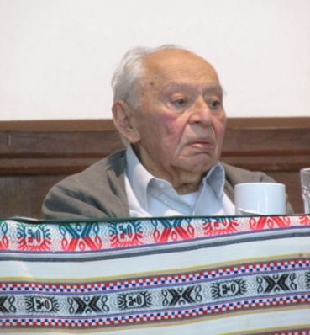
“We hear said that you are the promise … but I tell you, you are the promise only because of what you can do”. (F. Gustavo Gutiérrez)

“Always have your arms wide open”.
(Apostolic Nuncio of Peru)

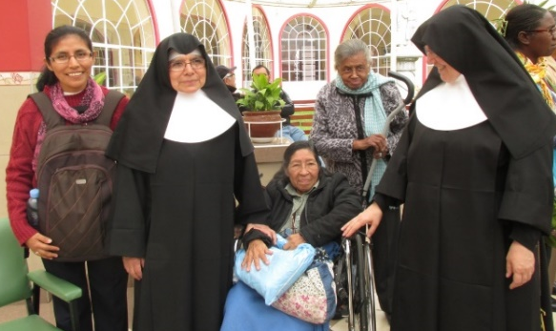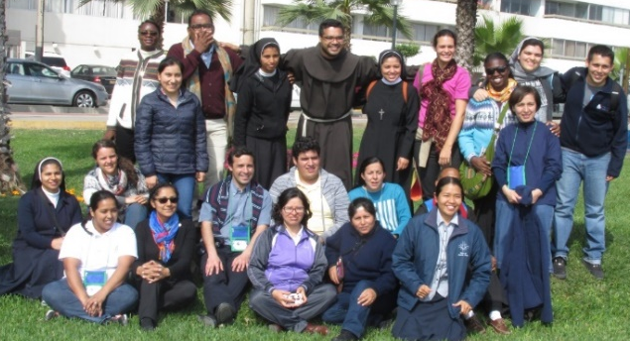
Maritza in Little Sisters of the Poor home Agripina and Yolanda with fellow participants

COMISIÓN DE ANIMACIÓN
Ruth Matos participated in the meeting of the Animation Committee in the Provincial House in Albany from the 18th to 21st of September. The meeting maintained an atmosphere of prayer and discernment, searching for how to respond to the mandate of the Extraordinary Chapter. For this year, on November 3rd, the commission will communicate via Zoom and there will be another meeting with presence in Los Angeles from the 28th to the 1st de December. We continue to pray the Prayer of Discernment, uniting us as a Congregation.

NEWS ABOUT ROSA ORELLANA
In the VP we were very conscious of what was happening in Central America and the Caribbean Islands, especially in what affected Puerto Rico. In the beginning, after the Hurricane hit, it was very difficult to have any communication with Rosa and the community. Through the Consulate, we were given hope and finally, Rosa herself called and gave us information about the hurricane: There was no water or electricity, classes were suspended. They were safe in Lajas, where she lives; they didn’t suffer any big disasters. The day before she was able to call, they were already restoring water to the city, later on, they would have electricity and communications up and running. This call relieved our tension, but we continue to pray for those who were affected like in San Juan. Rosa´s family also received this communication with gratitude.

NEWS FROM CASA VICE PROVINCIAL SAN JOSÉ (CENTER HOUSE)
This month, we were able to share times of relaxation as a community. We went to the Parque de las Leyendas for a short time of distractions and rest. We enjoyed this time together, sharing our joys with pleasant conversations and with a delicious lunch. What wisdom of God that He would allow us to marvel at the beauty of creation!

Community Retreat Day
We have also had the time for a community retreat day. Sisters María Schuh and María Vasquez were our guides with reflections on Pardon. We appreciate these moments so that we can recognize the action of God in our lives.

With the title, “Nothing new can happen without pardon” Sister Zaida shared with us her experience:
“Pardon allowed me to feel free, thankful and open to the new. I learned that when I remained in my pain, I was accompanied by bitterness and the vision of what I live is distorted. The effects of my bitterness contaminate my relationship with others, when I tend to talk with bad humor, there is loss of confidence and I am not a life giving source but rather of unrest.
I realized that I was not happy, that I wasn’t taking into account God´s love, the love of my sisters, of my family and of other persons. It was in this moment that my faith in God, in Jesus, that I was able to overcome myself by accepting what I had lived. I could look at the facts from other angles and transcend them. Then I approached the Lord with openness to accept pardon: Giving and receiving it with God´s grace to recuperate the joy of living, the freedom to recognize goodness in myself and in other persons, and opening myself up to the new. The gift of this experience was to understand that I can pardon and ask for pardon for my faults, and accept my humanity and that of other person. By pardoning, I make possible for something new to happen.”

Volunteers in Carapongo, Lima
Sisters Mauricia and Ruth continue their service volunteering in Carapongo, Lima visiting families in one sector affected by the flooding. This group of families lives with uncertainty because the Municipal Government of Chosica (to which they belong) refuses to dialog with the Municipal Authorities of Lima and the Central Government.
Because of this situation, NGO, Peace and Hope continues working with these families and is organizing a Forum focusing on “The Situation of the Homes of Carapongo that were affected by the landslides and flooding.” The forum will take place on October 4th in the Women’s Center located in the Municipality of Chosica.
Let us continue united in prayer for these families.

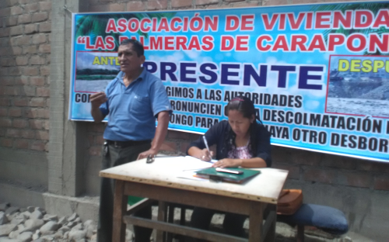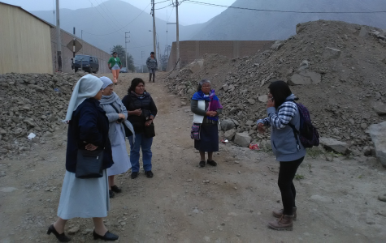
These home owners need titles to their properties. Mauricia and Ruth with other religious

NEWS FROM THE GRAN AMOR DE DIOS COMMUNITY (CANTO CHICO)
Jesus, the Master, the Companion on the road, asks us: How many fish do you have? We had the opportunity to taste of this sharing. Thanks to a friend of Sister Anni, we were able to buy a lawn mower. With this gift, the Acha family, who for years have dedicated themselves to the caring and beautifying of the park; they can now with less effort, continue to embellish the maintenance of this neighborhood park. Through this, we have the possibility to care for our planet. We are grateful to the people who help us be bridges joining efforts and permit us to be helpers. Also, the Acha family expressed their gratitude and joy for the economic support represented in this lawn mower.

CONFIRMATION GROUP
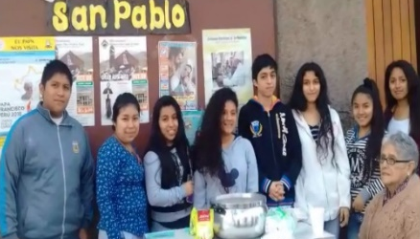
The Confirmation group in the “San Pablo” Parish are preparing themselves to live their retreat and with joy they want to confirm their faith in God. Every Sunday, they offer breakfast to the parishioner, which consists of a sandwich, some cookies and a delicious cup of coffee. This is how they are raising money to pay for their retreat. It is a pleasant experience to share their breakfast which they offer after every Mass. This is a good way to collaborate with them and also, to share with the people of the barrio who also do the same. Let us pray for this likeable and pleasant group in their endeavor, that they will soon realize their Confirmation.

*PASTORAL FOR VOCACIONS
Jesus, the Fisherman, who can see the depths of the sea with love and sees the riches that exist under the water. He contemplates, calls, smiles, interacts, and He shows us the way to life and to the mysteries that He makes known through a gradual process. Following this process, on September 17th we had a meeting in the Center House with Pamela, Yolanda, Fanny, Kettie and Sonia. They are responding to the “Come and See” and they want to get to know us as CSJs. In the meeting, we, Sisters and Interested women each shared about the process of responding to God. It resulted in a very beautiful encounter and at the end of the sharing we had a light supper and dessert which included apple pie and brownies.

Some lasting impressions after two days: “What a beautiful Sunday it was!” Really, to share our experience of having been called, to share our stories, to listen to each other; this too, helps us to look at our process of fidelity to God. For us still in the process of formation, this helps us to continue motivated by these experiences of faith and fidelity” (Sisters CSJ).

CELEBRATING LIFE!
September 18th we anticipated Pamela´s birthday (real date-20th) by celebrating with a special dinner and cake that Mary Luz Salazar had prepared. Pamela was visiting us for a few days and she went back to Huancayo on the night of the 19th of September. We are looking forward to her return.

“Ah, the desert! The desert to meditate… Solitude is everything that is bathed by the Sun. And the desert is the desert…that moved the foundations…The desert is there where all the points of encounter meet…between the Creator and His loved one (…)” (M. Luisa).
It is there in the desert where strangers become friends, it is the ones who have hope and a sense of humor, it is those who make joy contagious and who make sense of closeness, they are our dear neighbor who with their welcome and their love make us part of their group, quoting Sra. Yolanda: “I went to the mountain to find gold, but I found paradise (…). I am very happy that you visit us, Sisters, let us go see the paradise (in the mountain, where there are” only rocks, a beautiful experience materializes, the photos are the proof). Thanks to our Sister Teresa Lynch for the clothes, the tennis shoes, etc. for our children.

* GESTURES OF LOVE
Alex, the little boy who used to come to Sala San José, the one who with his timid smile showed his fragility, his disappointments and his solitude… Today, he is a young man who continues to smile. He works as a mototaxi driver and he is surprised to receive his lovely tee-shirts. It´s not the tee-shirt that is significant, rather it is what´s behind the gift: love, the fact that he was made to feel important. Thank you to all those who make these surprise gifts possible in a very simple way!

With surprises, with gestures that signify life, we come to the last week of September. Did you know that there is a special relationship between your two eyes? They blink together, they move together, they cry together, they see together, and they sleep together. Even though they can never look at each other, they are always united. Fraternal friendships should be exactly like that! It is possible that I may not see you for months or years, nor speak with you, but you have to know that I don’t need to see you to tell you that I appreciate you and that we are always together!

NEEWS FROM THE TRINITARIA COMMUNITY (TACNA)
September was a time of working intensely with educational projects on the primary and secondary school levels. María Inés Gutierrez continues to work with the Education Community of Fe y Alegría with a lot of enthusiasm and joy. We are preparing for the Anniversary celebration of the Institute which will take place on October 15th.

Zaida continues recuperating her health in Lima and she will return to Tacna around the 8th of October. She is very grateful to the San José community of the Vice Province for their loving care that she received during this time. She is recuperating from the thrombosis in her left leg that kept her in Lima for some weeks.

We are happy with the news that Zaida has been invited to form part of the group of Retreat Directors “Las Caminantes.” This group was initiated many years ago by our Sister Patricia Mc Hale (SP), Sister Carmen Foley HCSV and Father John Cima SJ. She will begin her service in this group in February of 2018.

UNITED IN PRAYER:
* For the health of Sra. Carmela de Urbina, sister of Sister Genoveva Herrera, who is recuperating. We ask also for prayers for the family, that they may feel our support and love.
* For Sra. Agripina Acosta, mother of Agripina Morales, who is hospitalized. With our prayers, faith, and confidence in the Lord, we are in solidarity with her family.
* For Carmen, the aunt and cousin of Sister Gloria Zapata who are suffering the effects of their illnesses. We accompany them with our prayers asking God and our Mother Blessed Mary will strengthen them and give them the grace they need.
* For Sister Ruth Matos’ parents, who both need surgery; we pray that they will regain their health soon.
* For Señor German Caceres, father of Sister María Elena Caceres, who is recuperating in Cusco.
1 Teresa Ponce
3 BarbaraDreher (ELC)
5 María José Cokely (A)
8 TheresaKvale (A)
14 DoreenGlynn (A)
14 Mary Kay Kottenstette (SL)
May God bless you all the days of your life!
15 Teresa Avalos (LA)
19 Cristina Takeichi (LA)
28 Agatha Grossman (SP)

