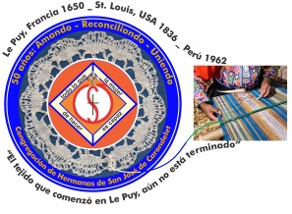
Congregación de las
Hermanas de San José de Carondelet

Jr. Talara 344 – Jesús María, Lima 11, Perú Tel. Casa 01-431-0881 Tel. Oficina 01-424-5092
Apartado 11082 – Jesús María, Lima, Perú Email: hna.csjperu@gmail.com
___________________________________________________________________________________________

NOTICIERO SETIEMBRE – 2017

Dear Sisters:

The month of August has terminated with the festivities of Santa Rosa de Lima. Our people have the custom of giving to our Saint many personal necessities, wishes and dreams that they hope that God will answer for them. We believe that God will answer them in time; we only have to remain alert and vigilant.

We have witnessed the teacher’s strike, accidents suffered by some of our own family members, constant acts of violence that appear in the news, natural disasters that have affected many families. At the same time, we are witnesses of life giving experiences, of fortitude, of gestures of reconciliation that unite families and that deeply restore their confidence in each other. Our life as Sisters of St. Joseph is distinguished by these situations; these are the elements that give color to our charism. Each experience, if we read it through the prism of our charism, is an opportunity to continue to opt for the Reign of God manifested by love of God and of the dear neighbor.

We begin a new month to continue to be companion one to the other but especially to our people. In a special manner, we lift up our prayers and intentions for the families and the Sisters of the United States during this difficult time of disasters through which they must live.

With love,
Gloria, Zaida and Maritza

IMPORTANT NOTICE
* We have scheduled the local community bookkeeper’s meeting for November first in the San José Center House. We will soon be sending the corresponding reflection to prepare our budget for the year 2018.

NEWS FROM CASA VP SAN JOSÉ (CENTER HOUSE)

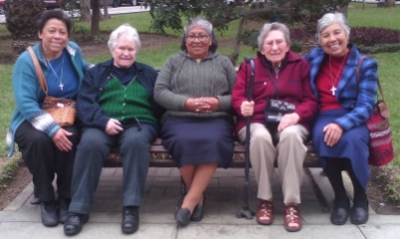
We began the month with the visit of the Vice Province Leadership Team to the community and we celebrated the 55th Anniversary of our presence in Peru.
Resting in the park
Gloria, Betty, Mauricia, Dolo, Zaida

Sisters Mauricia Carcasi and Ruth Matos are accompanying the victims caused by the terrible floods in Carapongo, Lima; they are working in coordination with CONFER (Conference of Religious in Peru). They are visiting families so as to assess the extent of their needs, and so that the families can receive the relief they need. The Sisters are helping them to organize themselves more efficiently.

Sisters Gloria Zapata, María Vasquez and María Schuh participated in the Fiesta in honor of their patron the Virgin de la Asunción in the San Hilarion Chapel, San Juan de Lurigancho, on the 20th of August. They felt the same love of the people in spite of the years that have passed since they left the parish; they were welcomed with joy and appreciation for the presence of our Sisters.

On August 12, Sisters Agripina Morales and Maritza Jarro were participants in the March “Ni una menos” (Not One More) which was organized by the movement for the promotion of respect for women and to denounce any form of mistreatment against women. It was a very significant experience because there were many organizations, parishes, universities, to name a few, who raised their voices to create a greater consciousness for the respect of women.
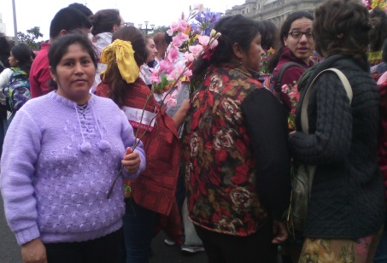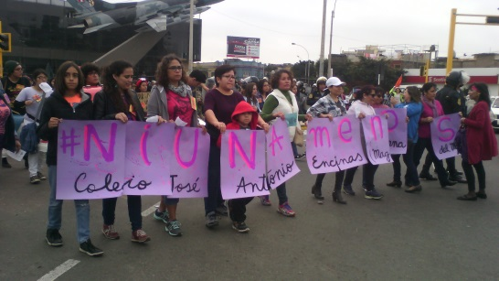
Agripina and Maritza in the March

On August 19, we had a welcomed and enjoyable visit from Yolanda Arribasplata and her mother, Sra. Liliam (she is in the center of the photo). She shared with u show much the landslides and flooding has affected her; she lives in Chepén, La Libertad (which is on the coast). Many families lost everything they had; what affected them most was the fact that the land was left almost useless, where they will not be able to plant as they did before. But she also shared that her neighbors hope to overcome this loss with the help of God and the solidarity of other people. We will accompany them in our prayers.

On the night of August 26, we had a little farewell for our Sister Zaida Perez and Genoveva Herrera, who were traveling to France very enthusiastically. “Bon voyage” Sisters, we wish you a very good experience!
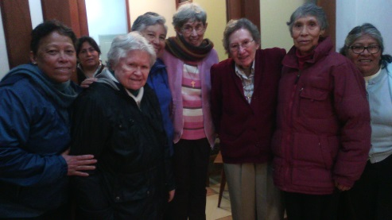
This year we celebrate the 400th Anniversary of the death of Santa Rosa de Lima, a woman who had much love of God and of the poor. On that occasion, August 30th, Sisters María Dolores Muñoz, Agripina Morales and Maritza Jarro assisted at the Mass in her honor in the Plaza Mayor, organized by the Archdioceses of Lima. The many people of God and the expression of their faith was very impressive; once again, they help us to continue to recognize the presence of God in our midst.

During August, we were, also, visited by Fanny and Rocío, two women desirous of knowing us better. They live nearby and they will continue to visit us to discover more about our CSJ charism. Welcome to our house! We continue to pray for vocations to the Consecrated Life.

NEWS FROM THE GRAN AMOR DE DIOS COMMUNITY (CANTO CHICO)
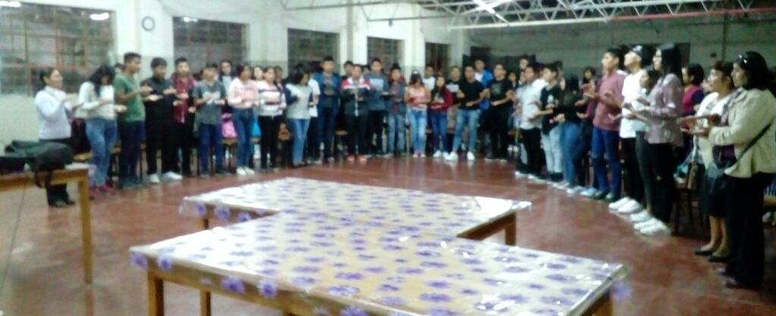
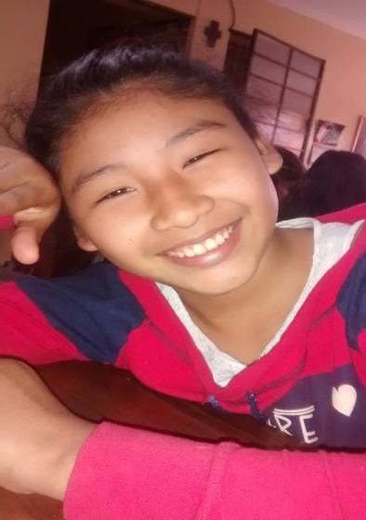Our Sister Mary Luz Salazar went to the City of Nazca on the 25th of August. She tells us the following: “I thank God for the friends who have woven themselves, in and out, of my life. They are the ones who invited me to speak to a group of Confirmation young people and their catechists. It was an experience that helped me a lot, especially during this time after the loss of my sister. It was also an opportunity to meet with my friends again. They expressed their gratitude and invited me to return again. Thank you, Sisters!
Nohemípidió ayudar en sus tareas a los niños que vienen asistiendo a nuestra sala San José.

Above Photos: Hna. Mary Luz in Nazca

Because of the teacher’s strike, the public school sector didn’t have classes so some students said:
Nohemí (First year high school): “Because of the teacher’s miserable pay we are the ones who pay; we don’t have any classes; it’s sad (…). There are some teachers who are negligent and they don’t teach their classes well just as there are students who are negligent and who fail their courses; these are happy when there are no classes. But, we have to consider that the classes are important and they will help to have better persons. If we don’t have classes, there is no way we can better ourselves; the classes help us to think. When we grow up, we want to have a profession, that’s why not having classes, now, is sad; we just don’t know what to do. We have come here (sala San José) because the Sisters help us to study so that we are not discouraged. The Sisters work with the primary grades so that they don’t get discouraged and we want to help them so that they will continue to study. It’s great that children who have difficulty with their studies can come here! I also want to say that the government should send teachers that are on contract because with them we would not lose any classes; they work. The regional government ministry of education shouldn’t send teachers with tenure because with them we are held back more”. (Reflection in her exact words)

Mariel (First year high school): “I think that teachers do have a right to strike because they need to earn more. I think teachers should earn more because they teach a lot of people and because of them they are educated and can be good professionals. Teachers have to think about the fact that their salaries little by Little, that’s why we should begin our classes again. I also think that they continue the strike because only 10% want to take the government examans with 90% who are opposed to it because they are afraid or because they know they cannot pass the test. Some teachers are already trained and others are not. In our school, there is a teacher who earns S/.5, 000 (five thousand) because he is always getting more training, that’s what all the teachers should do and they would be better off. In my opinion, the teachers should think of the students; we are not to blame. I ask myself, why are they striking now when they are harming us? Why don’t they strike during January, February and March? We are not the Regional Government Ministry of Education; we don’t keep us from having classes. There are many students who are failing their exams; these students are happy, but we are not. There are teachers who don’t want to keep up their training; if they want to teach us, they must learn. I feel bad because I’m not in class and the teachers don’t want to return nor do they want any more training, neither do they want to take exams; and what about us, we take exams. I feel bad because the Sisters have to teach us to read and to study so that we can learn to be professionals”. (Reflection in her exact words)

Kahori (Sixth grade primary): “To me, the Sala San José is a beautiful place because it helps us. All the Sister’s little helpers help us so that we can do our homework. Here, they are all good, they teach us well. I come here because my mother doesn’t know how to read, she only finished grade school and she can’t help me. Here, I feel that it is like my family that is helping me. I have a lot of problems and here I feel that my family is here because I am welcomed and they teach those who don’t know much.

There is no photo because like her, she represents many children in the same situation, but in spite of the difficulties they grow and blossom.

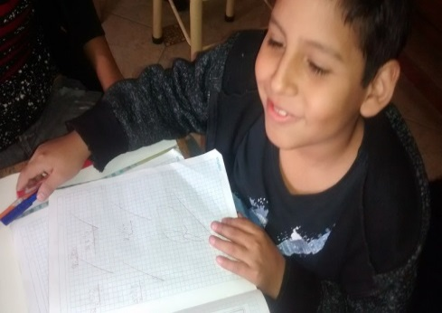
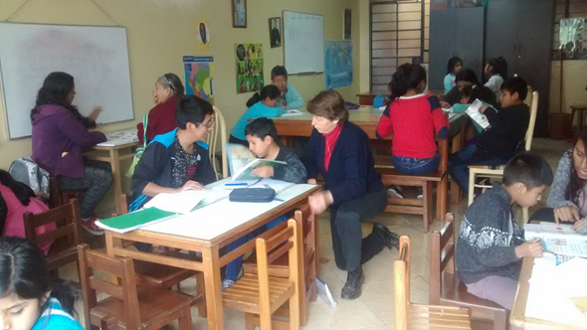
This is where they find security, confidence, joys and fulfillment in the studies.

N Little boy happily showing off his “A”

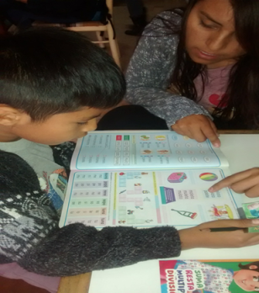
Nicolay(7 years): “I came here because my mother said: Go over there so they can teach you; I said, okay. I can read a little, I like to read stories from my Reader Coquito(…) At school, when I know how to read I feel happy (…) at school I thought I can’t read, I think I will continue to come (to la sala San José) to read and not like when my mother tells me: go read and I say “ya maaa!”

TRASFORMATION!
In the social, you can discover great gestures, the surprises of life, sometimes are found where you least expect them. Anne says: “What joy, now what’s happening is incredible! A while back, we were saying to them, “get out of here” (because they were drinking in front of our house), it was terrible, and now, it’s beautiful. We are with them. They are calling us and smiling. This is how the story began:
Anne: Yoli, please help me, I don’t understand.
Yoli: Sure, Anni. What happened?
Anne: You talk to them, please, I don’t understand.
Yoli: Yes? What can I do for you? Hooolaaa!
Neighbor: Sister, Please, we want you to baptize our sport uniforms. We who belong to barrios 19 and 20 have organized a game and we have joined together to play football and for reason we bought our sport shirts (smiling faces).
Yoli: Oh, Yes, of course! Yes! Tomorrow, we will baptize them. (This is interesting, what’s the difference, baptize or bless; what’s important here is their confidence and faith!)
Yoli: Where is it going to be?
Neighbor: In the stadium, near the parish, “San Pablo”.
Yoli: That’s where we are going to bless them?
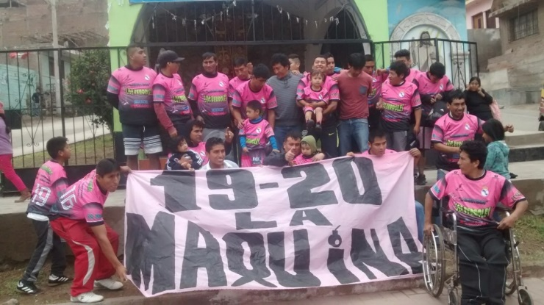
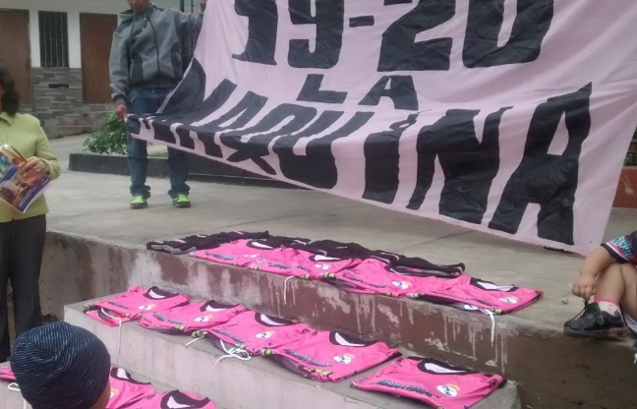
Neighbor: No, Sister. We want you to do it next to the little cross (the one that’s in Canto Chico’s little chapel, up the street), we want it there, with the little cross. We took up a collection to pay for some refreshments; it’s going to be very nice.
Uniform shirts to be blessed Our neighbors with their uniforms shirts

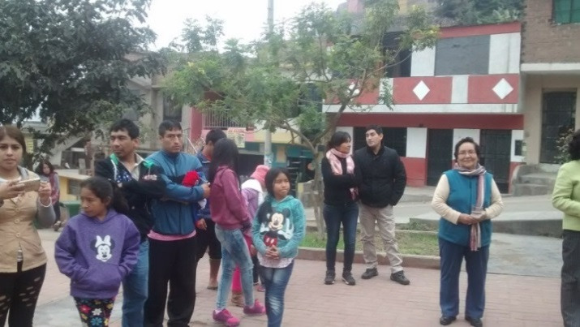

Some members of their families watching

These reflections by our students, our Sisters and our neighbors surprise us with details that are life giving; they invite us to keep dreaming. We close this month with the following adaptation of a poem:
Por Amor (Because there is love)
Life is beautiful, if there is love.
The barrio is beautiful if there is warmth.
The road is shorter, if we are two.
It’s better to relate to each other, if there’s love,
It’s easier to ask for help, if there is love.
Because there is love, our encounters are easier.
Because there is love, we can find it easier to admire changes.
Eyes are beautiful when they see everything with love.
(Adapted from José Luis Perales’, Por amor, In: https://www.youtube.com/watch?v=1-pDen2uBW)

NEWS FROM THE COMUNIDAD TRINITARIA (TACNA)

Sisters, we send our loving greetings all the way from the Heroic City of Tacna; we have recently celebrated another year since the reincorporation of Tacna to Peru.
In our barrio, Jorge Basadre G. Association, where we live, we had the inauguration of the new Board of Directors on august 25th. This Board of Directors includes many Young people from the area and they have a good plan to better the barrio, among other things the cleaning up of the streets with better garbage collection, and their desire to have a better relationship with the neighbors. The inauguration had an aspect of fiesta with the presence of some authorities, such as: the mayor of Alto de la Alianza (District to which the Barrio belongs), the Colonel representing the district’s police and others. We, Sisters, were present as members of our association.
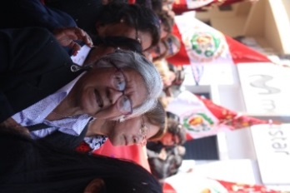
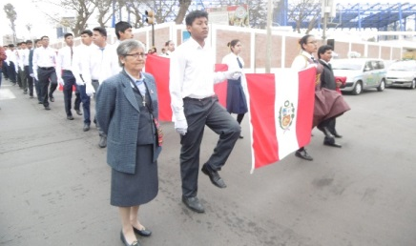
Among the multiple activities schduled to celebrate Tacna Day, there are two big ones: the Gift of the Youth, which is the carrying of 50 banners in procession from the Plaza de la Mujer all the way to the Civic Center where all the important celebrations are held. In this procession, the 50 banners are carried by two boys and one girl, representatives chosen from all the educational institutions. Needless to say, the procession was filled with patriotic emotion.
The other important activity is the procession of the giant flag which takes up the whole width of the street and is carried only by the women of Tacna. The people are filled with emotion as they witness the women’s spirit and joyfulness which can be very contagious.

Happy and enthusiastic, Zaida left Tacna on her way to France on the 25th of August; she had a lot of questions as to the how she would eventually reach the cradle of our congregation. We sent her off praying that she goes with God’s blessings and confident that God would be there in every part of the journey.

María Inés together with Sra. Antonieta takes time out to help make the plants grow better and more beautiful. Plants help beautify the community ambient.
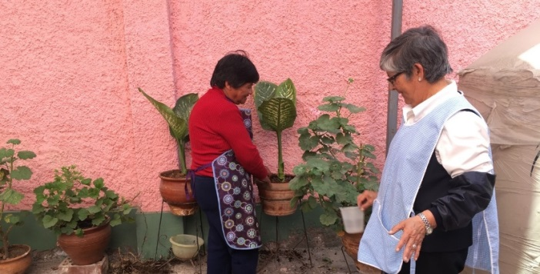

OUR CONDOLENCES
* We express our condolences to Sister Mary Luz Salazar for the tragic death of her Sister, Sra. Celia. We will continue to accompany her and her family with our love and prayers.

UNITED IN PRAYER:
* We pray for the victims of the hurricanes left in Texas, the Islands of the Caribbean and Puerto Rico where our Sister Rosa Orellana and the Sisters of St. Joseph of Brentwood minister.
* We pray for Mary Luz Salazar’s and Maritza Jarro’s families for the death of their loved ones.
* We pray for the Sisters who have a birthday during September.

3Dianielle Bonetti (ELC)
May God bless them all the days of their lives!
7 María Dolores Muñoz (P)
9 Rosa Orellana (P)
13Mauricia Carcasi (P)

