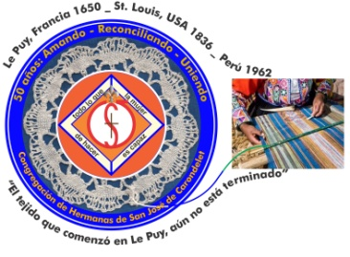
Congregación de las
Hermanas de San José de Carondelet

Jr. Talara 344 – Jesús María, Lima 11, Perú Tel. Casa 01-431-0881
Apartado 11082 – Jesús María, Lima, Perú Tel. Oficina 01-424-5092
Emaoficinaprovincial@csjvpperu.com

NOTICIERO – OCTUBRE 2016
Dear Sisters,
This month we begin our celebration of “Our Lord of the Miracles” together with our people who express their faith in God by saying: “God willing”. We pray that this faith and confidence in God will grow because we know that everything is in God’s hands.
With love,
Genoveva, Teresa and Sally
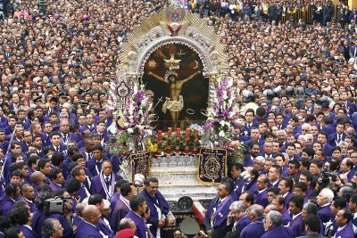
VICE PROVINCE
Congregational Experience and Study of English: For the year 2017, Sisters Teresa Ponce and Maritza Jarro will participate in this program that was begun in 2015.
ACOF MEETING: Sister Margaret (Peg) Murphy, the contact person between Peru and Chile, went to Los Angeles for the ACOF meeting. Srta. Menche Rojas of la Familia de San José will also be at the meeting.
GLC MEETING: September 15 to 19, Teresa, Genoveva and Sally participated in the GLC meeting in St. Paul. It was enjoyable to have the opportunity to see several sisters who have previously worked in Peru and we are very grateful to Teresa Avalos for her very generous service as interpreter and translator. We were treated to A-1 hospitality from the Leadership Team and the sisters of the St. Paul Province. Thank you so much for everything.

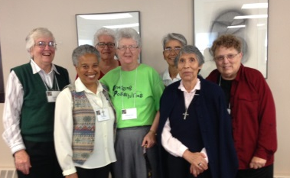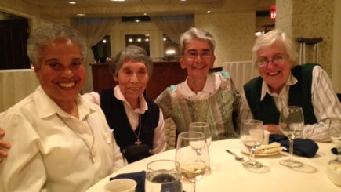
Sally, Teresa P., Mariana, Maureen, Teresa P., Geno, Teresa A., Sally
Teresa A., Geno, Theresa K.

TACNA
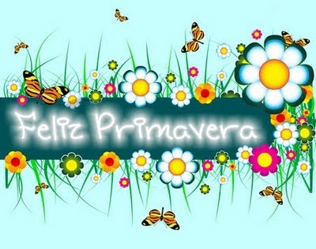
Once again, everything is possible
The great winter can now depart,
Spring has burst forth in the heart of the son of man.

Primavera en el corazón, primavera en el corazón
Todo vuelve a ser posible

If you would like to listen to the song, this is the link: https://www.youtube.com/watch?v=mCnd45JBvcA

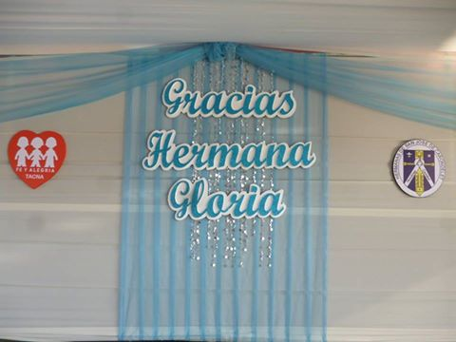
During this month in this season of spring, we are reminded that life is reborn, and we realize, once again, that GOD GIVES THE HUNDREDFOLD. All the “Fe y Alegría family” expressed their gratitude and love for our Sister Gloria Zapata for her 12 years as the principal of this institution!!! Everything was generously prepared beginning with family history, poetry, song, dance, toast, and dinner. These are the photos that show what happened and they express the details of our gratitude.
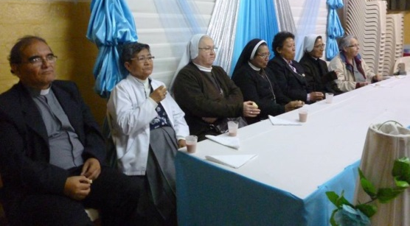Gloria with F. Enrique, Sister María Vásquez and friends
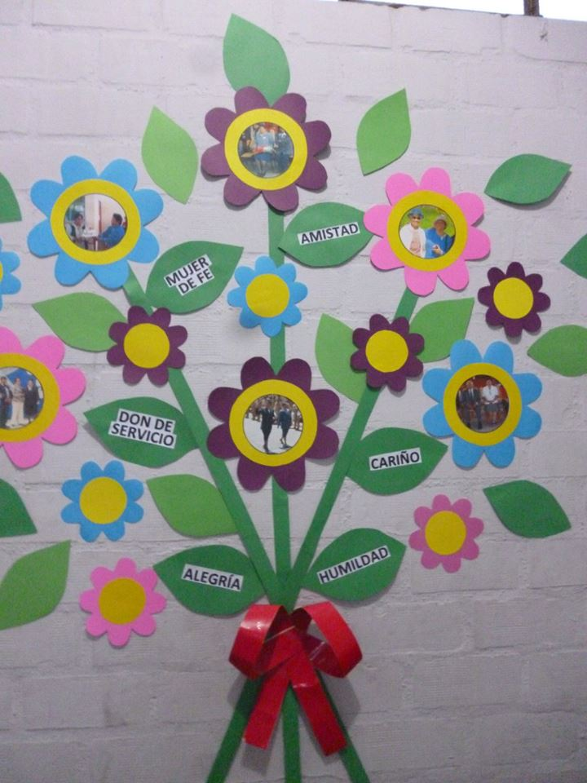
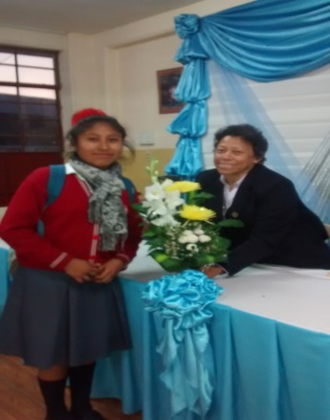
With a member of the graduating class who chose to name their class “Sister Gloria Zapata”

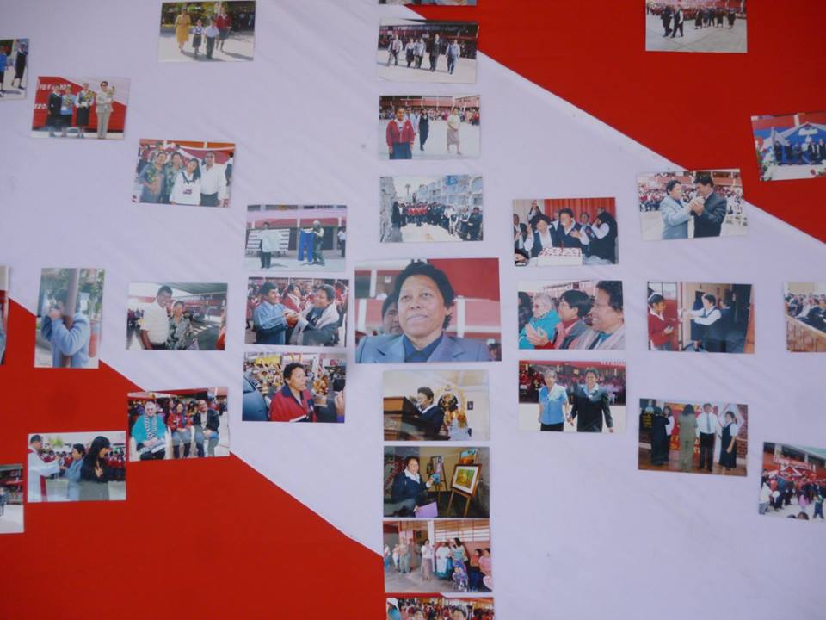
Pictures commemorating events through the years

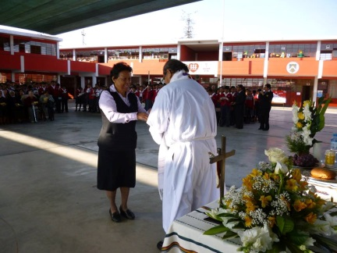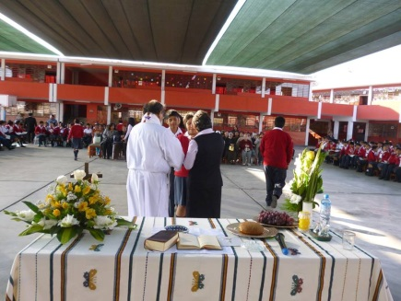
Gloria presenting her cross as a sign of fidelity and service Giving Communion

The show to honor Sister Gloria
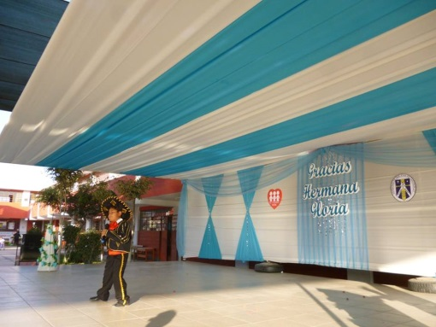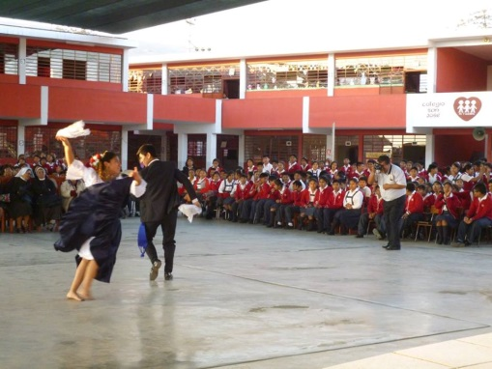
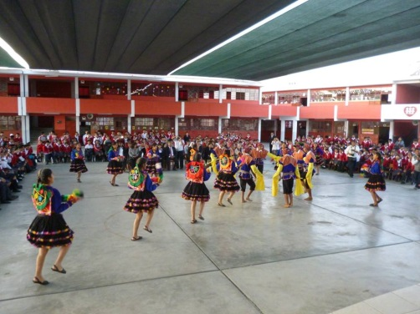
The new principal and the vice principals presenting a plaque and floral arrangement
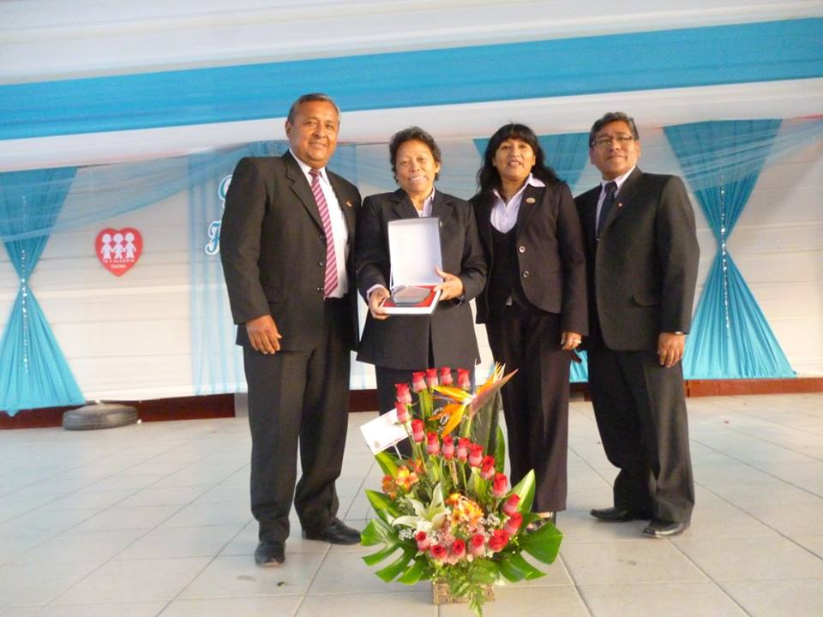

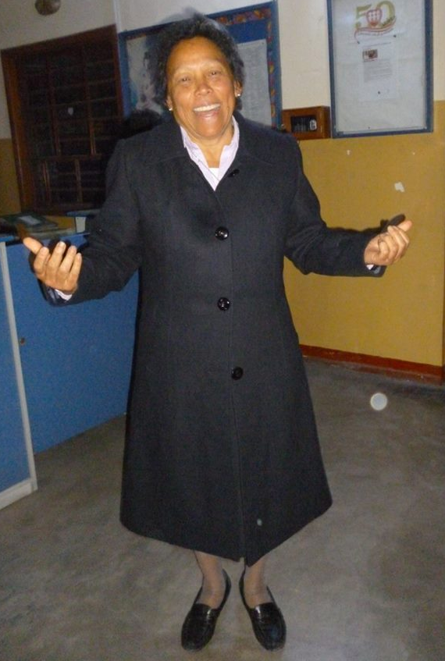
Gift of a new overcoat
This is how we THANKED GLORIA for her work. And we thank everybody who made this special and generous celebration possible!!
This month our school is also having a championship tournament of games for the alumni, who are excited about meeting their friends, teachers and families. And …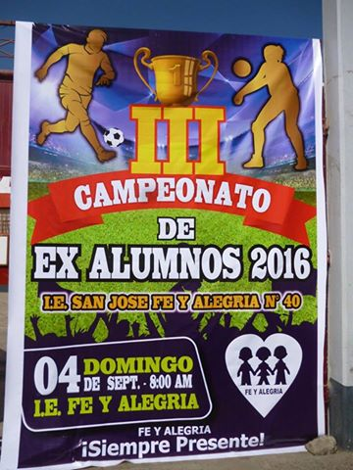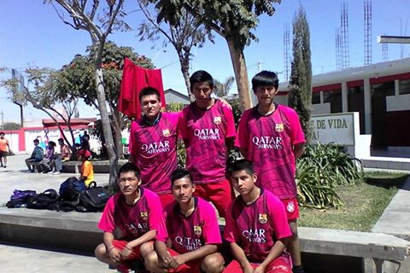
the class named after Sally Harper was also present!!!!!!!!!
OUR VISITORS THIS MONTH WERE VERY SPECIAL BECAUSE OF THEIR ACCEPTANCE, JOYOUSNESS AND SHARING.
With us we had Srta. Alina from the Fe y Alegría Central Office, who helped the teachers experience and reflect about the importance of communication, evaluation and pedagogic processes. This has helped them to continue to give a first class education to their students!!
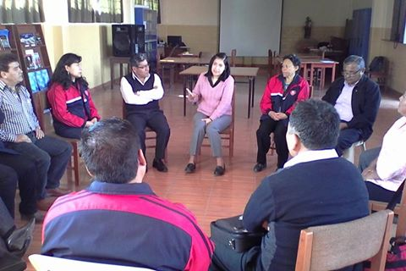
Another beautiful visitor was our Sister MARÍA VASQUEZ!!! She helped us with her smile and especially her expression of happiness when she encountered her friends. Thank you, Sister María for your words of encouragement to the teachers, thank you for your simplicity and humility and for your comments which have helped others to recognize their capabilities and their potential. We are happy for you and we thank you for your visit!

CANTO CHICO
Sister María Vasquez is participating in the meetings of the Biblical group in San Ignacio. The women were happy to be able to continue the meetings and they made a commitment to invite other women from the barrio.
On Sunday, September 25, we had an outing with the Young people who are helping the children with their homework in the Salon San José. We went to the park, the “Parque de las Leyendas” all day. The park is big and we were able to see a variety of animals, but we got tired and so we have to go back another time to see the animals from the coast. We had lunch with a variety of food from each one’s kitchen. We also played volleyball and we had a good time with lots of laughs and much happiness.
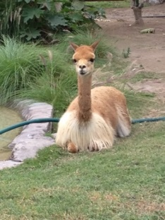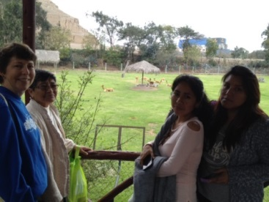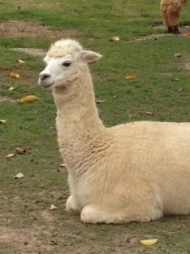
Sister Anne continues to visit the young mother and her daughter, refugees from Etiopia. Anne brought back books in English (from the mother´s family in the USA) so that the mother can read to her daughter. The little girl was very happy to receive these books especially “The Three Little Pigs”! On September 11, Anne brought a cake to celebrate Hanna’s birthday (the mother´s) with the children in this home where they are living.
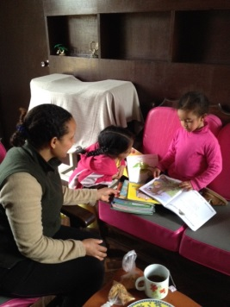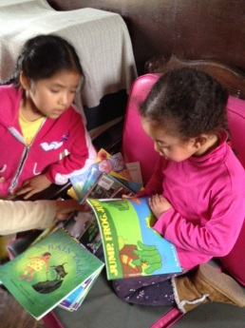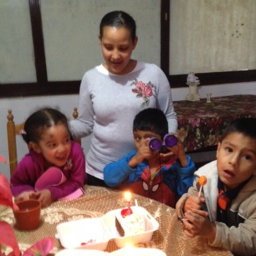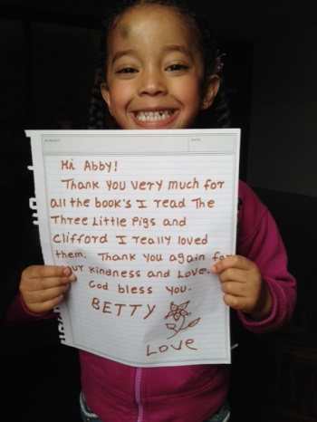
Anne visited two families who live up the hill. Some of the children who come to our Salón San José are living in a new place up there. They have just moved and the transition time is very difficult. There’s one little girl whose responsibility is to take care of another younger child (3 years old) because there is nobody to take care of her during the day. We need to allow the two of them to come to the salón so that the little girl who is in second grade can get the help she needs to do her homework. There’s another case of a little girl who has measles and her new house is very small and simple, with a dirt floor. The mother sells mazamorra and arroz con leche (desserts) on the corner to help her economy.
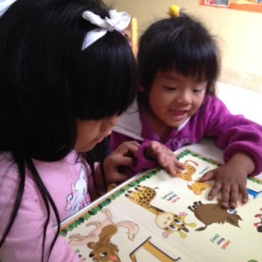
Sister Maria Vasquez had a great time visiting our sisters in Tacna for a week. Thank you for the welcome and the five star hospitality!

CASA CENTRAL
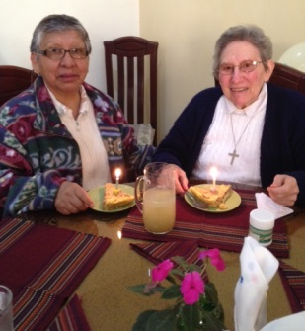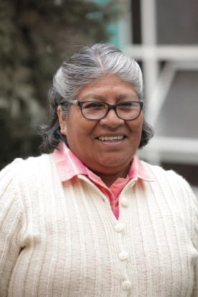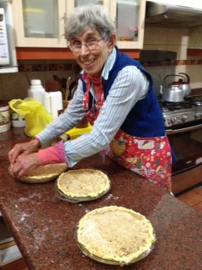
September was the month of birthdays in the Center House: María Dolores, Rosa Orellana y Mauricia Carcasi. With the pastry expert (Sister Marie Schuh), we are always guaranteed to have a delicious dessert.
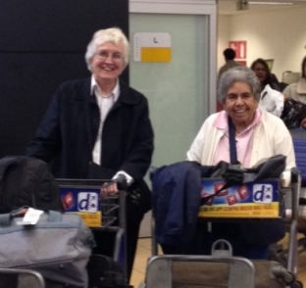
September 26, Sister Eleanor Ortega arrived for her visit to Peru as Coordinator of the Mission Office.
Welcome, Eleanor!

MESSAGE FROM RUTH MATOS: Greetings from Albany. It’s incredible that I have been here already eight weeks. I have acquired many experiences in the language. I have also ventured into praying and sharing my reflections. Cooking was an adventure for me. Everything is always a surprise.
Now, I am here, living the changes from summer to autumn. It’s incredible how the colors change in the leaves! It’s marvelous! It will be magnificent when all the leaves on the trees change color.
I have begun my English classes in Bossé School; we are four students: from México, China, Korea and Peru. I think that the first class made me touch reality because it was based on reading from a magazine to help us understand new vocabulary and be able to recognize verbs and impersonal phrases. God help me and above all, sustain me.
Greetings to all the sisters of the Vice Province; I really miss you and pray for each of you and know that I hold you with great love.
A big hug for each of you, Ruth

DIRECTORIO: Anne has a new cellular phone: 982-108-673 (Claro).

HAPPY BIRTHDAY
1 Teresa Ponce
3 Barbara Dreher (ELC)
5 María José Cokely
8 Theresa Kvale
14 Doreen Glynn
14 Mary Kay Kottenstette
15 Teresa Avalos
19 Cristina Takeichi
29 Agatha Grossman
On the 31st, we remember our Sister Clara Yañez in a special way; she went to God on the 15th of September.

