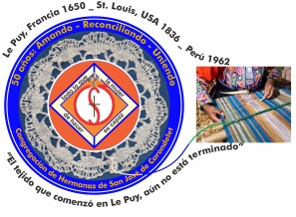
Congregación de las
Hermanas de San José de Carondelet

Jr. Talara 344 – Jesús María, Lima 11, Perú Tel. Casa 01-431-0881 Tel. Oficina 01-424-5092
Apartado 11082 – Jesús María, Lima, Perú Email: hna.csjperu@gmail.com
___________________________________________________________________________________________

NOTICIERO DECEMBER – 2017

Dear Sisters:

The Vice Province leadership team has started their second round of visits to the local communities. The encounter with the Sisters is a marvelous opportunity, personally and as a community. We give ourselves time to bring together moments of prayer, reflection, sharing and dialog, the fruit of the efforts we make in our lived experience. These personal and communal conversations are a treasure; they enable us to affirm, recognize and project our religious life together during our Assembly each year. We enjoy the warm welcome, the details of hospitality, and the time to talk about happy memories and definitely, we need to mention the delicious food that is a sign of love and friendship.

These life giving encounters are also encouraged by the Animation Committee for the entire congregation. We appreciate their suggestion as an excellent opportunity to generate life in our communities both interiorly and exteriorly. Let us live this Advent with open minds and hearts to the situations that millions of children in extreme vulnerability live, with the hope that the Child Jesus will inspire us to realize concrete actions of solidarity!

With love,

Gloria, Zaida and Maritza

IMPORTANT NEWS

* Visits to Local Communities:
The leadership team of the Vice Province has initiated visits to local communities corresponding to the second semester of the year:
- Gran Amor de Dios Community, Canto Chico: December 2 and 3
- Trinitarian Community, Tacna: December 8 and 9
- Jesús María Community, Lima: December 17,18 y 19
We are appreciative of the Sisters who have sent in their reflections on the indicated date answering the leadership team’s request for this visit. The Sisters, who have not yet sent in their reflections, can do so prior to their respective visit.

* A reminder: the dates for Retreat and Assembly, 2018
Please mark your calendars for the Vice Provincial Assembly:
- Community Retreat, January 31 to the 3rd of February, in the San José de Cluny Retreat House
- Peg Murphy’s 50th Jubilee Celebration, the fourth of February.
- Items of VP business, the 5th to the 7th of February.

ANIMATION COMMITTEE

The Animation Committee is sending each of us a weekly reflection for Advent to our personal e-mail. We urge you to share your insights, inspirations, desires, whatever surfaces as you communicate with Sisters of the congregation, beginning with your local community. Sister Ruth Matos, a member of this committee, returned very enthusiastic after her meeting in Los Angeles.

MAJOR SUPERIORS ASSEMBLY–CONFER

Sister Gloria Zapata participated in the Major Superiors Assembly from November 21 to 24th. She shared about different topics (formation, work of the committees, new callings, intercongregational mission, new generations, the economic report of donations received for those affected by the floods, among others). These topics continue to invite us to respond with fidelity and commitment to God’s call. Taking into account the fruit of these reflections, we shared the Message of Religious Life in the light of Pope Francis’ coming visit to Peru.

MISSION: CANTO CHICO / OCOÑA

The Vocation Promotion Team initiated the preparation for the “Come and See” experience in January, 2018. We encourage you to contact them to offer your support in whatever way you are able to help for the success of this common effort. Sisters María Vásquez, Maritza, Agripina and Mary Luz are also planning a short Mission in Ocoña (Camaná). They will be there from December 30 until the 14th of January. We accompany them with our prayers in this initiative that will help us continue to share our CSJ charism.

VISIT OF JULIE FERTSCH, CSJ (PHILADEPHIA)

Sister Julie will visit us from December 26 to December 3rd of January. Sister Anne Davis will help us coordinate her visit during this time. Welcome, Julie! Here, we share her message to us:
“Greeting to all! My name if Julie Fertsch. I’m a Sister of St. Joseph and I live in Philidephia. I am the director of the St. Joseph program. I work closely with other directors and offices of "St. Joseph Worker” in Los Angeles, Orange, St. Paul, y New York. We offer women the opportunity to serve for a year in different areas of education, social work and health. Our workers learn a lot about our spirituality and charism from their practical experiences.
I love people! I am so excited and I appreciate this opportunity to know my Sisters in Peru and to share life with them, even for a short time. I simply want to spend time learning how our Sisters spend time, energy and love in Peru.
Thank you ever so much for welcoming me to your house, your home and your lives.
See you soon.
Julie”

NEWS FROM THE VICE PROVINCIAL HOUSE SAN JOSÉ (CASA CENTRAL)
* Visit to the US Embassy
Our Sisters María Schuh, María Dolores Muñoz, Anne Davis and Betty Conrad were invited to a reception for the new ambassador of the United States in Peru. As good diplomats, they represented us very well.
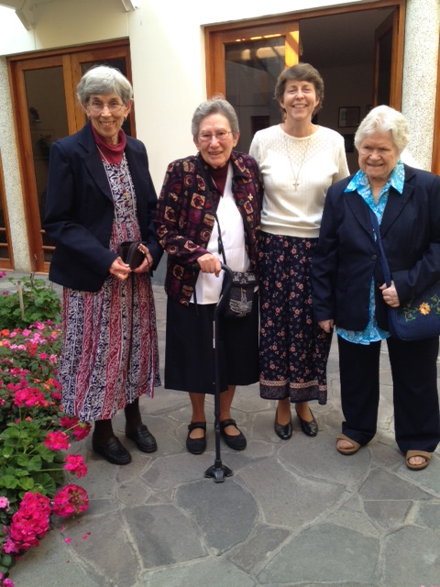

* Welcome, Peg!
We received our Sister Peg Murphy with joy in the early morning hours of the 16th of November. After two day in the house, she very generously accompanied Sister Marion Renkens giving her a tour of the city. Thank you Peg for your generosity and willingness to serve! Welcome to the VP!
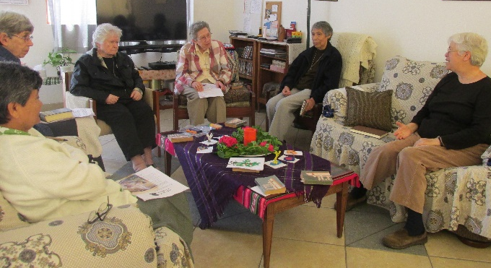
* Welcomed visitors
We have enjoyed the presence of our Sisters Patricia Vandenberg and Marion Renkens (SL). We shared our histories, memories, experiences, insights, desires, and our CSJ identity. These encounters help us to fortify our lives. Sister Patricia also shared how happy she was to return to Peru, especially for the celebration in Tacna. Sister Marion visited all of our communities and learned about our Peruvian history by visiting the museums. We thank both of them for their welcomed visit and we hope to see them again in other places as well.

* Thank you very much Sisters! (By Maritza Jarro, csj)
I recall with joy the first time my father took me to school; Colegio Fe y Alegría N° 40; it was Monday, April 4th, 1994. I was frightened because I was beginning high school in a new school and because my father had spoken to the Principal, Sister Zaida Perez. Then my father came and told me: “You will be fine with the Sisters; I told them to take care of you and to teach you well”. A few days later, my father died. At the funeral, the most surprising thing was to see Sister Kathy Crowley at the entrance of the cemetery with a group of students. How did they know that my father had died? I was in the school hardly a week and here they are accompanying me in these painful moments! These and many more gestures fill me with gratitude.
I have known many Sisters who have helped me to discover how God passes through my life as a student; some were my teachers and others my counselors. Neither will I ever forget the time when I was very angry I asked Sister Sally, who was my counselor and the director of theater: “Why are you leaving the school? What’s going to happen to us?” To which she answered with an incomprehensible assurance: “You will be fine; there are other persons to whom God is sending me; in this moment they are in greater need”. With this, I learned to let go and to accept the challenges with joy and confidence.
When I think about the 25 years that have gone by with the presence of our Sisters in the school Fe y Alegría, I thank God for their day to day companionship to persons that, like me, find support, testimony, a different style of living, Sisters who love without limit. Generations of families have experienced the charism of the Congregation through all the Sisters who have passed through the school.
That’s why, today I take advantage of the opportunity to tell them and us, THANK YOU, Sisters. All the shared happiness, their acceptance without distinction, the tenderness of their accompaniment, their fraternal corrections, the difficult challenges; that is, all the tenderness of their efforts to make the Reign of God present to us WAS WORTH IT. Paraphrasing my father’s words, they did a good job these 25 years; they took care of us and taught us well together with the entire community of the school. As an exAlumna, I give testimony of this.
Maritza y Patricia as CSJs

* Painting our House
The first floor of our Vice Provincial house is being painted by Sr. Eulogio and his efficient team. We hope that everything will be finished by mid January. This week-end they will paint the kitchen and dining room. This will give us new opportunities to adapt ourselves to the wear and tear of the painting. As the saying goes: “Today there are discomforts, tomorrow all smiles”.

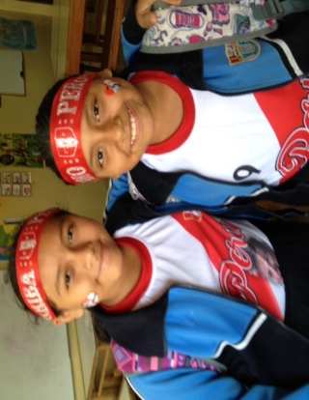
NEWS FROM THE GRAN AMOR DE DIOS COMMUNITY (CANTO CHICO)
Like most human beings, we live and experience events that generally are not the usual by which our encouragement and desires are revived. An example above all was when our team classified to participate in Russia, 2018. The majority of Peruvians wore a P for Patria (country) and a P for Peru. That’s why our boys and girls in “Salón San José” made us happy to see them with their Peruvian headband and T-shirt.

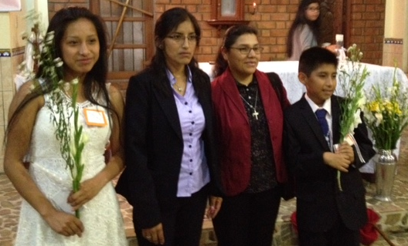
November 25th, our Sisters Mary Luz, Robertina and Anne accompanied a group of adolescents making their First Communion. We pray for them and hope that they will continue to grow in their faith.

Our community lived a very special day with the visits of our Sisters: Marion Renkins from St. Louis and Agripina Morales. Their fraternal presence brought back memories of the celebration of the 175 years of presence as CSJs in St. Louis; because Sister Marion was our hostess and we lived the experience with admiration. What happiness when our contacts reach out and cross borders!
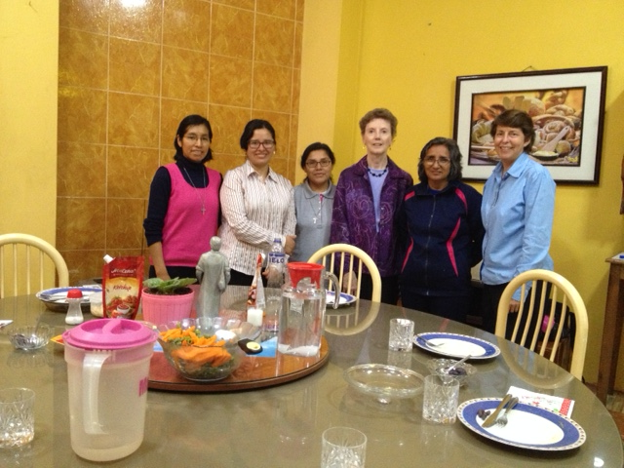
Jesus, the Lord, who converted water into wine, the one who laughs and dances with his friends, teaches us the value of friendship, the value of sharing. To share is to FEEL AT HOME and to FEEL that one is part of the other. It was like that when our dear Evelyn celebrated her birthday and invited us to share that special moment together with her family. We pray that the whole year will be blessing for you, Evelyn!

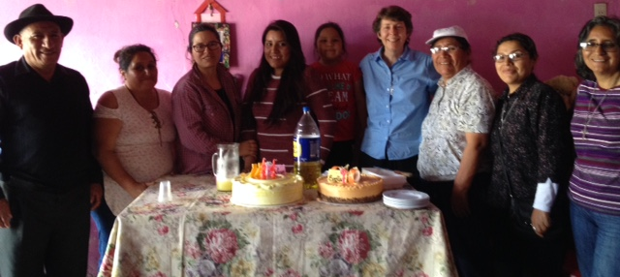
Evelyn is in the center next to Yoli.
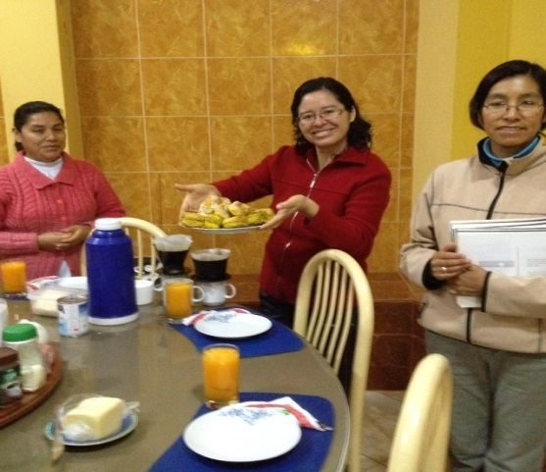
To have the privilege of belonging to an international congregation permits us to share, to know and to live the diversity that unites us and fills us with joy. As a community, we celebrated Thanksgiving Day with pastries made by Yoli’s father. He sent the pastries from San Silvestre de Cochán (Cajamarca). The pastries arrived the night before Thanksgiving Day. What a great surprise!

Modern life and technology can’t be held back, even though to various poorer sectors it arrives slower. None the less, today we can have Natural Gas in Canto Chico. The installation is very extensive; they have to install pipes in the house. The work is hard and super dirty. Dust invades every corner of the entire house.
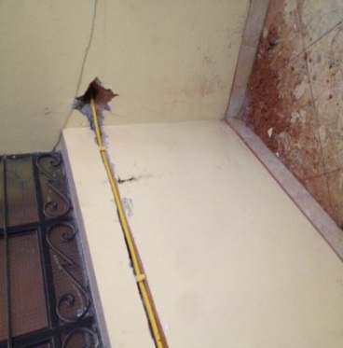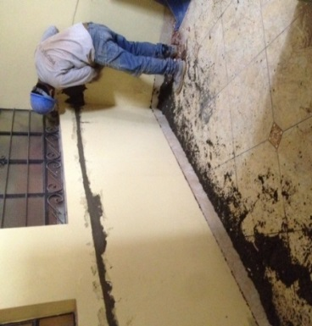

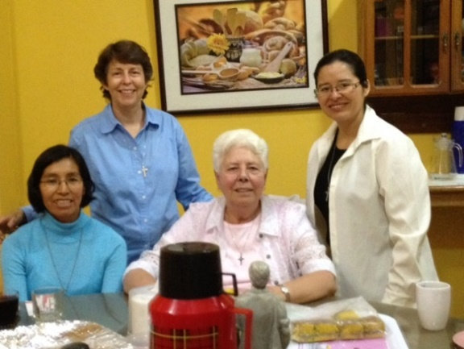
The month ended with the welcomed visit from our Sister Patricia VandenBergh. Her presence, even though it was only an hour, is significant in that we lived our unity with the experience of- seeing each other, giving each other a hug, laughing together; details that make our consecrated life an experience of faith. Moreover, to listen to her experiences lived in different parts of Peru (San José de Lourdes, the Sur Andino, Tacna, etc.) motivates us to continue to admire our life of ministry. Thank you, Patricia for your presence!

NEWS FROM TRINITARIAN COMMUNITY (TACNA)

GRATITUDE FOR WHAT WE HAVE LIVED, CONFIDENCE AND HOPE FOR WHAT IS TO COME, WITH GOD’S BLESSINGS
The Vice Province of Peru has lived a very gratifying experience when the educational community of San José Fe y Alegría N°.40 invited us to celebrate the 25 years of life and service with love of the Sisters of St. Joseph of Carondelet from 1993 to the present. It was a profusion of love, gratitude and great care in all the moments of the 24th of November of 2017, dedicated to the Sisters of St. Joseph of Carondelet.

It was planned in secret and with the participation o every member of the educative community. They asked us to arrive together at the school. A lovely formation of uniformed students welcomed us with a lot of love. As we looked up, we saw a poster of welcome (see photo 1). We remembered the Sisters who could not be present, but they were in our conversations at diverse moments: Sisters Alma Jones, Sally Harper, Kathy Crowley, and Rosa Orellana. The principal, professor Hernán Chiri, the vice principals Agustín Anquise of the High School and Rosa Luz Condori of Primary, and many of the teachers came to welcome us.
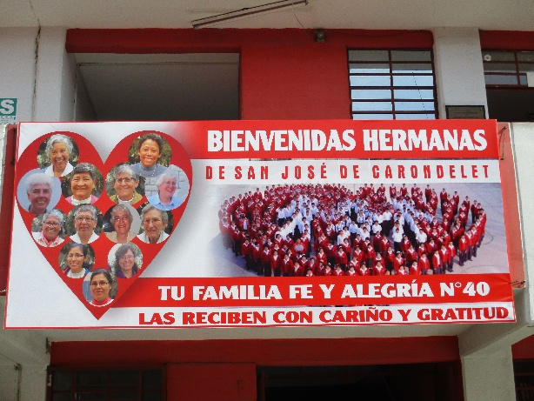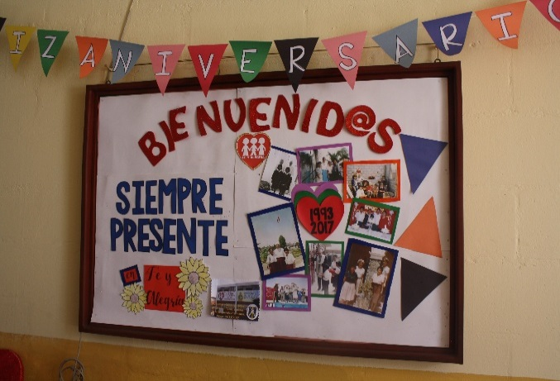
Welcome to the Sisters (photo 1) photo 2

The motto of the school could not be omitted. (See photo 2) It is sung by all the members of different groups and events where we participated. We enjoyed photos of the early years of the school and these brought back memories to our conversations.
These were exciting encounters with teachers, students and parents with the 10 of us Sisters who were present (see photo 3).
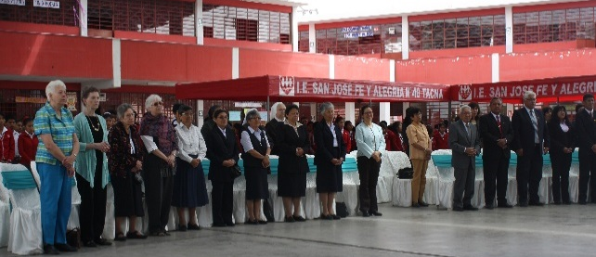
Photo 3: Left to right: Sisters Patricia VandenBergh, Marion Renkens, Dolores Muñoz, Peggy Murphy, María Vásquez, Mary Luz Salazar, María Inés Gutiérrez, Gloria Zapata, Zaida Perez and Yolanda Arribasplata.

We participated in a Eucharistic celebration presided by Father Nino Vasquez, Jesuit Superior in Tacna who in his homily spoke words honoring the Sisters and expressing gratitude for our work.

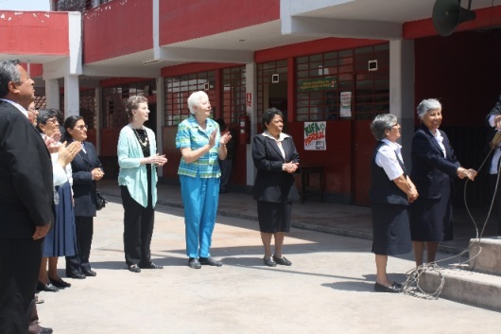
Following the Liturgy, there was a well prepared show of talents where gestures of gratitude were very significant. One of the important acts, to which we were invited to participate, was the raising of the National Flag accompanied by the band and the singing of the National Anthem. The principal and his team; other principals from neighboring Catholic schools; some authorities from the education office; some of the founders of the school and other professionals were present. (See photo 4).

Ten boys and girls presented us with beautiful white candles signifying the love and gratitude of the students. They were presented with the traditional “abrazo”. (See photos 5 y 6). Throughout the program there was an exuberant display of flowers which were presented to signify their appreciation for our friendship and service. The acts of homage given to the Congregation and the reception of their beautiful gifts left us very grateful and encouraged to continue this valuable work of formation of our youth.
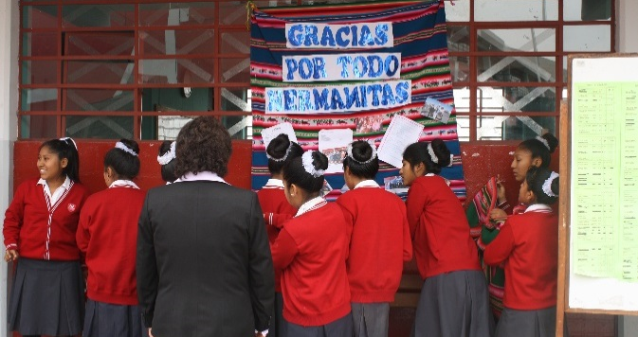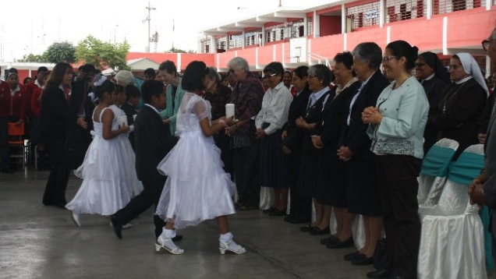

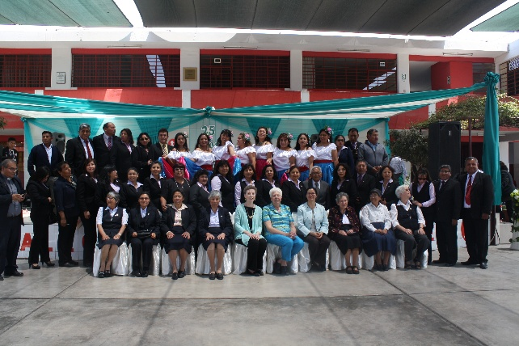
We closed this extravaganza taking a photo of all of us who were present (see photo 7). Through it all, we could appreciate each of their collaboration and coordination.

Following this, we were invited to enjoy a toast with the traditional pisco sour. One of the founding teachers, Professor Raul, gave the toast expressing his gratitude and hopes for the coming years. While “bocaditos” were being served, we heard the interesting poem written by Professor Reymundo Hualpa, “Las manos de San José” (The hands of St. Joseph). It was recited by a group of students.

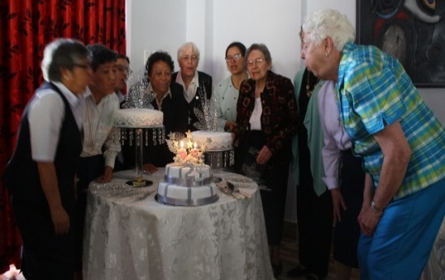
And finally for the day, we were taken to a new social events restaurant belonging to the Professor Patricia Ramírez, who opened it in her own home. Here, we enjoyed a delicious dinner with music and dancing after. The atmosphere was filled with happiness expressed through the conversations and we have a photo to remember the joy of our being together (see photo 8).

This event was like “a massage to the heart” because it encouraged us and we could live once again our service to our students in friendship. Thank you, Sisters, those of us still in this work and those who through the years have served here!

Thanksgiving Celebration in Tacna! With great joy, we had Patricia VandenBergh with us for Thanksgiving Day and together we prepared a feast. It was really giving thanks for sharing life with this educative community during 25 years. We are witnesses to the great love that went into the preparation of this homage to the Congregation.

On another note, in Tacna, we finished the year’s activities together with the Consortium of Catholic Schools with a Liturgy to celebrate Christmas. Each school presented what to them was the most significant event of the year and ended their presentation with a Christmas carol. We have also participated in CONFER-Tacna and will also celebrate Christmas with the Bishop of the Dioceses. In addition, we had a meeting with the Jesuit Regional Coordination to project actions for the coming year. One of the items was information about the Ignatian Spiritual Exercises offered to its board members in Arequipa. Our principal and his team of our school will be participants.
Also good news is that the Jesuits of Tacna are collaborating with their construction team in the much needed construction of extra classrooms for our school. We are hoping to have the support of the Central Office of Fe y Alegría as well. We ask you for prayers for this intention.

PRAYERS
* For the health of our families and friends as we accompany them with faith and hope.
8 María Vásquez (P)
May God Bless You All the Days of Your Life!
21 Zaida Pérez (P)
24 FrancineCostello (H)

