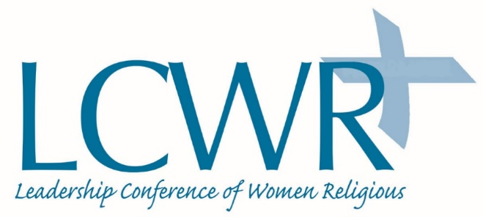

LCWR Denounces the Administrations’ Decision to Rescind TPS for Salvadorans

The Leadership Conference of Women Religious strongly denounces the cruel decision by the Trump administration to terminate Temporary Protected Status (TPS) for more than 200,000 Salvadorans. El Salvador is the fourth country whose citizens have been stripped of their right to protection by President Trump’s administration. Rescinding TPS from human beings under continuing threat of violence of all types is inconsistent with the values and traditions of this nation and with our belief in the dignity of all persons.

The TPS program is designed to protect people from being returned to harm. That is precisely what Salvadorans will face if they are deported. El Salvador is the most violent country in the Western Hemisphere and continues to suffer from endemic poverty, lack of access to quality education and healthcare.

TPS holders are our neighbors and friends. They have been have been contributing members of our communities for decades. Rescinding TPS protection for citizens of El Salvador, Haiti, Nicaragua, and Sudan and threatening Hondurans with the same, places us all at risk. Ending their protection will tear families apart, fragment our communities, and disrupt local economies.

Catholic sisters will continue to heed the scriptural command to welcome the stranger and care for those in need. We urge the Trump administration to reconsider its decisions and we call on Congress to work in a bipartisan manner to develop legislative solutions to protect vulnerable people.

January 9, 2018

