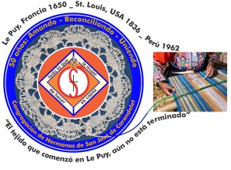
Congregación de las
Hermanas de San José de Carondelet

Jr. Talara 344 – Jesús María, Lima 11, Perú Tel. Casa 01-424-5092 Oficina 01-757-0980
Apartado 11082 – Jesús María, Lima, Perú Email: hna.csjperu@gmail.com
___________________________________________________________________________________________

NOTICIERO DE ABRIL – 2018

Dear Sisters: In this post Pascal time, we continue to meditate on the life of the resurrected Jesus, our Lord. We are also invited to discover his resurrected presence in the events of our daily lives and especially in all persons. We are a living presence of our Unifying God. In the midst of this terribly divided and violent world, we are called to love, reconcile and unite all things in the service of the dear neighbor without distinction.

With love,

Gloria, Zaida and Maritza

IMPORTANT NOTICE
* Sister Zaida Perez Peralta´s new cel number is 958-670-771.
* Please, put in your calendar two important dates for 2019: VP Assembly, from January 3 to 7 and the VP Chapter during Holy Week in April, 2019.
* The Kakehashi meeting will be from January 11 to 14 of 2019 in the Los Angeles Province.
* The VP Pre-Chapter meeting, with the presence of Sister Mary Ann Leininger and the facilitators, Sisters Sally Harper and Ruth Matos will begin on July 29 in the afternoon, 30 and 31 of August, 2018. Please, put these dates in your calendars.

WELCOME, SISTERS:
* Betty and Dolo returned from their home visits on May 6
* Gladys Leigh will visit us in May
* Patricia Chang (LA) will arrive on May 24 until June 30
* Norma Ramos, CSJL is in France from May 7 and will return on May 22
* Rosa Orellana will be with us from June 13 until July 26
*The Familia de San José will be here for CSJ days: July 30 to August 3
* Teresa Avalos and Theresa Kvale will visit us from the 1st of August ‘til the 15th
* Mary Mc Glone will arrive on July 30
* María Schuh is on home visit from April 14 to June 27
* Peggy Murphy will return on July 29
* Teresa Ponce will return on Nov. 2

WELCOME, PAMELA
* After several visits with us Pamela would like a longer time experience to get to know our CSJ community; this would help her in her discernment of God’s call in her life. Pamela will arrive in June and will stay a few months to serve the dear neighbor and to share life with us. We give her our warmest welcome; accepting and companioning her in this special time in her life.
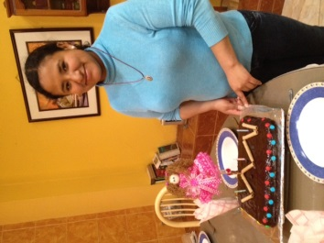

NEWS FROM LA CASA Viceprovincial SAN JOSÉ

*Getting closer to the dear neighbor, On April 11 Mauricia and Ruth had a meeting with Sisters Patricia Dieringer (Holy Cross) and Ana María (Holy Names of Jesus and María), who are the representatives of CONFER to assist the people after the disaster of the floods in the rural areas on the coast including Lima (Desastre del Niño Costero). Their object is to help the families in Carapongo (Lima) who are still living in the ruins left by the floods because the local and regional authorities have done little or nothing to bring help to the people. These families have been swindled by unscrupulous realtors who traffic with properties, cheating the residents affected by the floods with over 20 thousand dollars.
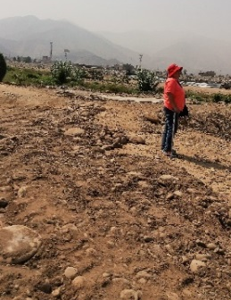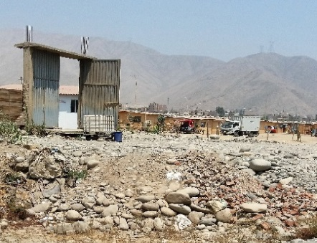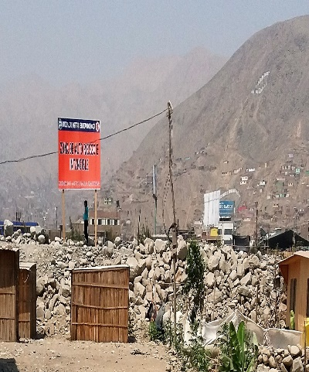
* Zoom about”Easter”. We had a very enjoyable meeting via zoom on April 12; it was a profound experience in sharing. We were a multicultural group: Hawaii, Japan, Los Angeles and Peru. Everybody participated and shared in the small groups sharing about the presence of God in our life and how we recognize God in the key moments of our lives. We can also recognize God as he comes to our encounter in our own congregational units. Thank you Sisters!
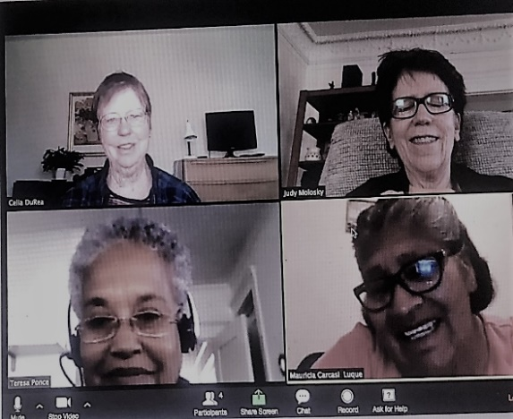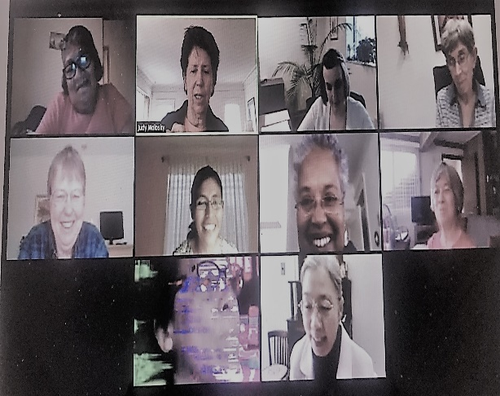
Potos by Judy Molosky (LA)

* Sisters Gloria, Genoveva, Norma (CSJ of Lyon), Patricia (Dominican of Springfield) and Robertina participated in the XII Theological Week on Consecrated Life sponsored by CONFER-Peru from 17 to 19 of April. The topics were: Where are the poor? Challenges for the Diminishing Consecrated Life: New opportunities of Option for the poor; and New opportunities for a diminishing religious life. We had a full panel for three days: TO SEE on the 1st; TO JUDGE on the second; and TO TAKE ACCION on the third day. – Celebration and Commitment.

* Health: Maria Ines has begun her chemotherapy; she receives it at home in the Center VP House. As of April, she is a member of this community: she can be reached at Apartado 11082 – Lima 11, and of course, she has her cel phone and WhatsApp; she would be very happy to receive your communications. We continue to pray from her health. We celebrated her birthday on the 21st of April and she had the visits of her nephew and family as well as from other friends.

* Return from Chincha-Ica, Maria Vasquez returned very happy and content with her experience with the Sisters of St. Joseph of Canada in Chincha. She was surprised by the reality of a lot of poor families and by the pastoral commitment of Sisters Gloria Muchaypiña and María Choquez.

* Family care giver, Mauricia will go to Puno to care for her Sister, Maria, who is 84 and lives alone in her rural community (Huancho - Huancane). She is not well; let us pray for her.

* Celebrating life, María Schuh and Gloria celebrated their birthdays with a delicious dinner and dessert, all prepared by Patricia De la ‘O (Dominican Sister). Later in the month we celebrated Robertina and María Inés; again, with a delicious dinner and a birthday cake. The chefs, in this case, were Genoveva and Gloria.

*Sister María Schuh had a beautiful farewell party, with a toast and time together. We hope you enjoy your vacation time, dear María!
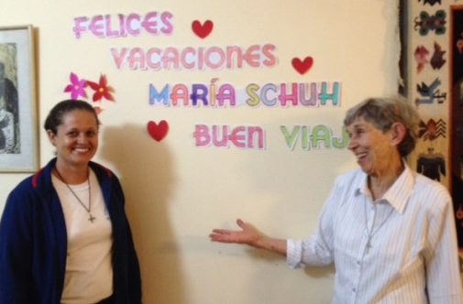
Sisters Norma and María Schuh Sally and María Schuh

* Dolo and Betty were visiting their families and the sisters of the Los Angeles Province. They visited with Teresa Ponce in her Wilton Place community. We are very happy to have them back again.
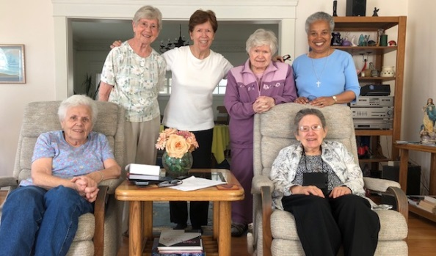
Seated: Anne McMullen and Dolo.
standing: Joan Goulden, Judy Molosky, Betty and Teresa

NEWS FROM THE GRAN AMOR DE DIOS COMMUNITY (CANTO CHICO)

We thank God for so many gifts
* On April 1st the Gran Amor de Dios community, together with our Sisters Betty, Dolito and María S. went to the San Miguel Mall to enjoy an ice cream preparation called “banana splits” in honor of Easter and because our Sister Yoli returned from her retreat with a renewed Spirit and was full of enthusiasm. We also wanted to enjoy time with Betty, Dolito and María S, before their trips to the USA for their home visit.
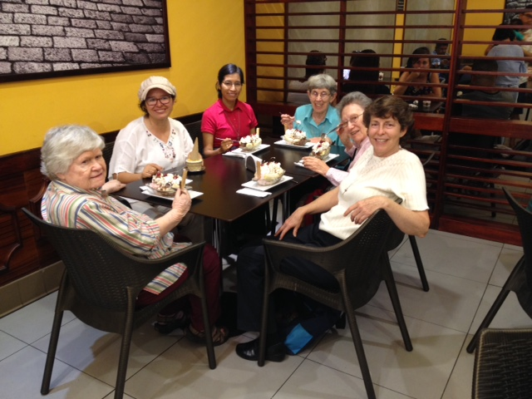
Service to the dear neighbor:
*During the month of April we had more than 100 children coming to the Sala San José asking for help with their homework and with a great desire to learn more. Thank God that our Sister Anne and 6 youths from the barrio accompany and fortify these children in their learning process.
* Here Anne is helping a child to study the multiplication tables; in the next photo Anderson is showing his good grade with great pride. We can expect all things; one day a little girl came with her homework and her dog.
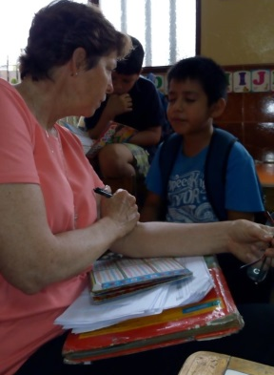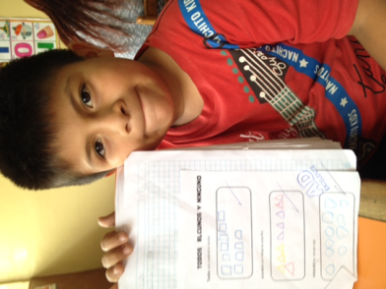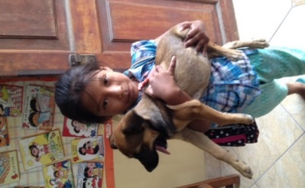
* What has become a custom, the children of Sala San José have something special every Friday; it could be a mathematics Bingo, Art or other games to enjoy and relax.
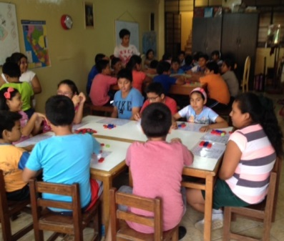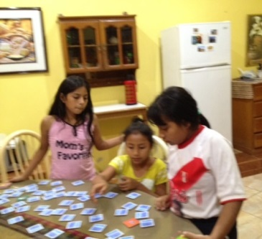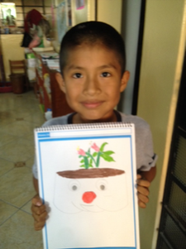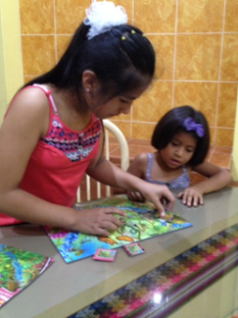
* In addition, after all the activities in Sala San Jose are finished, these children collaborate by cleaning the space that was used, as you can see in the following photos:
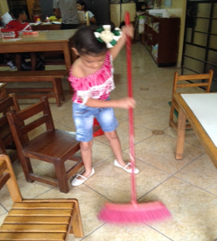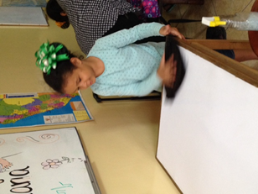

* Our Sister Yoli, is accompaning the children and some families in our barrio who need more help by using her profesional preparation in pyschology.
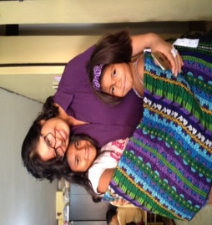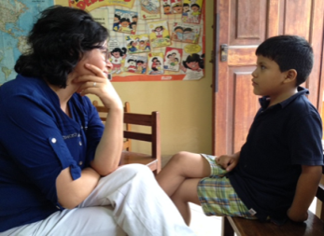
* In addition, Yoli comments the following: “As Sisters of St. Joseph living our charism and spirituality of Unity and Reconciliation, we do not separate ourselves from the dear neighbor and in a special manner, the most vulnerable”. Because of this, since February Yoli has been working with the foundation “Psychology Lives” (“Vive Psicología”) from Jaen (Northern Peru) helping young professionals and students in psychology to be listeners. She supervises the process virtually.
During the month of April, Yoli motivated young professionals to participate in the “Conversations of the Listening Centers” at the University “Antonio Ruiz de Montoya” in the city of Lima and whose objective is to make known the social work that is being done in the provinces to promote good mental health!
“Know all the theories. Master all the techniques, but when you are touching a human soul, remember to be just another human soul” (Jung).

* Our Sister María Elena is also enjoying her work in the Fe y Alegría School Nº 32. In the first photo, she is with her students who participated in the retreat, “Juveniles celebrating Easter”. The second photo is the pastoral activity on Saturdays where Maria Elena also participates.
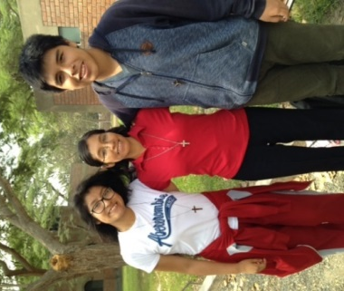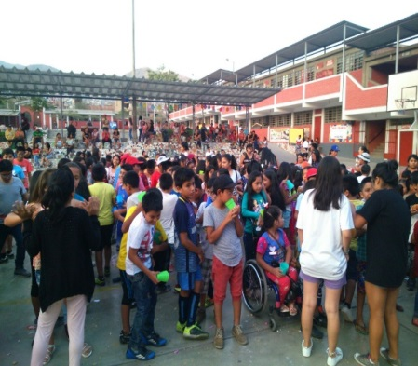
Community Life:
Our Sisters of the Gran Amor de Dios Community also took time out for community recreation in a very special place near the Pacific Ocean, where they enjoyed nature and some delicious food.
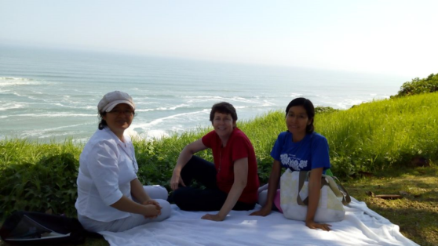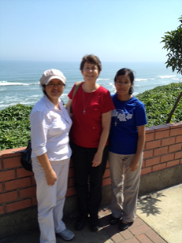

Visit from our friends
On April 27 we had a visit from Lily, Yoli’s friend from Cajamarca. We also had a visit from Rosa Luz and Lucero with her daughter Samy; this child was so happy and excited in our house, so much so, that Anne said she hoped that she will be a novice in 2038
.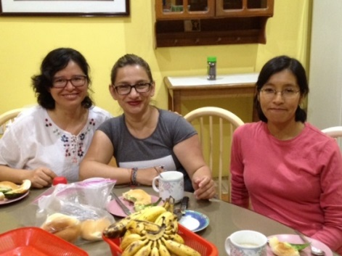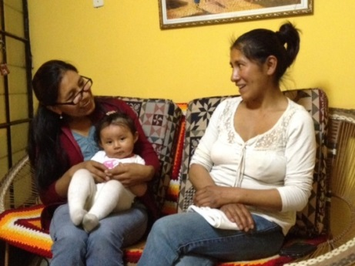
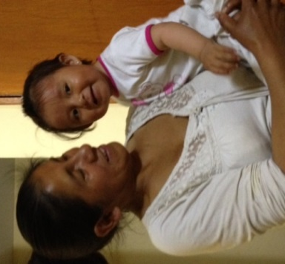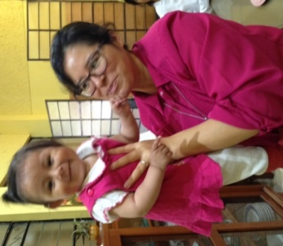

Visitors to come from the USA in the month of May
On Wednesday, May 30th, 18 students and 3 teachers from the Academy of Our Lady of Peace, in San Diego, California will visit us in Canto Chico. This academy was founded in 1882 by the Sisters of St. Joseph. The students want to know about our CSJ mission in Peru and they asked to visit our afterschool program and help the children with their homework in Canto Chico. Before their visit to Peru, these students had a fund raiser activity in their school pro our CSJ mission in Peru. The night of their visit, they will participate in the religious celebration in honor of the Cross. After their visit in Canto Chico, the group will go to Cusco, Machu Picchu and Puno. Welcome, Welcome!

NEWS FROM THE PEQUEÑO PROYECTO COMMUNITY (BRISAS)

Our community is at last united as it should be and is involved in the parish work. Agripina has been on a 30 day retreat in preparation for her final vows; we have accompanied her with our prayers and now that she is newly integrated into the community, she expresses her gratitude:
Dear Sisters,
I thank each of you for accompanying me with your love and prayers during the month of my spiritual exercises.
For me, this has been a time full of rich and profound experiences. It was a time to savor the living presence of God and to grow in familiarity with this God who totally gives himself to all humanity, for love.
At the same time, it was a time to look at my relationship and the way that I have been able to feel and discover Jesus, and how this relationship has, little by little, deepened in me. These have been special days and very significant because I have tried to walk with Christ, reviewing and enjoying his life and my history; I think the challenge is to live and practice it with the community and with the people.
Now, Jesus for me:
Is the one who gives meaning to life and is the reason for all of its existence,
Is the one who leads us along secure paths and sustains us when we fall,
Is the one who excites and surprises our days with the miracles of each day,
Is the one who knows us even to the smallest detail of our dreams,
Is the one who makes love to us all our being and with such gentle care,
Is the love who seduces us to abandon all and follow him,
Is indescribable and incomparable in the way we feel and see,
Is the peace in our hearts in all our adversities,
You are God and you lead us to eternity,
You are the face of God, Father Mother and
it is reflected in the little ones.

* We are also collaborating in the chapel with the sacramental preparation of First Communion, Liturgy, and help to the catechists of confirmation and later on, we will help with other projects. Mary Luz continues with her sessions of reflexology.
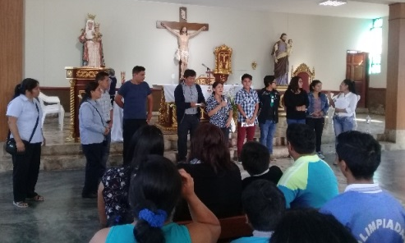
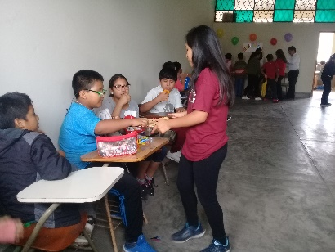

Maritza and Mary Luz are hard a work with the study of English and their university courses for their Masters.

NEWS FROM THE TRINITARIAN COMMUNITY (TACNA)
* Fe y Alegría of Perú has chosen us as a pilot center for the work with high school students in a program to form and prepare for the use of this 3 dimensional printer. In the photos we can see the young lady who trains for the skills, and the technician who installed it as the teachers for the Formation for the Work look on. We observe the machine and then the product: a cross which was designed and reproduced in a workshop to train technical teachers. With this program the students will learn the process beginning with how to state the problem until they learn to create the tools for the solution of those problems. We are surprised by the information that this tool is capable of opening new venues of work in the future. Because of this, it is necessary to prepare students from their infancy. Thank you, Fe y Alegría!
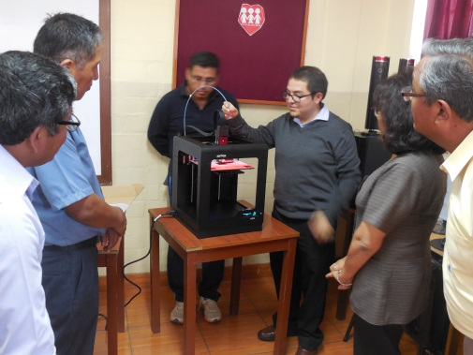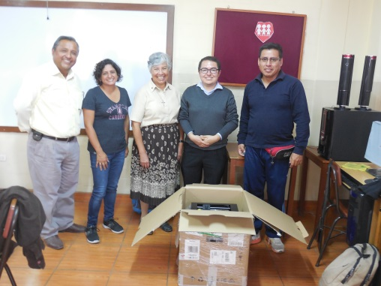

On April 30 we celebrated Mrs. Fresia Menendez for her 25 years of service in Fe y Alegría. She was part of the founding personnel; she served as secretary and the last few years as an auxiliary of education in high school. She is well known by all the sisters who have worked in the school. Fresia retired in January and this was an opportunity for all of us to thank her for her dedication, service and help through the years. In the photo, we can see her (next to Zaida) in the first years of the school.
UNITED IN PRAYER
* for María Inés who continues her battle against cancer with great courage. We continue to accompany her with our prayers.
* for Mrs. Liliana, Gloria’s cousin, who had heart surgery and is recuperating well.

Birthdays in the month of May
3 Mary Luz Salazar
31 Edilia Guerra (FSJ-Chile)

