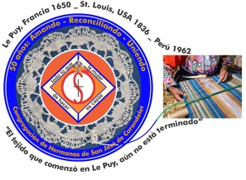
Congregación de las
Hermanas de San José de Carondelet

Jr. Talara 344 – Jesús María, Lima 11, Perú Tel. Casa 01-757-0980
Apartado 11082 – Jesús María, Lima, Perú Email: hna.csjperu@gmail.com
_________________________________________________________________________________________________

NOTICIERO SEPTEMBER AND OCTOBER 2018

Dear Sisters:

We begin the month of October with the theme of Señor de los Milagros (Lord of Miracles). Accompanying our people, we prepare ourselves to receive the God of Mercy who is inviting us to receive his gift with a grateful and confident simplicity of heart. We place before him very especially the joys and sorrows, the lights and shadows of our lives, as well as, those in all the families of our country. We know that God will give us the grace to help us respond with our best efforts all the situations that we must live.

Also, during this month dedicated to the missions, may we continue to respond to the various activities in favor of the most vulnerable. While visiting Tacna, Mons. Pedro Barreto invited us not to lose hope: he said “…for me this means that our encounters with the Lord… is a motive of joy and hope because we need these encounters with the Lord as brothers and sisters, we are like pilgrims walking together in this life…”

May our journey be blessed in community as well as in those moments when we share our lives with the dear neighbor so that our world may have more life.

With love,

Gloria, Zaida and Maritza

MEETING OF THE CLG IN ST. PAUL

* Gloria and Maritza participated in the CLG meeting in St. Paul September19 to 24. It has been a good opportunity to continue to open our minds, hearts and wills to follow God´s call to us today. We were accompanied by St. Pope John XXIII with his prayer “Only for today” in different ways. We are grateful for the hospitality of the Sisters in St. Paul. We had the opportunity to visit with Annie (Agatha) Grossman and Teresa Kim who send greeting to all of you. Soon we will share a summary of the meeting and more details in our next visit to the communities.

WELCOME SISTERS!

* After waiting a long time, our Sister Robertina finally was able to travel on September 15 to begin a more prolonged experience with the Los Angeles Province. Thanks be to God because her visa was approved without any problems. We wish her a new experience filled with many blessings. Bon Voyage, dear Sister!
*Maria Ines was invited to celebrate the Anniversary of Colegio Fe y Alegría de Tacna. She will be there from 12 to 17 of October. We give thanks to our Lord for her recuperation and for the energy she has now. We appreciate her courage and testimony.

VISITS TO THE COMMUNITIES

*The VPLT will be visiting the local communities in October and November. We appreciate these times which enable us to share in a more personal manner our community life and mission in the VP. We count on your prayers during these special times in the following dates:
- Gran Amor de Dios Community (Canto Chico) from the afternoon of 29 to 30 of October
- San José Community (Center House) 2, 3 and 4 of November
- Pequeño Proyecto Community (Las Brisas) from the night of 5 to 6 of November
- Trinitarian Community (Tacna) from 9 to 11 of November

NEWS FROM THE SAN JOSE COMMUNITY (Jesús María)

Crece la Comunidad Intercongregacional
As of September, we have a new member in the community: Sister Jenny Mori of the Congregation of St. Joseph of the Sacred Heart (RSJ). She is studying for her Masters in Counseling and is in her second year. She has classes every other night and she works at the Ruiz de Montoya University in their Pastoral Office during the day. This is the first Jesuit University in Peru.

We celebrate The Gift of Life
We began the month of September celebrating with Dolores Muñoz (CSJ) who was 88 years old, and has been a presence in Peru for 53 years. We had a delicious dinner at Chilis’ in a Mexi-American style. We had a toast with Pisco Sours the night before.
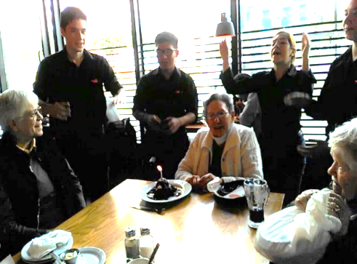

After that, it was Norma Ramos’ (HSJL) turn. It was a special day for her and she is very grateful to the Community for accompanying her during her time of studies in the Program of Accompaniment in Initial Formation. We shared a delicious cake and then we continued the fiesta with dancing.
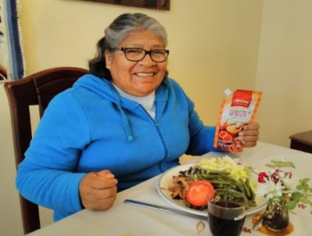
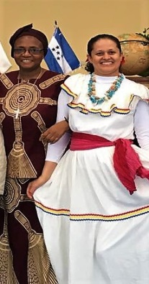
An then, the last Birthday of the month was Mauricia Carcasi’s (CSJ). We had a delicious dinner and then at night we toasted with Pisco Sours, a delicious pizza and time for conversation. There’s a saying here: “to remember is to live it again”.

We continue to Thank God for María Inés Gutiérrez’ (CSJ) recuperation; every day she has more energy. We are hopeful that she will continue to improve her health.

Vacations en el Altiplano
Genoveva Herrera (CSJ) went to Puno, her native land, for her vacation and at the same time to accompany her sister and brother-in-law. We hope that Genoveva will feel some relief in the health of her family.

Good news from the USA Embassy
Robertina Espinoza (CSJ) received the documents she needed from the lawyer in the US so that she could start the paper work for the VISA for Religious (R1) in the Embassy of the USA in Lima. Fortunately, her Passport with the VISA (R1) was approved and she could travel on the 15th of October on her way to the Province of Los Angeles.

Companioning the dear neighbor in Carapongo
In order to be more effective in the service to those suffering from the effects of the floods caused by ”el niño costero,” we have formed a network called “Carapongo Mission”. Sisters Patricia Dieringer, Ana María, Mauricia Carcasi, Ruth Matos and the lay women Sra. Ángela N. from Caritas Chosica and Sra. Patricia Casallo from the Aldeas Infantiles are part of this network.
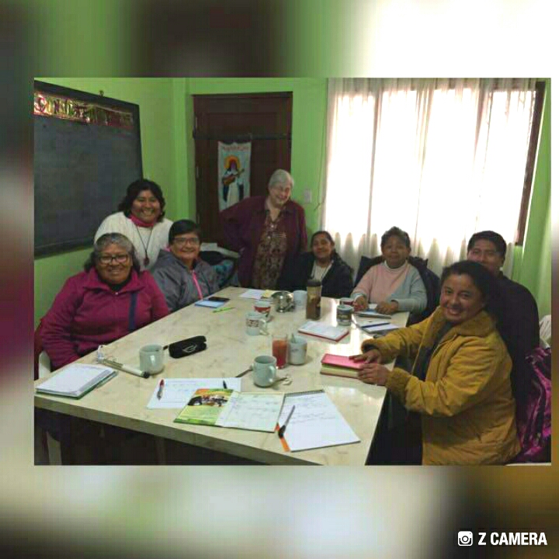

The barrios, Los Carrizales, Las Brisas, Guadalupe and Portillo were the objects of the Campaign for Health sponsored by the Conference of Religious of Peru (CONFER). The women received a surprise visit from Sister Escolastica of the Congregation Franciscan Missionaries of Mary and Sra. Dalila Gamarra, President of the National Network of Women Enterprisers. (Red Nacional de Mujeres Emprendedoras). They were encouraged to organize themselves and to open themselves up to consider the field of commercial occupations. At the same time, they offered to help them with consultations and training.
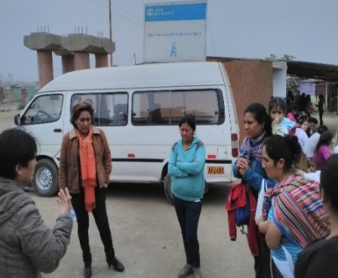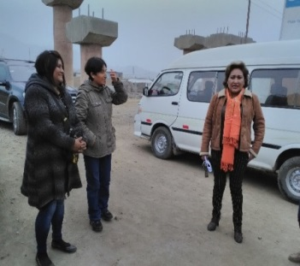

However, the families in the barrios, Nuevo Horizonte and Marino Segovia still dream of having their own home because they have a debt with the bank and need to continue paying it. Furthermore, due to the floods in 2017 they discovered that they had been swindled in the acquisition of this property. The Association of owners of this property started a law suit against the man who sold the people the property belonging to the original owners, and after that the directors of the Association told the people who bought the property that they would be evicted. And besides this, the land is declared not suitable to be used to build homes; it is for agriculture only. These families are facing difficult times. We ask for your prayers.
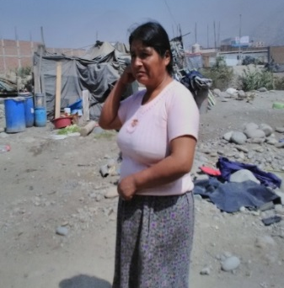

Soon a Psychological Assistance Office will be opened
The objective of this office is to respond to the Mental Health and Psychological needs in Carapongo. With the financial backing of the Sisters of St. Joseph’s STEP Board of Albany, services of Attention and Psychological Treatment will begin, preferably for Children and families at risk. The office is located in the Urbanization San Antonio de Carapongo, Avenue 3 west Mz I1 Lote 20. Soon we will receive the resolution from DIRIS, (Dirección Integral de Salud Lima Este) giving us permission to function. With that, the city license to function and the inspection from Civil Defense can be solicited. Thank you Sisters CSJ for your unconditional support. We are together in spirit and with one heart.

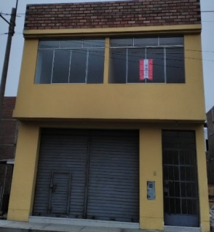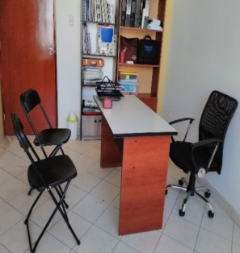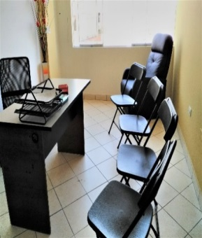

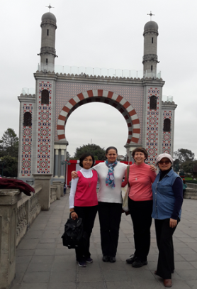
NEWS FROM THE GRAN AMOR DE DIOS COMMUNITY (Canto Chico)
September 16, we had a picnic as a community to strengthen our ties with one another by visiting new places we had never been to. We invited Sister Norma of the congregation of St. Joseph of Lyon to share it with us. We visited the Friendship Park and we all enjoyed a very special day.
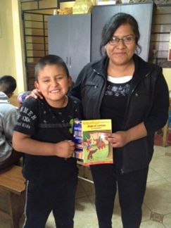
In the morning of September 21, we had a Eucharistic celebration and a gran breakfast with the Religious living in our parish. This event took place in the parish rectory so that we could get to know each other better and to share about our ministries. It was a good experience to share with other congregations about our life and mission. The next meeting will be held in our house in Canto Chico.
Activities in the Sala San José
In the San José classroom we continue to offer help so that the children can learn more, with the hope that their academic level will improve. The help and the personalized accompaniment that we give these children who need a lot are resulting very successful. Now we have children who have conquered their difficulties in Reading and Math. And, this is celebrated in the Sala San José with each child every Friday so that they may be more motivated in their studies.
In the photo, Samuel is pictured with Sandy one of the teachers. Samuel had difficulties with Reading, but now he has learned to read well, thanks to the additional help that Sandy gave him every Saturday. Sandy is an ex participant of Salón San José who is now actually studying in the university and majoring in mathematics.
The children not only have to do the homework their teachers give them but also must prepare themselves to be ready for the quizzes and tests that they have in their classes in school. At present, an incentive for the children to get good grades in school is that they can participate in a raffle with different prizes offered by Salón San José.
By doing this, all the children get excited and they want to work harder to get good grades. That way they can participate in the raffle. The photos show the children who have gotten good grades in their school; that’s the reason why their names entered into the raffle and they won good prizes.
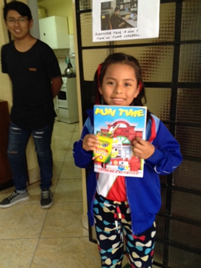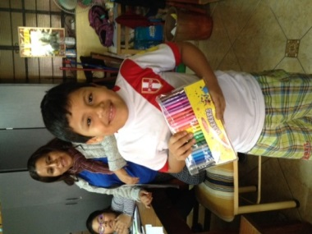

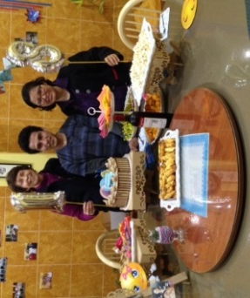
September 17, the young teachers who work in Salon San José together with our Sisters Anne and Yoli, celebrated the Birthday of Ronal, who is preparing to enter the university and who, in his free time teaches the children in Sala San José. Our Sisters Yoli and Anne said that it is a good experience to work and to celebrate life with them. It gives them a lot of joy to know that the majority of these young people have received help in Sala San José when they were children, and now they are becoming professionals.
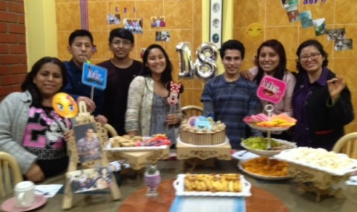

Activities in Fe y Alegría No. 32, Lima
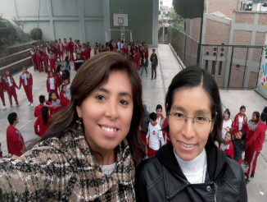
September 9, our Sister María Elena, together with her pastoral team, had a workshop with the high school students of 4th year in the Pastoral Center, Patricio Payton, which belongs to the Holy Cross congregation. She says that it was a good experience because the students participated with enthusiasm in all the programmed activities. The photo shows María Elena with her companion working together in Pastoral activities.

NEWS FROM THE PEQUEÑO PROYECTO COMMUNITY (Las Brisas de Villa)

Baptism of the children
It was a fiesta to see 39 children receiving the sacrament of Baptism and some were missing. The parents joyfully prepared the celebration for after the baptism. Before the celebration when the topic, the children of God, was introduced in class, a child, very concerned, asked “Where do the children who die without baptism go?” It was beautiful to see how happy he was on his Baptism day.
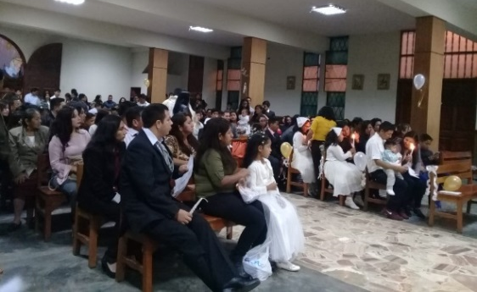
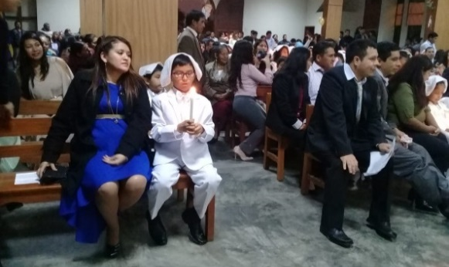

Activities pro remodeling of the Virgen de Lourdes Parish
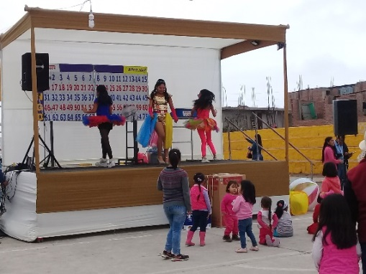
It is customary that every chapel supports the others in their activities when they need help so this time we in Brisas went to collaborate to raise funds for the remodeling of the parish.
There was a little bit of everything: Tombola, bingo, show, food, etc.

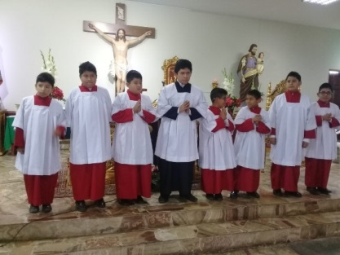
Mass Servers
On the day of San Tarsicio there were some servers who received their vestments in our chapel. We would have loved to have some girls for this service but the pastor says: “This is no role for girls, they can only be sacristans”, can that be interpreted to mean: the girls can wash the things that the boys dirty?

Milagros
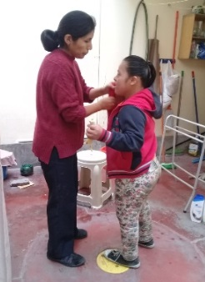
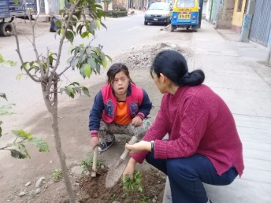
She is one of our neighbors who is always in the street, very often unkempt and forgotten by her family. We are happy because she comes near to greet us; she plays in front of our house, her favorite place. She loves to sweep the sidewalks and sometimes helps Maritza to clean and take care of the garden in front of our house. After the work, one day, she had a refreshing washing of her hair. We really enjoy this time with Milagros; we share her happiness because she teaches us to love with simplicity and confidence. We are looking forward to her next visit.

Remedial work in the Las Brisas School
With the permission of the principal of the Las Brisas School, Agripina is helping to bring up the level of understanding in the Spanish course of communication, specifically the “comprehension of selected texts”. She has class on Tuesdays and Thursdays applying the program she developed in her thesis. Our Sister Mary Luz is working on the primary school level with the children of first, second and third grades using language therapy in the same school.
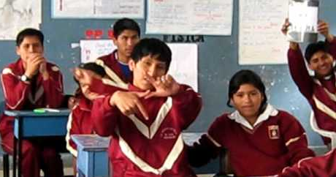

Sharing with a Venezuelan family
We have decided to invite some Venezuelan families to share with us our “almuerzo”; we invited those more or less known to us in the area. We are taking advantage of these moments to listen to them and ask them about their situation now.

Recently, we have had the pleasure o receiving the Yili family. They told us that they are happy to at last be together as a family in a place that is more tranquil and calm. Their three children are studying in the Las Brisas School because the principal gave them all the help they needed. Even though they must work many hours, they have what is necessary to live. At the same time, they talked about their fears because they don’t know the culture but they hope to find more opportunities for their children; they feel it is like a retrocession for them. We pray for the situation of so many Venezuelan families; that they may better their lives; both the ones who remained in Venezuela as well as those who emigrated.

NEWS FROM THE TRINITARIAN COMMUNITY (Tacna)

* September was the month of SPRING, YOUTH and the month of the LORD OF LOCUMBA which is the reason we had various interesting activities in Tacna – in the community and in the school.

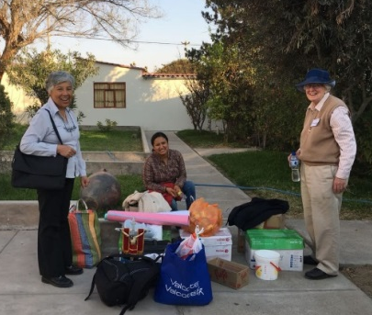
* From the middle of August until the end of September, Pamela Navarro shared with us our community life, ministry and prayer. Her presence and help were examples of her joy and generosity. Among other things, she helped with the retreat for the students of the Senior Class of 2018; she presented the content that is the fruit of many years of commitment as a catechist in her parish. She also contributed to the Spring march organized by the Pastoral of Juveniles together with Hanna, a Jesuit volunteer with whom she has become friends. In addition, she shared her knowledge of computer skills by putting the information from the family formularies into statistical form. We have enjoyed sharing our life with Pamela and we are very grateful for the way she contributed to our lives.

* We are celebrating Spring (Youth) with a lot of participation by the techers, admnistrative personnel and of service. The preparation for the numbers in the show took time with a lot of spirit which was exciting for the students. There were a variety of numbers: poems, songs and also the polyphonic choir of the school, and the teachers formed the honor guard with the flag. The students really enjoyed the show, the food and the music that were part of the celebration.

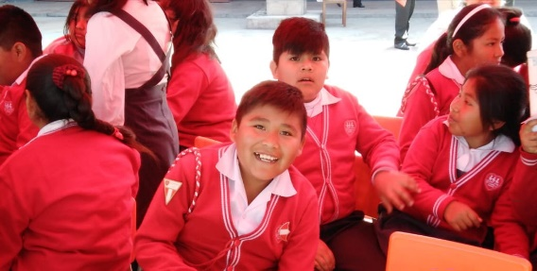

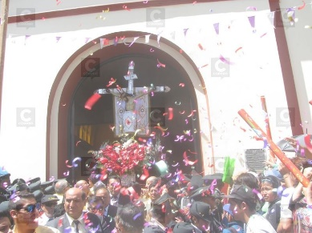
* We had a very welcomed visitor in the city of Tacna from the new Cardinal, Mons. Pedro Barreto. He celebrated the Mass in San Pedro Parish in the center of Tacna, a month’s mind for Mons. Santiago De Larracilla, SJ. He had been pastor there for many years, before he was named Bishop of Jaen. Monsignor Barreto, also, celebrated the principal Mass in the Señor de Locumba sanctuary on the day of its fiesta, which is on the 14th of September. For Monsignor the faith of the people is very important and he invited the people to stand firm and not allow anyone, under any circumstances, to take away their hope or their faith.
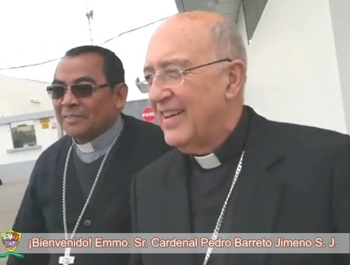
"It is with great joy that I am in the Heroic City once again; it is so that together, we can to meet with the Lord; that is the reason for my visit, for us to meet each other in our encounter with the Lord of Locumba, and that is the reason for my joy and hope because we are meeting with the Lord as brothers and sisters, as pilgrims who journey together in this life… Christ is Alive! And believe that He is not only an image; so I kneel at the feet of the Lord”.
(His first words when he arrived in Tacna)

* On Pamela’s Birthday, we took a trip to the City of Arica (Chile) as a community and we enjoyed it very much. It was a day of pure relaxation, visiting historic places and enjoying the view of the Pacific Ocean.

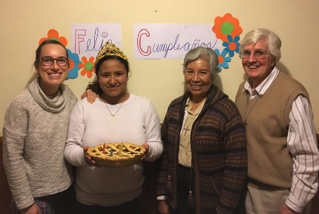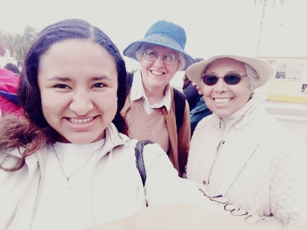

UNITED IN PRAYER
* We Thank God for the recuperation of our Sister Maria Ines. She has finished her sessions of chemotherapy. Prayer really is powerful.
*For the health of our sisters in different places so that they can continue to give testimony of unifying love in the midst of a world that becomes more vulnerable every day.
* For the eternal rest of Rosa Orellana’s uncle, who died in Huancayo. We express our condolences to all her family.

Happy Birthday to all who celebrate in the month of October
1 Teresa Ponce (P)
1 Mónica Ramírez (Familia SJ - Chile)
5 José María Cokely (A)
6 Juan Pedro Medaille (F)
8 Theresa Kvale (LA)
14 Mary Kay Kottenstete (SL)
14 Doreen Glynn (A)
15 Teresa Avalos (LA)
15 Anniversary of the Foundation of the Sisters of St. Joseph
19 Cristina Takeichi (J)
29 Agatha Grossman (SP)
30 Gladys Arancibia (Familia SJ - Chile)

