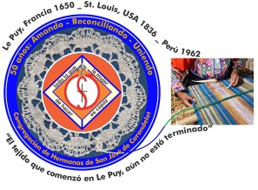
Congregación de las
Hermanas de San José de Carondelet

Jr. Talara 344 – Jesús María, Lima 11, Perú Tel. Casa 01-757-0980
Apartado 11082 – Jesús María, Lima, Perú Email: hna.csjperu@gmail.com
_________________________________________________________________________________________________

NOTICIERO NOVIEMBRE- 2018
Dear Sisters:

This time of Advent offers us the opportunity to renew our faith and our hope among ourselves and with the people of God that we accompany. We can experience what is life giving for them as well as their difficulties.

Even though we have received some bad news about our families and some about our Sisters, we know that God will give us the grace we need to confide totally in God who will not abandon his sons and daughters that he loves so much. God invites us to continue our journey with a vigilant spirit and a heart full of love.

Happy Advent!

With love,

Gloria, Zaida and Maritza

COMINGS AND GOINGS

* Mauricia who has been visiting and helping her sister will return on the 12th of December. We accompany them with our prayers and our love.
* Sally has visited with her family and she also attended the meeting of the Innovation committee. We are grateful to her for representing us in these important congregational meetings.
* We wish Teresa Ponce a pleasant journey to visit her family in Colombia; she will return on January 5th.
* We welcome Sister Sean Peters who is a member of the Leadership Team in Albany. Her objective is to practice her Spanish and to have time to get to know us better. She will arrive on December 23rd and will be with us until January 9th. Welcome Sean!

THE BOOKKEEPERS MEETING

On November 1st, the bookkeepers of the Vice Province gathered together with the VP Leadership Team to reflect and to prepare the budget for the coming year. We had a good dialog about important aspects of our lives and the mission of the Sisters of St. Joseph. We appreciate each community and the administration for their accountability in this important recourse. We renew our commitment to share our recourses with responsibility and to continue our service to the dear neighbor.
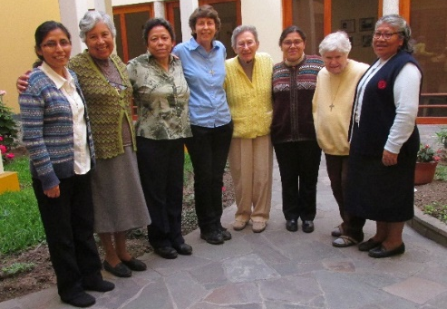
Maritza, Zaida, Gloria, Anne, Dolo, Mary Luz, Betty and Mauricia

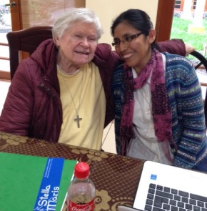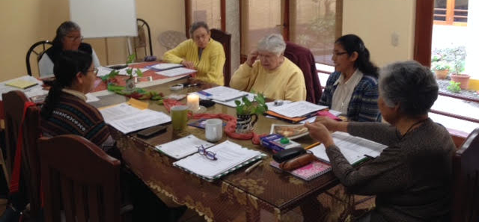
The dynamic duo We began the meeting with prayer lead by Betty

NEWS FROM THE SAN JOSE COMMUNITY (Jesus María)

* November 3rd we celebrated Betty Conrad’s 89th year of life. Your presence among us is a blessing, dear Sister. For dinner (almuerzo), we went to a Mexican restaurant, which Betty selected.
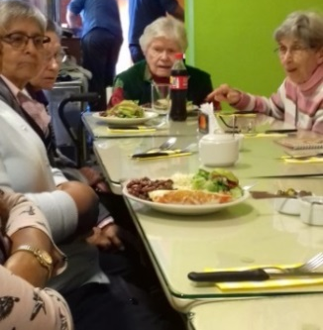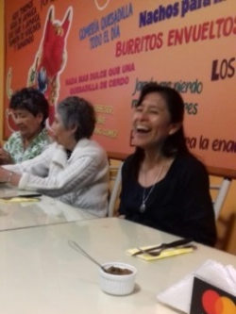

* The 4th of November, we had the blessing of the “Consultorio Psicológico”, (the Psychology Office), in Carapongo. The blessing was lead by Sisters Dolores Muñoz, Betty Conrad and Marie Schuh. The VP Leadership Team with the sisters from the “San José” Community, Anne Davis from the Canto Chico Community and Agripina from Las Brisas Community participated in the official inauguration of this project. Thank you, Sisters!
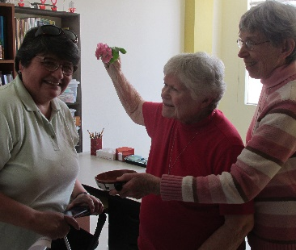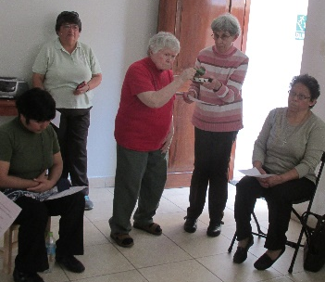
Blessing the Psychologist Blessing the Office

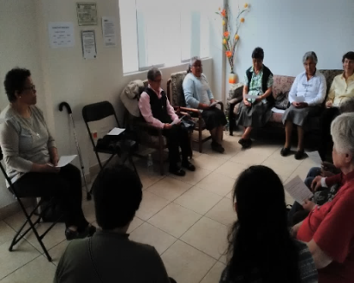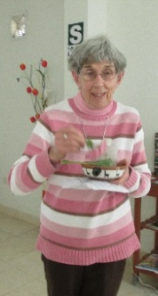
Here, we are in the waiting room of the Psychology Office

* Mauricia is on vacation in the “Holy Land of Huancho (Puno)”. She will return on December 12th.

* Gloria was on vacation from the 17th to the 27th of November in Chiclayo. She returned renewed.
* We gave Sisters Jenny Mori León, RSJC, and Norma Ramos, HSJL a blessing: “Anda y ve… el Señor te bendiga y te proteja”, (“Begin and go…the Lord bless and protect you”) which is part of a song. They returned to their respective Congregations: Jenny the 24th of November and Norma left for Mexico on November 27th.
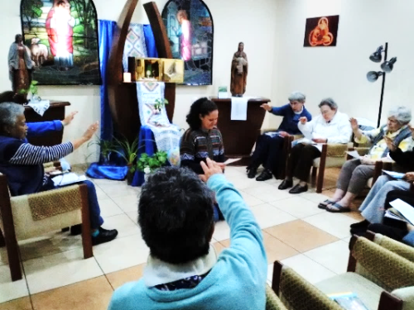
Blessing Sister Norma Ramos Sharing with Sister Jenny

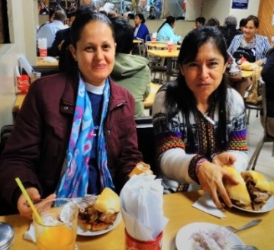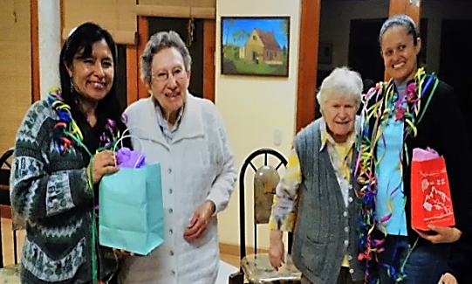
Enjoying!!! Jenny Mori RSJSC, Dolores Muñoz CSJ,
Betty Conrad CSJ and Norma Ramos HSJL
NEWS FROM THE GRAN AMOR DE DIOS COMMUNITY (Canto Chico)
* The mission in the Salón San Jose is impressive. The space is small, but it holds a lot of children and they share the space creatively in order to do their homework. The school year is coming to an end and the children continue to strive to better their learning as much now, or even more, as they did in the beginning of the year. During the month of November, we received 12 new students asking for help with their assignments because they have seen now much the children who come from the Salon San Jose are faithful to doing their homework and they see how much they are improving every day with their work in the classroom.
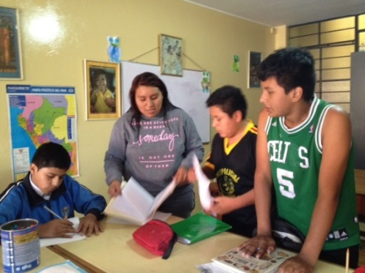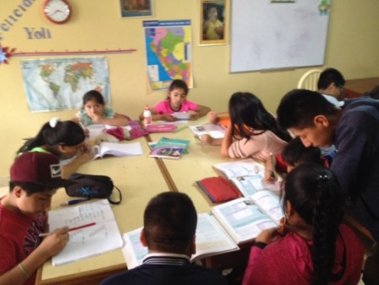

* This mission to accompany the children and to motivate them to do their assignments especially those who have more difficulties in learning; it is not easy. But thanks to the patience, perseverance and hope of the young students who help them, day after day, we can tell by the comments in the barrio that we are reaching our goal which is the advancement of these children and its fruits. We are grateful to all those who participate in this mission to help the children, directly or indirectly, giving of their time and sharing their gifts.

* In the following photo we see Jannik, a German volunteer, who is also helping to motivate the children in their studies with a lot of loving care and enthusiasm.
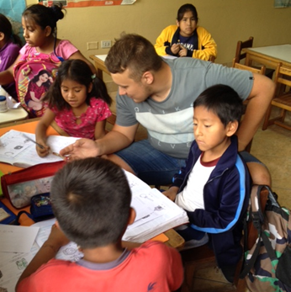
* Also, we had a lovely visit from Sister Maria Ines’ friends who were very touched by the children of Salón San José and they offered their services to prepare hot chocolate to celebrate Christmas with our children. We will have this activity on Sunday December 23rd at 10 o’clock in Canto Chico; with which we will terminate the school year of Salón San José.
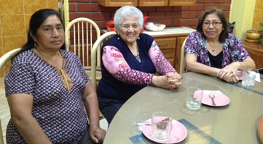
* Our Sister María Elena and her pastoral team in Fe y Alegría #32 School, had the last retreat of the year with their students on the 9th 10th and 11th of November at the Don Bosco Retreat House in Chosica with the participation of 140 students of fifth year high school, 4 parents and 8 members of the pastoral team. The experience was especially good for the majority of the students because it was a fraternal live-in experience for the graduates. The students were happy with the details of the retreat: the sharing of the reflections, the Mass, the dynamics, sharing the rooms and the food.
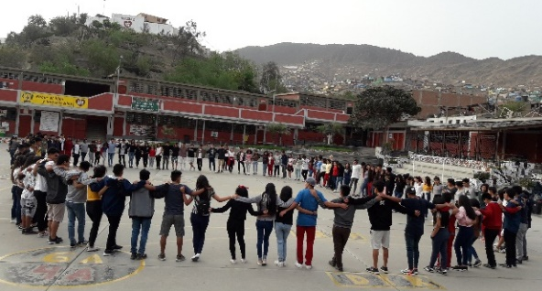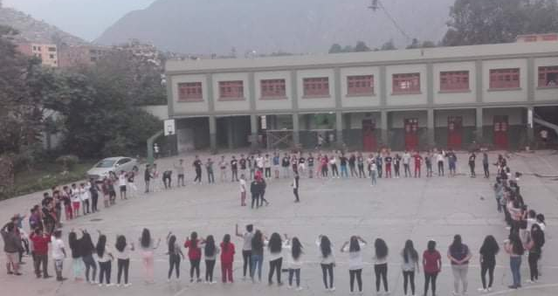

* Also, as a community, we had a meeting with the Holy Name Sisters who came to visit us; we had a lovely time sharing about our journey in the religious life and then we had a delicious lunch.
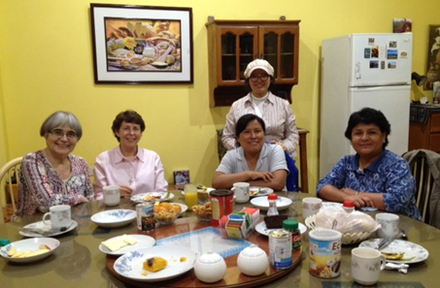

* Our Sister Yoli thoroughly enjoyed nature, as well as her time with her family and friends when she went on her vacation to the Holy Land of Cajamarca.
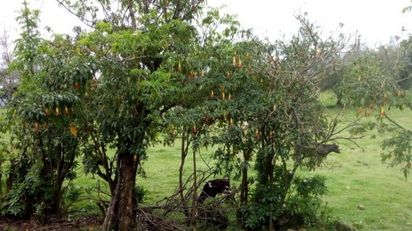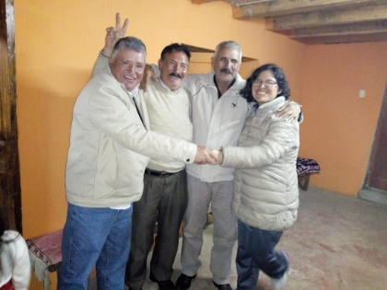

NEWS FROM THE PEQUEÑO PROYECTO COMMUNITY (Las Brisas de Villa)

Community living
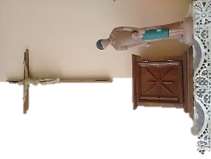
Day is awakening. I have been given a new day. We have another day to be able to hear, and read, and smell, and advance the new day in order to love and to give glory to God. We are alive to this new day.
It is in this way that we motivate each other at the beginning of our day with our prayer time and it is Jesus who sustains us in unity… and motivates us to share with the people.

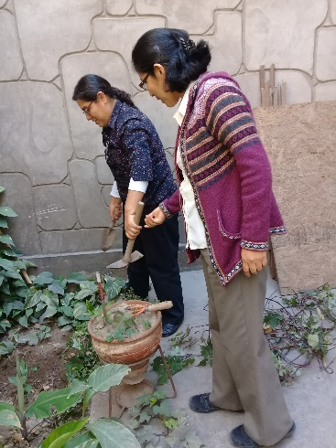
Generally, we are busy going about our mission but there are always at least short spaces of time to relax and to do things together; such as bursting bubbles, cultivating or harvesting the fruit in our small garden, trying to make sure that everything goes well.
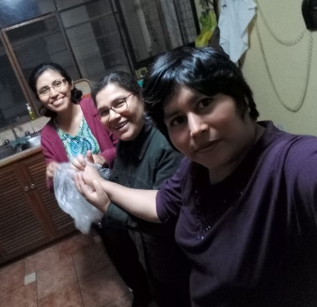
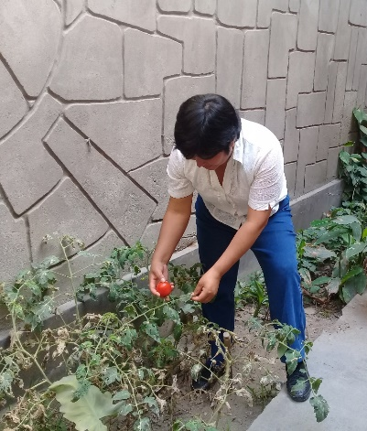
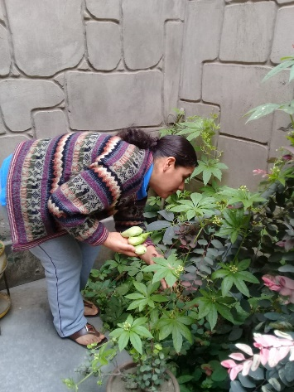

The Catechetical “family day meeting”
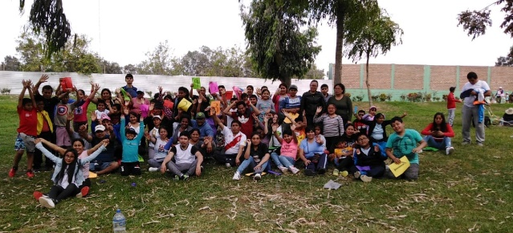
The children preparing for First Communion had a workshop and they shared it with the family. It was a day to acknowledge each other as a community and to commit themselves along with their children in the preparation to receive Jesus in the Eucharist. Their activities were: playing games, dramatizing passages from the Bible, dynamics, etc. It was a different experience because among them, there are Venezuelan families who have quickly integrated themselves into the group very easily and who have been wholeheartedly welcomed to the group without making any differences whatsoever.
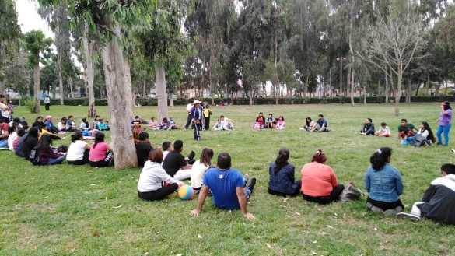
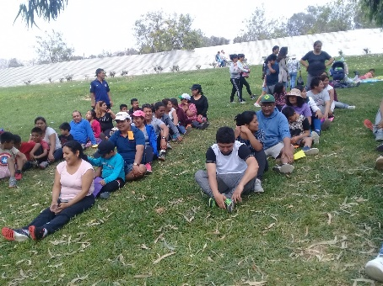
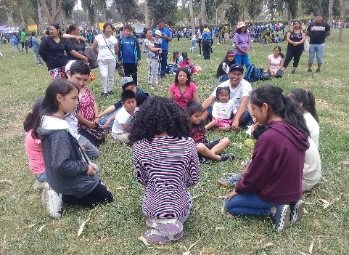
Celebrating the feast of el Señor de los Milagros
NOVEMBER! For sure, some will say, that feast is already passed, but in Brisas, it is celebrated this month because they respect the time that is recognized as the central celebration of Lima. As usual, the procession passed in front of our house. The enthusiasm of the neighbors was great because they took the initiative in the preparations and this says a lot about the faith of the people. We helped, animated and walked with them.
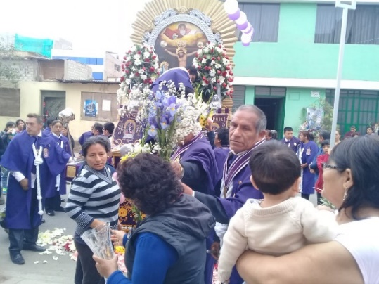
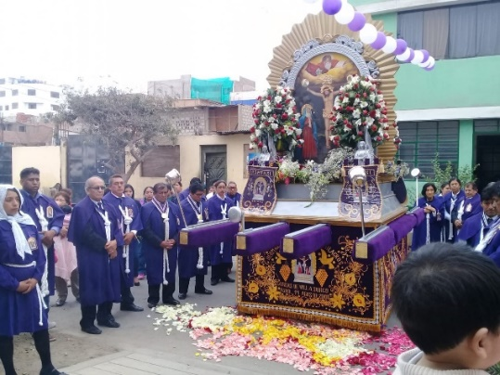

The Corner Stone celebration for the Umamarca chapel
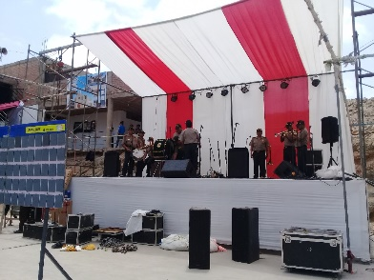
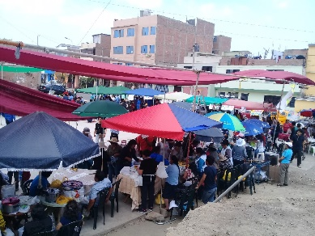
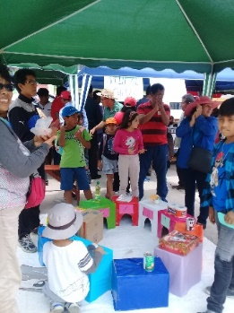
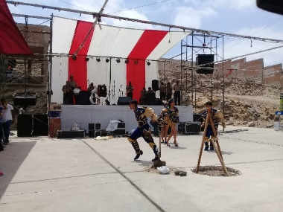
This time, it was our turn to help the community of Umamarca (in Aymara it means water town). On November 25th, the Corner Stone was planted for the construction of the chapel because this zone doesn’t have one. That’s the reason all the parish got together to help by raising funds by having different activities and in which we also participated.

The last topic: Why haven’t they arrived yet? (written by Pina)
These are the 8 year old children for the First Communion. The children are very excited and are concentrating on preparing themselves for the big day. Some children have been absent; probably they over-slept or they came late but the truth of the matter is that the preparation is almost over. We are worried about the ones who didn’t come for the last session because it was so important. The topic was “on Sunday, we celebrate the day of the Lord” because we reflected on the commitment Jesus had. It is our hope that the children will continue to participate in the parish, at least in the choir or as servers at Mass and especially, come to Sunday Masses. God will do the rest…
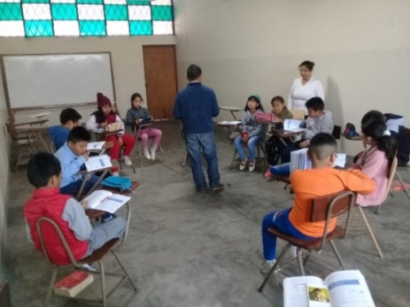

NEWS FROM THE TRINITARIAN COMMUNITY (Tacna)

* From the 8th to the 11th of November, we enjoyed the visit from the Leadership Team; sharing with them our life and ministry here in our beloved Tacna.

*November 13th during class hours, the 4th year students had an integration experience as the next graduating class of the Fe y Alegría 40 School. The 14, 15 and 16th there was a day of reflection with each section of 6th grade (primary), to prepare them to transition into high school. Both activities were very significant for the students.

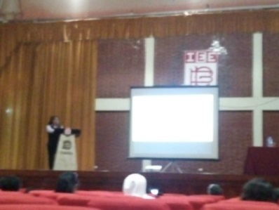
* Two years ago, a new curricular program was implemented in the primary grades. This is called “Learning for competency”. The teachers of our school shared their experiences with other Educative Institutions of Tacna. Their presentation was highly valued by the participants. Congratulations, we are grateful to all those who made this project possible.

*This year, the graduating class is preparing itself to bid farewell to their dear school which has seen them grow through these 11 years. The photo shows the 5th year C students.

* Zaida blessed the Advent Wreaths for each section.
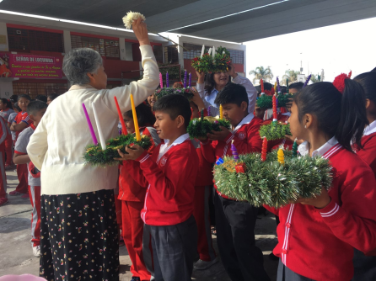

UNITED IN PRAYER
* For the health of Arturo Muñoz, Dolo’s brother.
* For the health of Angelica, Geno’s sister.
* For the health of Isabel, mother of Mary Luz.
* For the health of Wesley, Sally’s nephew.
* For all of our sisters in the Congregation who are in poor health.

May our faith and hope accompany all of our families at this time of life!

We wish you a Happy Day to all who celebrate during the month of December
1 Anita Morales (FSJ Chile)
1 María Elena Baeza (FSJ Chile)
7 Margarita (Maggi) Villena (FSL Chile)
8 María Vásquez (P)
21 Zaida Pérez (P)
24 Francine Costello (LA)
26 César Rodríguez (FSJ Chile)

