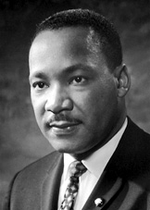

Dr. Martin Luther King, Jr.

A

Reflection

of the

Radiance of Christ

Dream.

Move.

Stand up.

Speak.

Love.

Respect.

Don’t be afraid.

Dr. martin Luther King, Jr. taught us this and so much more.

