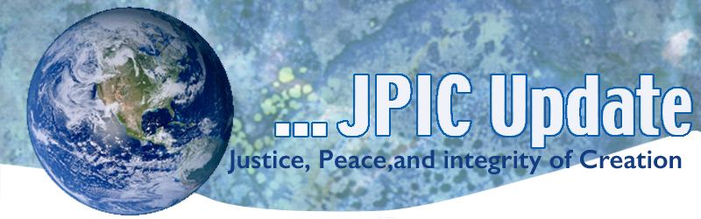
January 14, 2019
“We are called to reach out to those who find themselves in the existential peripheries of our societies and to show particular solidarity with the most vulnerable of our brothers and sisters: the poor, the disabled, the unborn and the sick, migrants and refugees, the elderly and the young who lack employment.” Pope Francis — Message to the 10th General Assembly of the World Council of Churches
CALENDAR

January 2019
Jan 19 Walk for Life
Jan 21 Martin Luther King Day
February 2019
Black History Month

TAKING ACTION
Email President Trump
Yes, we are under a humanitarian crisis but it is not solved by building a wall. Since the government shut down the phone lines to the White House are not open but emails can be sent by clicking on: Contact the White House | The White House. An example of an email: Dear President Trump, We are, indeed in the midst of a humanitarian crisis. However, the wall is not the crisis or answer. We need to expedite the process at the border for who are seeking asylum. Please do your homework. Those crossing the border are not the criminals and terrorists whose numbers you like to inflate. Or, you may want to include quotes from Bishop Joseph Vásquez calls for U.S. officials to prioritize human dignity in search for a border solution.

Shut Down Affecting those in Poverty
Catholic Charities USA continues to monitor the impact of the shutdown on people who are in poverty, particularly those dealing with food and housing insecurity. Please pray for those impacted by the shutdown and be sure to contact your local Catholic Charities agency to see how you can help. https://www.catholiccharitiesusa.org/find-help/

National Catholic Pledge to End the Death Penalty
On January 17th the Annual March for life will occur. Celebrate the March by opposing the death penalty. Cardinal Bergoglio reminds us: “Caring for life from the beginning to the end. What a simple thing, what a beautiful thing.. So, go forth and don’t be discouraged. Care for life. It’s worth it.”
“The death penalty is inadmissible because it is an attack on the inviolability and the dignity of the person.” (CCC 2267) #Pledge4Mercy Take the pledge to end the death penalty by clicking on LEARN MORE

INFORMATION

Your Advocacy makes a difference
Thanks to your many calls, letters, and emails in response to action alerts from USCCB and our collaborators, Congress passed into law several pieces of legislation which support those who are poor and vulnerable in our world:
The Iraq and Syria Genocide Relief and Accountability Act of 2018 was passed after two years of hard work.
The Farm Bill was passed with bipartisan support just before the end of the year.
The FIRST STEP Act, which included the reauthorization of the Second Chance Act, is progress towards long-term criminal justice reform.

These successes are possible when many choose to take action and raise their voices in response to our call as baptized Catholics to protect those who are poor and vulnerable. In 2019, let’s continue to be in communion with those on the margins of society as we call for continued work towards justice. If you’d like to receive Action Alerts, sign up here and read more about our other newsletters, too.

Ocean Absorbing Heat
A new study has found that the ocean has absorbed more than 90 per cent of the heat gained by the planet between 1971 and 2010.
The process of the ocean absorbing this heat leads to increase in ocean temperatures and associated sea level rise.
The study, undertaken by the University of Oxford, involved the reconstruction of ocean temperature change between 1871 and 2017.

UNSC to discuss UN chief's plan for Yemen
Members of the United Nations Security Council will meet today to discuss Secretary-General Antonio Guterres' proposal to deploy 75 UN observers to monitor the cease-fire in Yemen for the next six months. UN Yemen envoy Martin Griffiths is also scheduled to brief the council on peace efforts in the country.

RESOURCES

Learning More about Migration
If you are interested in learning more about the Church’s teaching on migration, explore the resources on Share the Journey.

Resources for Human tracking Awareness
COMPASS- Coalition of Organizations and Ministries Promoting the Abolition of Slavery at Sea
Trafficking Victim Assistance Program
Become a Shepherd
The Amistad Movement
February 8th: International Day of Prayer and Awareness Against Human Trafficking
If you would like more information about our past programs and work, click here.

