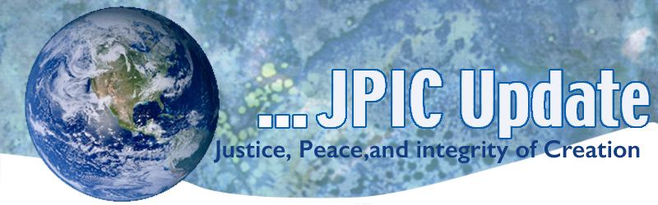
January 21, 2019

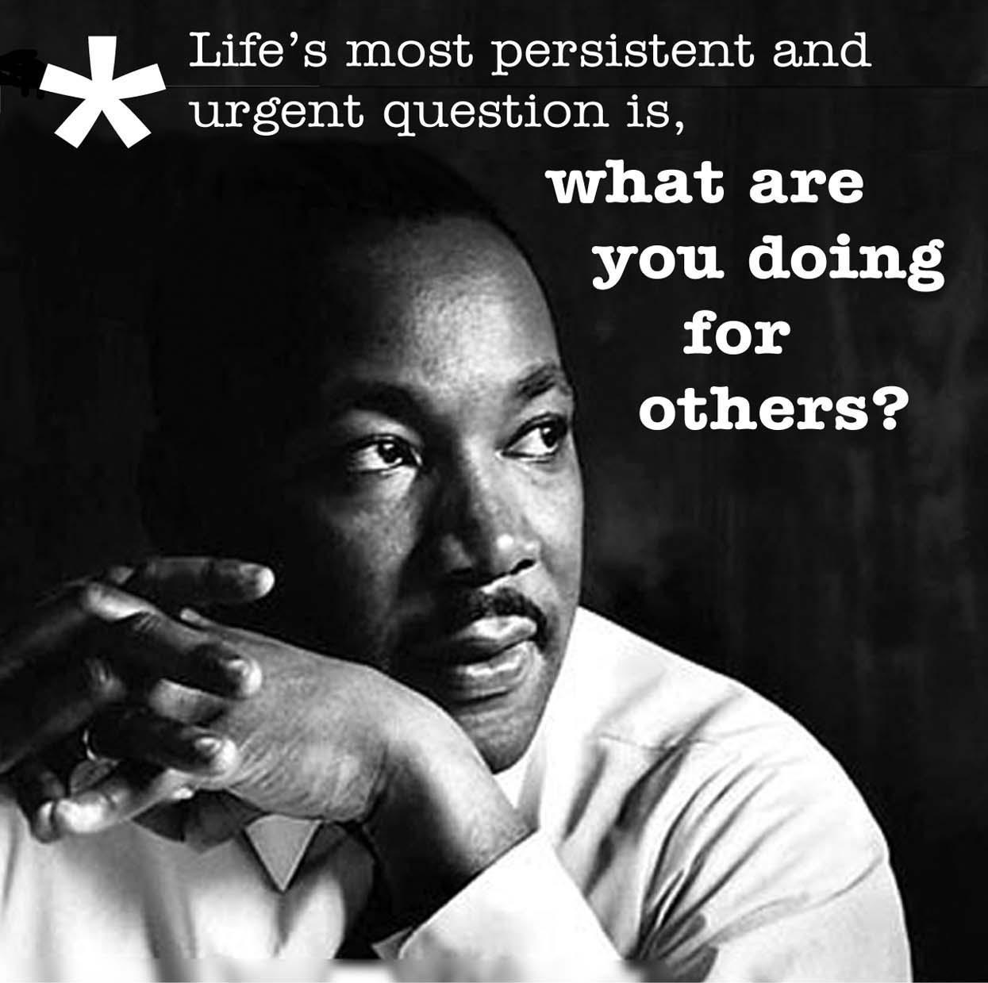

CALENDAR

January 2019
Jan 21 Martin Luther King Day
February 2019
Black History Month

TAKING ACTION

People Act Today
Today is Martin Luther King, Jr. Day. It is also the 9 year anniversary of the Citizens United Supreme Court ruling. Today serves as a great reminder for how far civil rights in the United States has come, and how much farther we still have to go. Until democracy reform is passed, it is nearly impossible to fix the other issues the faith community cares so much about.
Just imagine what a Congress that took our democracy seriously could accomplish. Thankfully, the House of Representatives has a plan. Sign your name in support of H.R. 1, the For the People Act, today.
Add Your Name

Facing the Crisis
On the occasion of Martin Luther King Day on January 21, eleven national and international Catholic justice and peace organizations delivered a joint statement to Congress today, entitled “Facing the Crisis: A Catholic Offer of Wisdom and Courage to Congress” which calls on Members to courageously take the first steps to end the political polarization that the group says is eroding democracy in the United States.
“Inspired by Dr. King, we declare that this is a moment of moral crisis in the United States,” the statement reads. “The habit of inflicting suffering on some for the supposed benefit of others is all too common in both our political discourse and policies today.”
Offering words by Dr. King and Pope Francis as sources of courage and wisdom, the Catholic organizations call on each Member of Congress to “break free of the division and polarization that grip our nation.”
Read the full statement online
Send the statement to your members of Congress

INFORMATION

Nearly 30 global firms pledge $1B to stop plastic waste
A group of close to 30 global companies have formed a nonprofit called the Alliance to End Plastic Waste, pledging $1 billion so far out of a goal of $1.5 billion to stem plastic waste issues. Among the group's goals are a focus on recycling in Southeast Asia, collaboration with the United Nations, capturing waste before it enters the oceans in 10 major rivers, joining with cities in developing countries to implement waste management systems and creating a way to share information to support waste management across the globe

Decline in Antarctica Ice Mass
A new report by NASA and the University of California, Irvine has found that ice mass in Antarctica has been declining rapidly over the last 40 years.
The study, published in the journal Proceedings of the National Academy of Sciences, used updated drainage inventory, ice thickness and ice velocity data for 176 basins draining the Antarctic Ice Sheet from 1979 to 2017.
The report found that Antarctica is losing six times more ice mass annually now than 40 years ago.
Eric Rignot, lead author of the study and chair of Earth system science at UCI, said: “That’s just the tip of the iceberg, so to speak. As the Antarctic ice sheet continues to melt away, we expect multi-meter sea level rise from Antarctica in the coming centuries.”

UNHCR chief presses wealthy countries to support African migrants
United Nations High Commissioner for Refugees Filippo Grandi is urging the world's affluent countries to fund services in developing nations, noting that 85% of the world's 68 million displaced people are in the Global South. Grandi said that if he were a migrant or refugee, "I would opt for anything to get out of there, even if I knew the risk of death was very high."

Guterres welcomes Palestine as head of G-77
United Nations Secretary-General Antonio Guterres this week welcomed Palestine's assumption of the chairmanship of the Group of 77, calling the country "well-placed" to lead the group. "Palestine and its citizens have first-hand experience of some of the most challenging and dramatic global issues we face," Guterres said.

RESOURCES

Standing Against Racism:
In continuing our education on racism, here are the links to TED talks/youtube videos on racism. Videos on this list were provided by the LCWR’s Standing against Racism Tool Kit.

Verna Myers- http://bit.ly/2yNXZOP
David Williams- http://bit.ly/2yP6TLQ
Brittney Cooper- http://bit.ly/2AhygjL
Luvvie Ajayi- http://bit.ly/2Ess0Kk
Founders of Black Lives Matter- http://bit.ly/2PGiIvn Mellody Hobson- http://bit.ly/2CTpFGz
Bryan Massingale- http://bit.ly/2Oxez07

7 Charts That Show the World Is Actually Getting Better
What a time to be alive! These charts show how the world has become a much better place compared to just a few decades ago.
Read

From the UN
Turkey to seek UN assistance in establishing Syrian "safe zone"
UNODC: Most trafficking of women in S. America is intracontinental

UNHCR: Conditions in Burundi not conducive to refugees' return

