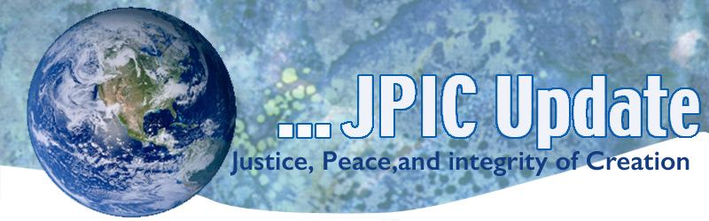
January 28, 2019
In this regard, it may be helpful to recall the “Beatitudes of the Politician” Pope Francis
Blessed be the politician who personally exemplifies credibility.
Blessed be the politician who works for the common good and not his or her own interest.
Blessed be the politician who remains consistent.
Blessed be the politician who works for unity.
Blessed be the politician who works to accomplish radical change.
Blessed be the politician who is capable of listening.
Blessed be the politician who is without fear.
CALENDAR
January 2019
Jan 28 World Leprosy Day
February 2019
Black History Month
Feb 1 World Interfaith Harmony week begins
Feb 2 World Wetlands Day
Feb 8 International Day of Prayer and Awareness against Human Trafficking
Feb World Day of the Sick

TAKING ACTION
Take the Quiz
UNICEF is working to ensure that one day no child will be for sale. Advocacy, protection services and awareness are all vital to this work, and you can help! Take the quiz and share your results on social media with the hashtag #EndTrafficking.

Protect wildlife
M-44 "cyanide bombs" are small metal cylinders that are staked into the ground and covered with bait. These sweet-smelling traps lure coyotes, wolves, foxes and other unsuspecting wildlife — then cruelly shoot sodium-cyanide powder into their faces. The result is horrible poisoning followed by death.
Fortunately the Environmental Protection Agency is at last reviewing the use of these controversial devices, and now's our chance to shut them down.
Send a letter to the EPA insisting that it protect wildlife and ban the use of sodium cyanide in M-44s.

INFORMATION
Report Calls for Action to Affordable Housing Crisis
Leading national organizations from the housing, education, health, civil rights, anti-hunger, anti-poverty and faith-based sectors have released a new report which calls for an ambitious federal response to the nation's housing affordability crisis. Over the past year, these organizations have joined together through Opportunity Starts at Home, an unprecedented multi-sector campaign to advocate more robust and equitable federal housing policies. The report, entitled "Within Reach," argues that stronger federal action is long-overdue to ensure that the most vulnerable low-income households can afford safe, decent rental homes.
"Coffee Is Being Threatened With Extinction Because of Climate Change"
UN Dispatch (1/22)

IOM, UNHCR rebuke EU countries for politicizing migrant rescues
The lives of migrants are being put at risk because European countries are refusing them safe ports or sending them back to appalling conditions in Libya, according to the International Organization for Migration and the United Nations High Commissioner for Refugees. The UN has warned that sending migrants back to Libya violates international law.

Acting UNEP chief hails Kenya's innovative recycled plastic boat
Joyce Msuya, acting United Nations Environment Programme executive director, is praising the innovation of a Kenyan group that developed a boat made of 11 tons of recycled plastic. Msuya says the project shows that community efforts can offer global solutions while also addressing the need for sustainable plastic use.

RESOURCES

What's needed to bring the US voting system into the 21st century
The American election system is complicated, to say the least -- but voting is one of the most tangible ways that each of us can shape our communities. How can we make the system more modern, inclusive and secure? Civil engagement champion Tiana Epps-Johnson shares what's needed to bring voting in the US into the 21st century -- and to get every person to the polls.
Watch now »

How to transform sinking cities into landscapes that fight floods
From London to Tokyo, climate change is causing cities to sink -- and our modern concrete infrastructure is making us even more vulnerable to severe flooding, says landscape architect and TED Fellow Kotchakorn Voraakhom. But what if we could design cities to help fight floods? In this inspiring talk, Voraakhom shows how she developed a massive park in Bangkok that can hold a million gallons of rainwater, calling for more climate change solutions that connect cities back to nature.
Watch now »

