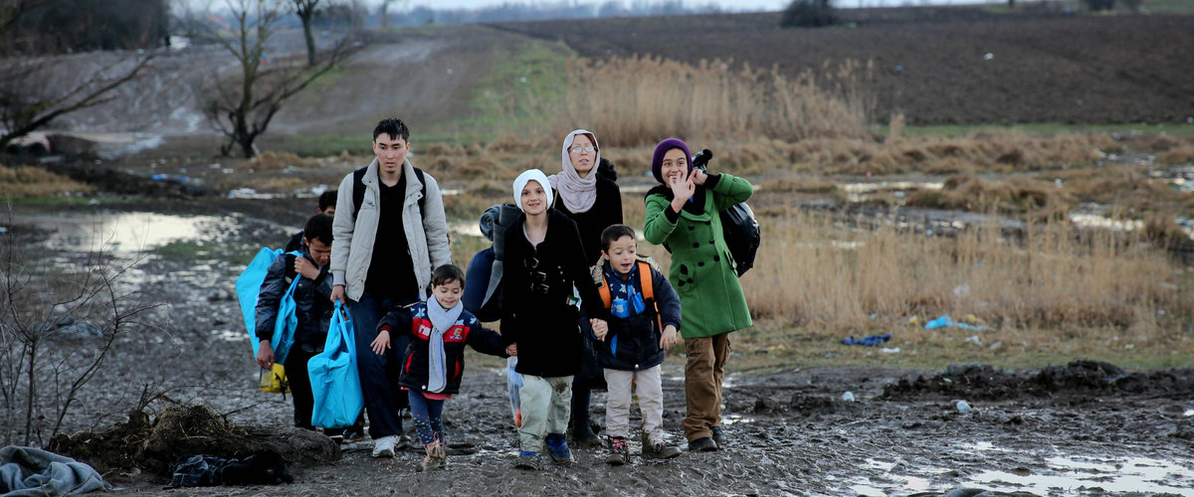

Justice Prayer for Immigrants
Come, O Holy Spirit!
Come, open us to the wonder, beauty, and dignity of the diversity found in each culture,
in each face, and in each experience we have of the other among us.
Come, fill us with generosity
as we are challenged to let go and allow others to share with us
the goods and beauty of earth.
Come, heal the divisions
that keep us from seeing the face of Christ in all men, women, and children.
Come, free us to stand with and for those
who must leave their own lands in order to find work, security, and welcome in a new land,
one that has enough to share.
Come, bring us understanding, inspiration, wisdom, and
the courage needed to embrace change and stay on the journey.
Come, O Holy Spirit,
show us the way.

(Catholic Charities USA)

