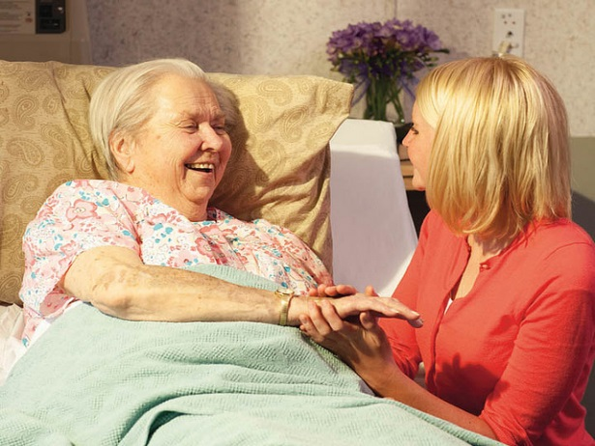
ADAPTED FROM WORLD DAY OF THE SICK
Catholic Health Accociation of the United States

CALL TO WORSHIP
Leader
We gather here as persons who are daily affected by and concerned about illness and disease. So much of our present lives revolve around issues of health and healing. And yet, today, we join in a very intentional way to pray for all who suffer from illness and all who care for them. We remember all who endure physical suffering as well as those who bear the pain and stigma of mental illness. We remember those who have undergone recent surgery and cancer treatments as well as those who face chronic illness that persists over months and years. We remember the daily labors of love offered by family and friends, health care providers and ministers, that sustain those who are sick.
So often when experiencing illness, we are isolated from our communities. We are not able to participate in those every day activities that make us feel connected to others, that make us feel productive and useful members of our families and workplaces. So often we feel that those things that give us a sense of dignity are taken away from us. And, in return, our caretakers can feel powerless to decrease our suffering and loss. Knowing how illness can affect everything in our lives—our relationships, our self-esteem, our dreams and hopes—let us turn to scripture and hear the words of the apostle James that speak of communal healing and wholeness.
Reader
Is any among you sick? Let him call for the elders of the Church, and let them pray over him, anointing him with oil in the name of the Lord; and the prayer of faith will save the sick man, and the Lord will raise him up; and if he has committed sins, he will be forgiven. (James 5:14-15)
(Moment of Silence for Reflection)
PETITIONS
Leader
James speaks to us of a community that does not isolate its sick members, but rather brings them into the center of the community's care and prays over them. Let us pray to God for our sisters and brothers, that God may strengthen them, bring healing to them and renew them with his love. To each petition, I ask you to respond, "Lord, hear our prayer."
Almighty God, look kindly on your suffering daughters and sons - give them peace of mind and heart, and renew your life and love within them. Free them from fear, worry and anxiety, ease their sufferings of mind, body, and spirit, and give them courage and hope. We pray to the Lord.
All
Lord, hear our prayer.
Leader
Bring healing to the weakened and injured parts of their bodies, renew their minds, heal wounded memories, strengthen their immune systems, and shrink the tumors that are within those suffering from cancer. We pray to the Lord.
All
Lord, hear our prayer.
Leader
Renew the strength and health of all who have been weakened by advancing age, sustain them with your love, and help them to witness to your faithfulness. We pray to the Lord.
All
Lord, hear our prayer.
Leader
Strengthen all who care for the sick, guide all medical personnel to be instruments of your healing, and help chaplains to be signs of your love and presence. We pray to the Lord.
All
Lord, hear our prayer.
Leader
Lord, we know that you hear our prayers — those spoken aloud and those spoken only in the silence of our hearts. Through the witness of Mary and all our ancestors in the faith, may we learn to wait in joyful & confident hope for the day when all our prayers will be answered in the fullness of your time. We pray in the name of Christ, in the power of his spirit. Amen.
CLOSING PRAYER
Leader
Lord, as commanded by your servant James, for those who are sick, we beg you to look kindly on the faith of your people and to answer the prayers expressed. In solidarity with believers around the world, we stand before you in hope and anticipation of that day when every tear will be wiped away and we shall see you, our God, as you are. As we go forth from here, we go in trust, knowing that wherever the paths of our lives take us, you have walked the path before us and guide us now on our way. In confidence, we say…
All
Amen.

