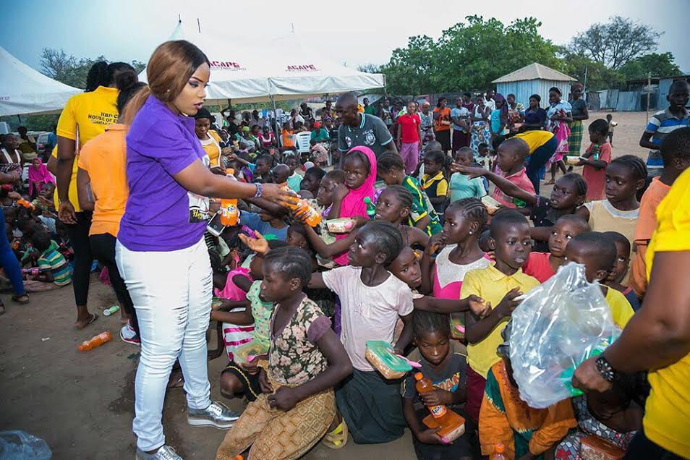
A Lenten Reflection

How best to spend this Lent? Read the advice given us by Isiah.

Isiah 58:1-9
This, rather, is the fasting that I wish:
releasing those bound unjustly,
untying the thongs of the yoke;
Setting free the oppressed,
breaking every yoke;
Sharing your bread with the hungry,
sheltering the oppressed and the homeless;
Clothing the naked when you see them,
and not turning your back on your own.
Then your light shall break forth like the dawn,
and your wound shall quickly be healed;
Your vindication shall go before you,
and the glory of the LORD shall be your rear guard.
Then you shall call, and the LORD will answer,
you shall cry for help, and he will say: Here I am!

Reflect on how you are already responding to Isiah. What more are you called to do?

Here is what Matthew 25: 34-40 tells us.
'Come, you who are blessed by my Father.
Inherit the kingdom prepared for you from the foundation of the world.
For I was hungry and you gave me food,
I was thirsty and you gave me drink,
a stranger and you welcomed me,
naked and you clothed me,
ill and you cared for me,
in prison and you visited me.'
Then the righteous will answer him and say,
'Lord, when did we see you hungry and feed you,
or thirsty and give you drink?
When did we see you a stranger and welcome you,
or naked and clothe you?
When did we see you ill or in prison, and visit you?'
And the king will say to them in reply,
'Amen, I say to you, whatever you did
for one of these least brothers of mine, you did for me.'

Reflect on how you are already responding to Jesus’ words. What more are you called to do?

Closing Prayer:
Creator of the universe,
holy and blessed be your name.
Acknowledging the web of life,
we embrace your presence in all things

Give us this day what we need
to embrace our brokenness,
enabling us to be reconcilers,
healing one another and the earth
(A modern translation of the Our Father)

