In Thanksgiving for Women
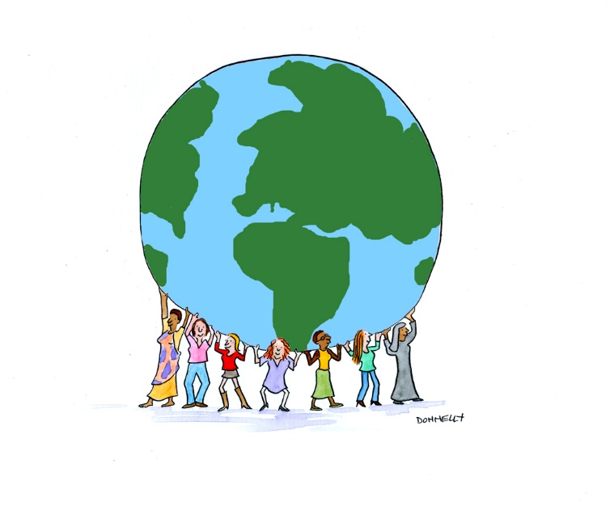
Leader: Let us pray in thanksgiving for the women who have and are making a difference. May their example encourage and strengthen us to be women who also bring about justice and peace to a world in need, women who bring a healing presence to Mother Earth and all creatures.
Reader 1: Dr. Lucy Boyle, as a member of Doctors Without Borders, searches the Jungle to stop a deadly outbreak of Chorea in Kivu, Democratic Republic of Congo. When a crowded truck overturns she is called upon to treat the accident victims.
All: Let us pray for all those who give up the comforts of life to respond to the medical needs of those who do not have access to health care.
Reader 2: Vandana Shiva is, among other things, an environmental activist who has served as an advisor to governments and NGOs regarding issues that affect the heath of the earth community. She assists grassroots organizations in the Green movement.
All: Let us pray in thanksgiving for all women who are awakening others to the new cosmology and who are making decisions based on the earth community’s health.
Reader 3: Sr. Megan Rice spent time in prison. Her crime? In July of 2012 she, along with others, penetrated the Y-12 nuclear facility in Tennessee. For many years she has been committed to Nuclear disarmament. Megan has tirelessly worked to create the Nevada nuclear test site experience of others by organizing regular demonstrations and civil disobedience.
All: Let us pray in thanksgiving for all those who work toward nuclear disbarment. May the spirit guide those who are engaged in talks with Iran, North Korea and Russia regarding nuclear capability.
Reader 4: Malala Yousafzal, a Pakistani schoolgirl, spoke out and refused to be silenced. It almost cost the ultimate sacrifice, life itself. Being shot in the head by a member of the Taliban has made her more determined to work toward the rights of all girls to be educated. Her message has been heard around the world and in the halls of the UN.
All: May all young women who are nudged by the spirit to act and speak for justice say yes to their call. May they be supported and affirmed as they work for justice, peace and care of the earth.
Reader 5: In thanksgiving for the many ways women have ministered to children in schools, orphanages and hospitals.
All: May all children find the love and nurturance they need to feel safe, healthy and loved.
Reader 6: A record 131 women were elected to serve in the 116th Congress joining ten incumbents. This number represents 24% of the Congress of the united States of America. As Speaker of the House Nancy Pelosi is now the most powerful woman in government.
All: Let us pray for all women who work to change systems and who initiate legislation that benefits the welfare of all. May they emulate the Beatitudes of Politicians:
Blessed be the politician who personally exemplifies credibility.
Blessed be the politician who works for the common good and not his or her own interest.
Blessed be the politician who remains consistent.
Blessed be the politician who works for unity.
Blessed be the politician who works to accomplish radical change.
Blessed be the politician who is capable of listening.
Blessed be the politician who is without fear.
(Pope Francis in his 2019 New Year Day Message)

Leader: Please name women who have or are making a difference. Begin by saying: I give thanks for….
Closing Prayer: Creator, ground us in prayer and make us contemplative activists. Energize us to continue the mission of Jesus. Guide us as we embrace each day as new and filled with possibilities. Amen

