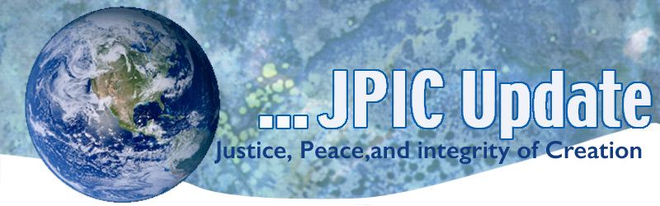
March 4, 2019
“We can ask: What keeps us united? Why are we united? What prompts us to encounter each other? The certainty of knowing that we have been loved with a profound love that we neither can nor want to keep quiet about a love that challenges us to respond in the same way:
with love. It is the love of Christ that urges us on (cf. 2 Cor 5:14).”
- Pope Francis, Welcome Ceremony Opening World Youth Day 2019, Panama

CALENDAR
March
Women’s History Month
March 6 Ash Wednesday
March 8 International Women’s Day
March 21 International Day for the Elimination of Racial Discrimination
April
April 22 Earth Day

TAKING ACTION
Support Haiti
You can support the people of Haiti by using the attached Lenten calendar. Haiti has been rocked by anti-government protests that have led to escalating violence; loss of life; widespread destruction of property; and disruption of ground transportation, communications and other services. While our program associates and representatives of our partner organizations in Haiti report that they are safe, many in their communities are experiencing growing hardships, including diminishing access to food and water.

Lenten Resource
Each year, NETWORK creates a Lenten resource for our community of justice-seekers to deepen our collective knowledge of one or more of our policy proposals. These resources provide opportunities for spiritual reflection and improve our advocacy. While Lenten resolutions often are to "give something up," we hope you will join us in doing the work to become more dedicated, mindful, faithful activists.
This year, we invite the NETWORK community to recommit to Racial Justice. It is crucial that we confront our history and the ways racism continues today, including in our federal policies. Are you with us? Sign up now.
Dozens of young people risked arrest to deliver a clear message to Senators on both sides of the aisle: Americans want a Green New Deal, and young voters will remember where Senators stand next time they want our votes.
The more people who know about what is happening in Washington, the closer we will be to making a Green New Deal a reality. Can you share our livestream of the action so we can reach as many people as possible? This video is long but worth the time to watch. Very powerful and hopeful. Call your legislators today to lobby for the green deal

INFORMATION

International Women’s Day
International Women's Day is a worldwide event with a human rights theme, highlighting the social, economic, cultural and political achievements and contributions made by women. It is held annually on the 8th of March. The day also sees demonstrations and protests aiming to further gender equality. In some areas the day has become an occasion to express appreciation for women in general, similar to Mother's Day and Valentine's Day. In many (mostly eastern) countries the day is a public holiday.

Poverty USA
How much do you know about poverty in the United States? Take Poverty USA’s interactive quiz to find out. Featuring both multiple choice and true-false questions, this quiz will help you to learn more about poverty in the U.S. and its impact on people across the country.
Take the quiz now, and then share it in your networks!

Cracks growing across Antarctica’s Brunt ice shelf are set to release an iceberg twice the size of New York City.
NASA Earth Observatory has released before and after images, taken 30 years apart, showing a massive difference in the Antarctic Brunt ice shelf.
One crack along part of the ice shelf, which first appeared in October 2016, has continued to grow eastward.
The images also show a rift, which has previously been stable for 35 years, has started accelerating northward as fast as 4 kilometres per year.

SPLC and Latin GRAMMY Award-winning band release song teaching immigrants their rights
In an effort to reach immigrants who may not understand their rights, we teamed up with the all-female mariachi band Flor De Toloache to launch a new song that aims to help them avoid being victimized by illegal law enforcement tactics.

READ MORE

RESOURCES

New Lenten Resource: ‘40 Days; 40 Ways A Guide to A Green Lent’
As the solemn season of Lent approaches, the Franciscan Action Network offers a new resource to assist the "reading" of nature: a guide entitled 40 Days; 40 Ways: A Guide to a Green Lent by Dianne Scheper. Despite its title, the guide is not fashioned as a daily devotional. It is described as "a range of suggestions for merging your Lenten disciplinary spirit with creation-centered activities." Go to: https://franciscanaction.org/sites/default/files/40Days40Ways.FINAL_.pdf?eType=EmailBlastContent&eId=0275a060-88f3-4920-9e52-599858e61fb4

USCCB Notes
- Chairman of U.S. Bishop’s Committee on International Justice and Peace expresses solidarity with the Church and people of Venezuala and seeks U.S. humanitarian aid.
- Chairman of the U.S. Bishop’s Committee on Domestic Justice and Human Development issued a joint statement condemning the decision of the state of Alabama to execute a man, who was Muslim, and to deny his request for appropriate spiritual care at the hour of his death.
- President of the U.S. Bishop’s Conference and Chairman of the Committee on Migration share deep concern about the administration’s funding appropriation for a border wall.

Racism: What Bishop’s pastoral fails to recognize: https://www.ncronline.org/news/bishops-letter-fails-recognize-racism-white-problem

