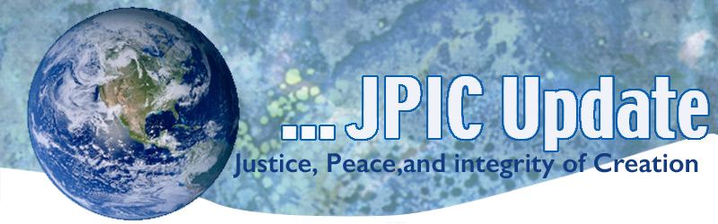
April 22, 2019
The resurrection is a process that will go out until it embraces all of creation.
Wherever an authentic human life is growing in the world
Whenever justice it triumphing over the instincts of domination
Whenever love is getting the better of selfish interests
Whenever the stanger is welcome
Leonard Boff

April 20-28 National Parks Week
April 22 Earth Day
April 25 International girls Day
May
May 24 Climate Strike on anniversary of Laudato Si’

*****************
TAKING ACTION
*****************
Earth Day Reflection
Having visited the Notre Dame Cathedral in 2005 and experienced its beauty and history I was indeed saddened as I watched it burn. Shock circled the world as people watched in disbelief that such an important religious and historical icon was in flames.

Yet, as I watched on TV and read the cover story the LA times, I am reminded of another Cathedral, Mother Earth that is suffering devastation and unlike a burning icon, is going, for the most part unnoticed. Where is the sorrow and horror of the effects of global warming? Unlike the fire at the Notre Dame Cathedral, we can do something. Daily news reports highlight the devastation around the globe of unprecedented weather events affecting the life and economy of millions. Yet of even greater impact is that of the destruction of the earth’s natural resources for generations to come. What am I/we doing today to put out the fire of global warming?
Ban a Toxic Pesticide
Chlorpyrifos is a toxic pesticide used on a wide variety of crops, including apples, oranges, strawberries, and other foods people eat daily. Science shows it harms the developing brain of children. Now, California has a chance to ban this dangerous pesticide — but we need your help
SB 458, which would ban chlorpyrifos, is navigating the State Senate now. The bill must pass the Senate Floor by May 31,2019.
TAKE ACTION
Join NETWORK's policy update call on drug pricing. The call will bring everyone up to speed on what is happening on Capitol Hill and at NETWORK on this important issue. You will learn about NETWORK's Principles for Drug Pricing, hear from members of our Government Relations team, and find out what you can do to get involved in advocacy efforts.
Join us on Wednesday, April 24 at 3:00 PM Eastern. RSVP today! (Once you register, we'll send you the call information and materials).
Sign our drug pricing principles petition. Wealth should never determine a person's access to lifesaving drug treatment, but the current reality means that people at the bottom half of the income scale and people with worse health outcomes are left out.

***************************
INFORMATION/RESOURCES
***************************
Join the Climate Strike
Pope Francis met Greta Thunberg, who has galvanized climate strikes around the world. We were fortunate as Tomás Insua, Executive Director of GCCM, was able to serve as the translator and be part of this historic, intergenerational meeting.
Greta filmed a wonderful video just after her meeting with Pope Francis. You are warmly welcomed to share the video, here.

From USCCB on Dreamers
The United States Conference of Catholic Bishops (USCCB) Committee on Migration endorsed the “Development Relief and Education for Alien Minors” (DREAM) Act of 2019, S. 874 and the “Safe Environment from Countries Under Repression & Emergency” (SECURE) Act of 2019, S. 879. The DREAM Act of 2019 would provide permanent legal protection and a pathway to citizenship for qualifying Dreamers. The SECURE Act of 2019 would provide permanent legal protection and a pathway to citizenship to qualifying Temporary Protected Status (TPS) and Deferred Enforced Departure (DED) holders.

Please see the USCCB Committee on Migration letters of support for the DREAM Act and Secure Act.
More information about Dreamers and TPS can be found on the Justice for Immigrants website.
Spotting Victims of Trafficking
Southeast Asia's largest ride-hailing firm Grab said on Monday it is to train its millions of drivers to spot victims of human trafficking in one of the world's worst hit regions. Taxi and ride-hailing drivers often unwittingly become the first point of contact.

Businesses around the world are under increased pressure to tackle human trafficking, which affects more than 40 million people globally and generates $150 billion a year, but they have been slow to act in Asia.
Empowering girls in Kenya
Kakenya Ntaiya turned her dream of getting an education into a movement to empower vulnerable girls and bring an end to harmful traditional practices in Kenya. Meet two students at the Kakenya Center for Excellence, a school where girls can live and study safely -- and uplift their community along the way. "When you empower a girl, you transform a community," Ntaiya says.
Watch now »

The Black Hole
At the center of a galaxy more than 55 million light-years away, there's a supermassive black hole with the mass of several billion suns. And now, for the first time ever, we can see it. Astrophysicist Sheperd Doeleman, head of the Event Horizon Telescope collaboration, speaks with TED's Chris Anderson about the iconic, first-ever image of a black hole -- and the epic, worldwide effort involved in capturing it.
Watch now »

