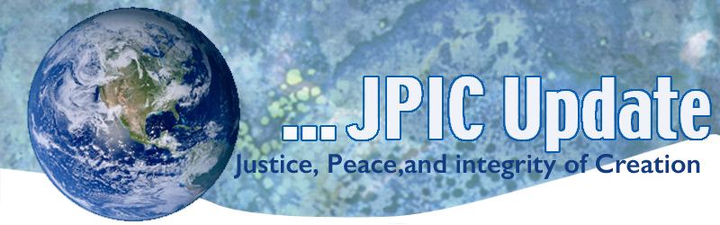
April 29, 2019
“Proclaim the truth and do not be silent through fear.”
“Speak the truth in a million voices. It is silence that kills.”
“Be who God meant you to be and you will set the world on fire.”
― Catherine of Siena (14th Century)

May
May 1 St. Joseph the Worker Day
May 1 Immigrants rights Day
May 2 National Day of Prayer
May 5 Cinco de Mayo
May 24 Climate Strike on anniversary of Laudato Si’

*****************
TAKING ACTION
Be a voice for the voiceless
*********************

Violence Affects Us All
Today we mourn the attack on the Jewish Synagogue, Chabad of Poway here in our own state of California. Last week we mourned the death of over three hundred killed in Sri Lanka. Prayer continues for healing and cessation of violence in that country.
Shootings in mosques, synagogues, churches, schools and in homes have become all too common. Since April 1-28, 2019, we have seen the blood of mass shootings and gang violence in 25 cities, towns and villages in our nation –places like Poway, Los Angeles, Jackson, Hugo, Wichita, Corpus Christi, Westmorland, Louisville, Stockton, Vallejo, Germantown, Moreno Valley, Philadelphia, Memphis, Baltimore, Kansas City, Phoenix and more.
We pray for all who have been victims of hate and violence and we say loudly and clearly, enough is enough. Take time to pray the attached prayer for those affected by violence. Support those advocating for safe gun laws.

https://www.csgv.org/

https://www.bradyunited.org/

US Climate Youth Strike
[This petition was co-authored by Karla Stephan, Isra Hirsi, Haven Coleman, Feliquan Charlemagne, Maddy Fernands, Anya Sastry, Salomée Levy, and the rest of the US Youth Climate Strike Team!]
That's why I signed a petition to 2020 Candidates and Democratic National Committee (DNC), which says: "There are many formidable candidates running for the Democratic nomination in 2020. We want all the candidates to commit to participating in a debate or forum on environmental issues and policies so we can hear detailed ideas and plans."
Will you sign the petition, too? Click here to add your name: https://petitions.moveon.org/p/e_anO_DFjJ

Support the Wellbeing of the People in Gaza
The blockade is the source of the crisis in Gaza and ending the blockade is necessary for ending the humanitarian crisis in Gaza. But ending the blockade is not enough. There must also be accountability for both the blockade and violence against Palestinian civilians. Join us in calling on congress to change policy by resuming aid to Palestine and demanding an end to the blockade and accountability for violence against civilians by Israel.
Click Here to contact your representatives in Washington, urging them to restore US funding for UNRWA and humanitarian assistance, to work to end the blockade of Gaza, and to insist upon accountability of Israel for violence used against Palestinian civilians there.

Support Workers’ safety
For almost fifty years now, we have come together on April 28th for Workers' Memorial Day to demand real action to prevent unnecessary injuries and deaths in the workplace. This Workers' Memorial Day, let’s send OSHA’s Deputy Assistant Secretary, Loren Sweatt, a message:
Hire more inspectors and put them to work protecting the lives of working people!
TAKE ACTION

Support Tenants in California
The struggle to build a community of belonging continues THIS Tuesday in the Assembly Judiciary Committee where AB1481 will be heard. If passed, this critical bill will protect tenants by stopping unjust, no-cause evictions across the state, but we need your help. CALL key elected officials TODAY at the Capitol to tell them to pass AB1481 Keep Families Home!

***************************
INFORMATION/RESOURCES
***************************
California: Here are the major pro-refugee highlights:
- A.J.R.1, which opposes efforts by the administration to ease deportations of Vietnamese refugees and immigrants, passed the House and Senate and was chaptered by the State Secretary of State in February 2019.
- A.B.1113, which establishes an Office and Director Immigrant and Refugee Affairs for the state, passed the Committee on Judiciary on April 9th and referred to Committee on Appropriations. It was heard in a committee hearing on April 24th and referred to the Appropriations suspense file for further consideration of the fiscal impact.
- Funding: Resettlement agencies across the state are coming together to support a funding initiative for resettlement (modeled after the appropriation made by New York State for three years in a row now). The California Governor’s modified budget is to be released in May and we await those details.

Pacific Garbage Patch
The oceans are so overwhelmed with plastic pollution that if the Great Pacific Garbage Patch were a country, it'd be the 19th largest in the world. Check out our new video on Facebook or YouTube

Helping People Makes Us Happier
Research shows that helping others makes us happier. But in her groundbreaking work on generosity and joy, social psychologist Elizabeth Dunn found that there's a catch: it matters how we help. Learn how we can make a greater impact -- and boost our own happiness along the way -- if we make one key shift in how we help others. "Let's stop thinking about giving as just this moral obligation and start thinking of it as a source of pleasure," Dunn says.
Watch now »

