Prayer for an end to Violence

Throughout history God has manifested love and care for those who have suffered from violence, hatred, and oppression. We commend those affected by the shooting at Chabad of Poway Synagogue to the healing mercy of a gracious God who binds up all our wounds and enfolds us in gentle care.
O Loving God, we see the pictures of death in Poway, Sri Lanka, Mumbai, Iraq, Syria, Afghanistan, Congo, Nigeria, Sudan and South Sudan, Ukraine, Israel and Palestine, Central African Republic, El Salvador, Honduras, Guatemala, etc…
Wrap all and each of these your people in your love.
Let them hear: “Come to me you who suffer
and are burdened and I will give you rest.”
Just in the month of April 2019, we have heard the weapons and seen the blood of mass shootings and gang violence in 25 cities, towns and villages in our nation –places like Poway, Los Angeles, Jackson, Hugo, Wichita, Corpus Christi, Westmorland, Louisville, Stockton, Vallejo, Germantown, Moreno Valley, Philadelphia, Memphis, Baltimore, Kansas City, Phoenix and more.
Wrap all and each of these your people in your love.
Let them hear: “Come to me you who suffer
and are burdened and I will give you rest.”
The bombs are exploding again in Gaza and Israel.
Wrap all and each of these your people in your love.
Let them hear: “Come to me you who suffer
and are burdened and I will give you rest.”
Violence continues hidden in so many homes and families around the world – and the abuse of innocent children….
Wrap all and each of these your people in your love.
Let them hear: “Come to me you who suffer
and are burdened and I will give you rest.”
In so many parts of the world today, the air is tense with waiting, uncertainty, insecurity.
From ravaged lands, destroyed by violence, your peoples lift their hands to you.
We pray for stillness, for justice, and for peace to come and to last.
Wrap all and each of these your people in your love.
Let them hear: “Come to me you who suffer
and are burdened and I will give you rest.”
O God, our Creator, God of Abraham and Sarah, from which three great religions stemmed. We pray for peace.
We pray for peaceful existence between Israelis and Palestinians, Sunnis and Shiites, Muslims, Jews and Christians.
We pray for negotiations that can reach the roots of historical conflicts.
We pray for a commitment to human rights by all sides and the protection of all lives.
We pray for effective international intervention to ensure justice for all sides.
We pray for humanitarian aid and rebuilding where destruction has occurred.
We pray for peace and for justice in our homes and on our city streets.
Wrap all and each of these your people in your love.
Let them hear: “Come to me you who suffer
and are burdened and I will give you rest.”
We pray for an end to violence, war and death.
Grant us this, peaceful God. Grant us a peaceful world.
Amen.
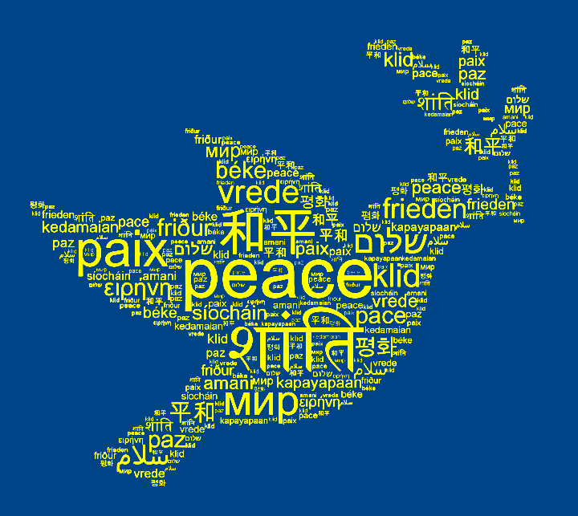

Sections adapted from Voices for Justice –by James Hug, S.J.

