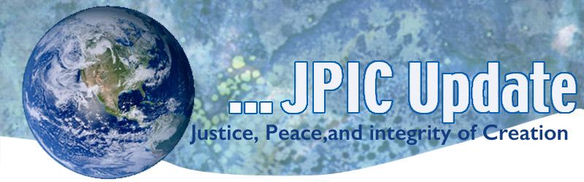
May 20, 2019

Let’s invite one another in. Maybe then we can begin to fear less, to make fewer wrong assumptions, to let go of the biases and stereotypes that unnecessarily divide us. Maybe we can better embrace the ways we are the same. It’s not about being perfect. It’s not about where you get yourself in the end. There’s power in allowing yourself to be known and heard, in owning your unique story, in using your authentic voice. And there’s grace in being willing to know and hear others. This, for me, is how we become." Michelle Obama

May
May 21 World Day of Cultural Diversity
May 22 International Day of Biological Diversity
May 24 Climate Strike on anniversary of Laudato Si’
May 25 African Liberation Day
May 27 Memorial Day
May 29 International day of UN Peacekeepers

*****************
TAKING ACTION
Be a voice for the voiceless
*********************
Protect our land and health
The Trump administration just took the next big step toward opening more than a million acres in California to dangerous oil drilling and fracking. If allowed, this would be a devastating blow to our public health and climate. And it would destroy lands desperately needed by a wide range of wildlife, from California condors to San Joaquin kit foxes.
Tell the Bureau of Land Management that you oppose any new fossil fuel development on California's beautiful public lands.

A new report has found that plastic pollution is having a detrimental effect on human health.
The report, a joint collaboration between Flora and Fauna and Tearfund, found that one person is dying every 30 seconds in developing countries from diseases and illnesses caused by plastic pollution and uncollected rubbish dumped or burnt near homes.

Plastic pollution from developed countries is ending up in places such as Malaysia and some of the poorest nations. 30 double-decker busloads of plastic waste are burned or dumped in developing countries.

Sir David Attenborough, who backs the report, said: “This report is one of the first to highlight the impacts of plastic pollution not just on wildlife but also on the world’s poorest people.”

Make a list of all the plastic you use and dispose of this week. Ask yourself: Can it be recycled, reused or am I able to use something else in its place.

***************************
INFORMATION/RESOURCES
***************************
Why does cultural diversity matter?
Three-quarters of the world’s major conflicts have a cultural dimension.
Bridging the gap between cultures is urgent and necessary for peace, stability and development.
Cultural diversity is a driving force of development, not only with respect to economic growth, but also as a means of leading a more fulfilling intellectual, emotional, moral and spiritual life.

Cultural diversity is thus an asset that is indispensable for poverty reduction and the achievement of sustainable development.
- The day provides us with an opportunity to deepen our understanding of the values of cultural diversity and to advance the four goals of the UNESCO Convention on the Protection and Promotion of the Diversity of Cultural Expressions adopted on 20 October 2005:Support sustainable systems of governance for culture
- Achieve a balanced flow of cultural goods and services and increase mobility of artists and cultural professionals
- Integrate culture in sustainable development frameworks
- Promote human rights and fundamental freedoms

House foreign affairs committee
Speaking at USIP’s Bipartisan Congressional Dialogue, Representatives Ami Bera and Lee Zeldin, leaders of the House Foreign Affairs Committee’s new panel on oversight and investigations, agreed that examining the nuts and bolts of diplomacy and development work is a critical—and often unfulfilled—job for Congress.

While some of the stark differences in policy are often focused on by the media, there is a wide bipartisan consensus on many foreign policy issues, Bera said. He cited as an example a recent hearing on Central America’s Northern Triangle, the area comprised of Honduras, Guatemala and El Salvador and the source of most migrants seeking entry to the U.S. While there is clearly a “challenge on the border,” he said, both sides recognize American policy has to address the root causes of the immigration issue. Consensus on that part of the immigration question unfortunately receives little public notice, he said.

“If you marked up 15 bills, the most controversial will get the media attention,” Zeldin said. “If there’s no controversy, none will get attention and you won’t know it took place.”

Catholic Health Association Supports Legislation to Strengthen ACA Provisions
CHA is supporting HR 987, the Strengthening Health Care and Lowering Prescription Drug Costs Act. The legislation would restore funding for outreach and enrollment efforts under the Affordable Care Act, which has been drastically reduced in the past several years. The bill also prevents an expansion of short-term, limited duration health plans, which do not cover the same number of services as other plans under the ACA and are allowed to freely discriminate based on age and pre-existing conditions. Other provisions in the bill, which have attracted bipartisan support as stand-alone legislation, would help to streamline the process for bringing generic drugs to the market and prevent price fixing. The House will consider HR 987 on the floor May 16 and it is expected to pass. In the Senate, the Health, Education, Labor and Pensions (HELP) Committee is working on its own health care package, which could be released as early as next week.
UN chief warns against slipping resolve in climate fight
Political will to fight climate change is fading, and governments around the world must focus on taxing carbon emissions rather than salaries, must stop relying on fossil fuels, and should work toward green economies, warns United Nations Secretary-General Antonio Guterres. "We need to protect the lives of our people and we need to protect our planet," he says.

UN Women works with Pakistani lawmakers on pro-women legislation
UN Women is working in partnership with female lawmakers in Pakistan's Khyber Pakhtunkhwa province to raise awareness and advocate for legislation aimed at protecting women. UN Women will offer support with research, drafting legislation and supporting documentation aimed at implementing laws to end child marriage and trafficking of women.

