Ramadan begins at sundown on May 6. Let us pray for all our Muslim brothers and sisters all over the world as they celebrate this sacred time.

Keeping Watch
In the morning
when I began to wake
it happened again.
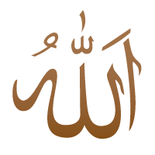
That feeling
that you, Beloved,
had stood over me all night
keeping watch.
That feeling
that as soon as I began to stir
You put your lips on my
forehead Allah in Arabic script
and lit a Holy Lamp
inside my heart.
~Hafiz (a term used by Muslims for people who have completely memorized the Qur'an)
from I Hear God Laughing

