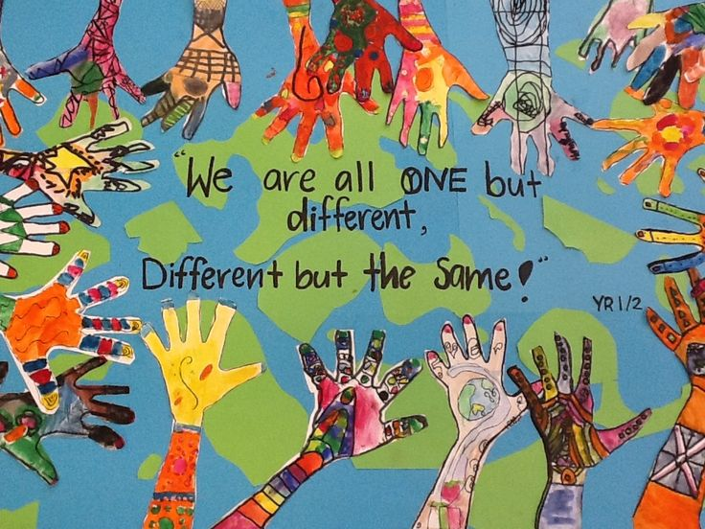

Prayers for Diversity
(Adapted from prayers from Xavier University)

A Spiritual Understanding of Diversity
There is great diversity among human beings. Physically we differ from each other in things such as size, body structure, skin color, and facial features. We also differ from one another mentally, emotionally, psychologically, and spiritually.
One of the greatest challenges of a healthy spirituality is learning to tolerate the differences we find in one another and not to view these differences as threats to ourselves.
Moreover, a healthy spirituality should lead us to celebrate our differences and to see them as a reflection of God's beneficence and creativity. (From Melannie Svoboda from Traits of a Healthy Spirituality)
Diversity Blessing
May the God who created a world of diversity and vibrancy,
Go with us as we embrace life in all its fullness.
May the Son who teaches us to care for stranger and foreigners,
Go with us as we try to be good neighbors in our communities.
May the Spirit who breaks down our barriers and celebrates community,
Go with us as we find the courage to create a place of welcome for all. (From Clare McBeath and Tim Presswood)
Response: We are one, different but the same!
Celebrating Diversity
Almighty God, through your Holy Spirit you created unity in the midst of diversity;
We acknowledge that human diversity is an expression of your manifold love for your creation;
We confess that in our brokenness as human beings we turn diversity into a source of alienation, injustice, oppression, and wounding.
Empower us to recognize and celebrate differences as your great gift to the human family.
Enable us to be the architects of understanding, of respect and love;
Through the Lord, the ground of all unity, we pray.

Response: We are one, different but the same!
For the Diversity of Races and Cultures
O God,
you created all people in your image.
We thank you for the astonishing variety
of races and cultures in this world.
Enrich our lives by ever-widening circles of friendship,
and show us your presence
in those who differ most from us,
until our knowledge of your love is made perfect
in our love for all your children;
through your Son, Jesus Christ our Lord. Amen. (From the Lutheran Book of Worship: Minister's Desk Edition)
Response: We are one, different but the same!
You, the One
You, the one
From whom on different paths
All of us have come.
To whom on different paths
All of us are going.
Make strong in our hearts what unites us;
Build bridges across all that divides us;
United make us rejoice in our diversity.
And at one in our witness to your peace,
A rainbow to your glory. Amen. (David Steindl-Rast OSB)
Response: We are one, different but the same!
Diversity Blessing
May the God who created a world of diversity and vibrancy,
Go with us as we embrace life in all its fullness.
May the Son who teaches us to care for strangers and foreigners,
Go with us as we try to be good neighbors in our communities.
May the Spirit who breaks down our barriers and celebrates community,
Go with us as we find the courage to create a place of welcome for all. (Clare McBeath and Tim Presswood)
Response: We are one, different but the same!
Prayer to Celebrate our Differences as Uniqueness
God has made all of us alike, yet different in so many ways.
People in our place of work, and in our school, come from different backgrounds.
Many of us have different customs and speak different languages.
Each and every one of us has a different way of reacting to any given situation.
We should show respect for all those who have entered our lives
and accept them for who they really are--Children of God.
Response: We are one, different but the same!
Prayer for Peace in our Communities
God of mercy and peace, you created us in your image, forming one human family. You love all your children without discrimination, and invite us to love each of our neighbors as ourselves. In hope, we lift up to you for healing the tensions and racism that plague our nation, and pray for increasing harmony and peace within our communities, and in our hearts.
Amen.

