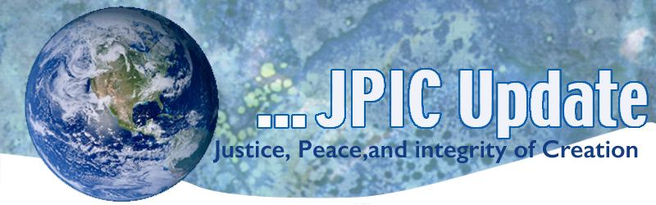

June 17, 2019

"A look, a smile, gestures of peace and friendship, attention and delicacy, these are the universal language, capable of demonstrating that we are much closer to one another than we imagined. Everywhere kindness touches, injustice wounds, peace is an ideal."
-Dom Helder Camara, Spiral

June 17 World Day to combat Desertification and Drought
June 19 Juneteenth
June 20 World Refugee Day
June 22-29 Religious Freedom Week
June 26 International Day in Support of Victims of Torture

*****************
TAKING ACTION
Be a voice for the voiceless
*********************
If you don’t do anything else, please watch this video!
Michael Tubbs is the youngest mayor in American history to represent a city with more than 100,000 people -- and his policies are sparking national conversations. In this rousing talk, he shares how growing up amid poverty and violence in Stockton, California shaped his bold vision for change and his commitment to govern as a neighbor, not a politician. "When we see someone different from us, they should not reflect our fears, our anxieties, our insecurities," he says. "We should see our common humanity."
Watch now »
eeptheseal.com
World Refugee Day June 20th
We invite our members and friends to stand in solidarity #WithRefugees and #StopRefugeeTrafficking on World Refugee Day, Thursday, June 20, 2019. Join us in calling your Representative and Senators and urging them to support two pro-refugee bills, the GRACE Act and the NO BAN Act.

We’ve prepared a tool kit that includes:
- Backgrounder
- USCSAHT Statement on Immigration and Human Trafficking
- Prayers for World Refugee Day
- Stories of Trafficked Immigrants and Asylum Seekers
- Take Action on World Refugee Day
- Sample Social Media Posts
- Complete Campaign Toolkit as PDF

SB 360
Those of you who live in California tell your legislator not to allow government interference in the practice of our faith.
SB 360 seeks to protect children from abuse and neglect, which is an intent we strongly support. However, the bill seeks to do this by violating the right to confidential Confession for priests and tens of thousands of Catholics who work with priests in parishes and other Church agencies and ministries.
Any law that violates the freedom of religion is wrong. Any government interference in the free practice of religion hurts all religions and all people of faith.

Click here to join the thousands of members who have sent letters to legislators asking them to vote down this bill.
keeptheseal.com

***************************
INFORMATION/RESOURCES
***************************

The Second Vatican Council's Declaration on Religious Liberty
On December 7, 1965, the Second Vatican Council approved Dignitatis humanae, the Declaration on Religious Liberty. The document roots religious freedom in the perennial teaching of the Church on human dignity. It teaches that religious freedom is the cornerstone of a society that promotes human dignity; it is a fundamental human right, which follows on the duty of all people to seek the truth about God. Learn more!

Juneteenth
Also known as Juneteenth Independence Day or Freedom Day, is an American holiday that commemorates the June 19, 1865, announcement of the abolition of slavery in the U.S. state of Texas, and more generally the emancipation of enslaved African Americans throughout the former Confederate States of America. It is observed as a legal holiday in Texas.

Interview with Dr. Mansour N'Diaye, Chef De Cabinet of the United Nations Convention to Combat Desertification secretariat
The sands across the world are crawling, turning vast stretches of land into desert each year. Their relentless march, invading villages, farmlands and water bodies, has made millions of people ecological refugees across the world. Desertification is not just an ecological issue but also one of shrinking food and water supplies, a loss of jobs and mass migration.

Desertification is a huge global environmental problem — like climate change. Desertification adds to, and worsens the impact of climate change. Currently, some two billion people are affected by desertification and the degradation of land; If we do not rehabilitate the degraded lands and stop the march of the deserts, there will be huge global shortages of food, water and fuels and unprecedented mass migrations.

Land degradation and desertification is a long process. They involve a host of issues such as deforestation, over-grazing, over-cultivation, logging, pressure of population, industrialisation and poor land-use practices. A naturally dry climate, long spells of droughts and heavy winds add to the anthropogenic causes.
kpmbasheer@thehindu.co.in
.
Key issues from UN
- Land & Drought — "By 2025, 1.8 billion people will experience absolute water scarcity, and 2/3 of the world will be living under water-stressed conditions."
A complex and slowly encroaching natural hazard with significant and pervasive socio-economic and environmental impacts that to cause more deaths and displace more people than any other natural disaster.
- Land & Human Security — "By 2045 some 135 million people may be displaced as a result of desertification."
Achieving land degradation neutrality -by rehabilitating already degraded land, scaling up sustainable land management and accelerating restoration initiatives- is a pathway to greater resilience and security for all.
- Land & Climate — "Restoring the soils of degraded ecosystems has the potential to store up to 3 billion tons of carbon annually."
The land use sector represents almost 25% of total global emissions. Its rehabilitation and sustainable management is critical to combating climate change.

Can the Paris Climate Goals Save Lives? (From the New York Times)
Under the Paris climate agreement, 195 countries pledged to cut their greenhouse gas in an effort to hold global warming to two degrees Celsius, or 3.6 degrees Fahrenheit, above preindustrial levels. They also promised efforts to limit the temperature increase even further, to 1.5 degrees Celsius.

The half-degree difference between 1.5 and two degrees may not seem like much, but, according to research published Wednesday in the journal Science Advances, it could mean saving or losing thousands of lives each year in the United States alone.

