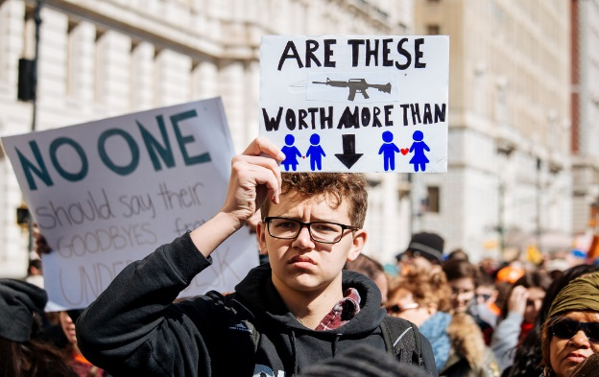

Against Gun Violence
By Aldon Solovy
God of the slain,
God of the murdered and the victim,
The voice of lamentation echoes across the land.
Wailing beside graves opened too soon,
Weeping beside stains of blood
From the dead and the injured
Pouring forth from bullet wounds:
The child shot,
The suicide,
The domestic assault,
The gang violence,
The mass murder,
The long night of death made easy by guns
And automatic weapons.
The long night of sorrow made easy
By reckless access to machines of slaughter.
Source of justice,
Rock of strength and truth,
You call upon us to stand
In the name of common sense and reason:
To witness on behalf of the innocent and the cut down –
The widowed, orphaned and bereaved –
To answer the scourge of senseless loss,
To advocate for gun control,
To remove military weapons from a civilian population,
To return sanity to our laws, our policies and our lives.
Bless those who dedicate themselves to gun control.
Grant them fortitude and perseverance.
May the work of their hands never falter
Nor despair deter them from their holy calling.
Bless those who are mourning the dead.
Grant them solace and comfort.
Bless those who are healing from the trauma of gun violence.
Grant them lives of health and prosperity,
Joy and peace.
Guardian of life, liberty, and the promise of peace, may our nation always merit Your protection.
We recognize that gun freedoms in our nation have resulted in too many losing the freedom to full lives
We know that peace anywhere might be shattered in a moment,
but we know, too, that many in this nation rarely experience the safety some of us take for granted
Help us to recall, as the prophet Jeremiah taught, that we must “seek the peace of the city,”
recognizing how our own peace is tied up in that of the city where we find ourselves.
The words of Isaiah remind us to share our bread, clothe the naked, unlock the fetters of wickedness
in this community and in our nation. [Isa 58:6-10]
In this prayer we focus on one common affliction of the soul
​Among us are those for whom gun violence is a policy issue
Grant our advocates light and wisdom, and help us all to support their efforts
Among us are those for whom gun violence is a real and present, if occasional, danger
Grant the fearful Your sheltering presence, and help us all to understand and address this burden
Among us are healers and others who deal directly with the aftermath of gun violence
Grant the responders strength in turmoil, and help us all to support their work
Among us are those who mourn victims of gun violence
Grant the mourners comfort, and help us all to better support them in their grief and cries for justice
​Among us are those who have experienced gun violence
Grant the shattered healing, and help us all to recognize this trauma and its cost
Keep us ever aware of the wonder of humanity and of threats to the sanctity of human life
Teach us to recognize the affect of gun violence on so many of our nation's children
May we never be lazy in the work of peace or complacent in our relative safety
May we honor those who have died in defense of our ideals
And may we acknowledge threats, some of our own making, to those ideals
Grant our leaders wisdom and forbearance
May they govern with justice, compassion and clear knowledge of the cost of gun violence
Help us all to appreciate one another, and the variety of viewpoints in this community and beyond,
and teach us to respect the many ways we may serve You
Then, we've been taught, shall our light rise in darkness, and this gloom be as the noon-day. [Isa 58:10]
Shine Your light through the gloom. Heal us and our local , national, and global communities.
Lead us toward homes free of affliction and strife, bodies and spirits untrammeled by gun violence.
​Help us to be the change we hope to see. Soon and in our lifetimes. – Amen.

